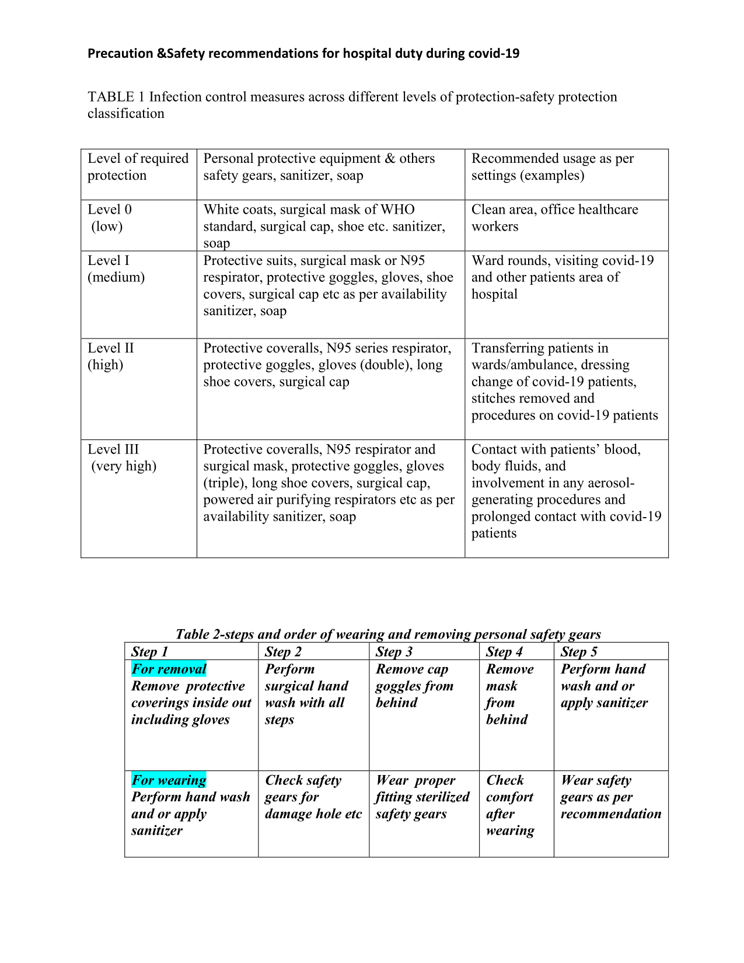

Table-4
No. of Health workers died due to COVID-19 as per PMGKP: Insurance Scheme
State/UT wise List (As on 11-09-2020)-source- https://pib.gov.in/PressReleasePage.aspx?PRID=1654454
S. No. | State/UT | Doctors | ANM/MPHW | ASHA | Others | Total
1 | Andaman & Nicobar | 1 | 0 | 0 | 0 | 1
2 | Andhra Pradesh | 5 | 5 | 1 | 1 | 12
3 | Arunachal Pradesh | 0 | 0 | 0 | 0 | 0
4 | Assam | 1 | 0 | 0 | 4 | 5
5 | Bihar | 4 | 1 | 1 | 0 | 6
6 | Chandigarh | 0 | 0 | 0 | 0 | 0
7 | Chhattisgarh | 2 | 0 | 1 | 1 | 4
8 | Delhi | 3 | 0 | 0 | 5 | 8
9 | Gujarat | 5 | 6 | 2 | 1 | 14
10 | Haryana | 2 | 0 | 0 | 0 | 2
11 | Himachal Pradesh | 0 | 0 | 1 | 0 | 1
12 | Jammu & Kashmir | 2 | 0 | 0 | 1 | 3
13 | Jharkhand | 2 | 2 | 1 | 1 | 6
14 | Karnataka | 2 | 0 | 1 | 1 | 4
15 | Kerala | 0 | 0 | 0 | 1 | 1
16 | Madhya Pradesh | 3 | 0 | 0 | 4 | 7
17 | Maharashtra | 6 | 3 | 0 | 12 | 21
18 | Mizoram | 0 | 0 | 0 | 2 | 2
19 | Odisha | 3 | 1 | 0 | 1 | 5
20 | Punjab | 1 | 2 | 1 | 1 | 5
21 | Puducherry | 0 | 0 | 0 | 0 | 0
22 | Rajasthan | 2 | 5 | 0 | 1 | 8
23 | Tamil Nadu | 5 | 3 | 0 | 2 | 10
24 | Telangana | 3 | 0 | 3 | 1 | 7
25 | Uttar Pradesh | 8 | 0 | 0 | 1 | 9
26 | West Bengal | 4 | 4 | 2 | 4 | 14
 | Total | 64 | 32 | 14 | 45 | 155

Table-3 below

Source- https://pqars.nic.in/annex/253/A85.pdf
No. of Healthcare Staff died due to COVID-19
(as on 22.01.2021)
Doctors | Nurses | ASHA workers
162 | 107 | 44

Healthcare workers death & infections due to covid-19 in 36 states and union territories of India
Table-5
Healthcare workers death & infections due to covid-19 in 36 states and union territories of India-5/19/2021 10:41:50 AM  India | Table-5  Medical Doctors |  | Medical Nurses |  | Other Medical Staff |  | HCWs (total) |  | Population | HCW  Mortality per 100,000
State/UT | died | infected | died | infected | died | infected | died | infected
Andhra Pradesh | 70+22 | ? | ? | ? | ? | ? | 14 | 994 | Census pending due to Covid-19 | ?
Arunachal Pradesh | 2 | ? | ? | ? | ? | ? | ? | ? | Census pending due to Covid | ?
Assam | 20+02 | ? | ? | ? | ? | ? | 03 | 1127 | Census pending due to Covid | ?
Bihar | 40+78 | ? | ? | ? | ? | ? | 04 | 940 | Census pending due to Covid | ?
Chhattisgarh | 03 | ? | ? | ? | ? | ? | ? | ? | Census pending due to Covid | ?
Goa | 01 | ? | ? | ? | ? | ? | ? | ? | Census pending due to Covid | ?
Gujarat | 02+62 | ? | ? | ? | ? | ? | 35 | 3177 | Census pending due to Covid | ?
Haryana | 02 | ? | ? | ? | ? | ? | 09 | 2434 | Census pending due to Covid | ?
Himachal Pradesh | 0 | ? | ? | ? | ? | ? | ? | ? | Census pending due to Covid | ?
Jharkhand | 0−5 | ? | ? | ? | ? | ? | 02 | 1275 | Census pending due to Covid | ?
Karnataka | 08+68 | ? | ? | ? | ? | ? | 46 | 12260 | Census pending due to Covid | ?
Kerala | 02 | ? | ? | ? | ? | ? | ? | ? | Census pending due to Covid | ?
Madhya Pradesh | 05+22 | ? | ? | ? | ? | ? | 17 | 2029 | Census pending due to Covid | ?
Maharashtra | 13+74 | 5913 | 10 | 4217 | 120 | 7845 | 292 | 24484 | Census pending due to Covid | ?
Manipur | ? | ? | ? | ? | ? | ? | ? | ? | Census pending due to Covid | ?
Meghalaya | ? | ? | ? | ? | ? | ? | ? | ? | Census pending due to Covid | ?
Mizoram | ? | ? | ? | ? | ? | ? | ? | ? | Census pending due to Covid | ?
Nagaland | 4 | ? | ? | ? | ? | ? | ? | ? | Census pending due to Covid | ?
Odisha | 08 | ? | ? | ? | ? | ? | 02 | 2185 | Census pending due to Covid | ?
Punjab | 20 | ? | ? | ? | ? | ? | 02 | 1055 | Census pending due to Covid | ?
Rajasthan | 0 | ? | ? | ? | ? | ? | 11 | 2398 | Census pending due to Covid | ?
Sikkim | ? | ? | ? | ? | ? | ? | ? | ? | Census pending due to Covid | ?
Tamil nadu | 10+89 | ? | ? | ? | ? | ? | 49 | 11169 | Census pending due to Covid | ?
Telangana | 19 | ? | ? | ? | ? | ? | 01 | 2704 | Census pending due to Covid | ?
Tripura | ? | ? | ? | ? | ? | ? | ? | ? | Census pending due to Covid | ?
Uttar Pradesh | 66+37 | ? | ? | ? | ? | ? | 06 | 1650 | Census pending due to Covid | ?
Uttarakhand | ? | ? | ? | ? | ? | ? | ? | ? | Census pending due to Covid | ?
West Bengal | 80+ | ? | ? | ? | ? | ? | 21 | 5126 | Census pending due to Covid | ?
A & N islands | ? | ? | ? | ? | ? | ? | ? | ? | Census pending due to Covid | ?
Chandigarh | ? | ? | ? | ? | ? | ? | ? | ? | Census pending due to Covid | ?
Dadar nagar haveli | ? | ? | ? | ? | ? | ? | ? | ? | Census pending due to Covid | ?
Delhi | 22+29 | ? | ? | ? | ? | ? | 51 | 8363 | Census pending due to Covid | ?
Jammu & Kashmir | 03 | ? | ? | ? | ? | ? | ? | ? | Census pending due to Covid | ?
Lakshadweep | ? | ? | ? | ? | ? | ? | ? | ? | Census pending due to Covid | ?
Puducherry | ? | ? | ? | ? | ? | ? | ? | ? | Census pending due to Covid | ?
Laddakh | ? | ? | ? | ? | ? | ? | ? | ? | Census pending due to Covid | ?
 | ? | ? | ? | ? | ? | ? | ? | 87176 |  | ?
All India | 108 | 1073 | 02 | 144 | ? | 96 | 110 | 1313 | Census pending due to Covid-19 | ?
748+270= 1st wave+2nd wave doctors-IMA ?
Healthcare workers death & infections due to covid-19 in 36 states and union territories of India
Note: It’s a fact well known worldwide that due to several reasons real data of mortality and morbidity is not available till date. The data sources are mentioned below from where it is collected.

References
https://www.thehindu.com/news/national/covid-19-surge-bihar-up-delhi-top-list-of-deaths-among-doctors-in-second-wave-says-ima/article34577689.ece
https://timesofindia.indiatimes.com/india/over-87k-health-workers-infected-with-covid-19-573-dead/articleshow/77814189.cms
https://www.indiatoday.in/coronavirus-outbreak/story/in-second-wave-india-lost-269-doctors-to-covid-1803828-2021-05-18
https://indianexpress.com/article/cities/pune/747-doctors-died-of-covid-19-in-india-ima-7277087
https://indianexpress.com/article/cities/pune/747-doctors-died-of-covid-19-in-india-ima-7277087
https://www.hindustantimes.com/india-news/270-doctors-have-dies-in-second-wave-of-covid-19-says-ima-101621321701122.html
https://doi.org/10.1016/J.IJID.2020.10.064

https://doi.org/10.1016/J.IJID.2020.10.064

