Supplementary Information
Supplementary Table. 1 Nutrients composition of both ND and HTD. ND, normal diet; HTD, high tryptophan diet
Nutrients | Content
Metabolizable energy
Protein | 23.07%
Carbohydrate | 65.08%
Fat | 11.85%
Vitamin
Vitamin A | 7800.00 IU/kg
Vitamin D | 1200.00 IU/kg
Vitamin E | 67.00 mg/kg
Vitamin K | 5.00 mg /kg
Vitamin B1 | 10.00 mg/kg
Vitamin B2 | 15.00 mg/kg
Vitamin B6 | 10.00 mg/kg
Vitamin B12 | 0.02 mg/kg
Nicotinic acid | 55.00 mg/kg
Pantothenic acid | 22.00 mg/kg
Biotin | 0.20 mg/kg
Folic acid | 6.60 mg/kg
Mineral substance
Sodium (Na) | 3.10 g/kg
Magnesium (Mg) | 2.90 g/kg
Kalium (K) | 7.40 g/kg
Cuprum (Cu) | 11.40 mg/kg
Iron (Fe) | 113.70 mg/kg
Manganese (Mn) | 80.00 mg/kg
Zinc (Zn) | 31.60 mg/kg
Selenium (Se) | 0.20 mg/kg
Iodine (I) | 0.70 mg/kg

Supplementary Table. 2 Aminoacids present in ND and HTD (g/kg). The ND and HTD are the same composition in nutrients except the tryptophan content. ND, normal diet; HTD, high tryptophan diet
Aminoacids | ND | HTD
Methionine+Cystine | 5.80 | 5.80
Lysine | 8.90 | 8.90
Arginine | 9.90 | 9.90
Leucine | 14.80 | 14.80
Isoleucine | 7.40 | 7.40
Threonine | 6.60 | 6.60
Valine | 8.90 | 8.90
Histidine | 4.90 | 4.90
Phenylalanine+Tyrosine | 14.60 | 14.60
Tryptophan | 2.10 | 4.00

Supplementary Fig. 1 The levels of 5-HT and 5-HIAA in midbrain were significantly increased in the Ab treatment group compared with the control group in DBA/1 mice. n=6 in each group. Statistical analysis was performed by the independent samples t-test. ** p < 0.01, *** p < 0.001. Data represents as mean ± SD. 5-HT, 5-hydroxytryptamine; 5-HIAA, 5-hydroxyindoleacetic acid; Ab, antibiotics
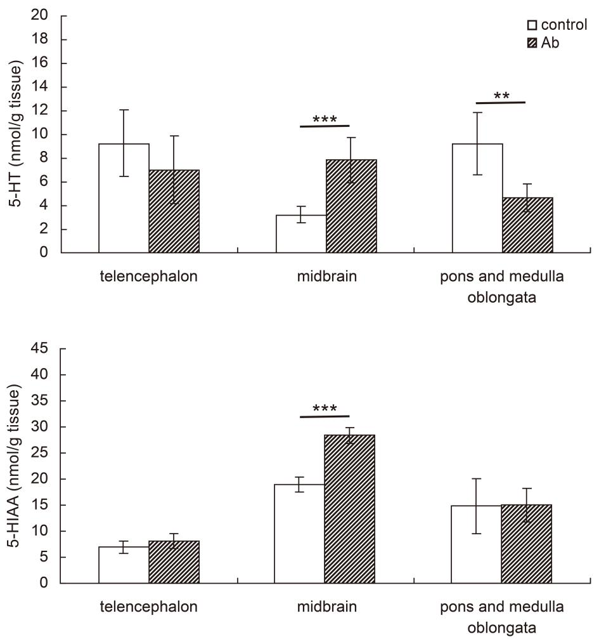

Supplementary Fig. 2 Ab treatment caused a change in the gut microbiota composition compared with their control in DBA/1 mice, and with a high frequency of Proteobacteria and low frequency of Firmicutes and Bacteroidetes in the Ab treatment mice. The horizontal bar charts depict the taxonomic differences between the two groups at the phylum level. n=10 in each group. Statistical analysis was performed by the Wilcoxon rank-sum test. * p ＜ 0.05, ** p ＜ 0.01, *** p ＜ 0.001. Ab, antibiotics
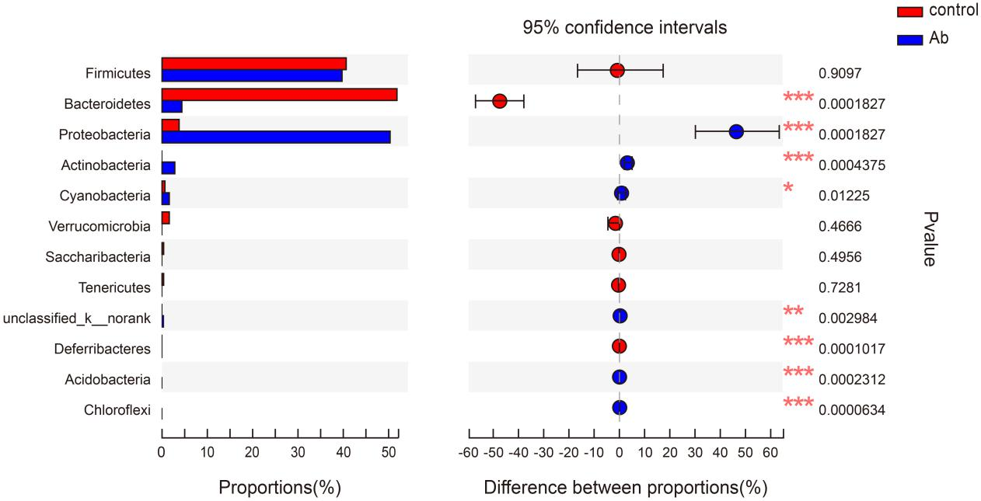

Supplementary Fig. 3 HTD+Ab treatment did not significantly increase the 5-HT level in the brain of DBA/1 mice compared with the HTD group. n=6 in each group. Statistical analysis was performed by the independent samples t-test. *** p < 0.001. Data represents as mean ± SD. 5-HT, 5-hydroxytryptamine; HTD, high tryptophan diet; HTD+Ab, high tryptophan diet with antibiotics

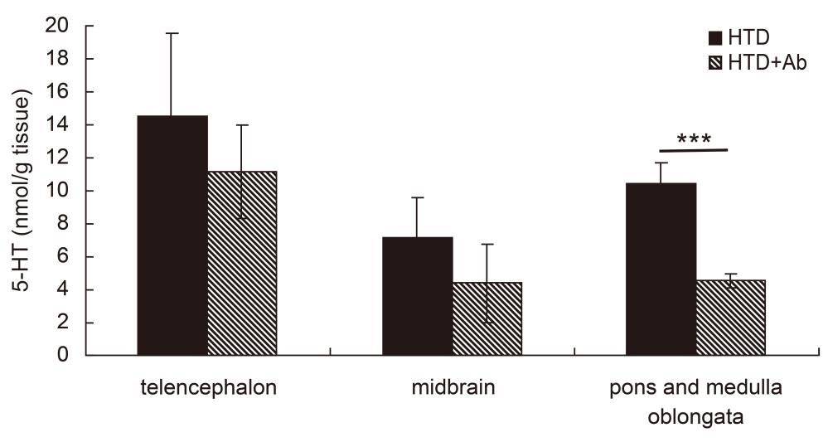

Supplementary Fig. 4 HTD+Pb treatment did not significantly change the metabolism of TRP and 5-HT in plasma and brain of DBA/1 mice. n=6 in each group. Statistical analysis was performed by the independent samples t-test. Data represents as mean ± SD. TRP, tryptophan; 5-HT, 5-hydroxytryptamine; HTD, high tryptophan diet; HTD+Pb, high tryptophan diet with probiotics

