Supporting Information

¹⁹F MRI-guided Flexible Low-intensity Focused Ultrasound for
Drug Delivery and Molecular Targeted Therapy

Jie Yang^{1,2,3}, Yingbo Li^{1,2,3}, Jiemei Sun^{1,2}, Hongyan Zou^{1,2}, Qian Xie^{1,2}, Rong A^{1,2}, Hongbin Wang^{1,2}, Xiaona Li^{1,2}, Kai Wang^{1,2}, Lili Yang^{1,2}, Lina Wu^{1,2}* & Xilin Sun^{1,2}*

¹ NHC and CAMS Key Laboratory of Molecular Probe and Targeted Theranostics, Molecular Imaging Research Center (MIRC), Harbin Medical University, 150028 Harbin, Heilongjiang, China.
² Department of Nuclear Medicine, the Fourth Hospital of Harbin Medical University, 150028 Harbin, Heilongjiang, China.
³These authors contributed equally: Jie Yang, Yingbo Li.
*email: sunxl@ems.hrbmu.edu.cn; LinaWu@hrbmu.edu.cn

Supplementary Figure 1. Dark-field image of PFCE NPs and the corresponding EDS elemental mapping of carbon (C), oxygen (O) and fluorine (F). Scale bar is 100 nm.

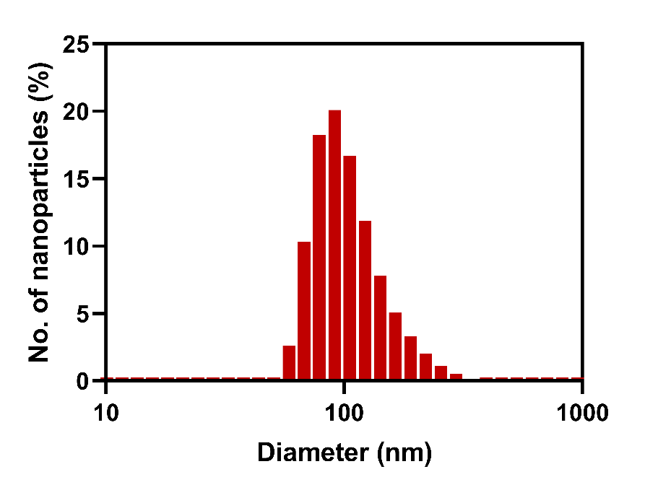
Supplementary Figure 2. Average hydrodynamic size of PFCE NPs characterized by dynamic light scattering (DLS).

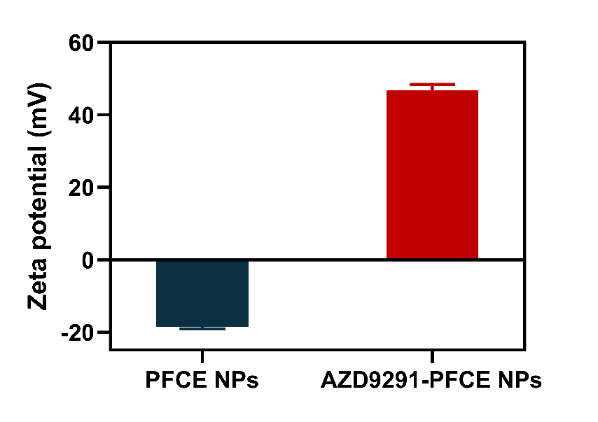
Supplementary Figure 3. Zeta potential of PFCE NPs and AZD9291-PFCE NPs.

Supplementary Figure 4. a Fluorescence image (top row) and ¹⁹F MR images (bottom row) of reference tubes with various ¹⁹F concentrations. b Correlation of fluorescence signal and ¹⁹F MR signal intensity of AZD9291-PFCE NPs.

Supplementary Figure 5. Cell viability of H1975 and H520 cells treated with PFCE NPs for 24h and 48h.

Supplementary Figure 6. Cell viability of H1975 and H520 cells treated with free AZD9291 at various concentrations for 24h and 48h.

Supplementary Figure 7. ¹H MR images of mice injected with 300 μL of PFCE NPs and AZD9291-PFCE NPs at different time points. Four hours after injection of nanoparticles, LIFU (1.1 MHz, 55.8 mW/cm², 20 min) was applied to trigger the location of the tumor and MRI was performed synchronously.

Supplementary Figure 8. Representative ex vivo images of tumors and major organs derived from mice treated with rhodamine-labeled PFCE NPs and AZD9291-PFCE NPs at 48 h post injection (n = 3).

Supplementary Figure 9. Rhodamine-labeled PFCE NPs and AZD9291-PFCE NPs distribution in normal tissues. Nuclei were stained by DAPI. Scale bar is 200 µm.
Supplementary Figure 10. Photos of H1975 tumor-bearing mice model from each group on day 0, 7 and 14 d after treatment with Control, PFCE NPs (0.1 g/kg), AZD9291 (0.5 mg/kg), AZD9291-PFCE NPs (0.5 mg/kg), Control+LIFU, PFCE NPs+LIFU (0.1 g/kg), AZD9291+LIFU (0.5 mg/kg) and AZD9291-PFCE NPs+LIFU (0.5 mg/kg). Free AZD9291 was given via gavage every day and other groups received intravenous injection every 3 days. LIFU was applied to the tumor site after different administrations for 4 h (1.1 MHz, 55.8 mW/cm², 20 min).

Supplementary Figure 11. a The photo of tumors excised from mice after different treatments on day 14. b Tumor growth inhibition (TGI) of H1975 tumor-bearing mice after various treatments (n = 5), **** P < 0.0001.

Supplementary Figure 12. a Proliferative index (n = 6) and (b) CD31-positive area of tumor tissues in various groups (n = 3). ** P < 0.01, *** P < 0.001, **** P < 0.0001.

Formulation | Cell | Mean IC₅₀±SD  （24h, μM） | Mean IC₅₀±SD  （48h, μM）
AZD9291 | H1975 | 0.018±0.123 | 0.005±0.107
AZD9291-PFCE NPs |  | 0.025±0.123 | 0.012±0.111
AZD9291 | H520 | 1.03±0.095 | 0.607±0.105
AZD9291-PFCE NPs |  | 1.468±0.063 | 1.125±0.074
Supplementary Table 1. The IC50 of H1975 and H520 cells treated with free AZD9291 and AZD9291-PFCE NPs for 24h and 48h. Results are presented as mean ± SD.

