Supplementary Materials include:

Command line steps to encode and decode the data.
Figure S1. The transcoding illustration using one of the 1536 rules of YYC.
Figure S2. The information density estimation and average rejection rate in the change of transcoding screening iteration runs.
Figure S3. The information density and transcoding time estimation of demo file using four randomly selected rules.
Figure S4. Percentage of unsuccessful decoded binary information according to DNA sequence loss
Figure S5. Information loss percentage of three individual files according to experimental validation result with average copy number of 1,000.
Figure S6. Evaluation of the influence of sequencing depth on sequence error rate and sequence loss rate for in vitro storage validation.
Figure S7. The design of generated DNA sequence by Yin-Yang Code for in vivo data storage in the form of a 54Kb DNA fragment inserted in the low-copy plasmid pRS416.
Table S1. The effect on compatibility of generated DNA sequence using different coding strategies for specific binary data patterns.
Table S2. The estimation of iteration runs and corresponding information density by transcoding 10 different types/formats of files.
Table S3. The in-silico simulation of the data recovery rate in the context of a gradient of DNA sequence loss.
Table S4. The comparisons between YYC and DNA Fountain for transcoding 9 different types of files.
Table S5. Minimum redundancy required for successful data retrieval with different bitmap images.
Table S6. The data recovery statistics of YYC coding in vitro binary data storage validation.
Table S7. The data recovery statistics of DNA Fountain coding in vitro binary data storage validation.
Table S8. Error analysis of in vivo storage demonstration.

Command line steps to encode and decode the data
For reproducibility, we provide the step-by-step pseudocodes in an Ubuntu environment using Python 3.7.3:
Encoding
python
>>> from yyc import pipeline
>>> from yyc import scheme
>>> pipeline.encode(method=scheme.YYC(support_bases="A", base_reference=[0, 1, 0, 1], current_code_matrix=[[1, 1, 0, 0], [1, 0, 0, 1], [1, 1, 0, 0], [1, 1, 0, 0]], search_count=100, max_homopolymer=4, max_content=0.6), input_path="./files/Mona Lisa.jpg", output_path="./output/mona_lisa.dna", model_path="./output/yyc.pkl", need_index=True, need_log=True)

Decoding
python
>>> from yyc import pipeline
>>> pipeline.decode(model_path="./output/yyc.pkl",input_path="./output/mona_lisa.dna", output_path="./output/output_mona_lisa.jpg", has_index=True, need_log=True)

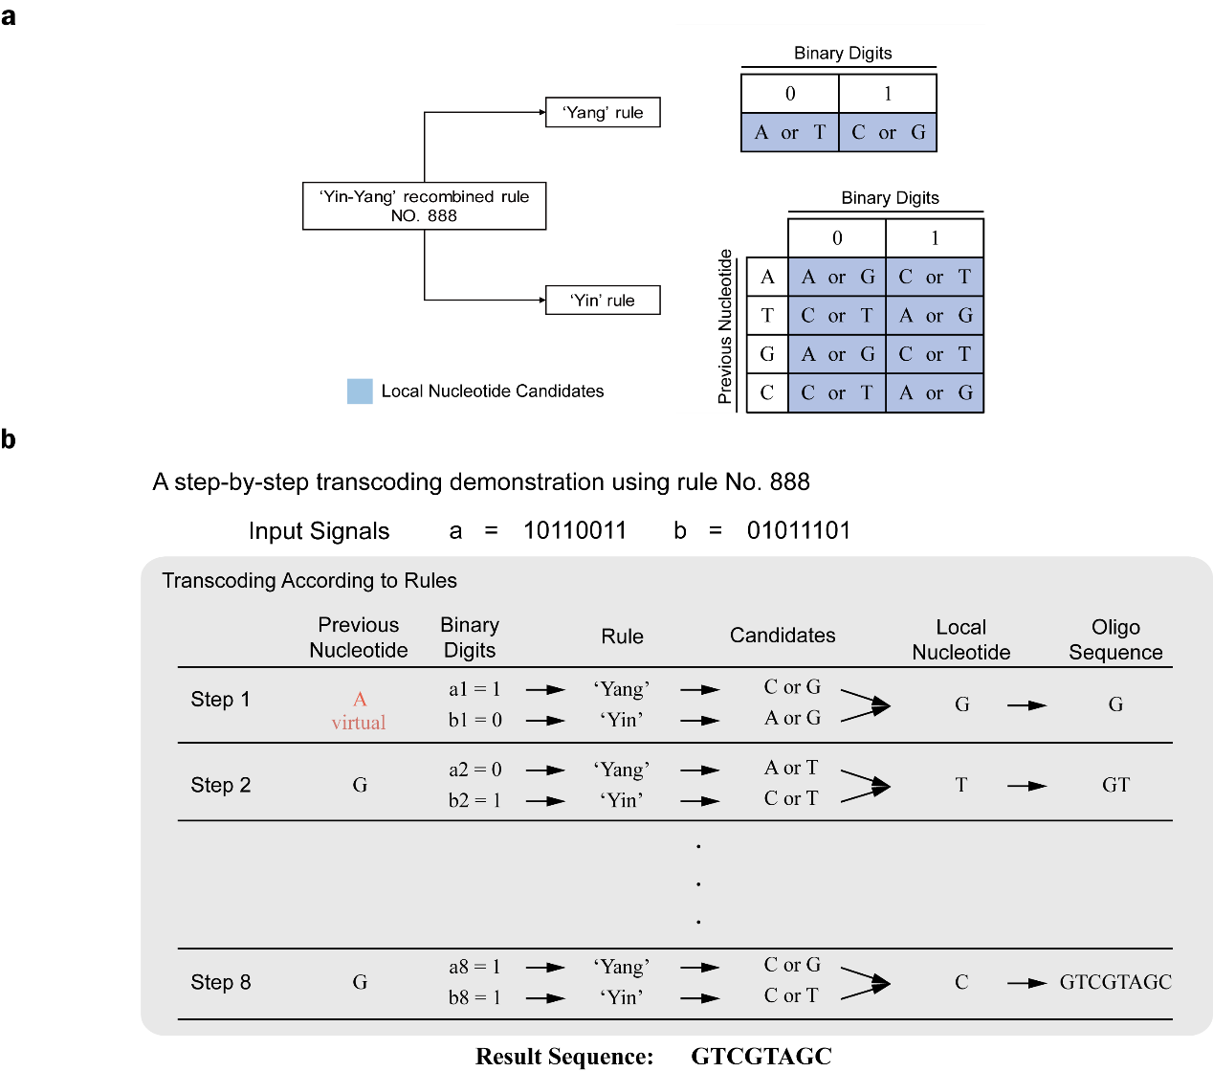
Figure S1. The transcoding illustration using one of the 1536 rules of YYC. (a) The coding principle of YYC rule No. 888. (b) The demonstration of step-by step YYC transcoding process. ‘a1’, ‘b1’ represents the first-position binary digit in segment ‘a’ and ‘b’, and so on. Virtual base A means this base is used only for determination of the output base in the first run of transcoding and will not appear in the result sequence.
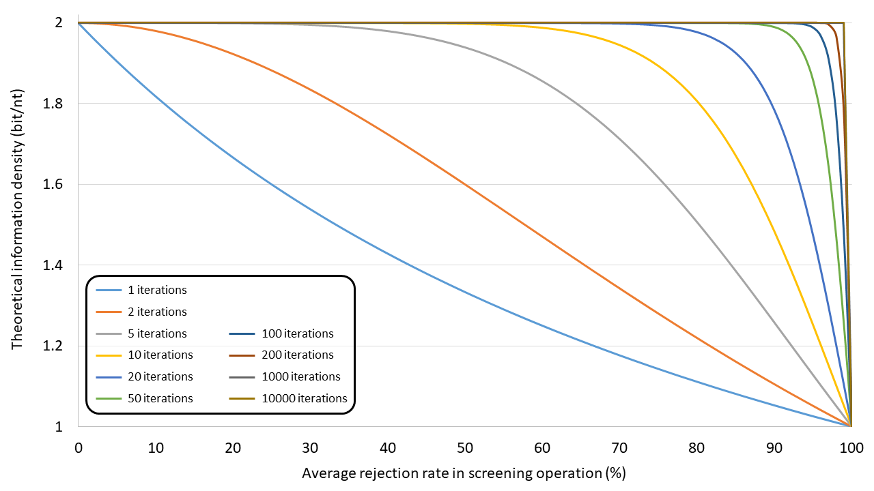
Figure S2. The information density estimation and average rejection rate in the change of transcoding screening iteration runs.

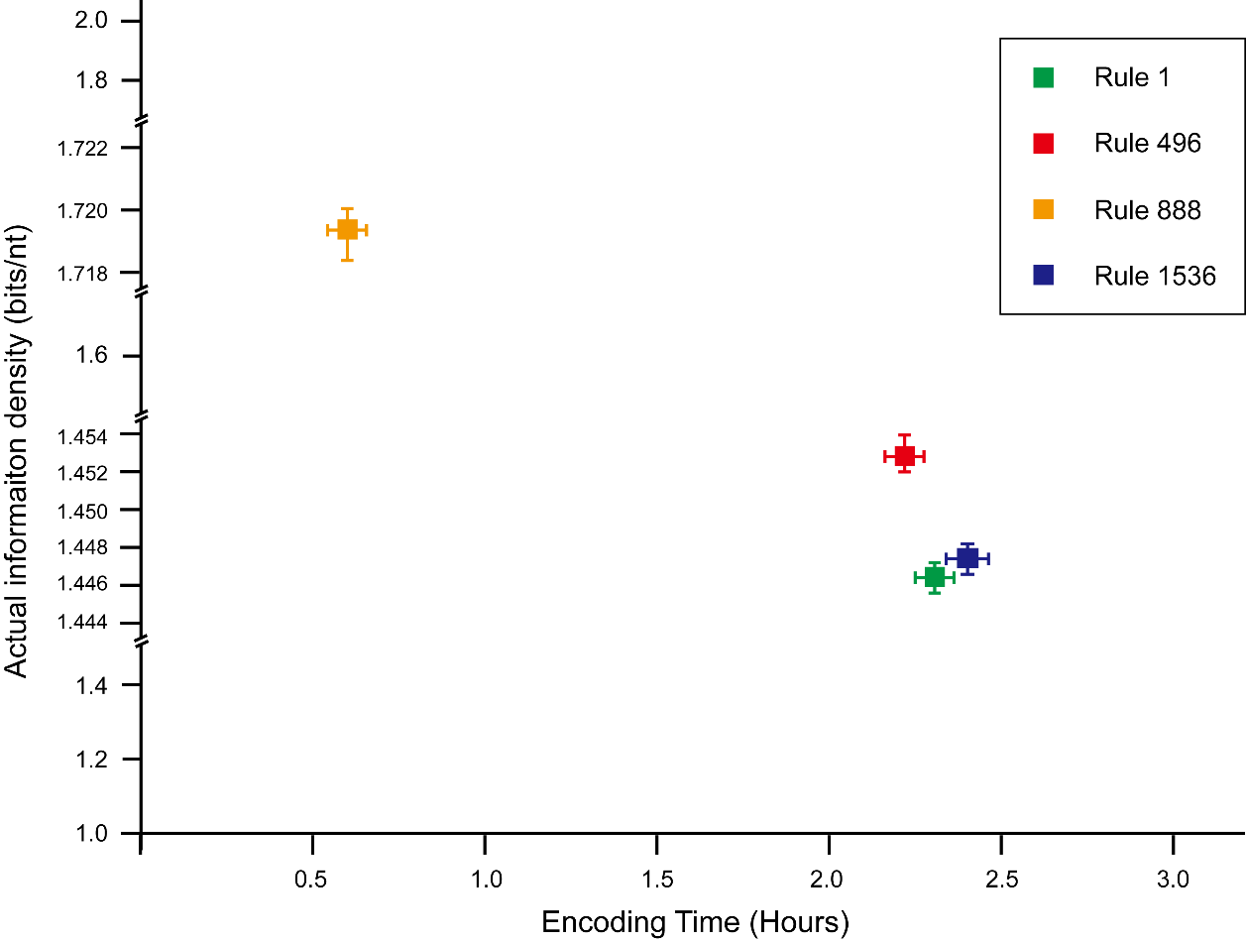
Figure S3. The information density and transcoding time estimation of demo file ‘Exiting the Factory.flv’ using four randomly selected rules Nos. 1, 496, 888, and 1536.

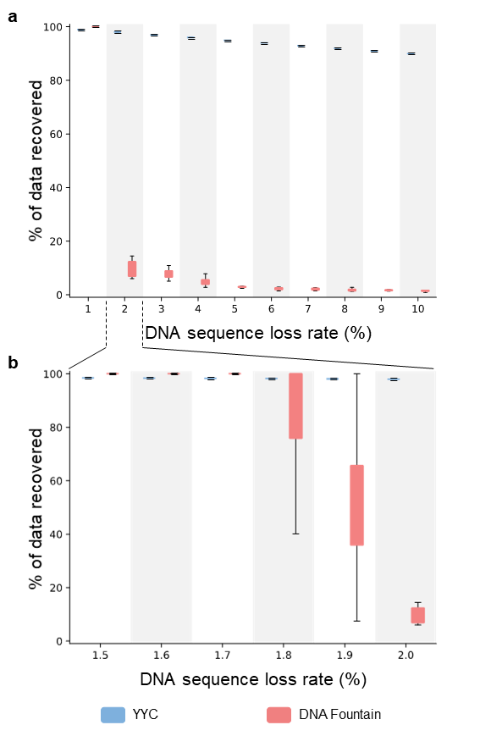
Figure S4. The data recovery rate in the presence of varying gradient of DNA sequence loss. The lost rate between a) 1% to 10% and b) 1.5% to 2.0%.

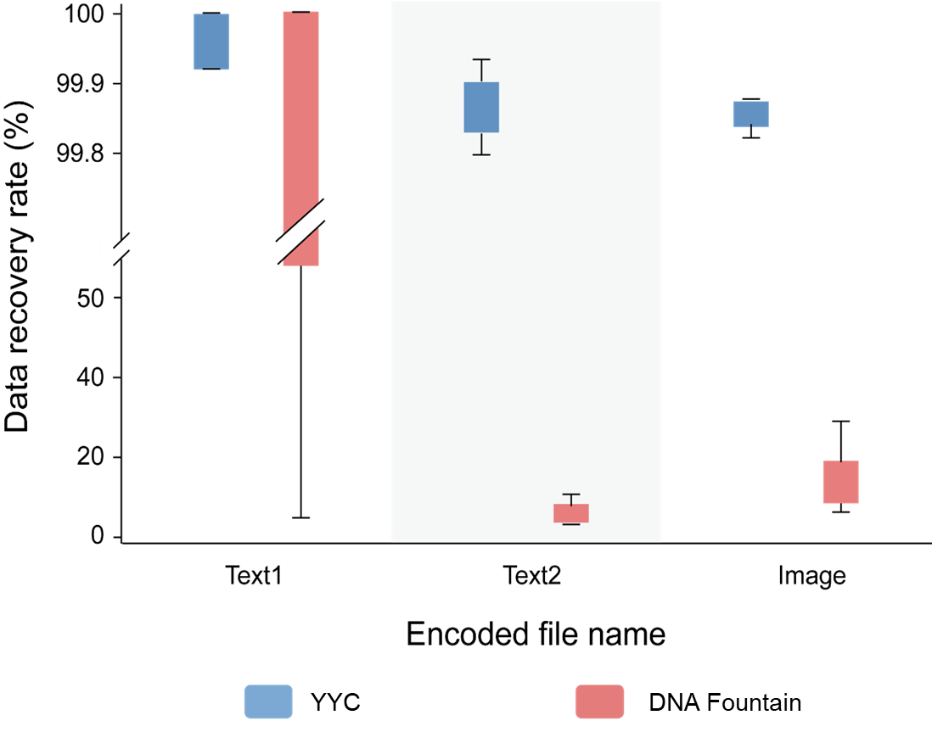
Figure S5. The data recovery rate of three individual files according to experimental validation result with average copy number of 1,000.

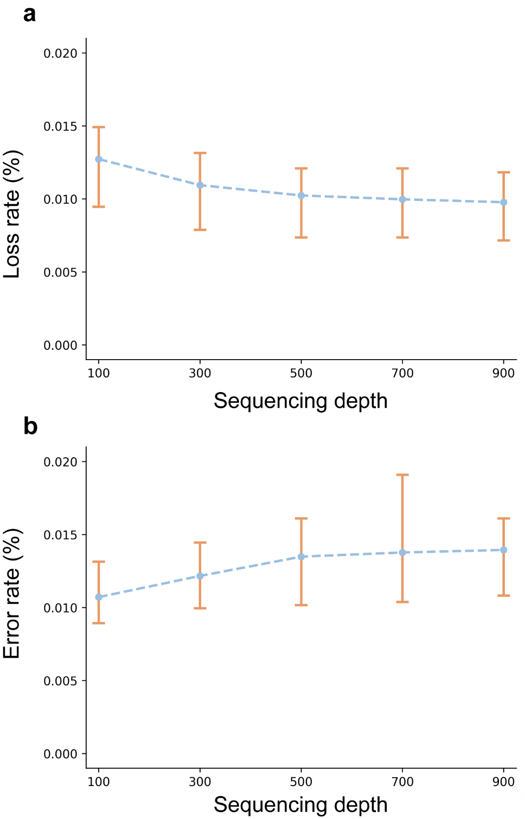

Figure S6. Evaluation of the influence of sequencing depth on sequence error rate (a) and sequence loss rate (b) for in vitro storage validation.

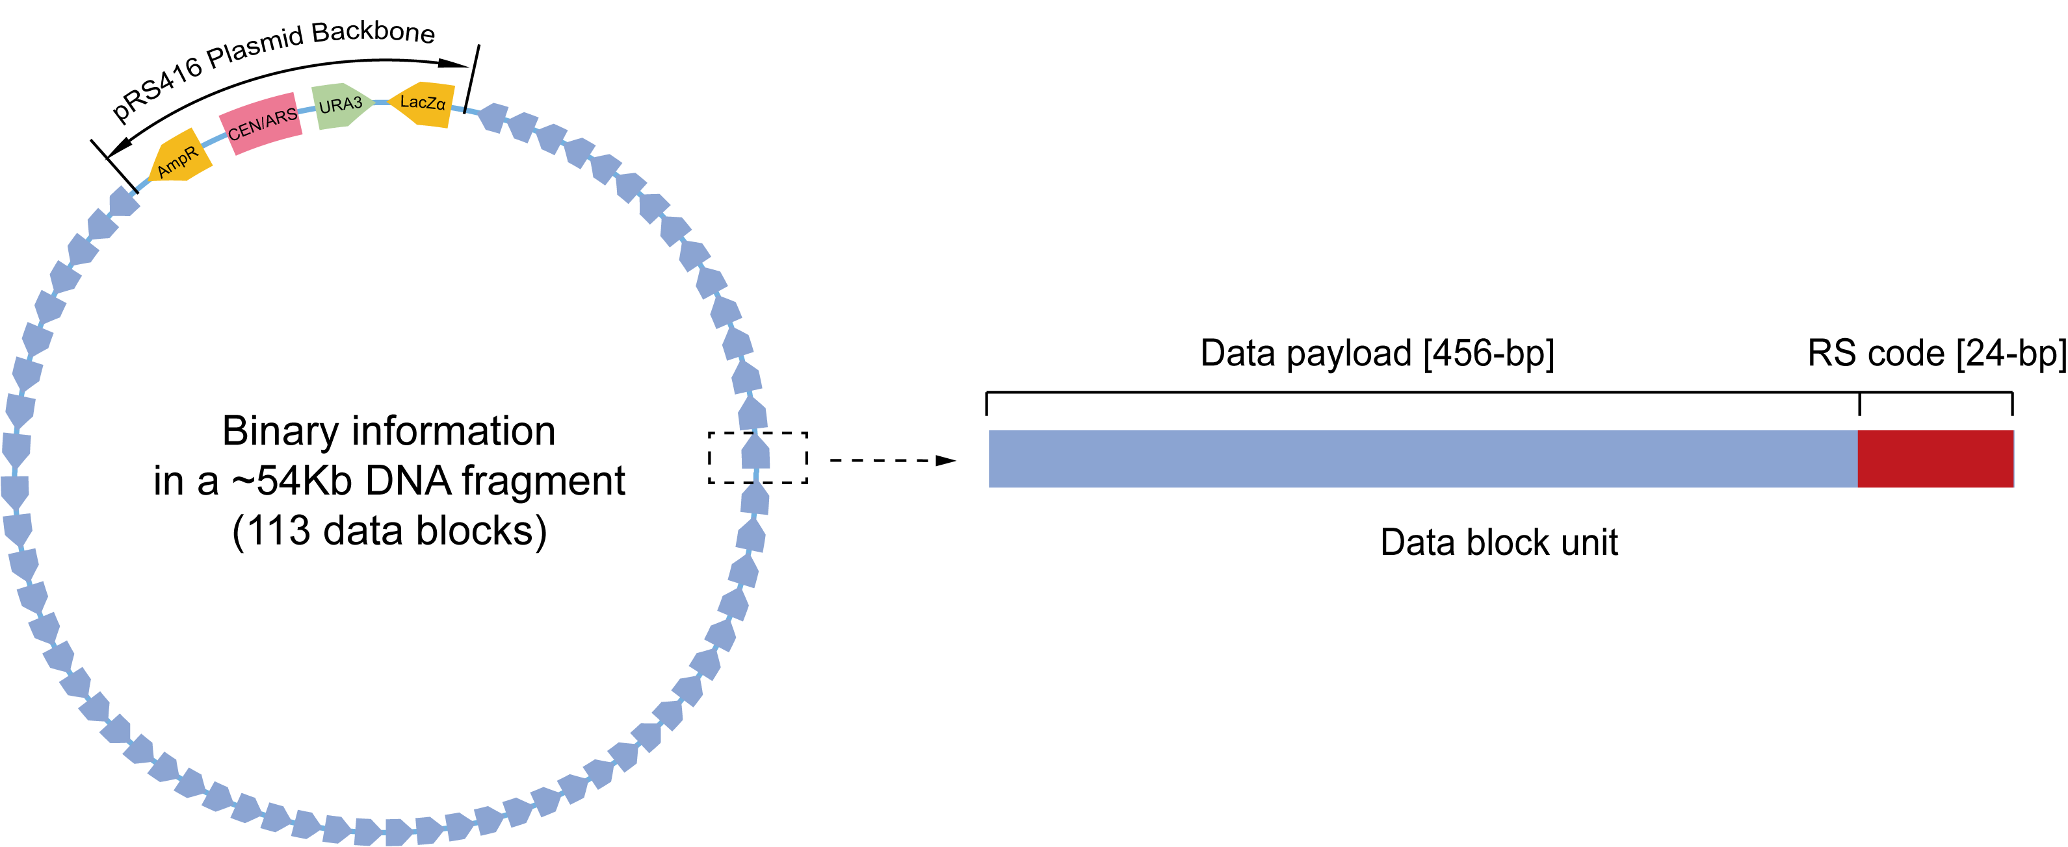
Figure S7. The design of generated DNA sequence by Yin-Yang Code for in vivo data storage in the form of a 54Kb DNA fragment inserted in the low-copy plasmid pRS416.

Table. S1. The effect on compatibility of generated DNA sequence using different coding strategies for specific binary data patterns.
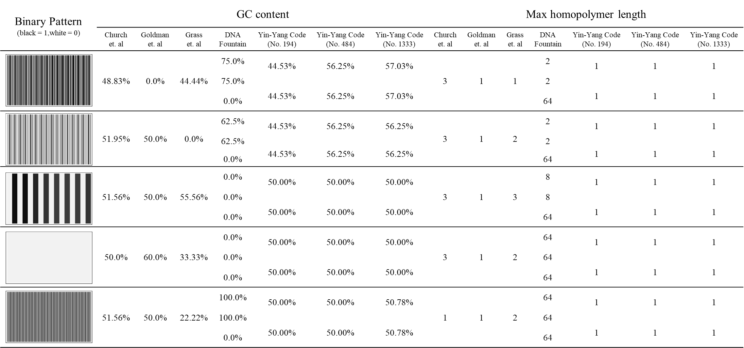

Table S2. The estimation of iteration runs and corresponding information density by transcoding 10 different types/formats of files.
File name | File format | File size (KB) | Rate of additional  information (%) | Average number of iteration run | Information  density (bits/nt)  (Rule 496)
Mona Lisa | jpg | 96 | 0.031 | 1.398 | 1.8037
United Nations Flag | bmp | 469 | 0.075 | 5.040 | 1.7764
A Tale of Two Cities | pdf | 1011 | 0.072 | 1.825 | 1.7506
The Wandering Earth | pdf | 368 | 0.064 | 1.924 | 1.7766
DNA Fountain Input Files | tar | 2096 | 0.004 | 1.493 | 1.7391
Microsoft Winmine | exe | 117 | 3.180 | 7.873 | 1.7489
For Elise | wma | 2544 | 0.462 | 3.482 | 1.7311
Summer | mp3 | 6033 | 0.006 | 1.924 | 1.7265
Exiting the Factory | flv | 4033 | 19.245 | 7.286 | 1.4480
I have a Dream | mp4 | 3986 | 0.094 | 1.923 | 1.7250

Table S3. The in-silico simulation of the data recovery rate in the context of a gradient of DNA sequence loss.
Oligo loss rate | YYC | DNA Fountain
1.0% | 99.00% ± 0.00% | 100.00% ± 0.00%
1.5% | 98.50% ± 0.00% | 100.00% ± 0.00%
1.6% | 98.40% ± 0.00% | 100.00% ± 0.00%
1.7% | 98.30% ± 0.00% | 100.00% ± 0.00%
1.8% | 98.20% ± 0.00% | 84.66% ± 23.11%
1.9% | 98.10% ± 0.00% | 53.20% ± 29.06%
2.0% | 98.00% ± 0.00% | 9.82% ± 3.17%
3.0% | 97.00% ± 0.00% | 7.84% ± 1.90%
4.0% | 96.00% ± 0.00% | 4.82% ± 1.66%
5.0% | 95.00% ± 0.00% | 2.9% ± 0.27%
6.0% | 94.00% ± 0.00% | 2.18% ± 0.50%
7.0% | 93.00% ± 0.00% | 2.04% ± 0.39%
8.0% | 92.00% ± 0.00% | 1.76% ± 0.55%
9.0% | 91.00% ± 0.00% | 1.68% ± 0.18%
10.0% | 90.00% ± 0.00% | 1.42% ± 0.28%

Table S4. The comparisons between YYC and DNA Fountain for transcoding 9 different types of files. Minimum required redundancy for successful encoding and decoding larger than 100% is marked as ‘N.A.’.
File Names | Methods
 | Yin-Yang Code (Rule 496) |  | DNA Fountain
 | Oligo Number | Net information Density (bits/nt) | Oligo Number | Minimum Redundancy | Net information Density (bits/nt)
Mona Lisa | 3252 | 1.804 | 3811 | 25% | 1.347
Microsoft Winmine | 4121 | 1.749 | 4980 | 33% | 1.266
The Wandering Earth | 12536 | 1.777 | 13390 | 14% | 1.477
United Nations Flag | 16014 | 1.776 | N.A.
A Tale of Two Cities | 34501 | 1.751 | 35554 | 10% | 1.531
DNA fountain input files | 71513 | 1.739 | 71734 | 7% | 1.574
For Elise | 87219 | 1.731 | 87090 | 7% | 1.574
I Have a Dream | 136183 | 1.725 | 202808 | 59% | 1.059
Summer | 205918 | 1.727 | N.A.

Table S5. Minimum redundancy required for successful data retrieval with different bitmap images. Minimum required redundancy for successful encoding and decoding larger than 300% is marked as ‘N.A.’.
Name | Flag Style | Minimum Available Redundancy
United Nations Flag |  | > 66%
China Flag |  | > 243%
Japan Flag |  | N.A.
India Flag |  | > 42%
Britain Flag |  | 13%
Ireland Flag |  | N.A.
Germany Flag |  | N.A.
America Flag |  | > 61%
Brazil Flag |  | > 116%
Singapore Flag |  | 33%

Table S6. The data recovery statistics of YYC coding in vitro binary data storage validation.
Encoded file | AMC number | Decoded file | Obtained  oligo amount | Required  oligo amount | Oligo coverage | Recovered binary  segments | Original binary  segments | Information recovery rate
Text1 | 10000 | YYC-File1-V300086833_L2_529.yyc_file1.dna | 1672 | 1676 | 99.76% | 2678 | 2678 | 100.00%
Text1 | 10000 | YYC-File1-V300086833_L2_530.yyc_file1.dna | 1672 | 1676 | 99.76% | 2678 | 2678 | 100.00%
Text1 | 10000 | YYC-File1-V300086833_L4_515.yyc_file1.dna | 1673 | 1676 | 99.82% | 2678 | 2678 | 100.00%
Text1 | 10000 | YYC-File1-V300086833_L4_501.yyc_file1.dna | 1670 | 1676 | 99.64% | 2676 | 2678 | 99.93%
Text1 | 10000 | YYC-File1-V300086833_L4_502.yyc_file1.dna | 1670 | 1676 | 99.64% | 2676 | 2678 | 99.93%
Text1 | 10000 | YYC-File1-V300086833_L4_516.yyc_file1.dna | 1672 | 1676 | 99.76% | 2676 | 2678 | 99.93%
Text1 | 1000 | YYC-File1-V300086833_L3_557.yyc_file1.dna | 1665 | 1676 | 99.34% | 2678 | 2678 | 100.00%
Text1 | 1000 | YYC-File1-V300086833_L3_558.yyc_file1.dna | 1664 | 1676 | 99.28% | 2678 | 2678 | 100.00%
Text1 | 1000 | YYC-File1-V300086833_L3_564.yyc_file1.dna | 1659 | 1676 | 98.99% | 2676 | 2678 | 99.93%
Text1 | 1000 | YYC-File1-V300086833_L3_563.yyc_file1.dna | 1658 | 1676 | 98.93% | 2676 | 2678 | 99.93%
Text1 | 100 | YYC-File1-V300086833_L3_578.yyc_file1.dna | 1281 | 1676 | 76.43% | 2164 | 2678 | 80.81%
Text1 | 100 | YYC-File1-V300086833_L3_577.yyc_file1.dna | 1271 | 1676 | 75.84% | 2135 | 2678 | 79.72%
Text1 | 100 | YYC-File1-V300086486_L3_583.yyc_file1.dna | 925 | 1676 | 55.19% | 1511 | 2678 | 56.42%
Text1 | 100 | YYC-File1-V300086486_L3_584.yyc_file1.dna | 916 | 1676 | 54.65% | 1494 | 2678 | 55.79%
Text1 | 100 | YYC-File1-V300086486_L4_584.yyc_file1.dna | 914 | 1676 | 54.53% | 1485 | 2678 | 55.45%
Text2 | 10000 | YYC-File2-V300086833_L4_518.yyc_file2.dna | 3796 | 3805 | 99.76% | 6083 | 6085 | 99.97%
Text2 | 10000 | YYC-File2-V300086833_L2_531.yyc_file2.dna | 3794 | 3805 | 99.71% | 6082 | 6085 | 99.95%
Text2 | 10000 | YYC-File2-V300086833_L2_532.yyc_file2.dna | 3795 | 3805 | 99.74% | 6082 | 6085 | 99.95%
Text2 | 10000 | YYC-File2-V300086833_L4_503.yyc_file2.dna | 3782 | 3805 | 99.40% | 6082 | 6085 | 99.95%
Text2 | 10000 | YYC-File2-V300086833_L4_504.yyc_file2.dna | 3783 | 3805 | 99.42% | 6081 | 6085 | 99.93%
Text2 | 10000 | YYC-File2-V300086833_L4_517.yyc_file2.dna | 3804 | 3805 | 99.97% | 6080 | 6085 | 99.92%
Text2 | 1000 | YYC-File2-V300086833_L3_560.yyc_file2.dna | 3767 | 3805 | 99.00% | 6080 | 6085 | 99.92%
Text2 | 1000 | YYC-File2-V300086833_L3_559.yyc_file2.dna | 3769 | 3805 | 99.05% | 6078 | 6085 | 99.88%
Text2 | 1000 | YYC-File2-V300086833_L3_566.yyc_file2.dna | 3752 | 3805 | 98.61% | 6074 | 6085 | 99.82%
Text2 | 1000 | YYC-File2-V300086833_L3_565.yyc_file2.dna | 3755 | 3805 | 98.69% | 6072 | 6085 | 99.79%
Text2 | 100 | YYC-File2-V300086833_L3_580.yyc_file2.dna | 3144 | 3805 | 82.63% | 5326 | 6085 | 87.53%
Text2 | 100 | YYC-File2-V300086833_L3_579.yyc_file2.dna | 3144 | 3805 | 82.63% | 5306 | 6085 | 87.20%
Text2 | 100 | YYC-File2-V300086486_L4_586.yyc_file2.dna | 2443 | 3805 | 64.20% | 4028 | 6085 | 66.20%
Text2 | 100 | YYC-File2-V300086486_L3_586.yyc_file2.dna | 2434 | 3805 | 63.97% | 4020 | 6085 | 66.06%
Text2 | 100 | YYC-File2-V300086486_L4_585.yyc_file2.dna | 2432 | 3805 | 63.92% | 4011 | 6085 | 65.92%
Text2 | 100 | YYC-File2-V300086486_L3_585.yyc_file2.dna | 2426 | 3805 | 63.76% | 3997 | 6085 | 65.69%
Image | 10000 | YYC-File3-V300086833_L4_519.yyc_file3.dna | 4607 | 4622 | 99.68% | 7275 | 7279 | 99.95%
Image | 10000 | YYC-File3-V300086833_L4_520.yyc_file3.dna | 4603 | 4622 | 99.59% | 7275 | 7279 | 99.95%
Image | 10000 | YYC-File3-V300086833_L2_542.yyc_file3.dna | 4601 | 4622 | 99.55% | 7273 | 7279 | 99.92%
Image | 10000 | YYC-File3-V300086833_L2_541.yyc_file3.dna | 4607 | 4622 | 99.68% | 7271 | 7279 | 99.89%
Image | 10000 | YYC-File3-V300086833_L4_505.yyc_file3.dna | 4596 | 4622 | 99.44% | 7270 | 7279 | 99.88%
Image | 10000 | YYC-File3-V300086833_L4_506.yyc_file3.dna | 4595 | 4622 | 99.42% | 7270 | 7279 | 99.88%
Image | 1000 | YYC-File3-V300086833_L3_567.yyc_file3.dna | 4569 | 4622 | 98.85% | 7268 | 7279 | 99.85%
Image | 1000 | YYC-File3-V300086833_L3_561.yyc_file3.dna | 4569 | 4622 | 98.85% | 7268 | 7279 | 99.85%
Image | 1000 | YYC-File3-V300086833_L3_568.yyc_file3.dna | 4570 | 4622 | 98.87% | 7267 | 7279 | 99.84%
Image | 1000 | YYC-File3-V300086833_L3_562.yyc_file3.dna | 4578 | 4622 | 99.05% | 7266 | 7279 | 99.82%
Image | 100 | YYC-File3-V300086486_L4_581.yyc_file3.dna | 3670 | 4622 | 79.40% | 6137 | 7279 | 84.31%
Image | 100 | YYC-File3-V300086486_L3_581.yyc_file3.dna | 3659 | 4622 | 79.16% | 6131 | 7279 | 84.23%
Image | 100 | YYC-File3-V300086486_L4_582.yyc_file3.dna | 3653 | 4622 | 79.04% | 6110 | 7279 | 83.94%
Image | 100 | YYC-File3-V300086486_L3_582.yyc_file3.dna | 3653 | 4622 | 79.04% | 6109 | 7279 | 83.93%
Image | 100 | YYC-File3-V300086486_L4_588.yyc_file3.dna | 2789 | 4622 | 60.34% | 4560 | 7279 | 62.65%
Image | 100 | YYC-File3-V300086486_L3_588.yyc_file3.dna | 2791 | 4622 | 60.39% | 4554 | 7279 | 62.56%
Image | 100 | YYC-File3-V300086486_L3_587.yyc_file3.dna | 2755 | 4622 | 59.61% | 4504 | 7279 | 61.88%
Image | 100 | YYC-File3-V300086486_L4_587.yyc_file3.dna | 2750 | 4622 | 59.50% | 4496 | 7279 | 61.77%

Table S7. The data recovery statistics of DNA Fountain coding in vitro binary data storage validation.
Encoded file | AMC number | Decoded file | Obtained  oligo amount | Required  oligo amount | Oligo coverage | Recovered binary  segments | Original binary  segments | Information recovery rate
Text1 | 10000 | DF-S-File1-WS2-0-V300086833_L2_543.df-s-file1.dna | 1634 | 1634 | 100.00% | 1339 | 1339 | 100.00%
Text1 | 10000 | DF-S-File1-WS2-0-V300086833_L2_544.df-s-file1.dna | 1634 | 1634 | 100.00% | 1339 | 1339 | 100.00%
Text1 | 10000 | DF-S-File1-WS2-0-V300086833_L4_507.df-s-file1.dna | 1634 | 1634 | 100.00% | 1339 | 1339 | 100.00%
Text1 | 10000 | DF-S-File1-WS2-0-V300086833_L4_508.df-s-file1.dna | 1634 | 1634 | 100.00% | 1339 | 1339 | 100.00%
Text1 | 10000 | DF-S-File1-WS2-0-V300086833_L4_521.df-s-file1.dna | 1634 | 1634 | 100.00% | 1339 | 1339 | 100.00%
Text1 | 10000 | DF-S-File1-WS2-0-V300086833_L4_522.df-s-file1.dna | 1634 | 1634 | 100.00% | 1339 | 1339 | 100.00%
Text1 | 1000 | DF-S-File1-WS2-1-20201229-2.df-s_f1.dna | 1634 | 1634 | 100.00% | 1339 | 1339 | 100.00%
Text1 | 1000 | DF-S-File1-WS2-1-20201229-3.df-s_f1.dna | 1634 | 1634 | 100.00% | 1339 | 1339 | 100.00%
Text1 | 1000 | DF-S-File1-WS2-1-20201229-1.df-s_f1.dna | 1630 | 1634 | 99.76% | 43 | 1339 | 3.21%
Text1 | 100 | DF-S-File1-WS2-2-20201229-2.df-s_f1.dna | 834 | 1634 | 51.04% | 10 | 1339 | 0.75%
Text1 | 100 | DF-S-File1-WS2-2-20201229-3.df-s_f1.dna | 681 | 1634 | 41.68% | 15 | 1339 | 1.12%
Text1 | 100 | DF-S-File1-WS2-2-20201229-1.df-s_f1.dna | 389 | 1634 | 23.81% | 8 | 1339 | 0.60%
Text1 | 100 | DF-S-File1-WS2-2-20201229-2-1.df-s_f1.dna | 1169 | 1634 | 71.54% | 97 | 1339 | 7.24%
Text1 | 100 | DF-S-File1-WS2-2-20201229-3-1.df-s_f1.dna | 941 | 1634 | 57.59% | 42 | 1339 | 3.14
Text2 | 10000 | DF-S-File2-WS2-0-V300086833_L2_546.df-s-file2.dna | 5262 | 5265 | 99.94% | 3040 | 3040 | 100.00%
Text2 | 10000 | DF-S-File2-WS2-0-V300086833_L4_509.df-s-file2.dna | 5262 | 5265 | 99.94% | 3040 | 3040 | 100.00%
Text2 | 10000 | DF-S-File2-WS2-0-V300086833_L2_523.df-s-file2.dna | 5262 | 5265 | 99.94% | 3040 | 3040 | 100.00%
Text2 | 10000 | DF-S-File2-WS2-0-V300086833_L2_545.df-s-file2.dna | 5261 | 5265 | 99.92% | 3040 | 3040 | 100.00%
Text2 | 10000 | DF-S-File2-WS2-0-V300086833_L4_510.df-s-file2.dna | 5260 | 5265 | 99.91% | 3040 | 3040 | 100.00%
Text2 | 10000 | DF-S-File2-WS2-0-V300086833_L2_524.df-s-file2.dna | 5258 | 5265 | 99.87% | 3040 | 3040 | 100.00%
Text2 | 1000 | DF-S-File2-WS2-1-20201229-2.df-s_f2.dna | 5246 | 5265 | 99.64% | 155 | 3040 | 5.10%
Text2 | 1000 | DF-S-File2-WS2-1-20201229-1.df-s_f2.dna | 5227 | 5265 | 99.28% | 15 | 3040 | 0.49%
Text2 | 1000 | DF-S-File2-WS2-1-20201229-3.df-s_f2.dna | 5223 | 5265 | 99.20% | 17 | 3040 | 0.56%
Text2 | 100 | DF-S-File2-WS2-2-20201229-2.df-s_f2.dna | 2426 | 5265 | 46.08% | 4 | 3040 | 0.13%
Text2 | 100 | DF-S-File2-WS2-2-20201229-3.df-s_f2.dna | 1663 | 5265 | 31.59% | 3 | 3040 | 0.10%
Text2 | 100 | DF-S-File2-WS2-2-20201229-1.df-s_f2.dna | 685 | 5265 | 13.01% | 4 | 3040 | 0.13%
Text2 | 100 | DF-S-File2-WS2-2-20201229-2-1.df-s_f2.dna | 2502 | 5265 | 47.52% | 103 | 3040 | 3.38%
Image | 10000 | DF-S-File3-WS2-0-V300086833_L4_511.df-s-file3.dna | 4076 | 4077 | 99.98% | 3640 | 3640 | 100.00%
Image | 10000 | DF-S-File3-WS2-0-V300086833_L2_547.df-s-file3.dna | 4074 | 4077 | 99.93% | 3640 | 3640 | 100.00%
Image | 10000 | DF-S-File3-WS2-0-V300086833_L2_525.df-s-file3.dna | 4073 | 4077 | 99.90% | 3640 | 3640 | 100.00%
Image | 10000 | DF-S-File3-WS2-0-V300086833_L2_526.df-s-file3.dna | 4073 | 4077 | 99.90% | 3640 | 3640 | 100.00%
Image | 10000 | DF-S-File3-WS2-0-V300086833_L4_512.df-s-file3.dna | 4073 | 4077 | 99.90% | 3640 | 3640 | 100.00%
Image | 10000 | DF-S-File3-WS2-0-V300086833_L2_548.df-s-file3.dna | 4072 | 4077 | 99.88% | 3640 | 3640 | 100.00%
Image | 1000 | DF-S-File3-WS2-1-20201229-3.df-s_f3.dna | 4071 | 4077 | 99.85% | 81 | 3640 | 2.23%
Image | 1000 | DF-S-File3-WS2-1-20201229-2.df-s_f3.dna | 4069 | 4077 | 99.80% | 802 | 3640 | 22.03%
Image | 1000 | DF-S-File3-WS2-1-20201229-1.df-s_f3.dna | 4066 | 4077 | 99.73% | 169 | 3640 | 4.64%
Image | 100 | DF-S-File3-WS2-2-20201229-2.df-s_f3.dna | 2119 | 4077 | 51.97% | 11 | 3640 | 0.30%
Image | 100 | DF-S-File3-WS2-2-20201229-3.df-s_f3.dna | 1650 | 4077 | 40.47% | 7 | 3640 | 0.19%
Image | 100 | DF-S-File3-WS2-2-20201229-1.df-s_f3.dna | 1335 | 4077 | 32.74% | 13 | 3640 | 0.36%
Image | 100 | DF-S-File3-WS2-2-20201229-1-1.df-s_f3.dna | 3151 | 4077 | 77.29% | 112 | 3640 | 3.08%
Image | 100 | DF-S-File3-WS2-2-20201229-3-1.df-s_f3.dna | 3009 | 4077 | 73.80% | 102 | 3640 | 2.80%
Image | 100 | DF-S-File3-WS2-2-20201229-2-1.df-s_f3.dna | 2801 | 4077 | 68.70% | 113 | 3640 | 3.10%
Tar file | 10000 | DF-tar-WS3-1-V300086833_L2_550.df-tar.dna | 9057 | 9185 | 98.61% | 8129 | 8129 | 100.00%
Tar file | 10000 | DF-tar-WS3-1V300086833_L2_549.df-tar.dna | 9052 | 9185 | 98.55% | 8129 | 8129 | 100.00%
Tar file | 10000 | DF-tar-WS3-1V300086833_L4_513.df-tar.dna | 8953 | 9185 | 97.47% | 8129 | 8129 | 100.00%
Tar file | 10000 | DF-tar-WS3-1V300086833_L4_514.df-tar.dna | 8861 | 9185 | 96.47% | 8129 | 8129 | 100.00%
Tar file | 1000 | DF-tar-WS3-1-20201229-2.df-tar.dna | 9048 | 9185 | 98.51% | 2669 | 8129 | 32.83%
Tar file | 1000 | DF-tar-WS3-1-20201229-3.df-tar.dna | 9021 | 9185 | 98.21% | 57 | 8129 | 0.70%
Tar file | 1000 | DF-tar-WS3-1-20201229-1.df-tar.dna | 9016 | 9185 | 98.16% | 215 | 8129 | 2.64%
Tar file | 100 | DF-tar-WS3-2-20201229-2.df-tar.dna | 5209 | 9185 | 56.71% | 5 | 8129 | 0.06%
Tar file | 100 | DF-tar-WS3-2-20201229-3.df-tar.dna | 3616 | 9185 | 39.37% | 11 | 8129 | 0.14%
Tar file | 100 | DF-tar-WS3-2-20201229-1.df-tar.dna | 1068 | 9185 | 11.63% | 4 | 8129 | 0.05%
Tar file | 100 | DF-tar-WS3-2-20201229-2-1.df-tar.dna | 5295 | 9185 | 57.65% | 93 | 8129 | 1.14%
Tar file | 100 | DF-tar-WS3-2-20201229-3-1.df-tar.dna | 3931 | 9185 | 42.80% | 96 | 8129 | 1.18%

Table S8. Error analysis of in vivo storage demonstration. Sequences are mapping to original sequence. SNV refers to substitution of a single nucleotide. Indel refers to insertion and deletion of a single nucleotide. Structural variation refers to the variation in structure, in this work, only deletion was observed.
Strain ID | Single nucleotide polymorphism (SNV) | 1-nt Indel | Structural Variation (SV)
L01 | 140 | 26 | 4
L02 | 146 | 41 | 2
L03 | 122 | 37 | 1

