Supporting Information:
Hexagonal CoOOH nanoflakes synthesized from three-dimensional cellulose membrane matrix with enhanced detection of ascorbic acid

Jian Xia^{1,2}, Mengru Yang¹, Xiangyang Jiang¹, Mohd Shabbir¹, Xiaogang Luo^{1, 3, ∗}

¹ Key Laboratory for Green Chemical Process of Ministry of Education; Hubei Key Laboratory for Novel Reactor and Green Chemistry Technology; School of Chemical Engineering and Pharmacy, Wuhan Institute of Technology, LiuFang Campus, No.206, Guanggu 1st road, Donghu New & High Technology Development Zone, Wuhan 430205, Hubei Province, PR China
²School of Materials Science and Engineering, Huazhong University of Science and Technology, Wuhan 430205, Hubei Province, PR China
³School of Materials Science and Engineering, Zhengzhou University, No.100 Science Avenue, Zhengzhou City, 450001, Henan Province, PR China

Preparation of pure CoOOH nanoflakes and cellulose membrane
The pure CoOOH nanoflakes were fabricated by a simple redox method
Briefly, 6.25 mL of NaOH (1 M) and 1.275 mL NaClO (0.2 M) were added into 25 mL CoCl₂ solution (10 mM) with vigorous stirring, and then the mixture was sonicated for 30 min. After that, CoOOH nanoflakes were collected from the suspension by centrifugation at 1000 rpm for 5 min. Finally, the nanoflakes were washed three times with deionized water.
The pure cellulose membrane was fabricated by a simple casting method.
Briefly, 14g NaOH, 24 g urea and 162 mL H₂O were pre-cool to -12.5 ºC, and then 6 g cotton linter was added into the NaOH/urea solution with vigorous stirring for 5 min. After that, the dissolved cellulose solution were centrifugated at 4000 rpm for 5 min to eliminate the bubble, and the regenerated cellulose membrane was fabricated by a simple casting method. Finally, the regenerated cellulose membrane was washed three times with deionized water.

Figure S1. FT-IR spectra of CoOOH, cotton linter, CM, CCM and CCM-AA
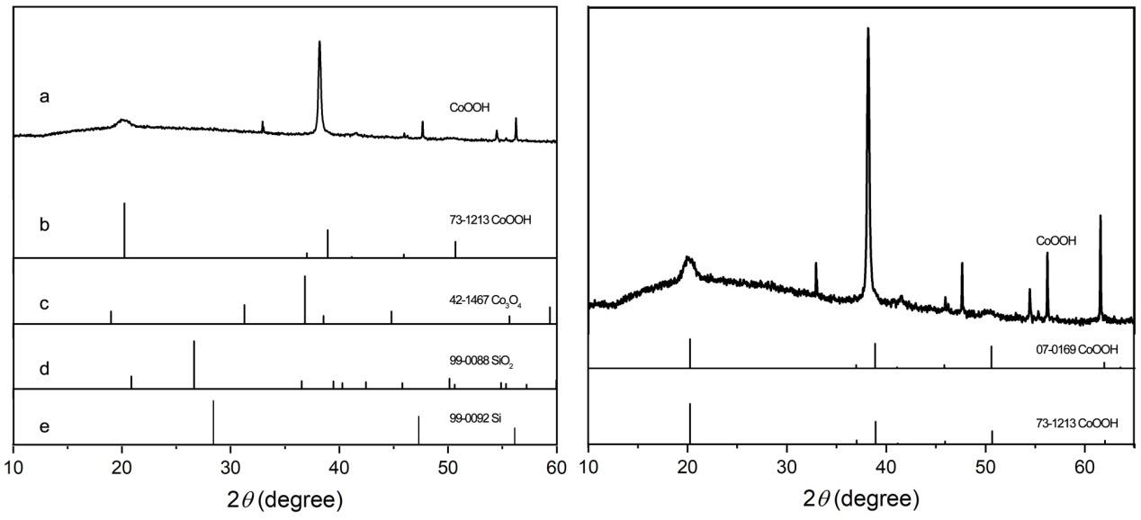
Figure S2. XRD patterns of pure CoOOH nanoflakes under silicon wafer as substrate (left), and right was the enlarge image of CoOOH nanoflakes.

Figure S3. Digital images of CoOOH nanoflakes (a) and CCM (b) upon adding TMB solution, respectively.

Table S1. Element content of pure CoOOH nanoflakes by EDS
Element | Line type | Wt% | Wt% sigma | At%
Co | K | 35.92 | 0.19 | 67.37
O | K | 64.08 | 0.19 | 32.63

Table S2. Element content of CM, CCM and CCM-AA by XPS
Type | Atom
 |  | C | O | Co
CM | Atom ratio (%) | 52.90 | 47.10 | 0.00
CCM |  | 66.26 | 33.18 | 0.56
CCM-AA-1 |  | 60.15 | 39.64 | 0.21
CCM-AA-2 |  | 57.78 | 42.03 | 0.19
CCM-AA-3 |  | 57.44 | 42.40 | 0.16
CCM-AA-1: the concentration of AA solution is 0 μM; CCM-AA-2: the concentration of AA solution is 15 μM; CCM-AA-3: the concentration of AA solution is 100 μM.

*Corresponding author: Xiaogang Luo, Professor, Ph.D. School of Chemical Engineering and Pharmacy, Wuhan Institute of Technology, LiuFang Campus, No.206, Guanggu 1st road, Donghu New & High Technology Development Zone, Wuhan 430205, Hubei Province, PR China Tel.: +86-139-86270668; Email: xgluo@wit.edu.cn; xgluo0310@hotmail.com (X. Luo)

