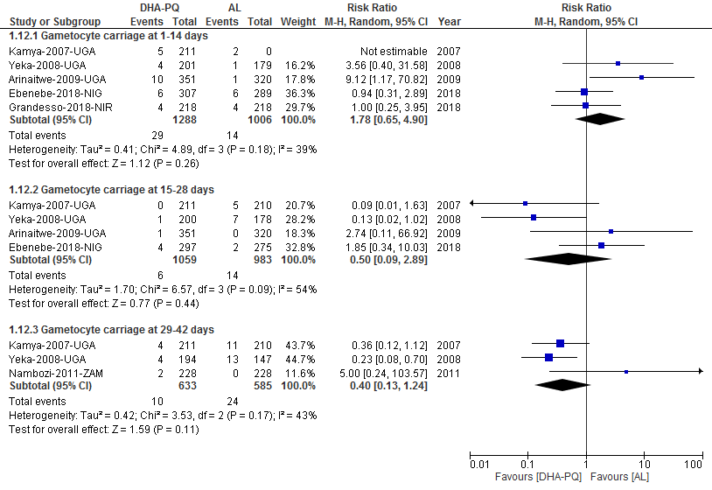

Additional file S11: Forest plot of comparison between dihydroartemisinin-piperaquine and artemether-lumefantrine for treatment of uncomplicated plasmodium falciparum malaria in African children on Gametocyte carriage.

