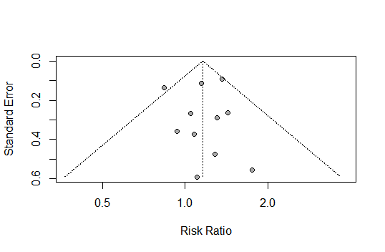
Additional file S14: Funnel plot of comparison: dihydroartemisinin-piperaquine versus artemether-lumefantrine for treatment of uncomplicated plasmodium falciparum malaria in African children, outcome: Gastrointestinal adverse events (diarrhea).

