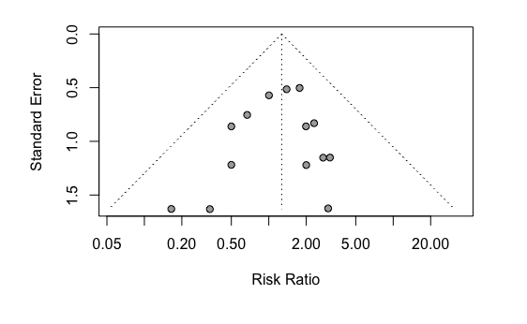
Additional file S20: Funnel plot of comparison: dihydroartemisinin-piperaquine versus artemether-lumefantrine for treatment of uncomplicated plasmodium falciparum malaria in African children, outcome: Serious adverse event (including death).

