Additional file 2
Figure S1. A comparison of 500 mg quinine IV infusion over 4 hours in African healthy adults between predicted result and published data [1].

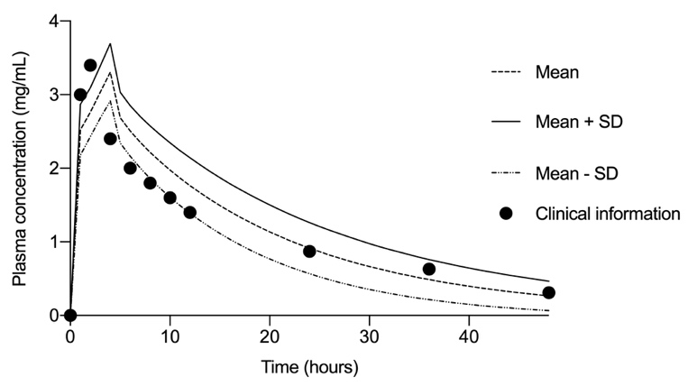
Figure S2. A comparison of 10 mg kg⁻¹ body weight quinine IV infusion over 4 hours in adult Thai patients with cerebral malaria between predicted result and published data [2].

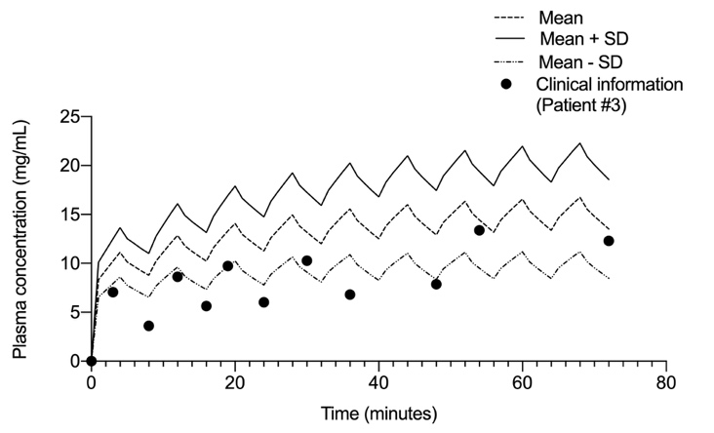

Figure S3. A comparison of 4 mg kg⁻¹ body weight quinine IV infusion over 4 hours in adult Thai patients with severe malaria between predicted result and published data [3].
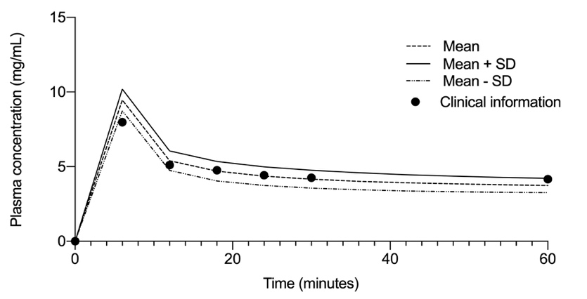

Figure S4. A comparison of loading dose of 20 mg kg⁻¹ body weight quinine IV infusion over 4 hours, followed by 10 mg kg⁻¹ body weight IV infusion over 4 hours given 3 times daily in adult Thai patients with cerebral malaria between predicted result and published data [4].
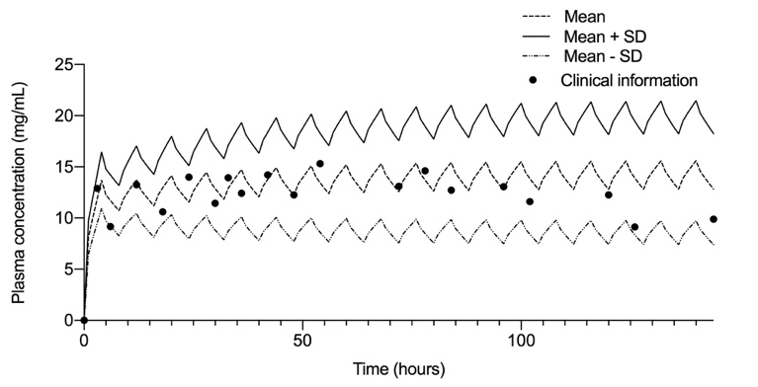

Figure S5 A comparison of 10 mg kg⁻¹ body weight IV infusion over 4 hours given 3 times daily in adult Thai patients with cerebral malaria between predicted result and published data [4].
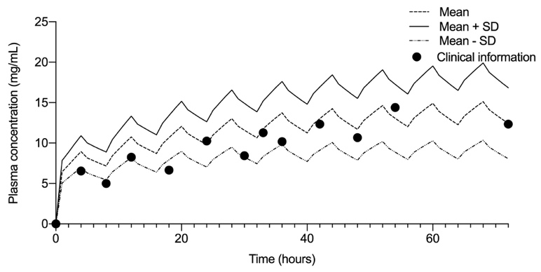

Figure S6 A comparison of 5 mg kg⁻¹ body weight IV infusion over 4 hours given 3 times daily in adult Thai patients with cerebral malaria between predicted result and published data [4].

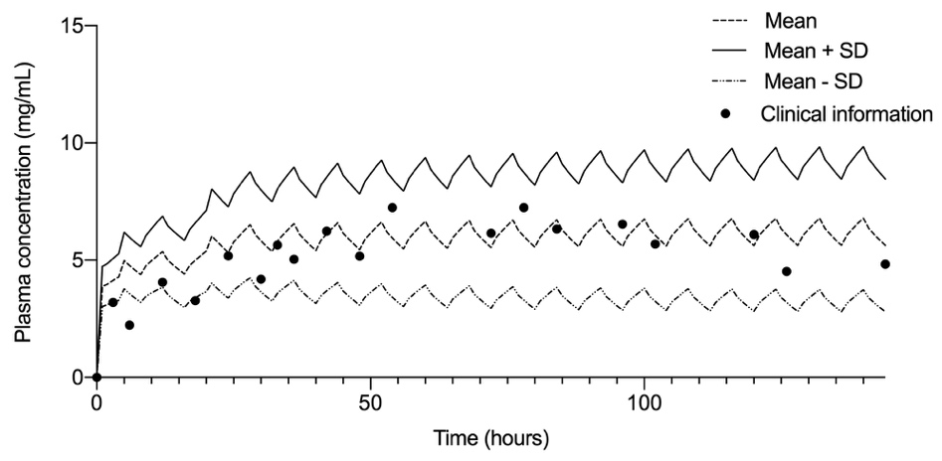
Figure S7 A comparison of 2.6 mg kg⁻¹ (218 mg) phenobarbital IV infusion over 6 minutes given in healthy male subjects between predicted result and published data [5].

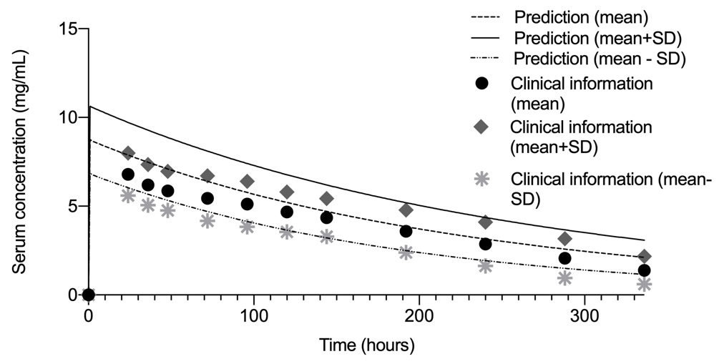
References

1. Salako LA, Sowunmi A: Disposition of quinine in plasma, red blood cells and saliva after oral and intravenous administration to healthy adult Africans. Eur J Clin Pharmacol 1992, 42:171-174.
2. White NJ, Looareesuwan S, Warrell DA, Warrell MJ, Bunnag D, Harinasuta T: Quinine pharmacokinetics and toxicity in cerebral and uncomplicated Falciparum malaria. Am J Med 1982, 73:564-572.
3. Crowe A, Ilett KF, Karunajeewa HA, Batty KT, Davis TM: Role of P glycoprotein in absorption of novel antimalarial drugs. Antimicrob Agents Chemother 2006, 50:3504-3506.
4. White NJ, Looareesuwan S, Warrell DA, Warrell MJ, Chanthavanich P, Bunnag D, Harinasuta T: Quinine loading dose in cerebral malaria. Am J Trop Med Hyg 1983, 32:1-5.
5. Nelson E, Powell JR, Conrad K, Likes K, Byers J, Baker S, Perrier D: Phenobarbital pharmacokinetics and bioavailability in adults. J Clin Pharmacol 1982, 22:141-148.

