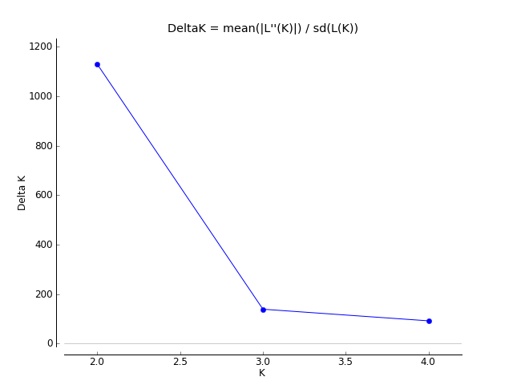
Fig. S2. Delta K vs K plot obtained from Structure Harvester

