Figure S7 Ramachandran plots for Glycine and Proline residues of USP18 variants.
- Wild variant of USP18 protein.
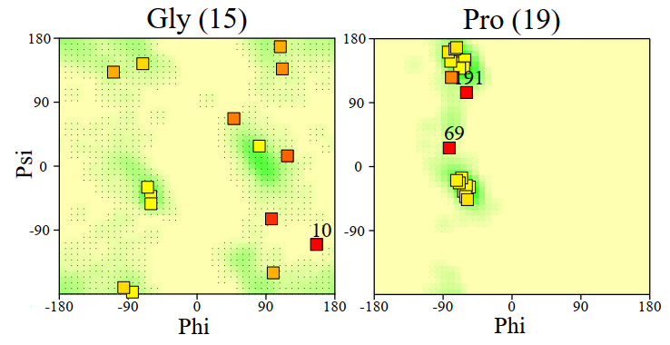
- Mutant variant of USP18 protein.

