Supplemental Data:
Development of Fe₃O₄ core-TiO₂ shell nanocomposites and nanoconjugates as a foundation for neuroblastoma radiosensitization

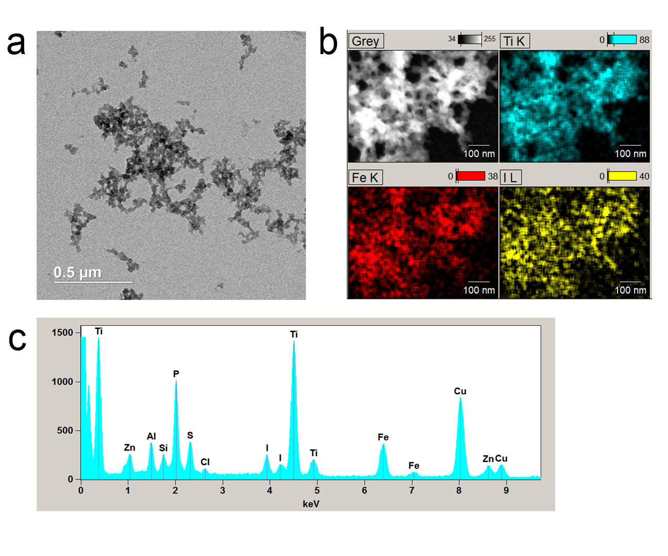
Supplemental Figure 1: Imaging of Fe₃O₄@TiO₂ Covered with MIBG by EDS-STEM
(a) STEM (bright-field) image of MIBG-Fe₃O₄@TiO₂ nanoconjugates, showing a degree of polydispersity and aggregation after drying and imaging (b) An elemental overlay (Z-contrast) of Ti, Fe, and I of an area of nanoconjugates from (a), demonstrating the co-localization of I (originating from MIBG) with Ti and Fe signals originating from the nanocomposite. (c) EDS generated elemental spectra from the area of interest in (b). Images were obtained at 200 kV.

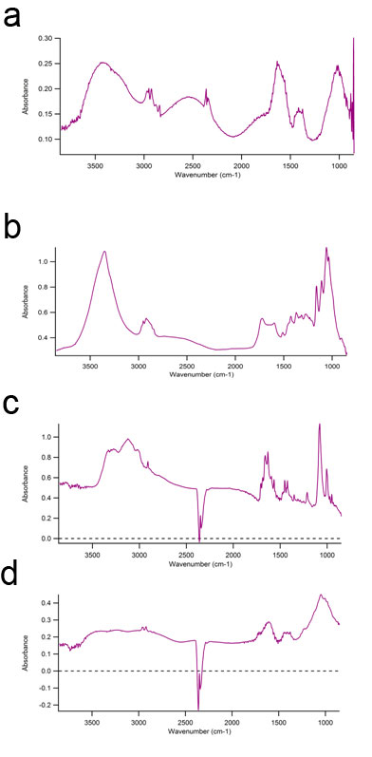

Supplemental Figure 2: Infrared Spectroscopy of Nanocomposites at Different Stages of Preparation
Infrared spectroscopy chemograms of nanoconjugates and their integral components before and after conjugation obtained at IRENI. a) Fe₃O₄@TiO₂ nanocomposites after dialysis; b) DOPAC- Fe₃O₄@TiO₂ nanocomposites after dialysis; c) MIBG; d) MIBG-(DOPAC)- Fe₃O₄@TiO₂ nanocomposites after dialysis.

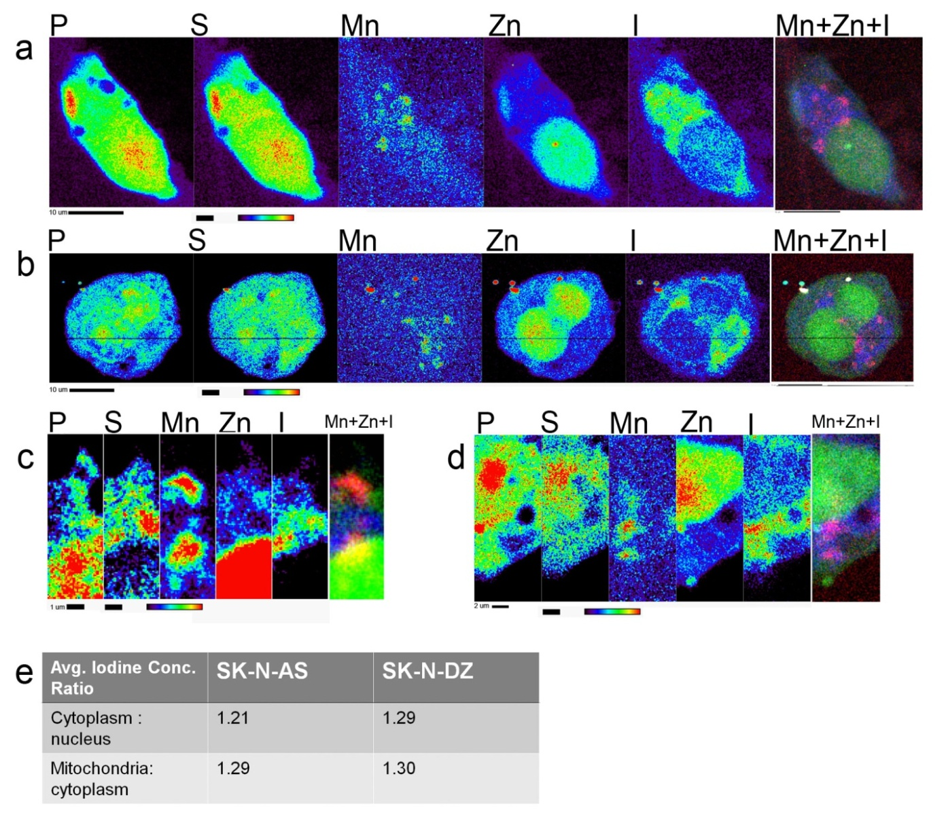
Supplemental Figure 3: Evaluation of Distribution of Free MIBG in Neuroblastoma Cells Evaluated by Cryo-XFM
(a) SK-N-AS cells treated with MIBG (60 µM) show cytoplasmic (outlines of cytoplasm can be considered to be outlines of S signal) distribution of MIBG (detected through the presence of I), with some overlap of I signal with mitochondria (enriched for the presence of Mn), but exclusion from the nucleus (the area overlapping with the strongest Zn signal). The co-localization image: Mn: Red, Zn: Green, I: Blue. (b) A similar result was observed in SK-N-DZ cells. (c) A smaller step scan (higher detail image) of a region of interest from the cell shown in (a) with cytoplasmic distribution of I, with apparent exclusion from the nucleus. (d) A smaller step scan of a region of interest from the cell shown in (b). (e) A table of iodine concentration ratios for the cytoplasm: nucleus or mitochondria: cytoplasm. 21 or 29% higher concentration of iodine is observed in the cytoplasm compared to the nucleus of the SK-N-AS or the SK-N-DZ cells, respectively. Mitochondria had a 29% or 30 % greater concentration of iodine than the cytoplasm in the SK-N-AS or the SK-N-DZ cells, respectively. Scale bar and elemental concentration indicator (black – no signal to red – highest signal) are located under each image.

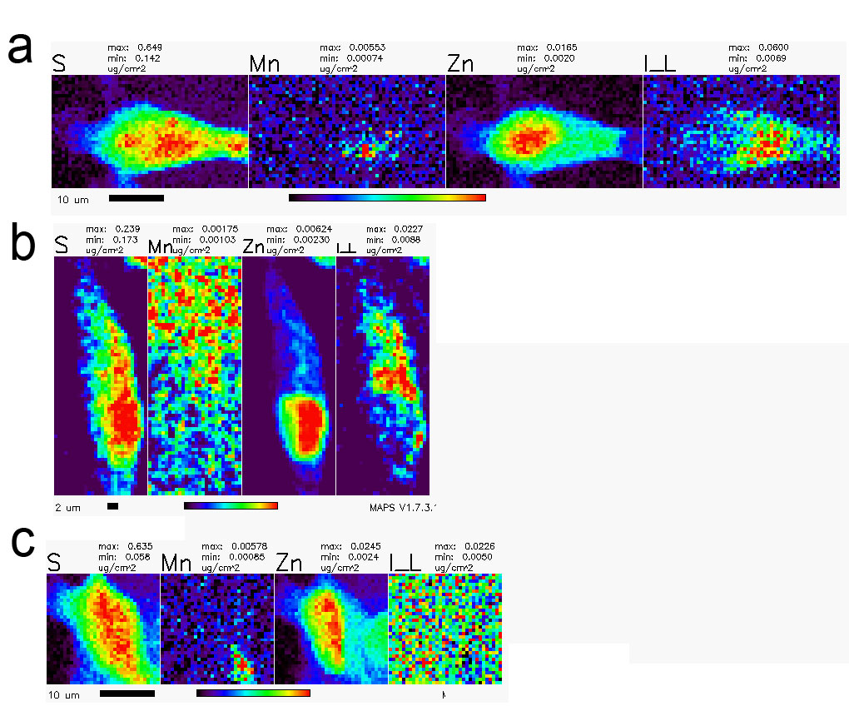
Supplemental Figure 4: Lower resolution cryo-XFM scans of AS cells at lower MIBG concentrations and vehicle (DMSO) control.
A) An Sk-N-AS cells treated with 25.44 µM MIBG b) or 4.24 µM MIBG c) or DMSO (.30%) alone as a control. a-b) Cells given decreased concentration of MIBG show similar pattern of I distribution as cells treated with higher concentrations of MIBG. No I signal can be noticed in DMSO control where “salt and pepper” pixel pattern indicates only background pixel intensity values. Scale bar and elemental concentration indicator (black – no signal to red – highest signal) are located under each image.

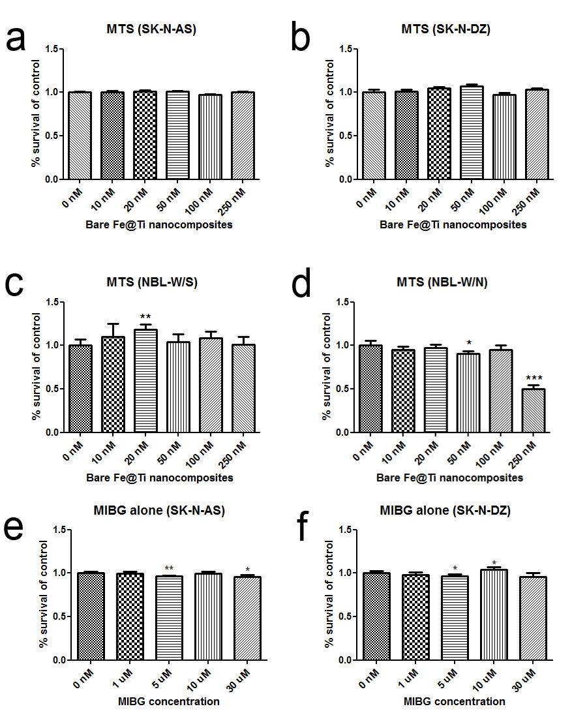
Supplemental Figure 5: Survival of neuroblastoma cells treated with Fe₃O₄@TiO₂ nanocomposites
(a) SK-N-AS cells treated with increasing doses of bare surface Fe₃O₄@TiO₂ nanocomposites. No significant decrease in survival was observed. (b) a similar result was observed in SK-N-DZ cells and (c) NBL-W/S cells also exhibited a similar response, although at lower concentrations, there was a significant increase in cell proliferation in response to bare nanocomposite treatment. (d) NBL-W/N cells exhibited a significant decrease in survival after nanocomposite treatment, particularly at 250 nM concentration. (e-f) SK-N-AS and SK-N-DZ cells treated with varying concentrations of free MIBG. The effect of MIBG on cell survival was minimal. Data points presented are an average of 5 biological replicates, and this dataset is representative of a minimum of two independent experiments. *<0.05 significance level, ** : <0.01 significance level, *** <0.001 significance level. Error bars indicate mean ± SD.

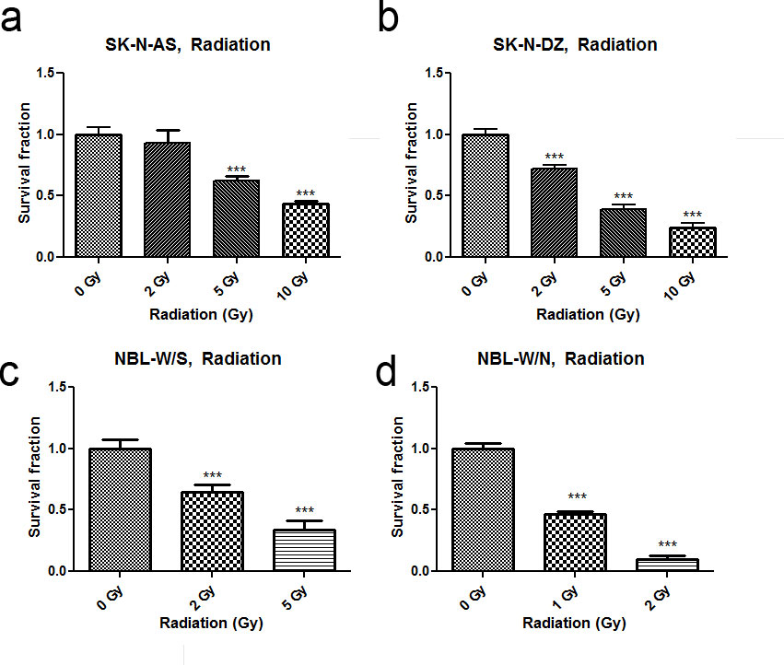
Supplemental Figure 6: Survival of different neuroblastoma cell lines in response to ionizing radiation evaluated by MTS assay
(a) SK-N-AS (b) SK-N-DZ (c) NBL-W/S (d) NBL-W/N. * <0.05 significance level, ** :<0.01 significance level, *** <0.001 significance level. Datapoints presented are an average of at least 5 biological replicates, and are representative of at least three independent irradiation experiments followed by an MTS assay as detailed in the Methods. Error bars indicate mean ± SD.

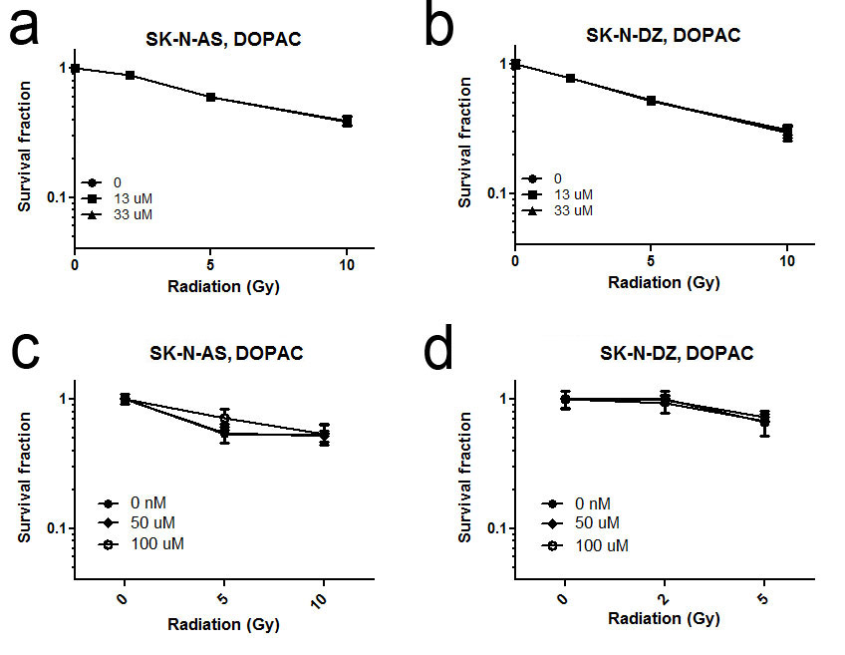
Supplemental Figure 7: No radiosensitization is observed in SK-N-AS and SK-N-DZ cells irradiated in the presence of DOPAC molecule
(a) SK-N-AS and (b) SK-N-DZ cells irradiated with different doses of x-rays were previously treated with DOPAC. Molecular DOPAC concentrations were equivalent to the concentration of DOPAC estimated to be bound to the surface of the nanocomposite. No sensitization was found in either SK-N-AS or SK-N-DZ cell lines (n = 5). This trend was unchanged at higher DOPAC concentrations (c,d) (n = 3). Error bars indicate mean ± SD.

 | Bare NC | MIBG NC | DOPAC NC
ZP (mV) | -37.1 ± 1.91 | -40.887 ± 1.85 | -33.367 ± 0.71

Supplemental Table 1: Zeta potentials of nanocomposites and nanoconjugates
Bare nanocomposites, DOPAC- Fe₃O₄@TiO₂ nanocomposites, and MIBG- Fe₃O₄@TiO₂ nanoconjugates were diluted 1:100 in filtered 10 mM NaCl and Zeta potentials measured at 25°C, as an average of three measurements.

Nanosight  (buffer) | Bare NC | MIBG NC | DOPAC NC
DMEM | 278 ± 117 | 272 ±110 | 291 ±117
ddH₂O | 269 ± 182 | 194 ± 98 | NA

Supplemental Table 2: Nanocomposite and nanoconjugate sizing by Nanosight
Bare nanocomposites, MIBG- Fe₃O₄@TiO₂ nanoconjugates, and DOPAC- Fe₃O₄@TiO₂ nanocomposites were diluted 1:100 in DMEM or ddH₂O and sizing evaluated on a Nanosight LM10-HS. Due to polydispersity and non-spherical shape of aggregates, sizing data obtained were not deemed particularly reliable.

