Supplementary figures: Incidence of thrombocytopenia stratified by renal function or duration of linezolid

Supplement figure S1
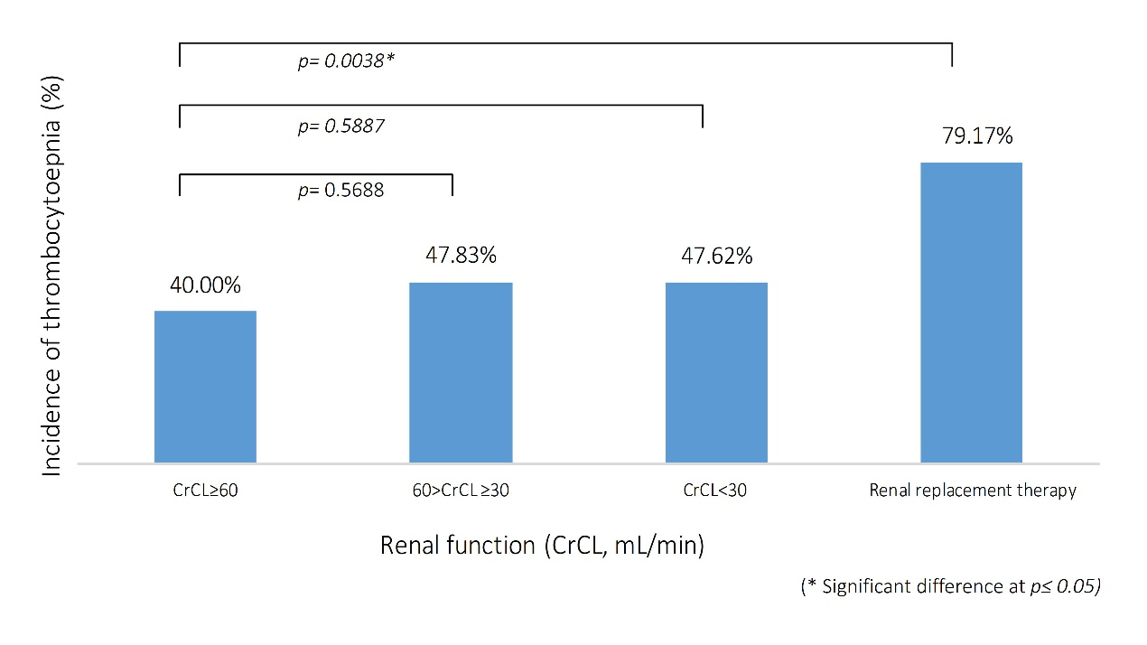
Figure S1.
Enrolled patients were classified into four groups according to renal function, including creatinine clearance (CrCL)≥ 60, 60> CrCL≥ 30, CrCL< 30 mL/min, and renal replacement therapy (RRT). Patients received RRT were with higher risk to develop thrombocytopenia (with vs without RRT: 79.2% vs 44.6%, P=0.0032). But, there was no significant difference between CrCL≥ 60, 60 >CrCL≥ 30, CrCL< 30 mL/min.

Supplementary figures: Incidence of thrombocytopenia stratified by renal function or duration of linezolid

Supplement figure S2
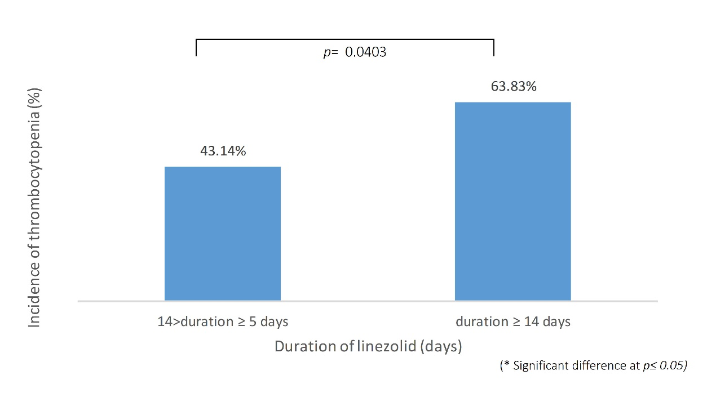
Figure S2.
All patients were also classified into two groups according to the duration of linezolid, including 14>duration≥ 5 and duration≥ 14 days. Patients with duration≥ 14 days were with higher risk of thrombocytopenia (14>duration≥ 5 days vs duration≥ 14 days: 43.14% vs 63.83% P = 0.0403).

