Supplemental Materials
Table S1. Demographics characteristics of postmenopausal women in participating studies
Study | Study Design | Cases |  |  |  |  | Controls
 |  | N | Age, Mean | Current  MHT use | Current  EPT use |  | N | Age, Mean (SD) | Current  MHT use | Current  EPT use
CBCS | Population-based  case-control | 379 | 63.6 (8.1) | 0.15 | 0.06 |  | 506 | 62.8 (8.1) | 0.16 | 0.08
CECILE | Population-based  case-control | 519 | 61.2 (7.2) | 0.17 | 0.13 |  | 604 | 61.2 (7.3) | 0.14 | 0.11
CPSII | Prospective cohort | 2,362 | 62.5 (5.8) | 0.44 | 0.20 |  | 3,113 | 62.3 (5.9) | 0.39 | 0.12
EPIC | Prospective cohort | 1,680 | 59.0 (5.5) | 0.31 | 0.26 |  | 1,766 | 58.7 (5.4) | 0.31 | 0.23
GENICA | Population-based  case-control | 691 | 62.6 (8.6) | 0.27 | 0.13 |  | 533 | 62.7 (8.7) | 0.30 | 0.12
KARMA | Prospective cohort | 836 | 64.6 (6.7) | 0.10 | NA |  | 4,153 | 63.9 (6.2) | 0.05 | NA
MARIE | Population-based  case-control | 1,483 | 63.8 (5.5) | 0.44 | 0.28 |  | 1,850 | 62.7 (5.5) | 0.35 | 0.21
MCBCS | Mixed | 973 | 63.3 (10.2) | 0.19 | 0.19 |  | 981 | 62.1 (9.8) | 0.25 | 0.14
MCCS | Prospective cohort | 794 | 66.6 (8.5) | 0.22 | NA |  | 874 | 65.5 (8.1) | 0.17 | NA
MEC | Prospective cohort | 591 | 64.4 (8.6) | 0.59 | 0.35 |  | 618 | 64.8 (7.7) | 0.47 | 0.21
MISS | Prospective cohort | 217 | 58.4 (6.0) | 0.27 | NA |  | 591 | 57.1 (5.2) | 0.18 | NA
MMHS | Prospective cohort | 216 | 64.6 (8.8) | 0.25 | 0.07 |  | 460 | 63.3 (10.9) | 0.28 | 0.05
NCBCS | Population-based  case-control | 1,075 | 60.0 (9.1) | 0.25 | 0.10 |  | 596 | 59.9 (9.0) | 0.44 | 0.15
NHS | Prospective cohort | 890 | 66.6 (8.0) | 0.40 | 0.18 |  | 1,513 | 67.6 (8.4) | 0.28 | 0.10
NHS2 | Prospective cohort | 508 | 54.7 (4.4) | 0.39 | 0.23 |  | 770 | 52.7 (5.0) | 0.45 | 0.15
OFBCR | Mixed | 666 | 58.5 (8.2) | 0.32 | NA |  | 287 | 57.3 (6.4) | 0.52 | NA
PBCS | Population-based  case-control | 1,276 | 59.9 (8.3) | 0.12 | 0.11 |  | 1,390 | 60.5 (7.4) | 0.07 | 0.05
PKARMA | Mixed | 2,320 | 65.4 (8.3) | 0.18 | 0.05 |  | 2,463 | 60.4 (6.8) | 0.08 | 0.02
PLCO | Prospective cohort | 1,819 | 68.3 (6.4) | 0.60 | NA |  | 2,578 | 62.3 (5.2) | 0.56 | NA
PROCAS | Population-based  case-control | 244 | 62.1 (5.4) | 0.07 | 0.04 |  | 1,265 | 61.8 (5.9) | 0.07 | 0.03
SASBAC | Population-based  case-control | 1,155 | 63.4 (6.4) | 0.37 | 0.20 |  | 1,363 | 63.3 (6.3) | 0.32 | 0.13
SMC | Prospective cohort | 805 | 61.1 (7.7) | 0.27 | NA |  | 520 | 60.8 (7.8) | 0.45 | NA
UCIBCS | Mixed | 259 | 66.9 (9.7) | 0.23 | 0.07 |  | 165 | 62.6 (7.3) | 0.42 | 0.11
UKBGS | Prospective cohort | 648 | 60.4 (6.9) | 0.25 | NA |  | 626 | 60.3 (6.9) | 0.17 | NA
USRT | Mixed | 304 | 64.1 (8.3) | 0.50 | NA |  | 639 | 64.2 (8.5) | 0.46 | NA
WHI | Prospective cohort | 4,875 | 69.0 (7.4) | 0.44 | 0.25 |  | 4,561 | 69.3 (7.4) | 0.36 | 0.18
Total |  | 27,585 | 64.0 (8.2) | 0.34 | 0.19 |  | 34,785 | 63.0 (7.7) | 0.28 | 0.13
* CBCS: Canadian Breast Cancer Study; CECILE CECILE Breast Cancer Study; CPSII: Cancer Prevention Study-II Nutrition Cohort; EPIC: European Prospective Investigation Into Cancer and Nutrition; GENICA: Gene Environment Interaction and Breast Cancer in Germany; KARMA: Karolinska Mammography Project for Risk Prediction of Breast Cancer - Cohort Study; MARIE: Mammary Carcinoma Risk Factor Investigation; MCBCS: Mayo Clinic Breast Cancer Study; MCCS: Melbourne Collaborative Cohort Study; MEC: Multiethnic Cohort; MISS: Melanoma Inquiry of Southern Sweden; MMHS: Mayo Mammography Health Study; NCBCS: North Carolina Breast Cancer Study; NHS: Nurses' Health Study; NHS2: Nurses' Health Study 2; OFBCR: Ontario Familial Breast Cancer Registry; PBCS: NCI Polish Breast Cancer Study; PKARMA: Karolinska Mammography Project for Risk Prediction of Breast Cancer - Case-Control Study; PLCO: The Prostate, Lung, Colorectal and Ovarian Cancer Screening Trial; PROCAS: Predicting the Risk Of Cancer At Screening Study; SASBAC: Singapore and Sweden Breast Cancer Study; SMC: Swedish Mammography Cohort; UCIBCS: UCI Breast Cancer Study; UKBGS: UK Breakthrough Generations Study; USRT: US Radiologic Technologists Study; WHI: Women's Health Initiative Observational Study.
** Current MHT use: Current use of menopausal hormone therapy; Current EPT use: Current use of estrogen + progesterone menopausal hormone therapy

Figure S1. Manhattan plot and quantile-quantile plot of genome-wide interaction of current use of menopausal hormone therapy on breast cancer risk among population-based studies only
- Manhattan plot | - Quantile-quantile plot
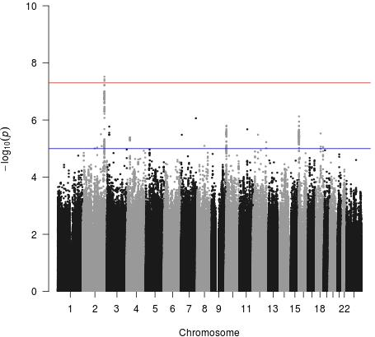  * Red line: log-transformed genome-wide significant threshold at 5x10⁻⁸;  Blue line: log-transformed suggestive threshold at 1x10⁻⁵. | 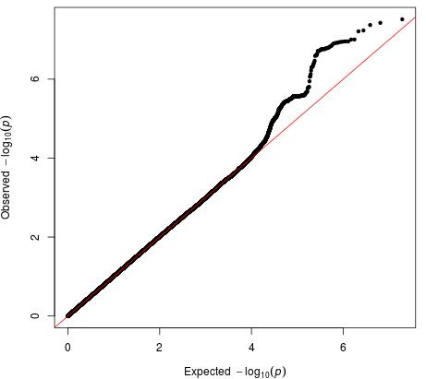

Figure S2. Manhattan plot and quantile-quantile plot of genome-wide interaction of current use of menopausal hormone therapy on estrogen-receptor positive breast cancer risk
- Manhattan plot | - Quantile-quantile plot
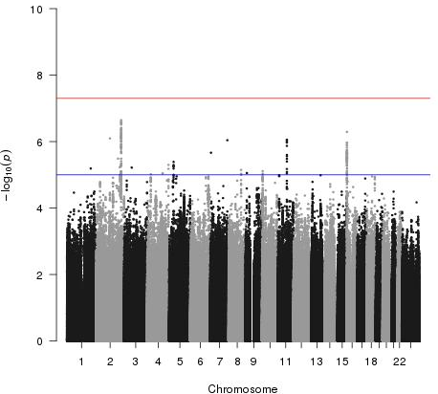  * Red line: log-transformed genome-wide significant threshold at 5x10⁻⁸;  Blue line: log-transformed suggestive threshold at 1x10⁻⁵. | 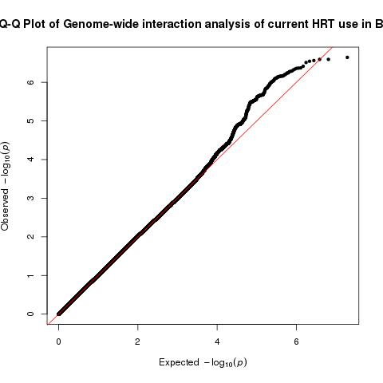

Figure S3. Quantile-quantile plots of genome-wide interaction of current use of menopausal hormone therapy on breast cancer risk
- Current MHT use | - Current EPT use
 | 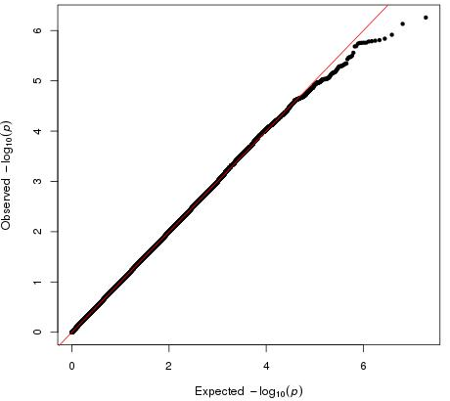
* Genomic control factor λ=1.012 | * Genomic control factor λ=1.006

