Supplementary Information for:

Operando Raman analysis of electrolyte composition in Li-ion batteries with hollow-core optical fibre sensors

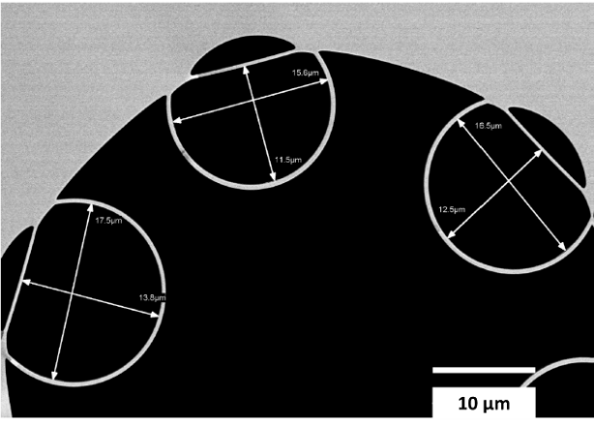
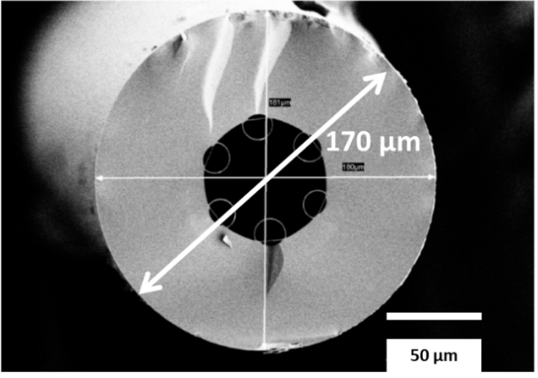
a
b

Supplementary Figure 1 | SEM Images of hollow-core fibre. (a) Fibre comprises a single ring negative curvature fibre with outer diameter of 174 μm and internal hollow-core diameter measuring 36 μm, with (b) 6 internal capillaries of 16 μm in diameter.

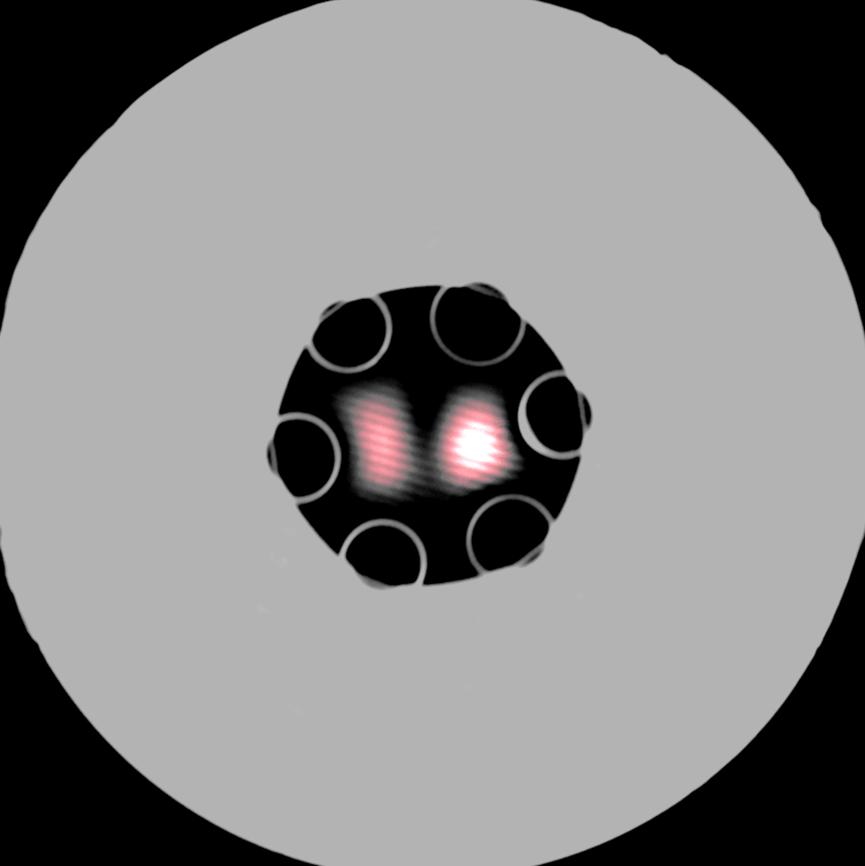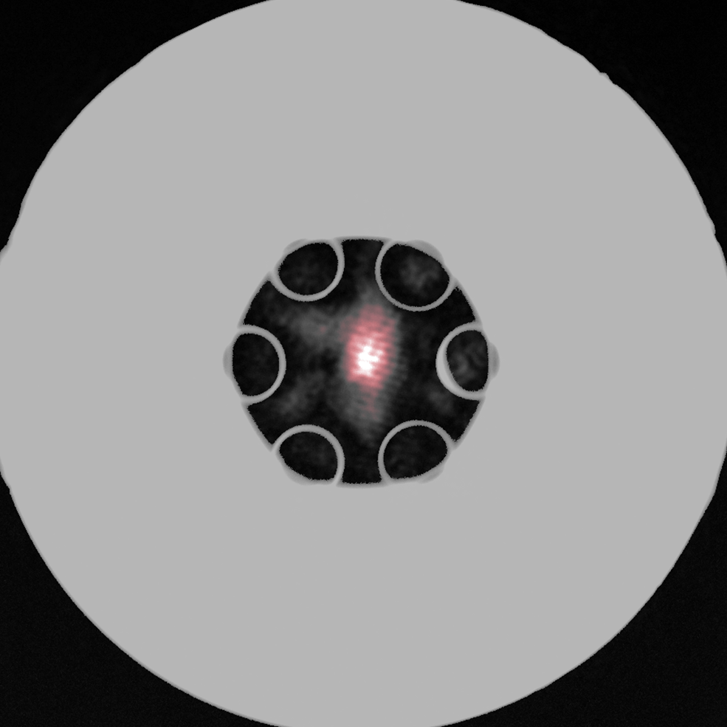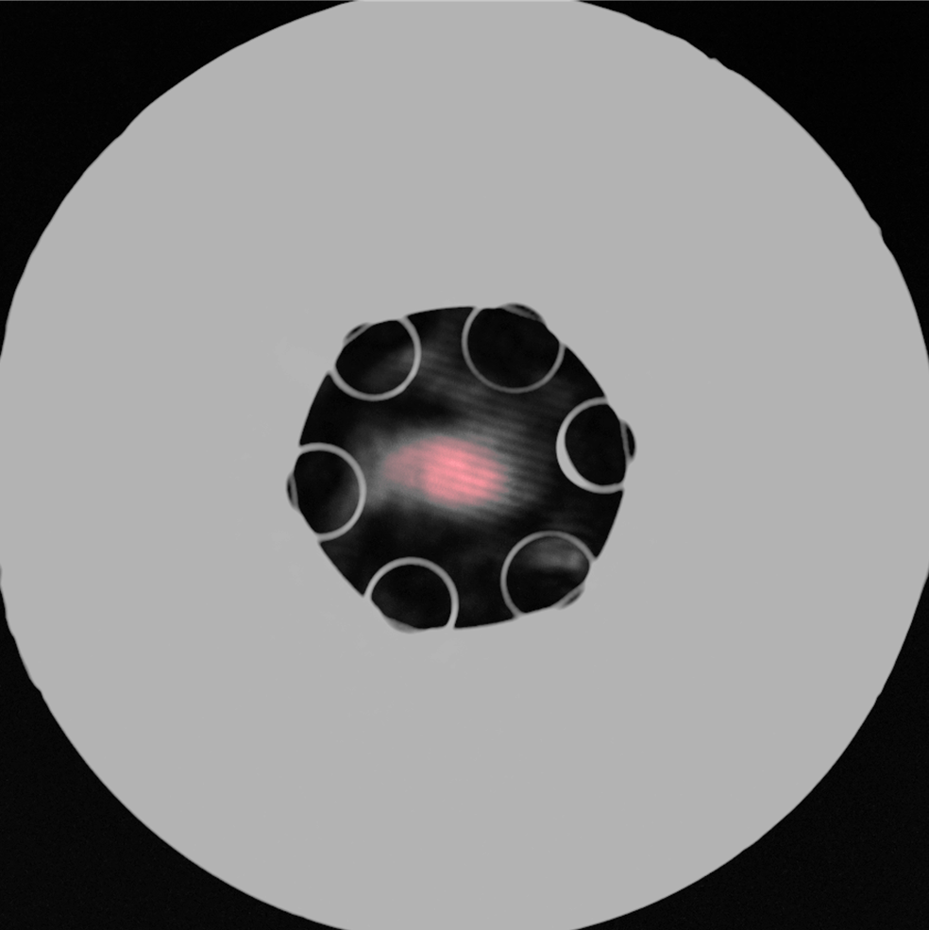Supplementary Figure 2 | Fibre transmission properties at 785 nm. Transmitted optical modes at
785 nm for three filling materials with different refractive indices: (a) air, (b) IPA, and (c) EC:EMC (3:7). The CCD images are overlaid with optical microscope images taken in the same setup, using a white-light source to illuminate the glass cladding structure. The transmitted power was measured using a Si photodiode power meter with typical values between 10% and 20% for refractive indices between 1.37 and 1.42.
T= 10%
T= 20%
T= 7%
a
n = 1.00
b
n = 1.377
30μm
c
n = 1.39

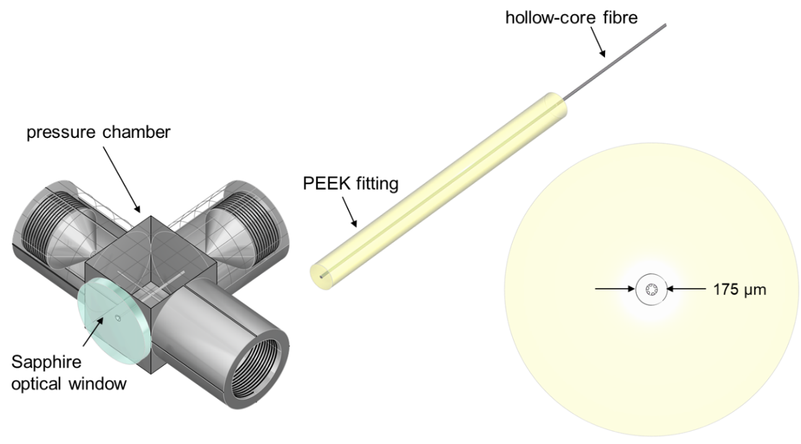
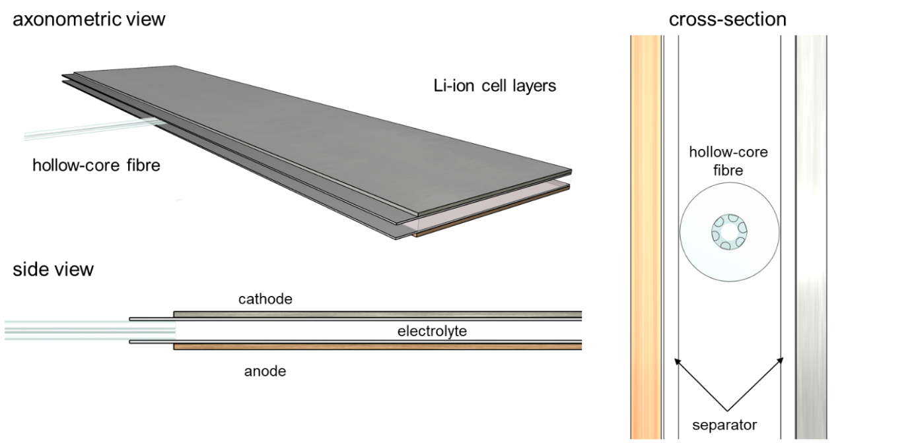
Supplementary Figure 3 | Ultralow dead-volume pressure chamber for light coupling and microfluidic actuation. A HPLC tee-connector (Idex UH-422) is customized to connect the fibre to the syringe pump, while allowing for optical access. A 1 mm thick sapphire optical access window (Edmund optics #43-366) is mounted to the cell using optical adhesive. The fibre is connected to an access port by embedding it in a 1/16” outer diameter, 229 µm inner diameter PEEK sleeve (Upchurch F-227), and fixed with a finger-tight fitting (Upchurch F-120, not shown).
a
c
b
Supplementary Figure 4 |Li-ion cell stack geometry and assembly. (a-b) The hollow-core fibre is embedded in the electrolyte compartment, protected by two 25 µm-thick layers of monolayer PE polymer separator (MTI). (c) Cross-section of the hollow-core fibre position within the cell. The outer diameter of the fibre is 174 µm.
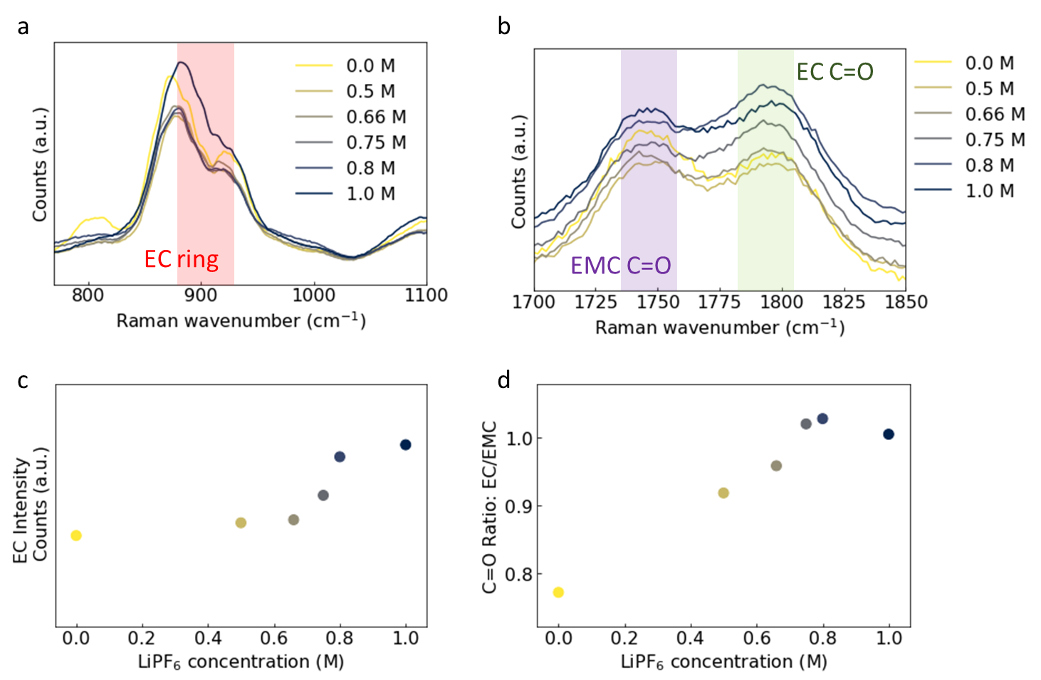
Supplementary Figure 5 | Ex-situ calibration of Raman response. The effect of Li concentration on the EC/EMC Raman spectra is studied by infiltrating prepared solutions of LiPF₆ salt in EC:EMC (3:7 (v)) in the HC-fibre sensor. (a-b) The EC breathing mode (shaded area in (a)) and the EMC- and EC C=O stretch modes (shaded areas in (b)) are measured for a range of [LiPF₆] concentrations between 0 and 1.0 M. The EC breathing mode (c) as well as the ratio between the EC and EMC (C=O) stretching modes (d) are observed to increase with [LiPF₆].

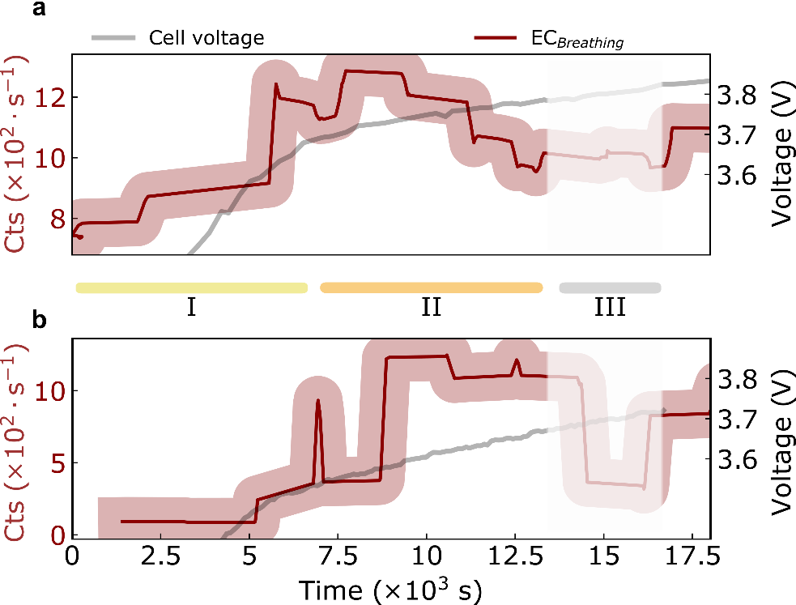
Supplementary Figure 6 | Representative measurements on different Li-ion pouch cells.
Both experiments in (a-b) display a step increase in EC breathing mode intensity during charging
(as in Fig. 3 in main text), as well as a reduction in signal due to bubble formation at higher voltages (shaded areas). Sections I-III correspond to the same parts of the cycle as in Fig. 4 in the main text.

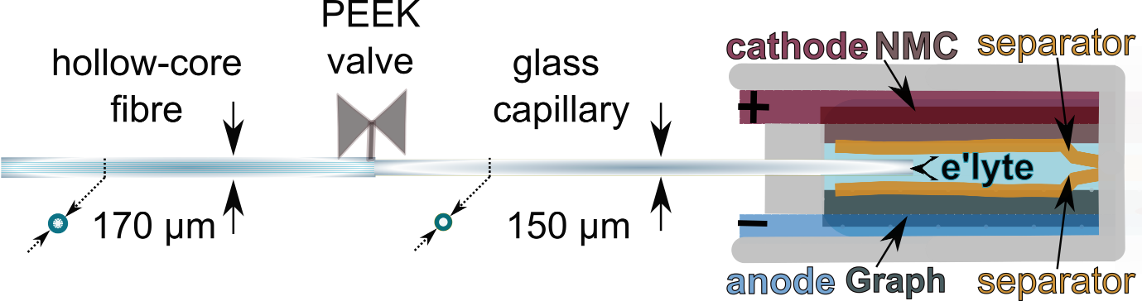
Supplementary Figure 7 | Alternative microfluidic configuration for a Li-ion cell. The drawing depicts the stack layers arrangement and the position of the coated glass capillary used for experiments discussed in Fig. 6 in the main text. This configuration allows for separation between the hollow-core used for Raman detection and the capillary used for sampling the LP57 (VC-free) electrolyte.

Supplementary Movie 1 | Gas bubble trapped in hollow-core fibre.
https://youtu.be/G7Jn4_sGrN8

