Supplementary Materials
Supplementary Table 1. Characteristics of enrolled patients
 | ACPA-positive MTX-naïve eRA patients | Established RA patients | Established RA patients with DAS28-ESR ≤ 3·2 | OA patients
Individuals (n) | 28 | 59 | 34 | 16
Females (n), (%) | 23 (82.1) | 52 (88.1) | 30 (88.2) | 11 (68.8)
Median ages of samples (IQR) | 49 (42.75-56.25) | 56 (44.5-63.0) | 56.5 (47.25-63.0) | 61.5 (54.0-64.5)
RF positive (n), (%) | 22 (78.6) | 48 (81.4) | 19 (55.9) | 0 (0)
ACPA positive (n), (%) | 28 (100) | 59 (100) | 34 (100) | 0 (0)
ESR (mm/hr, median and IQR) | 28.5 (16.5-38.5) | 24.0 (17.0-36.0) | 14 (10.0-18.75) | 9.5 (6.75-13.5)
CRP (mg/dL, median and IQR) | 0.28 (0.15-0.53) | 0.23 (0.07-1.22) | 0.12 (0.07-0.26) | 0.07 (0.05-0.14)
Disease duration (months, median and IQR) | 3 (1-7) | 36 (24-72) | 36 (24-60) | ND
DAS28-ESR (0-10, median and IQR) | 4.70 (4.31-5.28) | 3.83 (3.51-4.59) | 2.82 (2.53-3.08) | ND
The positive range for ACPA is more than 5.0 IU/mL.
The positive range for RF is more than 18.0 IU/mL.
ACPA, anticitrullinated peptide antibodies; CRP, C-reactive protein; DAS28, disease activity score; ESR, erythrocyte sedimentation rate; eRA, early rheumatoid arthritis; RF, rheumatoid factor; ND, not determined; MTX, methotrexate

Supplementary Figure Legends
Supplementary Figure 1. Multiplex cytokine assay of established RA with low disease activity (DAS28-ESR ≤ 3·2). (A) Plasma cytokine levels of five cytokines (IFN-γ, IL-17A, IL-6, IL-12, TNF-α) in patients with established RA with low disease activity. (B) Correlation between plasma IFN-γ and IL-17A/IL-6/IL-12/TNF-α. (C) Correlation between DAS28-ESR and plasma cytokine levels. ***P < 0.001.
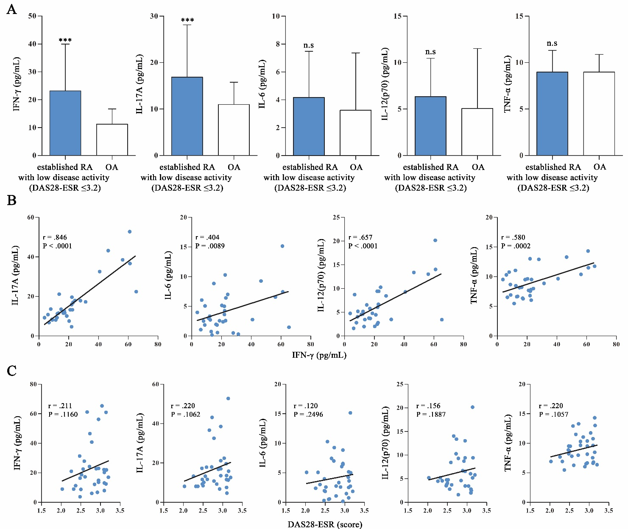
Supplementary Figure 2. Multiplex cytokine assay of established RA with moderate to high disease activity (DAS28-ESR > 3·2). (A) Plasma cytokine levels of five cytokines (IFN-γ, IL-17A, IL-6, IL-12, TNF-α) in patients with established RA with high disease activity. (B) Correlation between plasma IFN-γ and IL-17A/IL-6/IL-12/TNF-α. (C) Correlation between DAS28-ESR and plasma cytokine levels. ***P < 0.001.
