Carbon dioxide atmospheric concentration
and hydrometeorological disasters

Andrés Fortunato, Helmut Herwartz, Ramón E. López, Eugenio Figueroa B.

Online Appendix

Appendix A Cointegration analysis Robustness tests
This appendix provides some alternative results for the cointegration exercise in section 5.1.

A.1 Significance tests for equation (9) using non-standard critical ratios
Equation (9) in the main text allows for error correcting mechanisms:
$Δτ_{t}=k_{2}+α_{2}τ_{t-1}+β_{2}q_{t-1}+ω_{2,t}$ (9)
Where $τ$ stands for the GPOD and $q$ for log(CO₂). Noting under the null hypothesis of no cointegration testing the significance of $α_{2}$requires non-standard critical values, we check if sampled estimates of $α_{2}$ are less than zero for a significant fraction of the 1000 performed regressions. Moreover, we evaluate how often single equation t-ratios for $α_{2}$ are below a non-standard 5% critical value of -3.3. Confirming the strong evidence against the hypothesis of `no cointegration', 15.6% of the t-ratios of $α_{2}$ are smaller than a 5% critical value of -3.3.
A.2 Cointegration analysis using global temperature and World GDP per capita
Following López et al. (2020), in analogy to Table 4 in the main text, Tables A1 and A2 below show cointegration parameter estimates using alternative Climate Change related variables, namely log(Global temperature) and log(World GDP pc) instead of log(CO₂), respectively, as potential (weekly exogenous) determinants ($q_{t}$) of the GPOD ($τ_{t}$) in equations (7), (8) and (9) (see Section 5.1 in the main text).
Both trending variables (log) world GDP per capita and global temperature exhibit a long-term relation with the GPOD ($β_{1}$ is positive and significant for both sets of regressions). For both variables, log(global temp) and log(World GDP pc), however, positivity of parameter estimates for $α_{3}$ in regression (9) implies that these variables adjust to deviations of $τ_{t}$ (the GPOD) from the long-term equilibrium. Hence, these variables cannot be regarded as weakly exogenous, and are prone to obtain biased GPOD projections if used as conditional information.
Table A1 Estimated parameters for cointegration analysis using global temperature
Parameter | Mean | SD | Q2.5% | Q50% | Q97.5%
Regression (7)
$$k_{1}$$ | -10.814 | 1.817 | -7.582 | -10.664 | -14.749
$$β_{1}$$ | 4.129 | 0.693 | 5.639 | 4.072 | 2.896
$R^{2}$ | 0.768 | 0.030 | 0.819 | 0.771 | 0.700
Regression (8)
$$k_{2}$$ | -1.502 | 0.879 | 0.013 | -1.449 | -3.378
$$α_{2}$$ | -0.172 | 0.067 | -0.050 | -0.167 | -0.304
$$β_{2}$$ | 0.578 | 0.335 | 1.292 | 0.557 | 0.001
Regression (9)
$$k_{3}$$ | 1.259 | 0.164 | 1.583 | 1.251 | 0.944
$$α_{3}$$ | 0.092 | 0.020 | 0.139 | 0.090 | 0.060
$$β_{3}$$ | -0.478 | 0.062 | -0.358 | -0.476 | -0.601
Note: SD indicates standard deviations. Q2.5%, Q50% and Q97.5% stand for posterior MCMC quantiles. We regard a parameter as significant if the zero is not included in the Q2.5% - Q97.5% interval.

Table A2 Estimated parameters for cointegration analysis using World GDP per capita
Parameter | Mean | SD | Q2.5% | Q50% | Q97.5%
Regression (7)
$$k_{1}$$ | -3.355 | 0.563 | -2.322 | -3.314 | -4.579
$$β_{1}$$ | 0.398 | 0.066 | 0.544 | 0.393 | 0.276
$R^{2}$ | 0.858 | 0.027 | 0.905 | 0.860 | 0.794
Regression (8)
$$k_{2}$$ | -1.117 | 0.387 | -0.434 | -1.088 | -1.980
$$α_{2}$$ | -0.351 | 0.095 | -0.179 | -0.352 | -0.541
$$β_{2}$$ | 0.133 | 0.046 | 0.236 | 0.130 | 0.053
Regression (9)
$$k_{3}$$ | 0.365 | 0.113 | 0.594 | 0.359 | 0.156
$$α_{3}$$ | 0.089 | 0.036 | 0.167 | 0.085 | 0.025
$$β_{3}$$ | -0.041 | 0.013 | -0.016 | -0.040 | -0.068
Note: See Table A1.

Appendix B Diagnostics of the predictive properties of log(CO₂) for the GPOD
In this section we implement a series of out-of-sample forecast exercises to inspect the potential of log(CO₂) as a predictor for the GPOD. The specification used for all pseudo predictive analysis is based on the static regression model (7) and stated in equation (10) in the main text.

Fig. B1 CUSUM statistics for the parameters in equation (10)
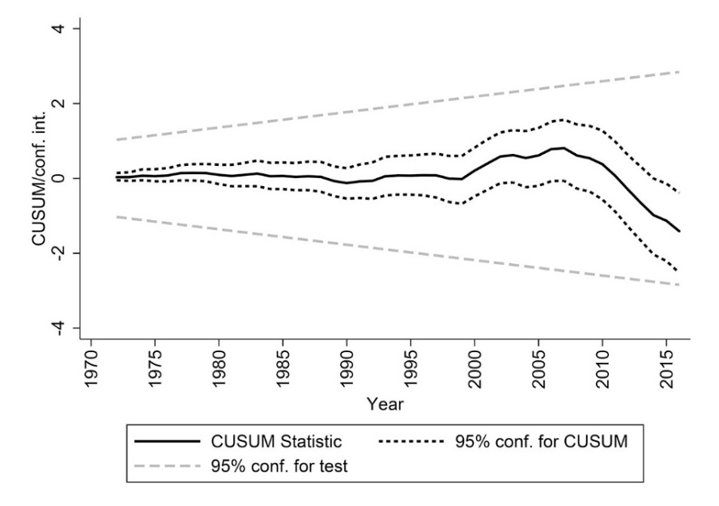

The static regression model would be unsuitable for a conditional predictive analysis if it suffers from structural instability. Therefore, we first investigate parameter stability by means of CUSUM statistics. Figure B1 displays the outcomes from the set of 1000 CUSUM profiles joint with the corresponding critical values. As a result, we cannot reject the null hypothesis of parameter stability with 5% significance.

Fig. B2 Forecast exercises results (left: leave one out; right: recursive analysis starting in 2000)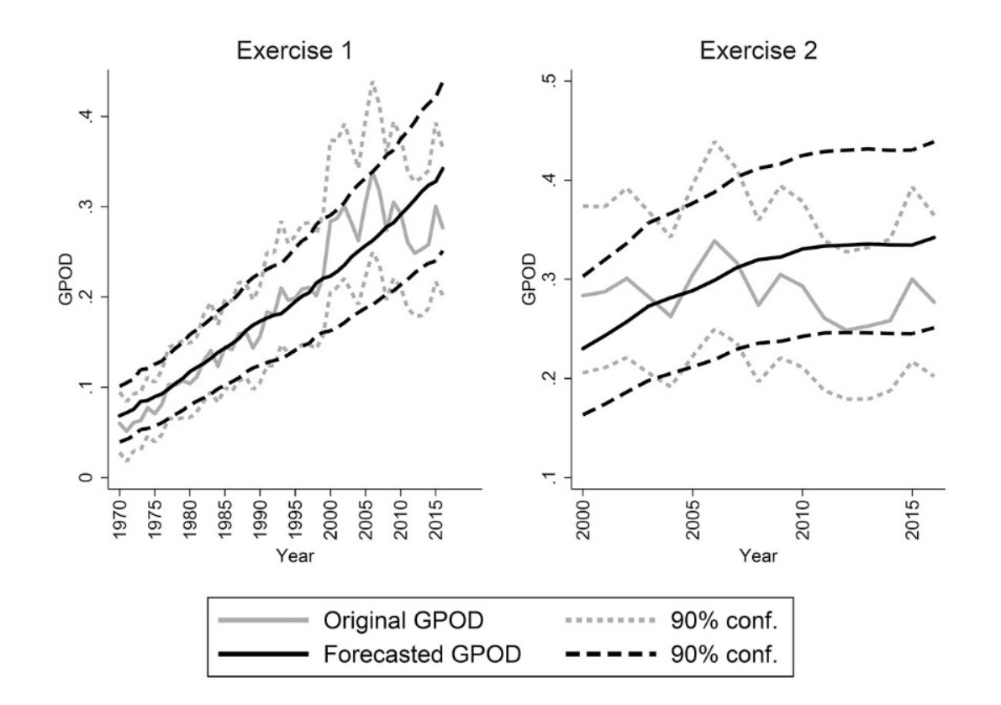

Since the parameters in equation (10) are stable, we can use it for predicting GPOD trends $τ_{t}$ conditional on information about log(CO₂), i.e., $q_{t}$. We perform two exercises to assess the accuracy of such predictions in a pseudo out-of-sample context. On the one hand, we adopt so-called `leave one out’ regressions for parameter estimation and subsequent prediction of the left-out observation $τ_{t}$ conditional on the left-out information about $q_{t}$. On the other hand, we perform sequential one-step ahead predictions in a recursive manner starting with initial samples covering the period from 1970 until 1999. For both exercises, we consider a forecasted probability curve as a good fit, if the mean of the original probabilities is covered by the 90% confidence interval of the forecasted one. Respective results are displayed in Figure B2. As can be seen in both panels of Figure B2, our criteria for acceptable forecasts are met throughout.

Appendix C Results for a more stringent codification of hydrometeorological disasters
The EM-DAT criterion for coding a natural event as a disaster is that it fulfills at least one of the following conditions: 10 or more people dead, 100 or more people affected, declaration of state of emergency or a call for international assistance was given. Thomas et al. (2013) have suggested more demanding conditions, i.e., 100 or more people dead or 1000 or more people affected (see also Thomas et al., 2014 and Lopez el al. 2015), since such a more exigent criterion is less likely to suffer from underreporting bias. In this appendix we redo the analysis described in Sections 4 and 5.1 adopting this more stringent classification. Tables C1, C2, C3 and C4 show statistics and results for this second category of disasters, which are analogous to the results and statistics in Tables 1, 2, 3 and 4 in the main text, respectively. As it can be seen, all results are qualitatively similar to those reported in the main text in terms of order of magnitude and effect directions
Table C1 Summary statistics of hydrometeorological disasters (more demanding coding)
Variable | Statistic | Complete sample | Decade
 |  |  | 1970 | 1980 | 1990 | 2000 | 2010
Dependent Variable
Hydrometeorological disasters (more demanding coding) | Total number of | 3185 | 178 | 353 | 624 | 1204 | 826
 | Mean per year/country | 0.424 | 0.158 | 0.252 | 0.361 | 0.624 | 0.621
 | Standard deviation | 1.068 | 0.486 | 0.714 | 0.846 | 1.375 | 1.359
Note: Data source is EM-DAT

Table C2 Included explanatory variables in the model with minimal DIC
Parameter | Linear Covariates |  | Random Effects
$$λ_{it}$$ | $f_{t}$ | trend | $α_{2t}^{(λ)}$ | year
 |  | trend²
 |  | Δlog(CO2) |  | decade
 | $$x_{it}$$ | Temperature deviation
 |  | Precipitation deviation | $$α_{1i}^{(λ)}$$ | country
 |  | GDP per capita growth |  | isosubregion
 |  | Population density growth
$$π_{it}$$ | $g_{t}$ | trend | $α_{2t}^{(π)}$ | decade
 |  | Δlog(CO₂)
 | $z_{it}$ | Precipitation deviation | $α_{1i}^{(π)}$ | isoregion
 |  |  |  | isosubregion
Note: Parameters and symbols refer to the model in (2) and (3) in section 4 of the main text.
Table C3 Estimated marginal effects over second category of disaster probabilities and distribution parameters
 | $$P\left(y_{it}>0\right)$$ |  |  |  |  | $$λ_{it}$$ |  | $$π_{it}$$
Variable | MEAN | SD | Q2.5% | Q50% | Q97.5% | MEAN | SD | MEAN | SD
Country level
temperature deviation | 0.000 | 0.004 | -0.008 | 0.000 | 0.008 | 0.000 | 0.015 | - | -
precipitation deviation | 0.043 | 0.003 | 0.036 | 0.043 | 0.049 | 0.124 | 0.015 | -0.040 | 0.013
GDP p.c. growth | 0.004 | 0.004 | -0.004 | 0.003 | 0.011 | 0.013 | 0.013 | - | -
population density growth | 0.004 | 0.007 | -0.010 | 0.004 | 0.018 | 0.014 | 0.024 | - | -
Global
trend | 0.113 | 0.031 | 0.046 | 0.113 | 0.172 | 0.304 | 0.117 | -0.135 | 0.031
trend² | -0.031 | 0.030 | -0.090 | -0.031 | 0.030 | -0.108 | 0.105 | - | -
Δlog(CO2) | 0.008 | 0.005 | 0.000 | 0.008 | 0.016 | 0.005 | 0.016 | -0.033 | 0.012
Note: See note in Table A1.

Table C4 Estimated parameters for cointegration analysis
Parameter | Mean | SD | Q2.5% | Q50% | Q97.5%
Regression (7)
$$k_{1}$$ | -5.106 | 1.728 | -2.466 | -4.866 | -9.531
$$β_{1}$$ | 0.887 | 0.299 | 1.649 | 0.846 | 0.431
$R^{2}$ | 0.893 | 0.031 | 0.945 | 0.896 | 0.824
Regression (8)
$$k_{2}$$ | -1.773 | 0.857 | -0.487 | -1.654 | -3.782
$$α_{2}$$ | -0.365 | 0.137 | -0.123 | -0.356 | -0.648
$$β_{2}$$ | 0.309 | 0.149 | 0.659 | 0.288 | 0.086
Regression (9)
$$k_{3}$$ | -0.049 | 0.029 | 0.014 | -0.050 | -0.104
$$α_{3}$$ | 0.003 | 0.007 | 0.019 | 0.003 | -0.008
$$β_{3}$$ | 0.009 | 0.005 | 0.019 | 0.009 | -0.002
Note: See Table A1.

Appendix D Results displayed in Figure 1 and Figure 3
This Appendix documents estimates and projections of disaster probabilities by country as displayed in Figure 1 and Figure 3 in the main text.
Table D1 (part 1 of 5). Probability of at least on disaster to happen estimated for years 1990 and 2010 and projected to 2040 for the four top tier SSPs
Country | 1990 | 2010 | 2040
 |  |  | SSP1_26 | SSP2_45 | SSP3_70 | SSP5_85
Afghanistan |  | 0.992 | 1 | 1 | 1 | 1
Albania | 0.118 | 0.562 | 0.578 | 0.625 | 0.673 | 0.691
Algeria | 0.503 | 0.79 | 0.876 | 0.918 | 0.951 | 0.96
Andorra | 0.302 | 0.773 | 0.777 | 0.817 | 0.854 | 0.867
Angola | 0.01 | 0.049 | 0.297 | 0.344 | 0.392 | 0.409
Antigua and Barbuda | 0.254 | 0.593 | 0.635 | 0.681 | 0.727 | 0.744
Argentina | 0.71 | 0.857 | 0.939 | 0.955 | 0.968 | 0.972
Armenia |  | 0.033 | 0.27 | 0.318 | 0.365 | 0.383
Australia | 0.442 | 0.731 | 0.793 | 0.827 | 0.858 | 0.868
Austria | 0.061 | 0.145 | 0.397 | 0.444 | 0.492 | 0.509
Azerbaijan |  | 0.329 | 0.517 | 0.564 | 0.612 | 0.629
Bahamas | 0.024 | 0.067 | 0.352 | 0.399 | 0.447 | 0.464
Bahrain | 0.168 | 0.334 | 0.546 | 0.593 | 0.64 | 0.657
Bangladesh | 0.562 | 0.618 | 0.788 | 0.824 | 0.857 | 0.868
Barbados |  | 0.523 | 0.532 | 0.579 | 0.626 | 0.643
Belarus |  | 0.174 | 0.376 | 0.424 | 0.471 | 0.489
Belgium |  | 0.056 | 0.272 | 0.319 | 0.367 | 0.384
Belize | 0.159 | 0.231 | 0.455 | 0.502 | 0.55 | 0.567
Benin | 0.205 | 0.509 | 0.616 | 0.663 | 0.711 | 0.729
Bermuda | 0.011 | 0.037 | 0.351 | 0.398 | 0.446 | 0.463
Bhutan | 0.682 | 0.871 | 0.936 | 0.954 | 0.968 | 0.972
Bolivarian Republic of Venezuela | 0.166 | 0.312 | 0.487 | 0.534 | 0.582 | 0.599
Bosnia and Herzegovina |  | 0.378 | 0.496 | 0.543 | 0.59 | 0.607
Botswana | 0.447 | 0.809 | 0.859 | 0.889 | 0.915 | 0.923
Brazil | 0.228 | 0.397 | 0.603 | 0.65 | 0.695 | 0.712
Brunei Darussalam | 0.026 | 0.943 | 0.728 | 0.773 | 0.815 | 0.83
Bulgaria | 0.225 | 0.654 | 0.726 | 0.77 | 0.811 | 0.826
Burkina Faso | 0.021 | 0.116 | 0.367 | 0.415 | 0.462 | 0.48
Cambodia |  | 0.412 | 0.735 | 0.782 | 0.829 | 0.845
Cameroon | 0.116 | 0.512 | 0.563 | 0.61 | 0.658 | 0.675
Canada | 0.446 | 0.713 | 0.82 | 0.866 | 0.908 | 0.921
Cape Verde | 0.016 | 0.083 | 0.331 | 0.378 | 0.426 | 0.444
Central African Republic | 0.127 | 0.474 | 0.554 | 0.602 | 0.65 | 0.667
Chad | 0.126 | 0.515 | 0.578 | 0.626 | 0.674 | 0.691
Chile | 0.411 | 0.63 | 0.786 | 0.833 | 0.878 | 0.893
China | 0.864 | 1 | 0.999 | 1 | 1 | 1
Colombia | 0.804 | 0.985 | 1 | 1 | 1 | 1
Comoros | 0.042 | 0.067 | 0.349 | 0.397 | 0.444 | 0.462
Congo | 0.09 | 0.32 | 0.47 | 0.518 | 0.566 | 0.583

Table D1 (part 2 of 5)
Country | 1990 | 2010 | 2040
 |  |  | SSP1_26 | SSP2_45 | SSP3_70 | SSP5_85
Costa Rica | 0.377 | 0.772 | 0.71 | 0.757 | 0.804 | 0.822
Cote d'Ivoire | 0.038 | 0.481 | 0.499 | 0.546 | 0.594 | 0.612
Croatia |  | 0.506 | 0.592 | 0.639 | 0.687 | 0.705
Cuba | 0.301 | 0.577 | 0.69 | 0.737 | 0.785 | 0.802
Cyprus | 0.006 | 0.034 | 0.315 | 0.362 | 0.41 | 0.427
Czech Republic |  | 0.517 | 0.627 | 0.674 | 0.722 | 0.739
Denmark | 0.011 | 0.027 | 0.329 | 0.376 | 0.424 | 0.442
Djibouti |  | 0.192 | 0.376 | 0.424 | 0.471 | 0.489
Dominica | 0.008 | 0.047 | 0.315 | 0.362 | 0.41 | 0.427
Dominican Republic | 0.306 | 0.705 | 0.704 | 0.752 | 0.799 | 0.817
Ecuador | 0.401 | 0.707 | 0.844 | 0.889 | 0.928 | 0.94
Egypt | 0.281 | 0.489 | 0.647 | 0.692 | 0.736 | 0.752
El Salvador | 0.25 | 0.665 | 0.603 | 0.651 | 0.699 | 0.716
Equatorial Guinea | 0.009 | 0.052 | 0.307 | 0.355 | 0.403 | 0.42
Eritrea |  | 0.162 | 0.369 | 0.416 | 0.464 | 0.482
Estonia |  | 0.04 | 0.264 | 0.311 | 0.359 | 0.377
Ethiopia | 0.352 | 0.875 | 0.93 | 0.962 | 0.982 | 0.987
Federated States of Micronesia |  | 0.028 | 0.292 | 0.339 | 0.387 | 0.405
Fiji | 0.105 | 0.331 | 0.509 | 0.557 | 0.604 | 0.622
Finland | 0.017 | 0.051 | 0.342 | 0.39 | 0.437 | 0.455
France | 0.523 | 0.828 | 0.923 | 0.956 | 0.978 | 0.983
Gabon | 0.033 | 0.118 | 0.365 | 0.413 | 0.46 | 0.478
Gambia | 0.037 | 0.423 | 0.473 | 0.521 | 0.569 | 0.586
Georgia | 0.063 | 0.445 | 0.531 | 0.579 | 0.627 | 0.644
Germany | 0.217 | 0.466 | 0.595 | 0.643 | 0.69 | 0.708
Ghana | 0.07 | 0.584 | 0.581 | 0.628 | 0.676 | 0.694
Greece | 0.174 | 0.629 | 0.67 | 0.717 | 0.765 | 0.782
Greenland | 0.016 | 0.039 | 0.337 | 0.384 | 0.432 | 0.45
Grenada | 0.018 | 0.051 | 0.314 | 0.361 | 0.409 | 0.427
Guam |  | 0.019 | 0.259 | 0.307 | 0.355 | 0.372
Guatemala | 0.454 | 0.825 | 0.763 | 0.81 | 0.856 | 0.873
Guinea | 0.077 | 0.286 | 0.569 | 0.617 | 0.665 | 0.682
Guinea-Bissau | 0.01 | 0.163 | 0.396 | 0.444 | 0.492 | 0.509
Guyana | 0.138 | 0.236 | 0.455 | 0.503 | 0.55 | 0.568
Haiti |  | 0.904 | 0.99 | 0.997 | 0.999 | 0.999
Honduras | 0.533 | 0.743 | 0.774 | 0.821 | 0.867 | 0.883
Hong Kong | 0.165 | 0.487 | 0.689 | 0.736 | 0.784 | 0.801
Hungary |  | 0.622 | 0.677 | 0.724 | 0.771 | 0.789
Iceland | 0.073 | 0.122 | 0.408 | 0.455 | 0.503 | 0.521
India | 0.986 | 1 | 1 | 1 | 1 | 1

Table D1 (part 3 of 5)
country_name | 1990 | 2010 | 2040
 |  |  | SSP1_26 | SSP2_45 | SSP3_70 | SSP5_85
Indonesia | 0.889 | 1 | 1 | 1 | 1 | 1
Iraq | 0.044 | 0.324 | 0.465 | 0.513 | 0.56 | 0.578
Ireland | 0.075 | 0.112 | 0.405 | 0.452 | 0.5 | 0.518
Islamic Republic of Iran | 0.661 | 0.899 | 0.983 | 0.994 | 0.998 | 0.999
Isle of Man | 0.289 | 0.636 | 0.803 | 0.849 | 0.892 | 0.907
Israel | 0.052 | 0.125 | 0.394 | 0.442 | 0.489 | 0.507
Italy | 0.499 | 0.874 | 0.894 | 0.933 | 0.963 | 0.971
Jamaica | 0.086 | 0.412 | 0.473 | 0.52 | 0.568 | 0.586
Japan | 0.637 | 0.87 | 0.91 | 0.946 | 0.971 | 0.978
Jordan | 0.043 | 0.109 | 0.368 | 0.416 | 0.464 | 0.481
Kazakhstan |  | 0.404 | 0.595 | 0.643 | 0.691 | 0.708
Kenya | 0.323 | 0.884 | 0.795 | 0.842 | 0.886 | 0.901
Kiribati | 0.022 | 0.085 | 0.353 | 0.4 | 0.448 | 0.466
Kuwait |  | 0.064 | 0.295 | 0.342 | 0.39 | 0.408
Kyrgyzstan | 0.168 | 0.414 | 0.577 | 0.624 | 0.672 | 0.689
Lao People's Democratic Republic | 0.349 | 0.477 | 0.695 | 0.743 | 0.79 | 0.808
Latvia |  | 0.04 | 0.263 | 0.31 | 0.358 | 0.376
Lebanon | 0.012 | 0.058 | 0.304 | 0.352 | 0.399 | 0.417
Lesotho | 0.062 | 0.17 | 0.417 | 0.465 | 0.512 | 0.53
Liberia | 0.017 | 0.24 | 0.429 | 0.476 | 0.524 | 0.541
Libyan Arab Jamahiriya |  | 0.076 | 0.283 | 0.331 | 0.378 | 0.396
Lithuania |  | 0.115 | 0.32 | 0.368 | 0.415 | 0.433
Luxembourg |  | 0.058 | 0.274 | 0.322 | 0.369 | 0.387
Macao | 0.007 | 0.056 | 0.308 | 0.356 | 0.404 | 0.421
Madagascar | 0.018 | 0.212 | 0.444 | 0.491 | 0.539 | 0.557
Malawi | 0.129 | 0.706 | 0.724 | 0.771 | 0.818 | 0.835
Malaysia | 0.254 | 0.879 | 0.835 | 0.88 | 0.92 | 0.933
Maldives |  | 0.139 | 0.335 | 0.382 | 0.43 | 0.448
Mali | 0.09 | 0.663 | 0.623 | 0.67 | 0.718 | 0.736
Malta | 0.017 | 0.046 | 0.334 | 0.382 | 0.43 | 0.447
Marshall Islands |  | 0.088 | 0.314 | 0.361 | 0.409 | 0.427
Mauritania | 0.128 | 0.501 | 0.569 | 0.616 | 0.664 | 0.682
Mauritius | 0.005 | 0.065 | 0.336 | 0.384 | 0.431 | 0.449
Mexico | 0.699 | 0.918 | 0.985 | 0.995 | 0.998 | 0.999
Mongolia | 0.1 | 0.187 | 0.419 | 0.466 | 0.514 | 0.532
Montenegro |  | 0.324 | 0.418 | 0.465 | 0.513 | 0.531
Morocco | 0.322 | 0.6 | 0.7 | 0.747 | 0.795 | 0.812
Mozambique | 0.12 | 0.654 | 0.751 | 0.798 | 0.845 | 0.861
Myanmar | 0.544 | 0.825 | 0.867 | 0.898 | 0.925 | 0.933
Namibia | 0.08 | 0.44 | 0.547 | 0.594 | 0.642 | 0.66

Table D1 (part 4 of 5)
country_name | 1990 | 2010 | 2040
 |  |  | SSP1_26 | SSP2_45 | SSP3_70 | SSP5_85
Nepal | 0.734 | 0.887 | 0.985 | 0.994 | 0.998 | 0.999
Netherlands | 0.054 | 0.122 | 0.385 | 0.432 | 0.48 | 0.498
New Zealand | 0.453 | 0.713 | 0.849 | 0.893 | 0.932 | 0.943
Nicaragua | 0.343 | 0.608 | 0.635 | 0.682 | 0.73 | 0.748
Niger | 0.137 | 0.654 | 0.644 | 0.691 | 0.739 | 0.756
Nigeria | 0.138 | 0.913 | 0.742 | 0.789 | 0.836 | 0.853
Northern Mariana Islands |  | 0.022 | 0.253 | 0.301 | 0.348 | 0.366
Norway | 0.045 | 0.1 | 0.375 | 0.423 | 0.47 | 0.488
Oman | 0.01 | 0.035 | 0.334 | 0.381 | 0.429 | 0.446
Pakistan | 0.803 | 0.97 | 0.999 | 1 | 1 | 1
Palau |  | 0.005 | 0.267 | 0.315 | 0.363 | 0.38
Panama | 0.451 | 0.927 | 0.781 | 0.828 | 0.873 | 0.889
Papua New Guinea | 0.405 | 0.583 | 0.702 | 0.75 | 0.797 | 0.815
Paraguay | 0.29 | 0.453 | 0.633 | 0.68 | 0.728 | 0.746
Peru | 0.697 | 0.871 | 0.994 | 0.998 | 1 | 1
Philippines | 0.838 | 0.987 | 1 | 1 | 1 | 1
Plurinational State of Bolivia | 0.548 | 0.71 | 0.867 | 0.897 | 0.923 | 0.931
Poland |  | 0.435 | 0.556 | 0.604 | 0.651 | 0.669
Portugal | 0.155 | 0.446 | 0.538 | 0.586 | 0.633 | 0.651
Puerto Rico | 0.121 | 0.362 | 0.474 | 0.522 | 0.569 | 0.587
Qatar |  | 0.047 | 0.262 | 0.309 | 0.357 | 0.374
Republic of Korea | 0.571 | 0.753 | 0.81 | 0.856 | 0.899 | 0.913
Republic of Moldova |  | 0.326 | 0.483 | 0.53 | 0.578 | 0.596
Romania |  | 0.911 | 0.98 | 0.993 | 0.998 | 0.998
Russian Federation | 0.635 | 0.945 | 1 | 1 | 1 | 1
Saint Kitts and Nevis | 0.165 | 0.494 | 0.539 | 0.586 | 0.634 | 0.651
Saint Lucia | 0.029 | 0.088 | 0.328 | 0.375 | 0.423 | 0.441
Saint Vincent and The Grenadines | 0.054 | 0.199 | 0.388 | 0.436 | 0.483 | 0.501
Samoa | 0.008 | 0.182 | 0.385 | 0.433 | 0.48 | 0.498
San Marino |  | 0.329 | 0.453 | 0.5 | 0.548 | 0.565
Sao Tome and Principe |  | 0.046 | 0.277 | 0.324 | 0.372 | 0.39
Saudi Arabia | 0.01 | 0.029 | 0.33 | 0.377 | 0.425 | 0.443
Senegal | 0.062 | 0.928 | 0.692 | 0.739 | 0.785 | 0.801
Serbia |  | 0.464 | 0.585 | 0.631 | 0.677 | 0.694
Seychelles | 0.045 | 0.497 | 0.593 | 0.64 | 0.687 | 0.704
Sierra Leone | 0.014 | 0.007 | 0.36 | 0.407 | 0.455 | 0.473
Singapore | 0.148 | 0.46 | 0.619 | 0.665 | 0.711 | 0.728
Slovakia |  | 0.063 | 0.276 | 0.323 | 0.371 | 0.389
Slovenia |  | 0.814 | 0.887 | 0.914 | 0.937 | 0.944
Solomon Islands |  | 0.025 | 0.263 | 0.311 | 0.359 | 0.376

Table D1 (part 5 of 5)
country_name | 1990 | 2010 | 2040
 |  |  | SSP1_26 | SSP2_45 | SSP3_70 | SSP5_85
South Africa | 0.061 | 0.194 | 0.427 | 0.474 | 0.522 | 0.54
Spain | 0.105 | 0.352 | 0.492 | 0.54 | 0.587 | 0.605
Sri Lanka | 0.657 | 0.946 | 0.965 | 0.985 | 0.994 | 0.996
Sudan | 0.442 | 0.705 | 0.821 | 0.857 | 0.888 | 0.898
Suriname | 0.741 | 0.876 | 0.921 | 0.943 | 0.96 | 0.965
Swaziland | 0.016 | 0.049 | 0.34 | 0.387 | 0.435 | 0.453
Sweden | 0.018 | 0.049 | 0.341 | 0.388 | 0.436 | 0.453
Switzerland | 0.176 | 0.346 | 0.537 | 0.583 | 0.629 | 0.645
Tajikistan | 0.163 | 0.354 | 0.536 | 0.583 | 0.629 | 0.645
Thailand | 0.718 | 0.897 | 0.958 | 0.97 | 0.979 | 0.982
The Democratic Republic of the Congo | 0.161 | 0.726 | 0.682 | 0.729 | 0.777 | 0.794
The Former Yugoslav Republic of Macedonia |  | 0.378 | 0.509 | 0.556 | 0.603 | 0.621
Timor-Leste |  | 0.286 | 0.476 | 0.524 | 0.571 | 0.589
Togo | 0.117 | 0.821 | 0.719 | 0.765 | 0.809 | 0.825
Tonga | 0.046 | 0.136 | 0.358 | 0.406 | 0.453 | 0.471
Trinidad and Tobago | 0.044 | 0.119 | 0.367 | 0.414 | 0.462 | 0.479
Tunisia | 0.057 | 0.099 | 0.376 | 0.423 | 0.471 | 0.488
Turkey | 0.039 | 0.158 | 0.397 | 0.444 | 0.492 | 0.51
Turkmenistan | 0.755 | 0.909 | 0.977 | 0.984 | 0.989 | 0.991
Tuvalu |  | 0.009 | 0.268 | 0.315 | 0.363 | 0.381
U.S. Virgin Islands |  | 0.992 | 0.995 | 0.997 | 0.998 | 0.999
Uganda | 0.041 | 0.162 | 0.383 | 0.43 | 0.478 | 0.495
Ukraine | 0.204 | 0.767 | 0.813 | 0.85 | 0.884 | 0.895
United Arab Emirates | 0.025 | 0.067 | 0.339 | 0.386 | 0.434 | 0.452
United Kingdom | 0.052 | 0.086 | 0.378 | 0.426 | 0.474 | 0.491
United Republic of Tanzania | 0.031 | 0.119 | 0.353 | 0.401 | 0.448 | 0.466
United States | 0.417 | 0.628 | 0.756 | 0.795 | 0.831 | 0.843
Uruguay | 0.496 | 0.651 | 0.791 | 0.831 | 0.867 | 0.88
Uzbekistan | 0.084 | 0.206 | 0.422 | 0.469 | 0.517 | 0.534
Vanuatu | 0.044 | 0.129 | 0.368 | 0.416 | 0.463 | 0.481
Viet Nam | 0.302 | 0.455 | 0.664 | 0.709 | 0.751 | 0.767
Yemen |  | 0.103 | 0.326 | 0.374 | 0.421 | 0.439
Zambia | 0.39 | 0.947 | 0.883 | 0.915 | 0.941 | 0.949
Zimbabwe | 0.257 | 0.756 | 0.752 | 0.795 | 0.834 | 0.848

