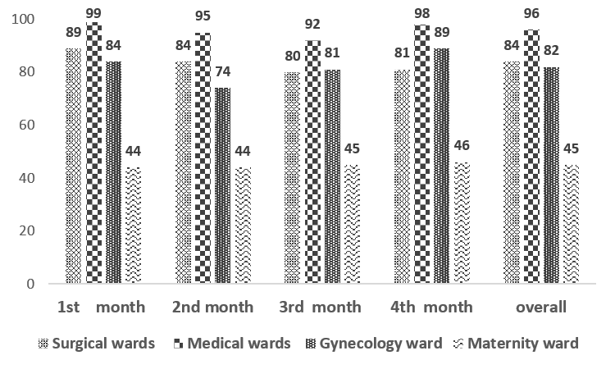
Supplementary material 2. The percentage of staff nurses’ compliance with the rounding schedule by units of admission.
The percentage was calculated by Number of visits completed divided by the number of visits expected according to schedule

