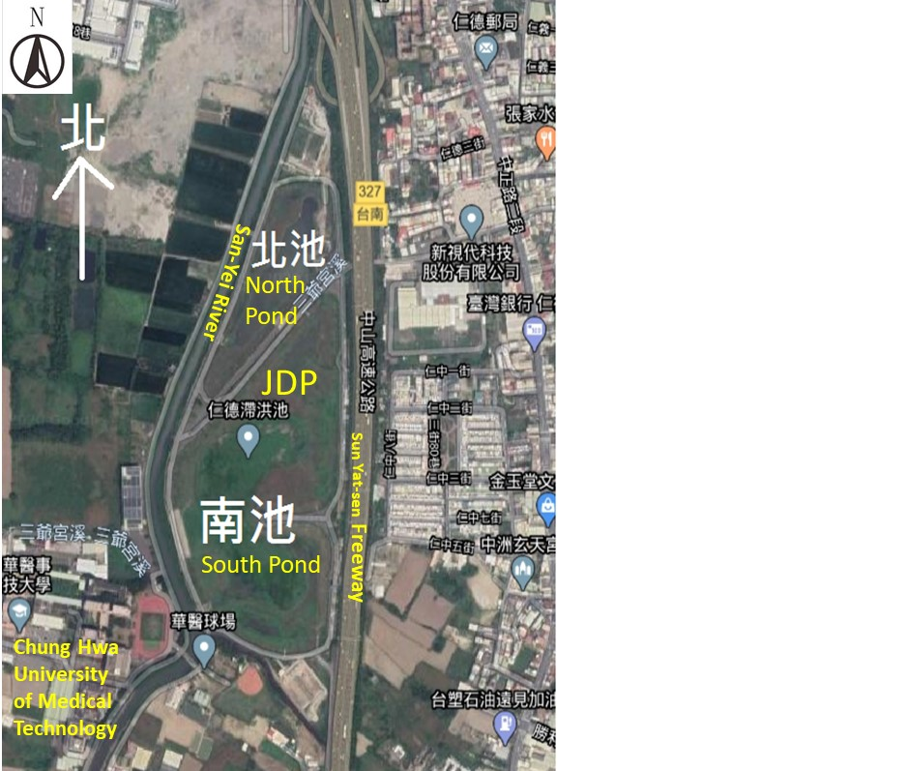

Supplementary Fig. 1. Location of JDP adapted from Google Earth.

