SUPPORTING INFORMATION FOR:
Preparation and optimization of Starch/Poly vinyl alcohol/ ZnO nanocomposite films applicable for food packaging
Saeed Yari, Mohsen Shahrousvand, Jamshid Mohammadi-Rovshandeh *
Caspian Faculty of Engineering, College of Engineering, University of Tehran, Rezvanshar, P.O. Box 43841-119, Guilan, Iran.
Corresponding author: Jamshid Mohammadi-Rovshandeh, Caspian Faculty of Engineering, College of Engineering, University of Tehran, Rezvanshar, P.O. Box 43841-119, Guilan, Iran, roshandeh@ut.ac.ir

Table S1. Experimental variables and their coded levels for RSM-CCD.
Name | Units | Low | High | -alpha | +alpha
A (PVA) | g | 0.3 | 0.9 | 0 | 1.2
B (Glycerol) | g | 0.75 | 1.25 | 0.5 | 1.5
C (ZnO) | % | 1.25 | 3.75 | 0 | 5

Table S2. The generated polynomial equation from the reduced quadratic model in terms of actual factors for responses.
Response | Final equation in terms of code factors | P | PLOF | R² | Adj.R² | AP
Formation (a. u.) | 1.85341+0.519886A-3.73977B-0.195227C-0.083333AB-0.41667AC+0.2200BC+1.15530A²+  1.66364B²+0.050545C² | 0.0001 | 0.3167 | 0.9366 | 0.9796 | 13.90
Tensile Strength (MPa) | -2.48262-9.09260A+37.02690B-3.10059C  -6.74646AB-0.264668AC+3.10085BC+12.0780A²  -20.53928B²-0.082219C² | 0.0001 | 0.0001 | 0.9657 | 0.9348 | 24.10
Elongation (%) | -52.34097+69.39194A+14.92536B+2.75656C+  14.78497AB-10.93579AC-8.85095BC-22.60936A²+47.95662B²+1.91959C² | 0.0001 | 0.0001 | 0.9799 | 0.9619 | 28.19
Solubility in water (%) | 86.70-38.61032A-100.76102B-12.84748C  +40.6583AB-4.6750A+9.6300BC+31.7594A²  +34.03364B²+1.25095C² | 0.0005 | 0.8426 | 0.9066 | 0.8225 | 10.99
WVP (g H₂O/pa.s.m×10⁻¹⁰) | -1.11438E-07+1.52025E-07A+8.31723E-08B  +2.14198E-08C-1.4347E-09AB-1.7483E-08AC  +2.3761E-08BC-5.4311E-08A²-4.5758E-08 B²  -6.6515E-09 C² | 0.0001 | 0.5832 | 0.9872 | 0.9757 | 28.83
Swelling (%) | 886.5169-787.16939A-778.85B-120.02C  +214.8914AB+51.78363AC+54.05013BC  +300.16484A²+230.12199B²+5.20488C² | 0.0001 | 0.0002 | 0.9402 | 0.8864 | 14.59

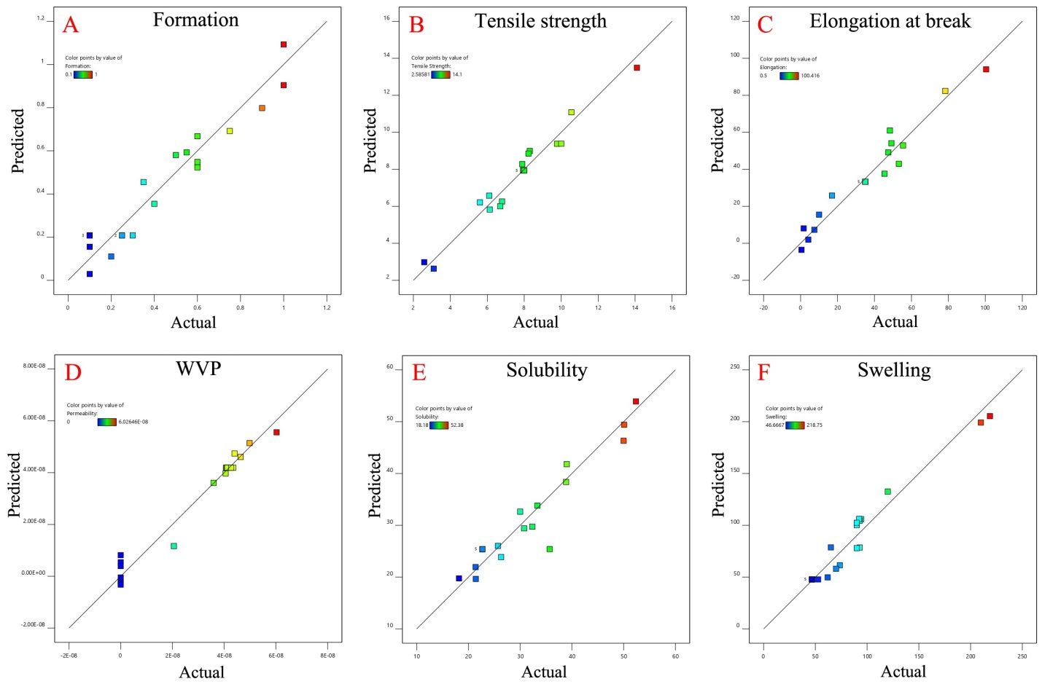
Figure S1. Normal plots of residuals of responses; (A) Formation; (B) Tensile strength; (C) Elongation at break; (D) WVP; (E) Solubility; (F) Swelling.
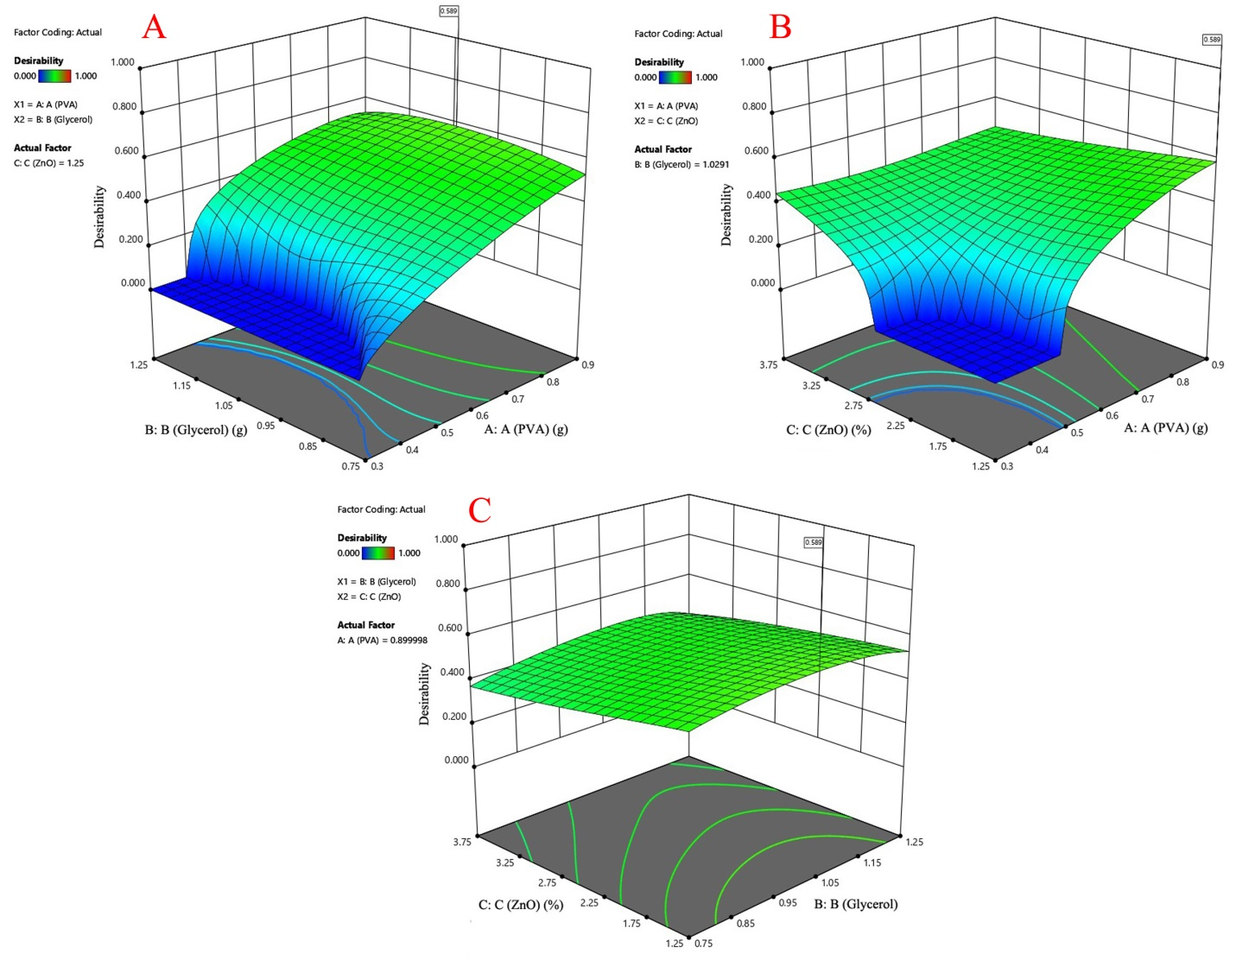
Figure S2. Desirability of responses as optimization of effective factors for preparation of optimum starch/PVA/ZnO nanocomposite films.

