Supplementary materials

Supplementary table 1. Bigrams by community in the fitness-talk network.
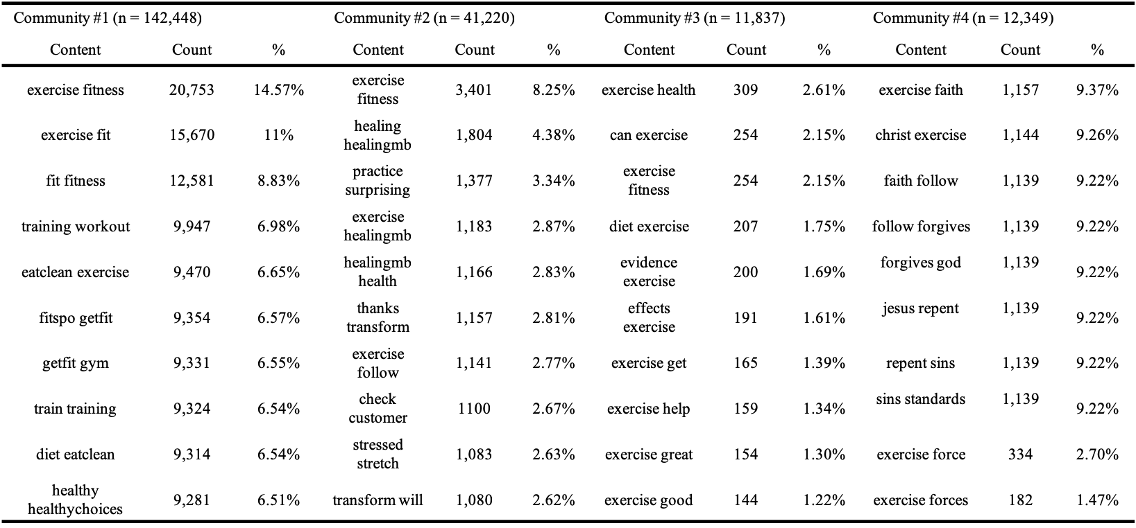
Supplementary table 2. Bigrams by community in the weight-talk network.
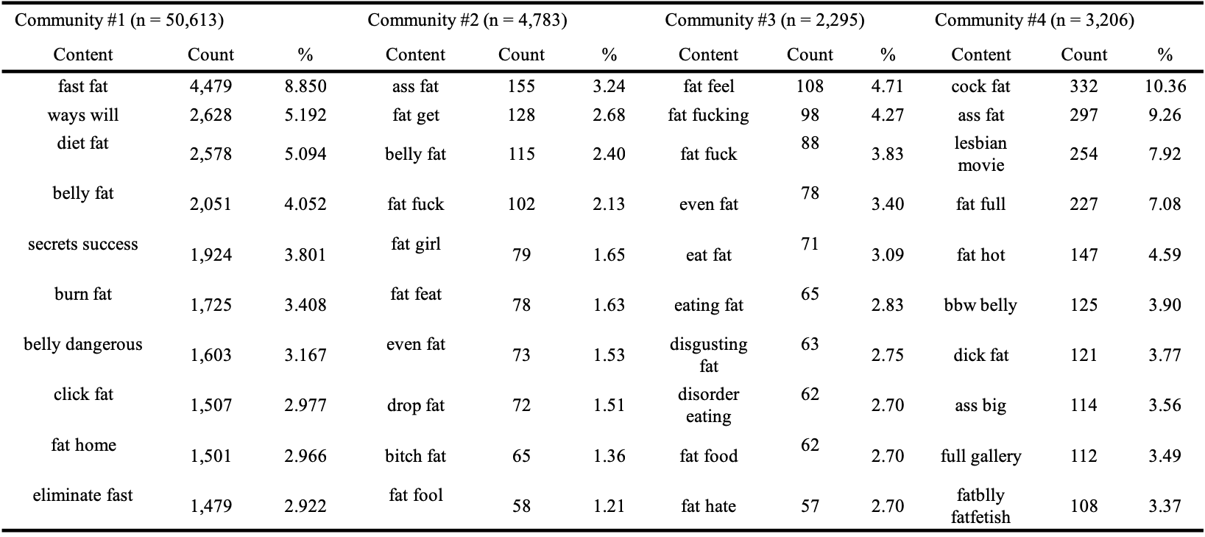

Description of themes by network and community

Fitness-talk Community #1
Fitness-related exercise tweets
The most common theme emerging from the bigrams and LDA analysis within the first community is the relationship between fitness, and fitness related words (e.g. workout, training and yoga) and exercise:
Example 1: RT @USERNAME: Cable chest press slow n controlled, forcing blood into the tissue for a major #pump #burn #gym #fit #fitness #fitchick
Example 2: RT @USERNAME: Daily #Running Day 48 #Adidas #Nike #Puma #KeepGoing #15krun #run #runner #15k #fitness #training #runnerslife #exercise
These kinds of tweets exhibit the relationship between physical abilities like endurance, strength, flexibility and agility, and the practice of exercise. They tend to be a report of goal fulfillment or positive feelings associated with the practice of physical activity.
Health-related exercise tweets
Another sub-topic that appears within the first community is that of exercise and health.
Example 1: RT @USERNAME: Why Strength Training Is so Important for Optimal Health [URL omitted] #IntermittentFasting #Keto #Exercise #Diet #LowCarb
Example 2: RT @USERNAME: Do you exercise enough to prevent heart disease? Only 1/2 of American adults exercise enough to benefit their health.
These tweets focus on the health benefits of exercise in a specific or general manner, generally providing external links for further information and in some cases the focus tends to be on nutritional advice in addition to exercise.
Both of the tweets found in this community resemble themes reported as common motivation for the practice of physical activity (Kilpatrick, Hebert, & Bartholomew, 2005).

Fitness-talk Community #2
Both fitness-related and health-related tweets appear in this community, however there is a small, third word sub-group that emerged:
English learning-related tweets
The use of the word exercise is also associated to repetitive goal-oriented tasks in the language learning context, therefore finding a cluster of accounts related to the teaching of English as a foreign language is not surprising.
Example 1: RT @USERNAME: Develop your English grammar with this exercise on expressing personal opinions: [URL omitted]
Example 2: RT @USERNAME: Grammar test: Give a try. #Grammar #Exercise

Fitness-talk Community #3
This cluster is mainly composed of health-related tweets, especially those pertaining cancer and stress.
Example 1: RT @USERNAME: Not only does exercise and eliminating sugar from your diet lead to weight loss, but it also may prevent colon cancer. [URL omitted]
Example 2: RT @USERNAME: Stressed? Stretching is a very effective way to relax #Exercise #StressReliever #Wellness [URL omitted]

Fitness-talk Community #4
Politics-related exercise tweets
Another cluster that isn’t related to physical activity is the 4th one from the exercise network, in this case most of the tweets hold a relationship to military and air force exercises, and the exercise of rights particularly the second and first amendments of the United States.
Example 1: RT @USERNAME: @USERNAME sends aircraft carriers to western Pacific in rare military exercise following North Korea warning [URL omitted]
Example 2: RT @USERNAME: Philadelphia is the birthplace of the First Amendment. We exercise it, every day, on your behalf. [URL omitted]

Weight-talk Community #1
Weight loss-related fat tweets
The largest community within the weight-talk core network is related to the use of the word fat not so much as a macronutrient but as a bodily characteristic that can and should be burned or disposed of, mainly through diet but sometimes through exercise.
Example 1: RT @USERNAME: #StrengthTraining #Workouts Increase Your #Metabolism By Building Lean #Muscle, Greatly Enhancing #FatBurning [URL omitted]
Example 2: RT @USERNAME: Is "Cardio" Really Needed to Burn Extra Tummy Fat? Is Weight Training Better Than "Cardio"? [URL omitted]
Again, this tweets resemble common motives for the practice of physical activity as well as previous findings of a pro-thin effort of exercise promotion on Twitter (Kilpatrick et al., 2005; Lydecker et al., 2016).

Weight-talk Community #2
General weight stigmatization
The vast majority of this cluster of the weight-talk network uses the word fat in a negative connotation accompanied with generally negative terms:
Example 1: @USERNAME Look bitch your mother has a fat ass.
Example 2: RT @USERNAME: This Fat Girl Sent Me One Nude Picture And My 2GB data Expired When I Downloaded 10%. [URL omitted]
The attacks tend to be either un-directed or personal towards other users. They can be conveyed with a negative emotion or through humor. This findings have been previously reported in Twitter on several occasions although with deeper qualitative categories (Chou et al., 2009; So et al., 2016).

Weight-talk Community #3
Internalized stigma tweets
Tweets in the third community of the weight-talk community are mainly characterized by an internalization of stigma, generally expressing self-directed stigmatizing content:
Example 1: RT @USERNAME: ugh i just want to wear high waisted jeans without looking like a pig and serve cut looks but im so fat and disgusting
Example 2: RT @USERNAME: Let's get this straight. YOU ARE FAT. Do you really deserve to eat? Maybe if you'd stop shoveling food into your fatass.
Internalized stigma is the tendency to internalize and self-direct negative weight-based stereotypes, resulting in poor self-esteem or poor perceived competence (e.g., Hilbert et al., 2014). It is also worth noticing that the descriptions of some of the accounts in this cluster are explicitly pro-eating disorders and fat phobic which is a fear of being overweight or obese (Woud, Anschutz, Van Strien, & Becker, 2011).

Weight-talk Community #4
Porn related tweets
Finally, the 4th cluster of the weight-talk group is mostly related to pornography, with explicit content and tweets referring to body parts or the actors as fat:
Example 1: RT @USERNAME: OVER 8 0 0 HOT FAT ASS VIDEO CLIPS!! [URL omitted]
Example 2: RT @USERNAME: @USERNAME shakes her fat ass [URL omitted]

