Supplementary figure 1: High-quality reads of (a) 2-cell stage (b) 8-cell stage (c) blastocyst stage cloned and IVF embryos were aligned against Bos taurus reference genome, UMD 3.1.1. Percentage of the total reads that got aligned was determined. For all the samples, 79.67 to 85.40% of the total reads got aligned against the reference genome.
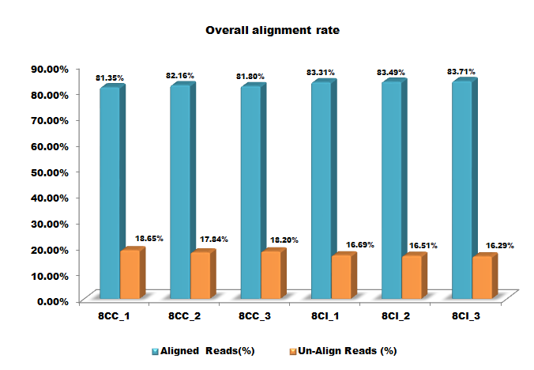
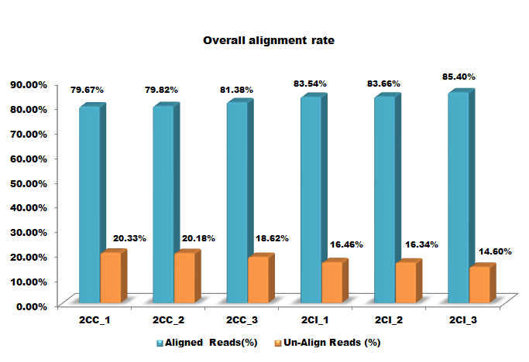
b
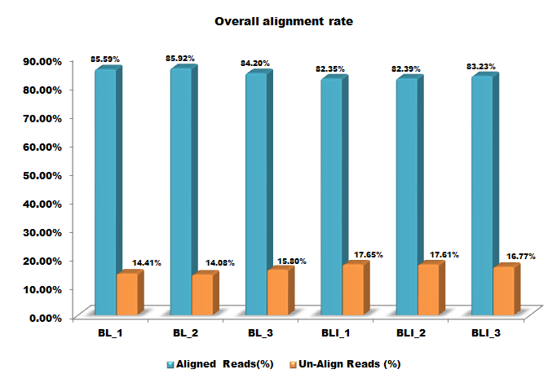
a

c

Supplementary figure 2: Box whisker plot showing the distribution of normalized signal values in the three replicates of a) 2-cell stage, b) 8-cell stage and c) blastocyst stage cloned and IVF embryos.
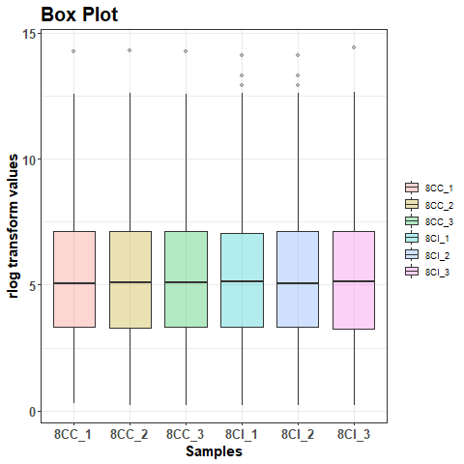
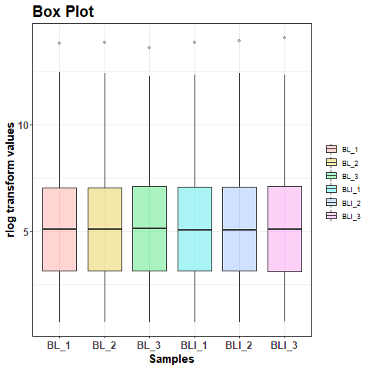
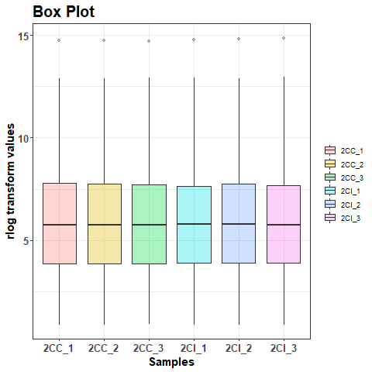

Supplementary figure 3: The quality of the sequencing data generated was analyzed by Principal Component Analysis (PCA). The 2D scatter plot shows that the three replicates of 2-cell stage cloned embryos clustered together in one group while the three replicates of a) 2-cell, b) 8-cell and c) blastocyst stage IVF embryos clustered together in another group. A high correlation amongst the replicates of same origin was observed with correlation coefficient value of R=1.

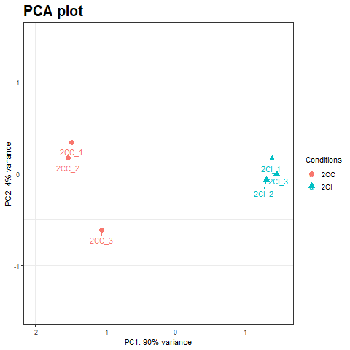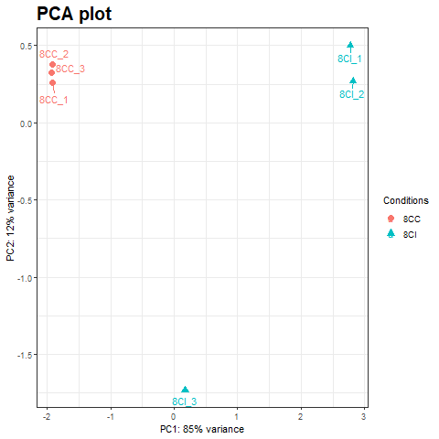
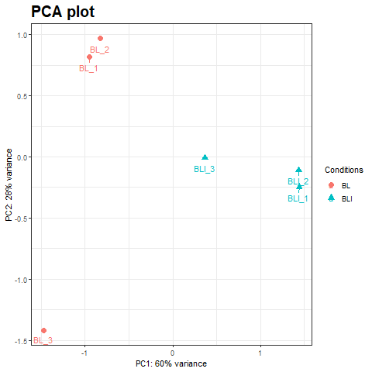

Supplementary figure 4: miRNAs expressed differentially between cloned and IVF a) 2-cell stage b) 8-cell stage c) blastocyst stage embryos were sorted on the basis of FC values. The graph represents the number of miRNAs expressed differentially at different FC values (≥2 to <3, ≥3 to <5 and ≥5-fold).
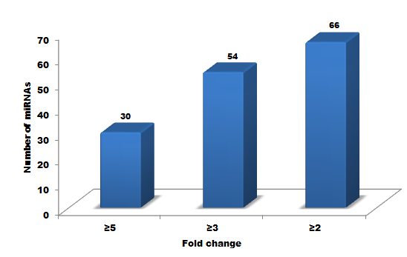

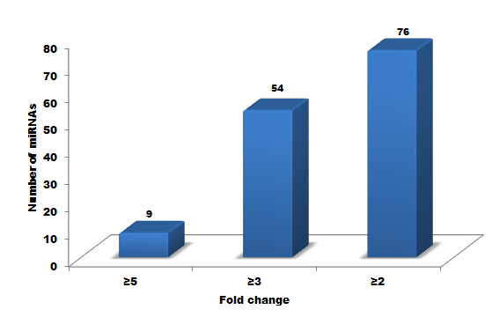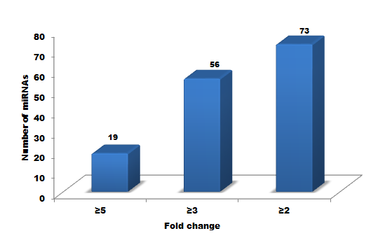

Supplementary figure 5: miRNAs expressed differentially between cloned and IVF IVF a) 2-cell stage b) 8-cell stage c) blastocyst stage embryos at different FC values (≥2 to <3, ≥3 to <5 and ≥5-fold) were sorted on the basis of regulation. The graph represents the number of miRNAs up- or down-regulated in cloned compared to IVF embryos.

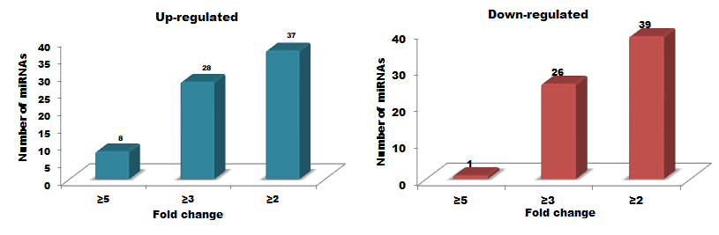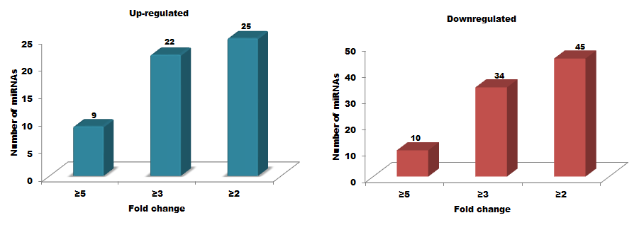

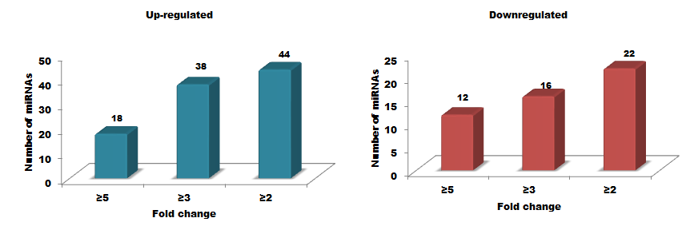

Supplementary figure 6: Venn diagrams depicting the miRNAs expressed commonly and uniquely in cloned and IVF a) 2-cell stage b) 8-cell stage c) blastocyst stage embryos at different FC values (≥2 to <3, ≥3 to <5, ≥5-fold).

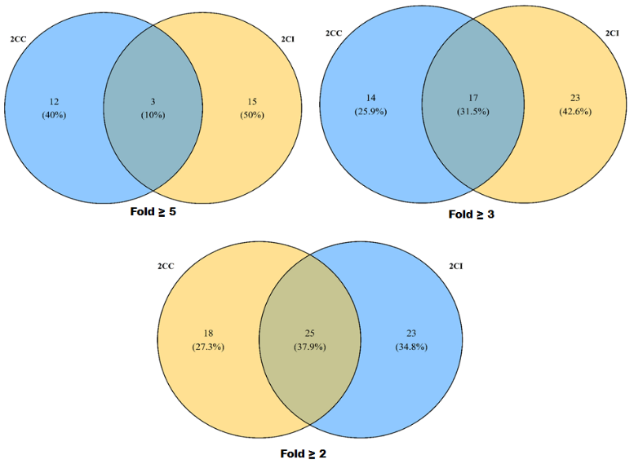
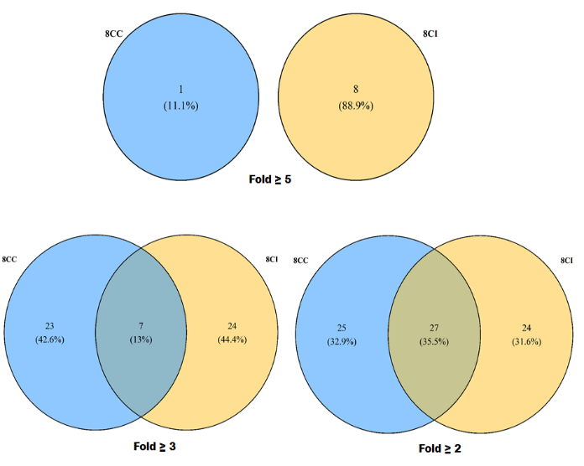

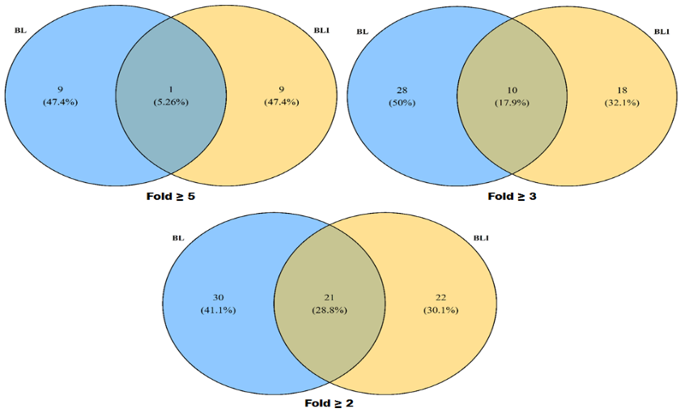

Supplementary figure 7: miRNAs expressed commonly in cloned and IVF a) 2-cell stage b) 8-cell stage c) blastocyst stage embryos at different FC values (≥2 to <3, ≥3 to <5 and ≥5-fold) were sorted on the basis of regulation. The graph represents the number of miRNAs up- or down-regulated in cloned compared to IVF embryos.
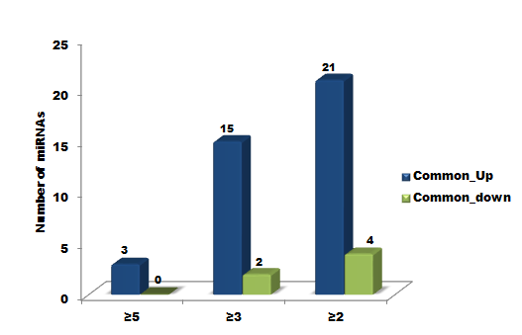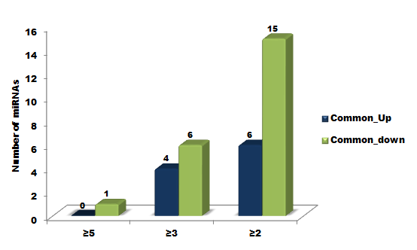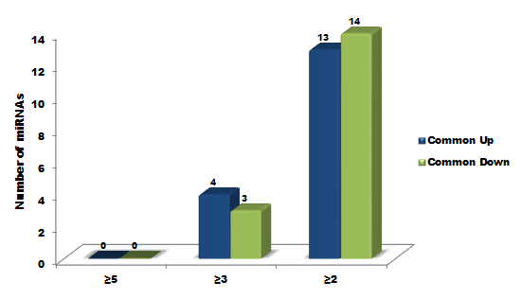

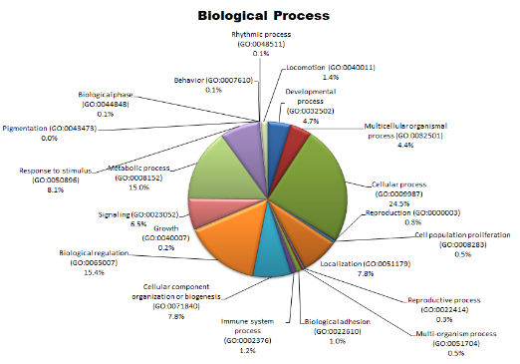
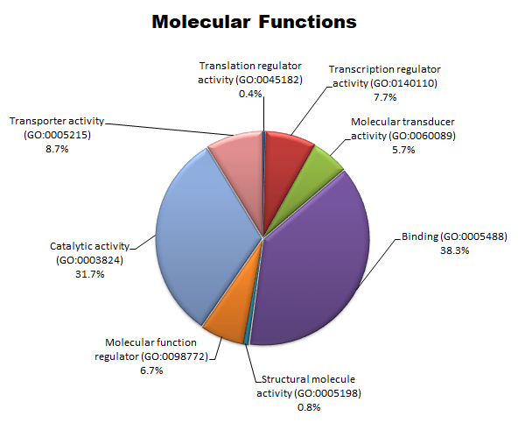
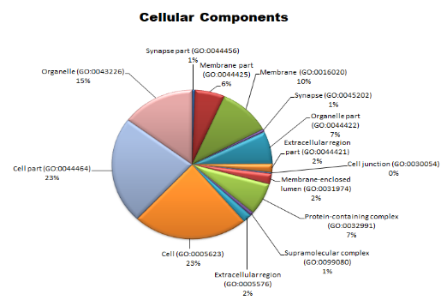
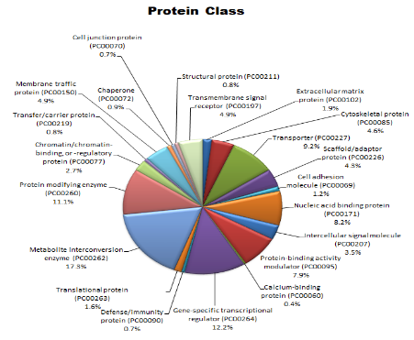
Supplementary figure 8: GO categories across the target genes of differentially expressed miRNAs in cloned a) 2-cell stage b) 8-cell stage c) blastocyst stage embryos relative to IVF counterparts.

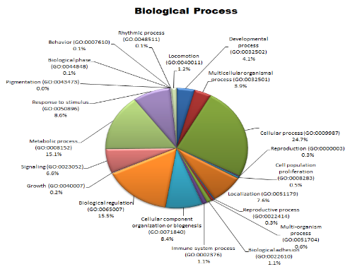
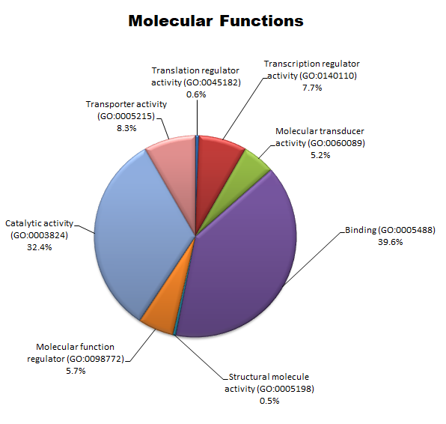
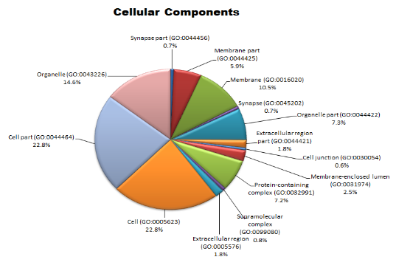
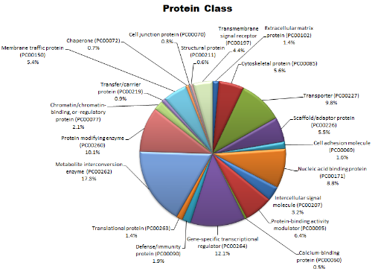

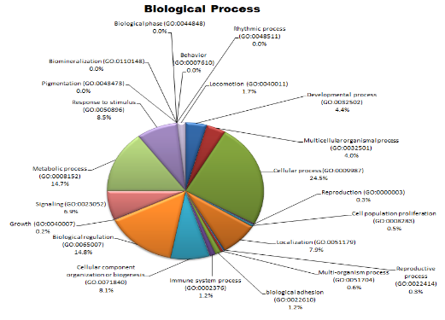
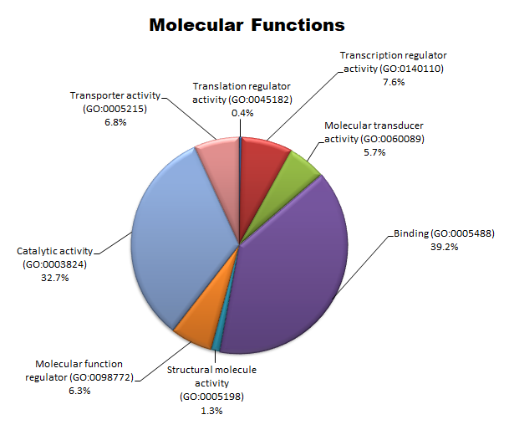
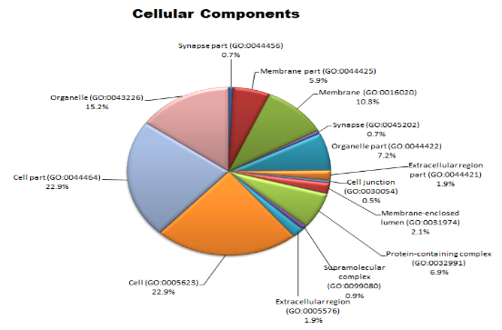
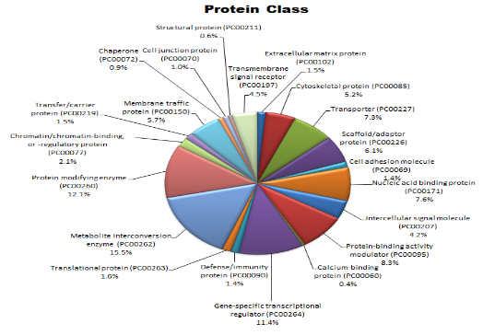

Supplementary figure 9: Pie-chart representing the pathways affected by the target genes of differentially expressed miRNAs at a) 2-cell stage b) 8-cell stage c) blastocyst stage cloned embryos relative to IVF counterparts.

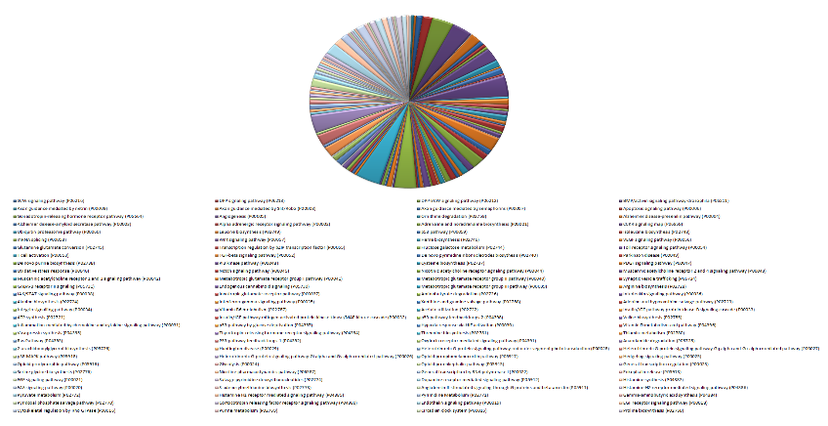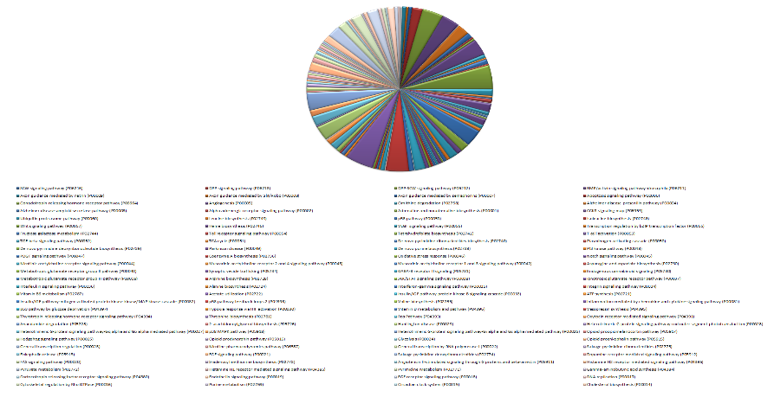

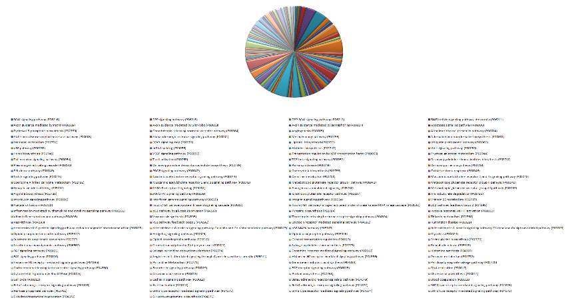

Down-regulated
S.No | miRNA | Gene ID | Fold Change
1 | bta-mir-141 | MI0009742 | -7.31919
2 | bta-mir-451 | MI0009837 | -6.91573
3 | bta-mir-340 | MI0009809 | -6.55886
4 | bta-mir-205 | MI0004759 | -6.24835
5 | bta-mir-760 | MI0009894 | -6.23108
6 | bta-mir-3956 | MI0022291 | -5.95104
7 | bta-mir-208a | MI0009773 | -5.88637
8 | bta-mir-195 | MI0005459 | -5.79194
9 | bta-mir-218 | MI0009780 | -5.64761
10 | bta-mir-3064 | MI0031503 | -5.64761
Supplementary table 1: List of top 10 miRNAs up-regulated and downregulated in cloned relative to IVF 2-cell stage embryos with minimum FC of ≥2.
Up-regulated
S.No | miRNA | Gene ID | Fold Change
1 | bta-mir-136 | MI0009739 | 7.432896
2 | bta-mir-1187 | - | 7.412167
3 | bta-mir-431 | MI0009830 | 7.352068
4 | bta-mir-494 | MI0009848 | 7.335247
5 | bta-mir-2474 | MI0011534 | 6.884633
6 | bta-mir-2355 | MI0011384 | 6.880918
7 | bta-mir-3431 | MI0014498 | 6.865685
8 | bta-mir-11988 | MI0038217 | 6.280845
9 | bta-mir-1291 | MI0010458 | 6.244429
10 | bta-mir-3141 | MI0021117 | 6.232131

Supplementary table 2: List of top 10 miRNAs up-regulated and downregulated in cloned relative to IVF 8-cell stage embryos with minimum FC of ≥2.
Up-regulated
S. No. | miRNA | Gene ID | Fold Change
1 | bta-mir-133a-2 | MI0009732 | 8.784764
2 | bta-mir-431 | MI0009830 | 8.748791
3 | bta-mir-202 | MI0009771 | 8.63385
4 | bta-mir-1973 | - | 8.031015
5 | bta-mir-282 | - | 7.703359
6 | bta-mir-136 | MI0009739 | 7.587887
7 | bta-mir-1949 | MI0038481 | 7.497515
8 | bta-mir-263 | - | 6.344238
9 | bta-mir-11995 | MI0038372 | 4.886532
10 | bta-mir-1244 | - | 4.886532
Down-regulated
S. No. | miRNA | Gene ID | Fold Change
1 | bta-mir-139 | MI0005009 | -5.06179
2 | bta-mir-214 | MI0005040 | -4.90516
3 | bta-mir-328 | MI0009800 | -4.47833
4 | bta-mir-135 | MI0009736 | -4.2404
5 | bta-mir-2435 | MI0011486 | -4.11921
6 | bta-mir-10395 | - | -4.09689
7 | bta-mir-758 | MI0009892 | -4.02584
8 | bta-mir-218-1 | MI0009780 | -3.89558
9 | bta-mir-497 | MI0005467 | -3.8403
10 | bta-mir-11991 | MI0038355 | -3.83427

Supplementary table 3: List of top 10 miRNAs up-regulated and downregulated in cloned relative to IVF blastocyst stage embryos with minimum FC of ≥2.
Up-regulated
S. No. | miRNA | Gene ID | Fold Change
1 | bta-mir-1949 | MI0038481 | 6.866632
2 | bta-mir-1692 | - | 6.558697
3 | bta-mir-431 | MI0009830 | 6.185156
4 | bta-mir-3956 | MI0022291 | 5.970153
5 | bta-mir-664a | MI0011547 | 5.755526
6 | bta-mir-100 | MI0009720 | 5.610384
7 | bta-mir-11982 | MI0038196 | 5.531622
8 | bta-mir-9226 | - | 5.334239
9 | bta-mir-33a | MI0009807 | 5.084101
10 | bta-mir-329a | MI0009801 | 4.860397
Down-regulated
S. No. | miRNA | Gene ID | Fold Change
1 | bta-mir-1973 | - | -6.53716
2 | bta-mir-1839 | MI0010473 | -6.3781
3 | bta-mir-188 | MI0009760 | -5.95997
4 | bta-mir-126 | MI0004754 | -5.92198
5 | bta-mir-592 | MI0009875 | -5.90065
6 | bta-mir-451 | MI0009837 | -5.55396
7 | bta-mir-32 | MI0009796 | -5.23674
8 | bta-mir-345 | MI0005019 | -5.23674
9 | bta-mir-328 | MI0009800 | -5.21535
10 | bta-mir-551a | MI0009863 | -5.21535

Supplementary table 4: Details of Locked nucleic acid (LNA) primers for miRNAs

S.No. | miRNA | Target sequence | miRCURY Cat. No. (for LNA universal primers) | Annealing Temperature  (ᵒC)
1. | miR-423 | 5'UGAGGGGCAGAGAGCGAGACUUU | YP00205624 | 56
2. | miR-202 | 5'UUCCUAUGCAUAUACUUCUUUG | YP00205616 | 56
3. | miR-340 | 5'UUAUAAAGCAAUGAGACUGAUU | YP00206068 | 56
4. | miR-218 | 5'UUGUGCUUGAUCUAACCAUGU | YP00206034 | 56
5. | miR-96 | 5'UUUGGCACUAGCACAUUUUUGCU | YP00204417 | 56
6. | miR-139 | 5'UCUACAGUGCACGUGUCUCCAGU | YP00205874 | 56
7. | miR-214 | 5'UGCCUGUCUACACUUGCUGUGC | YP00204575 | 56
8. | miR-370 | 5'GCCUGCUGGGGUGGAACCUGGU | YP00204011 | 56

