Supplementary information
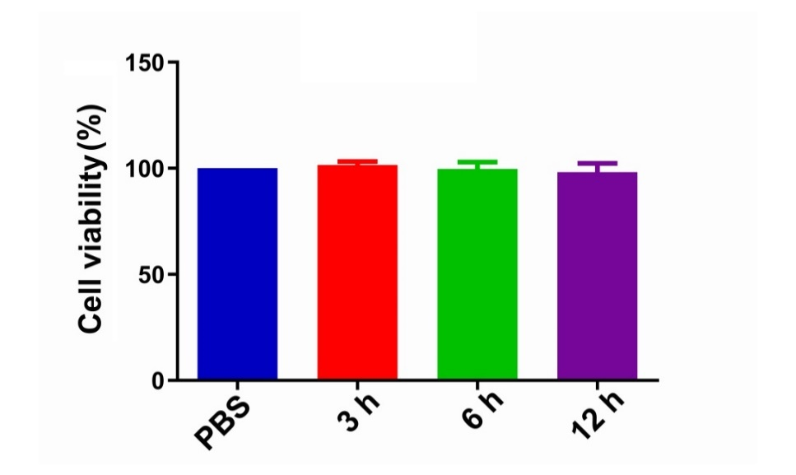
Fig.S1. The security of the Pol hydrogel by measuring cell viability.
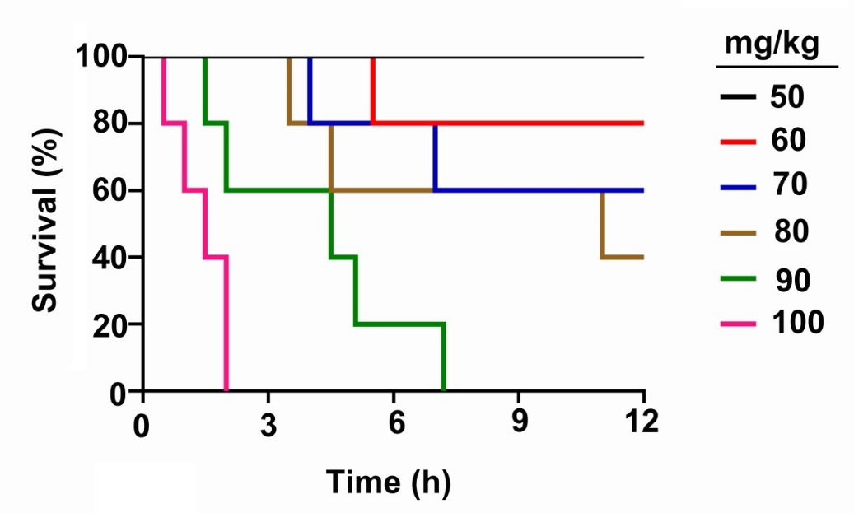
Fig.S2. Survival curve for the mice treated with different dose of T1AM, injected i.p.

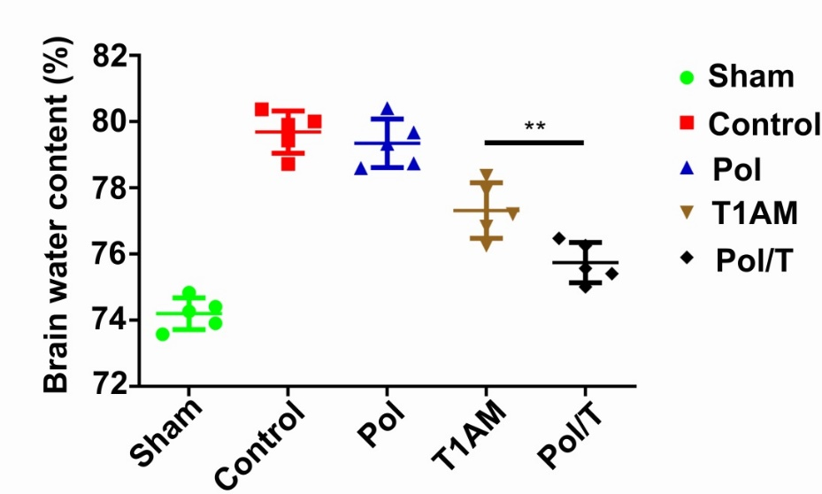
Fig.S3. Brain water content. Values are the mean ± SEM. (n = 5). **P < 0.01.
Movie S1. The behavior of TBI models treated with T1AM, injected i.p.
Movie S2. The behavior of TBI models treated with Pol/T hydrogel.
Data availability
The data that support the findings of this study are available from the corresponding
author upon reasonable request.

