Supplemental Data

 | Subjects without PEX  (n = 10) | Sustained  Responders  (n = 10) | Non-Sustained Responders  (n = 10)
Age, yrs | 33.5 (19-58) | 31 (25-46) | 26 (21-52)
Male / Female, n | 5 / 5 | 7 / 3 | 6 / 4
Body weight, kg | 59.3 (52.4-78.6) | 57.7 (43.1-99.6) | 60.2 (44.0-74.0)
F508del-CFTR x 2, n (%) | 5 (50) | 6 (60) | 6 (60)
FEV1, % predicted | 69.0 (22-97) | 60.5 (25-91) | 35.5 (22-70) *†
FVC%, % predicted | 77.5 (37-96) | 81.5 (36-102) | 44.5 (36-86)
MRSA, n (%) | 0 (0) | 3 (30) | 2 (20)
Burkholderia species, n (%) | 0 (0) | 2 (20) | 2 (20)
P. aeruginosa, n (%) | 8 (80) | 4 (40) | 6 (60)
Akron PES | 2 (0-4) | 0.5 (0-4) | 1.0 (0-4)
CFRSD-CRISS | 36.5 (23-48) | 31.5 (23-44) | 39 (23-52)
WBC, x10³/μl | 9.3 (6.7-17.2) | 9.2 (5.0-14.2) | 11.0 (4.5-15.5)
WBC neutrophils, % | 73.5 (53.0-86.0) | 68.8 (54.3-75.1) | 77.2 (56.1-81.4)
Hemoglobin, gm/dl | 12.9 (12.0-15.8) | 12.6 (9.7-15.1) | 13.0 (11.8-16.5)
Platelets, x10³/μl | 333 (165-422) | 333 (195-551) | 296 (207-374)
Serum iron, μg/dl | 59.5 (34-108) | 44.5 (10-160) | 27.5 (17-80)
Sputum iron, ng/mg | N/A | 2,415 (373-10,366) | 1,711 (677-8,352)
Serum hepcidin-25, ng/ml | N/A | 52.9 (10.5-214.3) | 64.6 (9.4-165.9)
Serum IL-6, pg/ml | N/A | 11.6 (1.6-22.8) | 9.4 (2.6-17.3)

Table S1. Baseline clinical and biochemical characteristics of subjects who were screened but never experienced a PEX, SRs, and NSRs. N/A = not available. Data are presented as median (range) unless otherwise noted. * p < 0.05 vs. SRs. † p < 0.05 vs. subjects without PEX.

Model Parameter | Coefficient (β) | 95% C.I. (β) | p-value
Quadratic Interaction term (Group • days²) | 0.11 | 0.04, 0.18 | 0.003
Linear Interaction term (Group • days) | 0.09 | -0.55, 0.73 | 0.78
Quadratic Time After PEX Onset (days²) | 0.07 | 0.02, 0.12 | 0.004
Linear Time After PEX Onset (days) | -2.2 | -2.6, -1.7 | <0.0001
Difference in CFRSD-CRISS at PEX Onset (NSR - SR) | -5.5 | -12.5, 1.5 | 0.12
Constant (CFRSD-CRISS) | 40.3 | 35.4, 45.2 | <0.0001

Table S2. Linear mixed model (LMM) describing CFRSD-CRISS over time between two PEX treatment response groups, sustained responders (SRs, n = 10) and non-sustained responders (NSRs, n = 10). C.I. = confidence interval. Number of observations = 96. Number of subjects = 20. Observations per group: minimum = 3, maximum = 7, average = 4.8.

Model Parameter | Coefficient (β) | 95% C.I. (β) | p-value
Quadratic Interaction term (Group • days²) | 0.06 | 0.01, 0.11 | 0.02
Linear Interaction term (Group • days) | -1.7 | -2.2, -1.2 | <0.0001
Quadratic Time After PEX Onset (days²) | -0.08 | -0.12, -0.05 | <0.0001
Linear Time After PEX Onset (days) | 2.1 | 1.7, 2.5 | <0.0001
Difference in FEV1% at PEX Onset (NSR - SR) | -15.3 | -31.0, 0.4 | 0.06
Constant (FEV1%) | 53.4 | 42.2, 64.6 | <0.0001

Table S3. Linear mixed model (LMM) describing FEV1% as a function of time between two PEX treatment response groups, sustained responders (SRs, n = 10) and non-sustained responders (NSRs, n = 10). C.I. = confidence interval. Number of observations = 62. Number of subjects = 20. Observations per group: minimum = 1, maximum = 7, average = 3.1.

Model Parameter | Coefficient (β) | 95% C.I. (β) | p-value
Linear Interaction term (Group • days) | 0.052 | -0.003, 0.108 | 0.06
Quadratic Time After PEX Onset (days²) | 0.006 | 0.002, 0.011 | 0.007
Linear Time After PEX Onset (days) | -0.14 | -0.19, -0.08 | <0.0001
Difference in ln(Serum IL-6) at PEX Onset (NSR - SR) | -0.01 | -0.57, 0.54 | 0.96
Constant [ln(Serum IL-6)] | 1.69 | 1.28, 2.10 | <0.0001

Table S4. Linear mixed model (LMM) describing ln(serum IL-6) over time between two PEX treatment response groups, sustained responders (SRs, n = 10) and non-sustained responders (NSRs, n = 10). C.I. = confidence interval. Number of observations = 98. Number of subjects = 20. Observations per group: minimum = 3, maximum = 8, average = 4.9.

Model Parameter | Coefficient (β) | 95% C.I. (β) | p-value
Linear Interaction term (Group • days) | 0.04 | -0.01, 0.09 | 0.09
Quadratic Time After PEX Onset (days²) | 0.006 | 0.002, 0.010 | 0.007
Linear Time After PEX Onset (days) | -0.13 | -0.18, -0.08 | <0.0001
Difference in ln(Serum hepcidin-25) at PEX Onset (NSR - SR) | -0.24 | -0.75, 0.28 | 0.37
Constant [ln(Serum hepcidin-25)] | 3.87 | 3.49, 4.25 | <0.0001

Table S5. Linear mixed model (LMM) describing ln(serum hepcidin-25) over time between two PEX treatment response groups, sustained responders (SRs, n = 10) and non-sustained responders (NSRs, n = 10). C.I. = confidence interval. Number of observations = 98. Number of subjects = 20. Observations per group: minimum = 3, maximum = 8, average = 4.9.

Model Parameter | Coefficient (β) | 95% C.I. (β) | p-value
Quadratic Interaction term (Group • days²) | -0.006 | -0.011, -0.0004 | 0.04
Linear Interaction term (Group • days) | 0.02 | -0.02, 0.07 | 0.36
Quadratic Time After PEX Onset (days²) | 0.001 | -0.026, 0.004 | 0.68
Linear Time After PEX Onset (days) | 0.03 | 0.002, 0.066 | 0.04
Difference in ln(Serum iron) at PEX Onset (NSR - SR) | 0.32 | -0.10, 0.75 | 0.14
Constant [ln(Serum iron)] | 3.43 | 3.14, 3.73 | <0.0001

Table S6. Linear mixed model (LMM) describing ln(Serum iron) over time between two PEX treatment response groups, sustained responders (SRs, n = 10) and non-sustained responders (NSRs, n = 10). C.I. = confidence interval. Number of observations = 98. Number of subjects = 20. Observations per group: minimum = 3, maximum = 8, average = 4.9.

Model Parameter | Coefficient (β) | 95% C.I. (β) | p-value
Quadratic Interaction term (Group • days²) | 32 | 17, 48 | <0.0001
Linear Interaction term (Group • days) | -132 | -264, 1 | 0.05
Linear Time After PEX Onset (days) | -9 | -100, 82 | 0.85
Quadratic Time After PEX Onset (days²) | -2 | -10, 7 | 0.72
Difference in sputum iron at PEX Onset (NSR - SR) | -343 | -1,425, 739 | 0.53
Constant (sputum iron) | 2200 | 1500, 3000 | <0.0001

Table S7. Linear mixed model (LMM) describing sputum iron (ng/mg of sputum) over time between two PEX treatment response groups, sustained responders (SRs, n = 10) and non-sustained responders (NSRs, n = 10). C.I. = confidence interval. Number of observations = 63. Number of subjects = 18. Observations per group: minimum = 1, maximum = 7, average = 3.5.

Parameter | Interpretation
Hemoglobin, gm/dl | No between-cohort difference
Hematocrit, % | No between-cohort difference
RDWSD, fl | No between-cohort difference
RDWCV, % | Different time trends between cohorts
MCHC, gm/dl | Different time trends between cohorts
MCV, fl | Different time trends between cohorts
WBC, x10³/μl | No between-cohort difference
WBC Neutrophils, % | Borderline different time trends between cohorts
WBC Lymphocytes, % | Borderline different time trends between cohorts
WBC Monocytes, % | No between-cohort difference
WBC Basophils, % | Different time trends between cohorts
WBC Eosinophils, % | Different time trends between cohorts
Platelets, x10³/μl | Different time trends between cohorts
MPV, fl | Different time trends between cohorts
TSAT, % | Borderline different time trends between cohorts
TIBC, μg/dl | No between-cohort difference

Table S8. Summary of findings about the trend differences between SRs and NSRs based on the final LMMs for all variables. Different time trends between cohorts means the quadratic and or linear interaction(s) between cohort and time was significant with p<0.05 while borderline means neither term is significant but the p-value was within 0.05-0.1. No between-cohort difference means neither interaction term was significant and the p-value>0.1. RDWSD = standard deviation of red cell distribution width; RDWCV = coefficient of variation of red cell distribution width; MCHC = mean corpuscular hemoglobin concentration; MCV = mean corpuscular volume; WBC = white blood cell; MPV = mean platelet volume; TSAT = transferrin saturation; TIBC = total iron binding capacity.

Predictor | Obs  (n) | Subjects  (n) | Coefficient of  Predictor | p-value  (Predictor) | Coefficient of CFRSD-CRISS  at PEX Onset | p-value  (CFRSD-CRISS  at PEX Onset)
ΔFEV1% | 35 | 12 | -0.70 | <0.001 | 0.60 | 0.01
ΔHemoglobin, gm/dl | 75 | 20 | 0.99 | 0.48 | 0.49 | 0.02
ΔHematocrit, % | 75 | 20 | 0.05 | 0.91 | 0.50 | 0.02
ΔRDWSD, fl | 75 | 20 | -1.03 | 0.08 | 0.52 | 0.01
ΔRDWCV, % | 75 | 20 | -1.22 | 0.43 | 0.51 | 0.01
ΔMCHC, gm/dl | 75 | 20 | 2.59 | 0.14 | 0.54 | 0.01
ΔMCV, fl | 75 | 20 | -1.50 | 0.047 | 0.46 | 0.04
ΔWBC, x10³/μl | 75 | 20 | 0.29 | 0.36 | 0.50 | 0.02
ΔWBC Neutrophils, % | 65 | 19 | 0.31 | <0.001 | 0.53 | 0.001
ΔWBC Lymphocytes, % | 65 | 19 | -0.40 | 0.001 | 0.58 | 0.001
ΔWBC Monocytes, % | 65 | 19 | 0.05 | 0.93 | 0.51 | 0.01
ΔWBC Basophils, % | 65 | 19 | -0.69 | 0.85 | 0.52 | 0.02
ΔWBC Eosinophils, % | 65 | 19 | -0.59 | 0.04 | 0.46 | 0.01
ΔPlatelets, x10³/μl | 75 | 20 | -0.01 | 0.61 | 0.54 | 0.01
ΔMPV, fl | 75 | 20 | 1.29 | 0.65 | 0.52 | 0.02
ΔSerum IL-6, pg/ml | 76 | 20 | 0.23 | 0.005 | 0.66 | 0.004
ΔSerum hepcidin-25, ng/ml | 76 | 20 | 0.03 | 0.02 | 0.53 | 0.02
ΔSerum iron, μg/dl | 76 | 20 | -0.09 | 0.002 | 0.44 | 0.02
ΔSputum iron, ng/mg | 42 | 12 | -0.0006 | 0.52 | 0.41 | 0.03
ΔTSAT, % | 76 | 20 | -0.20 | 0.03 | 0.47 | 0.01
ΔTIBC, μg/dl | 76 | 20 | -0.10 | <0.001 | 0.55 | 0.02
Table S9. LMMs for CFRSD-CRISS in response to changes in physiologic and/or biochemical indices, respectively, with control for CFRSD-CRISS at PEX onset. Each coefficient means the expected change in CFRSD-CRISS for every unit increase in the corresponding predictor variable. RDWSD = standard deviation of red cell distribution width; RDWCV = coefficient of variation of red cell distribution width; MCHC = mean corpuscular hemoglobin concentration; MCV = mean corpuscular volume; WBC = white blood cell; MPV = mean platelet volume; TSAT = transferrin saturation; TIBC = total iron binding capacity.

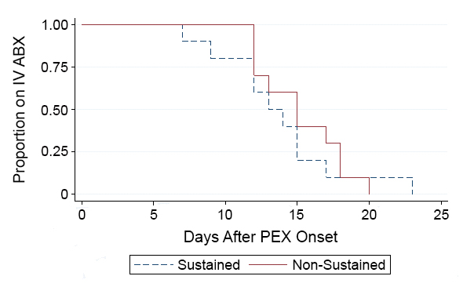
Fig. S1. Kaplan-Meier estimator curves depicting the length of PEX treatment with IV ABX for SRs and NSRs. The median length of treatment for SRs is 13.5 days and that for NSRs is 15 days. The Chi-square statistic for the log-rank test of equality of medians was 0.37 (p = 0.54).

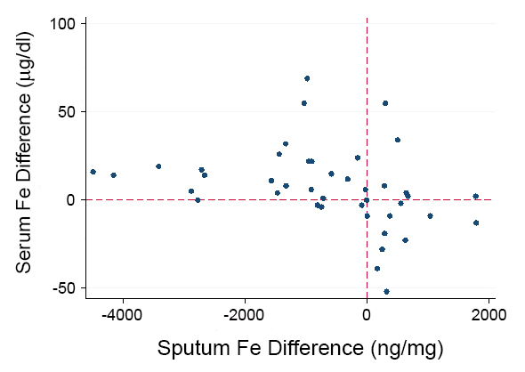

Fig. S2. Correlation between treatment-associated changes in serum and sputum iron over time beginning with treatment day 1. The correlation coefficient is -0.34 (p = 0.02).

