Appendix. Sample derivation for Diabetes Health Plan (A) and Control Beneficiaries (B)
A)
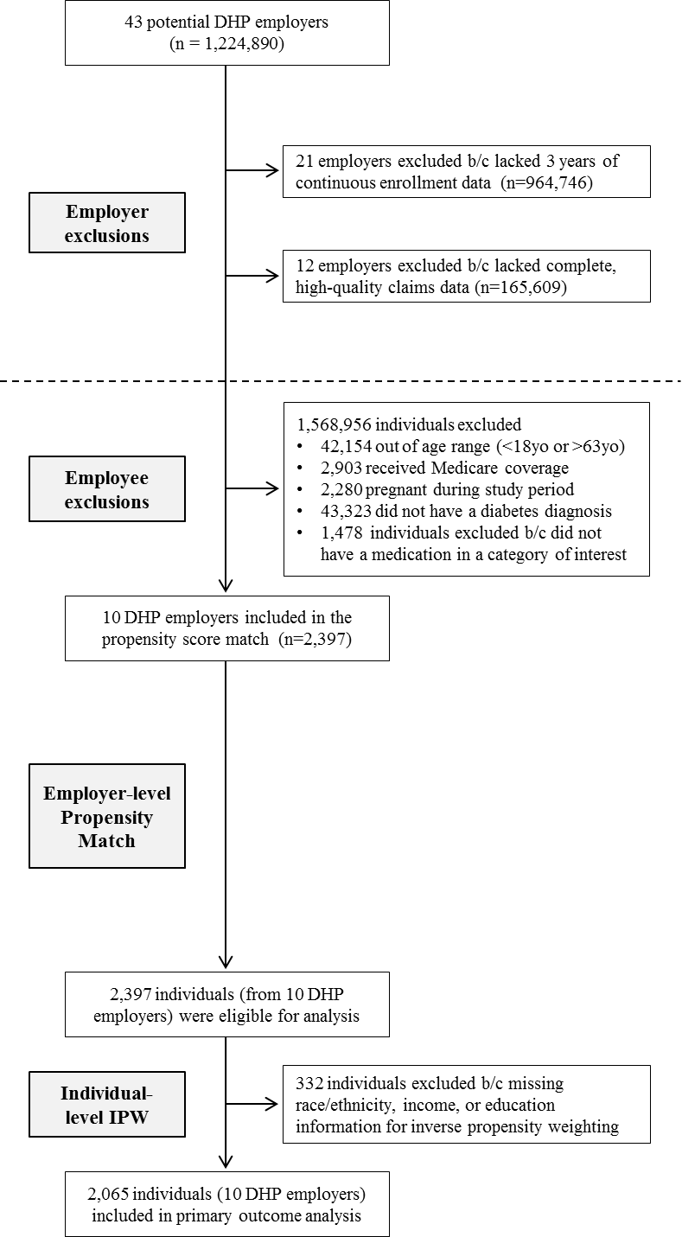

B)
