Table 1

Effects of EDTA, EDDS and NTA on pore water metal concentration at HT site (n=3)
HMs  (mg/L) | Days | Controls | EDTA  1:1 | EDTA  0.5+0.5 | NTA  1:1 | NTA  0.5:0.5 | EDDS  1:1 | EDDS  0.5:0.5
As | 1 | 0.744 | 0.146 | 0.056 | 0.075 | 0.024 | 0.106 | 0.036
 | 14 | 0.000 | 0.116 | 0.075 | 0.016 | 0.007 | 0.090 | 0.006
 | 28 | 0.002 | 0.070 | 0.044 | 0.021 | 0.015 | 0.059 | 0.030
Cd | 1 | 0.003 | 0.342 | 0.126 | 0.179 | 0.054 | 0.039 | 0.000
 | 14 | 0.015 | 0.296 | 0.124 | 0.137 | 0.036 | 0.062 | 0.019
 | 28 | 0.577 | 0.213 | 0.159 | 0.091 | 0.052 | 0.038 | 0.013
Cu | 1 | 0.014 | 40.33 | 24.25 | 26.09 | 10.20 | 21.37 | 13.79
 | 14 | 0.081 | 24.31 | 13.60 | 23.28 | 7.12 | 19.77 | 13.43
 | 28 | 0.085 | 11.74 | 12.80 | 10.70 | 5.63 | 15.13 | 15.82
Pb | 1 | 0.66 | 131.8 | 35.33 | 6.89 | 1.73 | 13.67 | 1.60
 | 14 | 0.95 | 102.9 | 23.68 | 1.88 | 0.27 | 4.28 | 0.37
 | 28 | 0.23 | 56.90 | 38.58 | 1.07 | 0.43 | 2.13 | 0.49
Zn | 1 | 0.85 | 52.90 | 21.46 | 22.51 | 7.48 | 19.14 | 9.82
 | 14 | 0.57 | 55.84 | 24.04 | 22.40 | 5.68 | 27.68 | 9.35
 | 28 | 0.57 | 35.88 | 24.74 | 11.65 | 5.50 | 20.70 | 10.97

Table 2

Effects of EDTA, EDDS and NTA on pore water metal concentration at LH site (n=3)
HMs (mg/L) | Days | Controls | EDTA 1:1 | EDTA 0.5+0.5 | NTA 1:1 | NTA 0.5:0.5 | EDDS 1:1 | EDDS 0.5:0.5
As | 1 | 0.302 | 1.418 | 1.419 | 0.478 | 0.200 | 0.404 | 1.203
 | 14 | 0.000 | 1.282 | 0.357 | 0.106 | 0.028 | 0.000 | 0.285
 | 28 | 0.000 | 0.614 | 0.856 | 0.083 | 0.156 | 0.411 | 0.759
Cd | 1 | 0.001 | 3.854 | 18.040 | 0.303 | 0.095 | 4.936 | 14.647
 | 14 | 0.011 | 1.772 | 7.290 | 0.014 | 0.044 | 1.547 | 3.785
 | 28 | 0.161 | 1.036 | 2.692 | 0.033 | 0.064 | 0.744 | 3.339
Cu | 1 | 0.026 | 23.344 | 51.424 | 29.820 | 17.211 | 38.30 | 47.54
 | 14 | 0.080 | 6.175 | 18.071 | 7.169 | 4.636 | 14.18 | 21.64
 | 28 | 0.123 | 2.511 | 0.465 | 3.212 | 2.352 | 8.789 | 12.09
Pb | 1 | 0.499 | 36801 | 7329 | 179.8 | 186.4 | 4425 | 6197
 | 14 | 0.922 | 1236 | 2798 | 78.97 | 207.9 | 2198 | 2767
 | 28 | 0.826 | 685.1 | 1169 | 111.4 | 212.7 | 1265 | 1477
Zn | 1 | 1.150 | 516.3 | 2038 | 453.1 | 520.8 | 701.3 | 1992
 | 14 | 1.028 | 271.4 | 1099 | 183.7 | 398.1 | 385.9 | 1120
 | 28 | 2.014 | 161.16 | 523.0 | 122.3 | 310.6 | 248.7 | 635.3

Table 3

Effects of EDTA, EDDS and NTA on pore water metal concentration at TC mine site (n=3)
HMs (mg/L) | Days | Controls | EDTA 1:1 | EDTA 0.5+0.5 | NTA 1:1 | NTA 0.5:0.5 | EDDS 1:1 | EDDS 0.5:0.5
As | 1 | 5.826 | 0.057 | 0.024 | 0.078 | 0.022 | 0.050 | 0.013
 | 14 | 0.090 | 0.056 | 0.013 | 0.024 | 0.014 | 0.000 | 0.004
 | 28 | 0.156 | 0.023 | 0.856 | 0.033 | 0.004 | 0.411 | 0.759
Cd | 1 | 0.000 | 0.349 | 0.089 | 0.105 | 0.017 | 0.020 | 0.000
 | 14 | 0.011 | 0.304 | 0.084 | 0.106 | 0.015 | 0.033 | 0.011
 | 28 | 0.078 | 0.214 | 0.094 | 0.082 | 0.026 | 0.024 | 0.008
Cu | 1 | 0.001 | 3.681 | 1.126 | 0.73 | 0.118 | 3.401 | 1.003
 | 14 | 0.06 | 2.924 | 1.078 | 0.705 | 0.06 | 2.71 | 0.648
 | 28 | 0.040 | 1.860 | 1.043 | 0.325 | 0.083 | 2.109 | 1.282
Pb | 1 | 0.373 | 74.129 | 25.907 | 27.802 | 9.586 | 14.609 | 2.889
 | 14 | 0.592 | 64.055 | 26.294 | 17.684 | 5.836 | 13.683 | 1.676
 | 28 | 0.183 | 41.153 | 26.249 | 8.216 | 6.052 | 7.818 | 1.939
Zn | 1 | 0.96 | 21.611 | 3.420 | 6.825 | 1.463 | 8.783 | 2.61
 | 14 | 0.453 | 20.840 | 3.834 | 5.994 | 0.916 | 9.480 | 1.739
 | 28 | 0.386 | 13.697 | 3.406 | 3.146 | 0.645 | 9.193 | 3.258

Table 4

Effects of EDTA, EDDS and NTA on DOC by sites (n=3)

DOC  (mg/L) | Days | Controls | EDTA 1:1 | EDTA 0.5+0.5 | NTA 1:1 | NTA 0.5:0.5 | EDDS 1:1 | EDDS 0.5:0.5
HT | 1 | 35.90 | 10906 | 4778 | 6558 | 2221 | 17784 | 6471
 | 14 | 21.89 | 12157 | 4080 | 4332 | 1351 | 9261 | 2738
 | 28 | 9.23 | 6316 | 4421 | 2237 | 1071 | 4782 | 2138
LT | 1 | 65.53 | 47100 | 14419 | 963.0 | 1016 | 45105 | 20562
 | 14 | 52.20 | 9591 | 8589 | 385.0 | 502.5 | 9623 | 4719
 | 28 | 36.93 | 4503 | 9078 | 555.6 | 1253 | 3292 | 6667
TC mine | 1 | 43.91 | 6918 | 2090 | 4457 | 1178 | 7167 | 1763
 | 14 | 10.93 | 6702 | 1783 | 2777 | 468.6 | 4137 | 1423
 | 28 | 15.49 | 4567 | 2144 | 2188 | 466.8 | 2575 | 1428

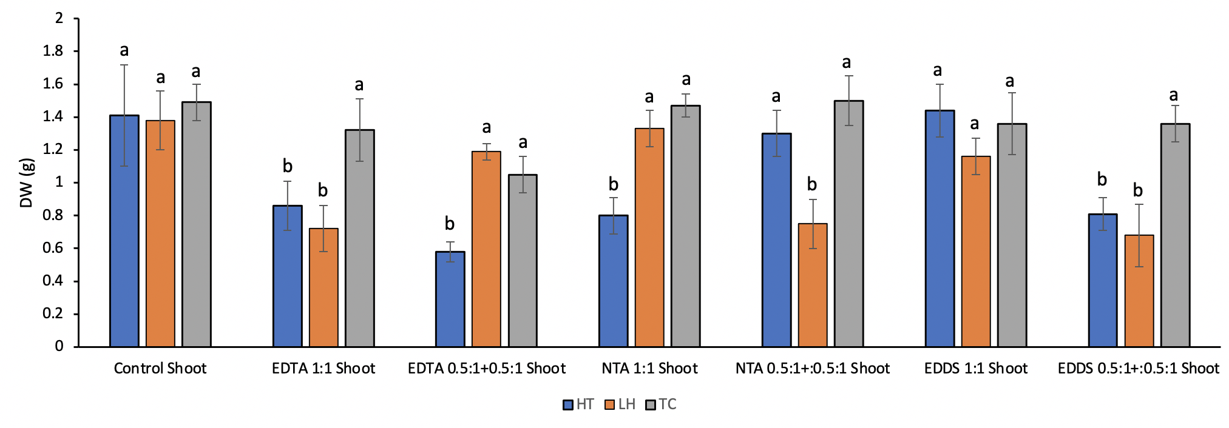

Fig. 1. Effects of EDTA, EDDS and NTA in dry biomass of shoot. Values are means ±SD (n = 3). Lower-case letters represent significant difference between treatments for shoots and roots at each soil sample; values are in the order a > b

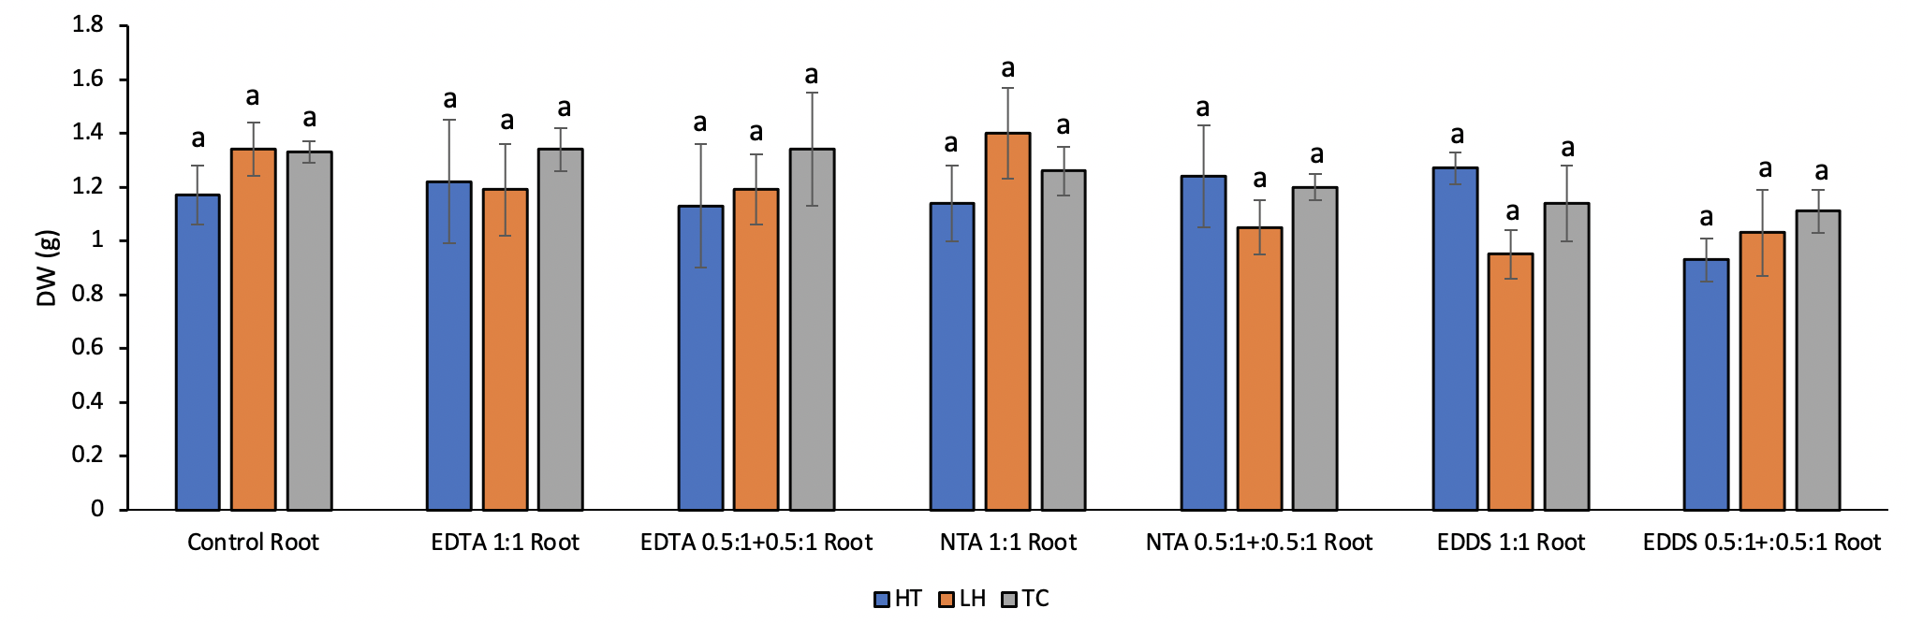

Fig. 2. Effects of EDTA, EDDS and NTA in dry biomass of root. Values are means ±SD (n = 3). Lower-case letter represent significant difference between treatments for shoots and roots at each soil sample

Appendix
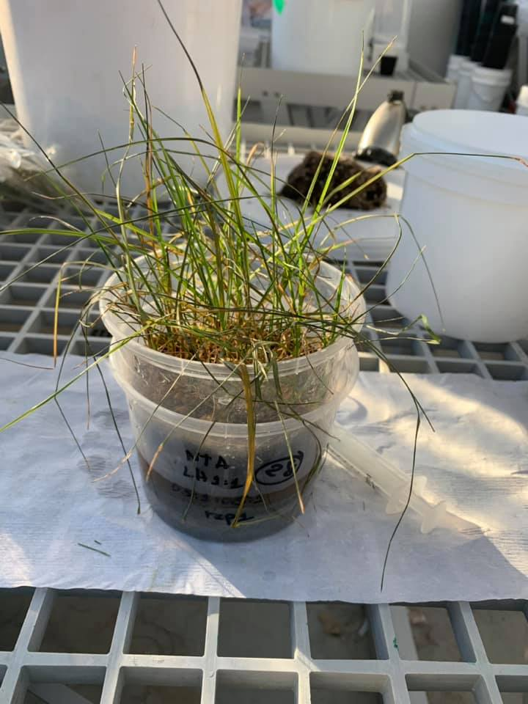

Appendix 1. Toxic symptoms of ryegrass in NTA (0.5:1+0.5:1) treatment using LH soil

