Supplementary Figure 1 Full-length blots/gels of figure 5B.

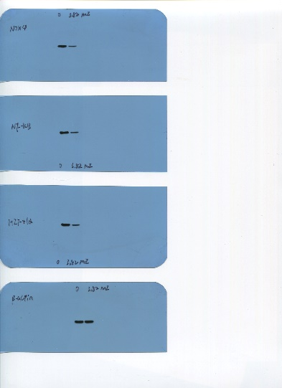

Supplementary Figure 2 Full-length blots/gels of figure 5C.
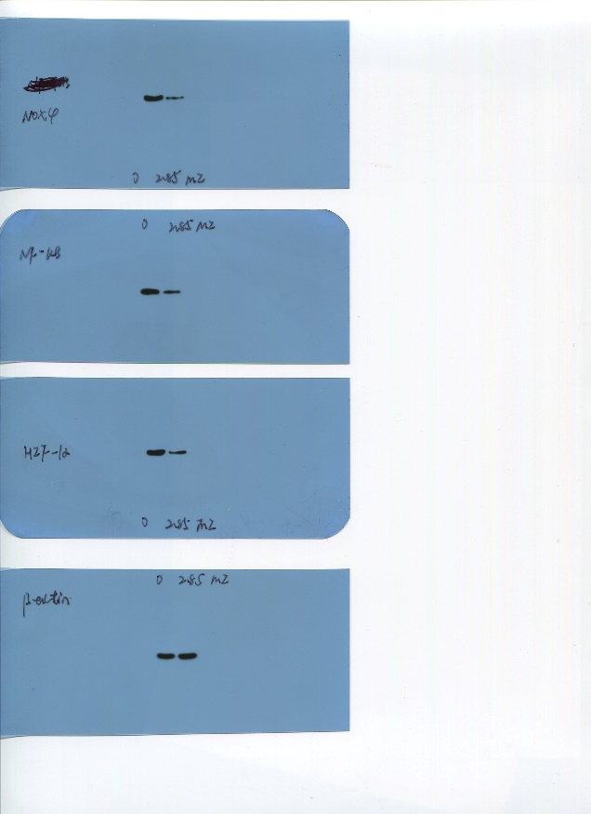

Supplementary Figure 3 Full-length blots/gels of figure 6E.
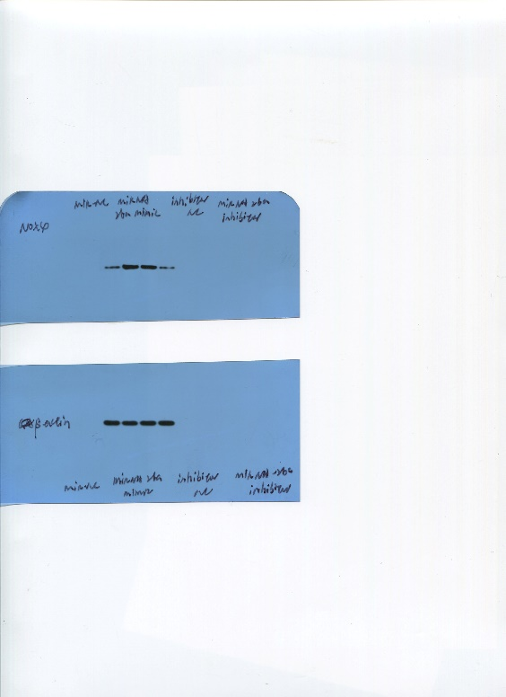

Supplementary Figure 4 Full-length blots/gels of figure 7F.
