Table 1. Specific humidity, S, g/kg moist air, in Winter and Summer, and the isotopic compositions (δ¹⁸O, δ²H, and d-excess/V-SMOW‰) of the three atmospheric vapor sources we refer to in this study. The S value in Summertime is higher than in Winter for these three vapor origins, respectively, in response to the significant increase in the total S values in the local air masses downtown Cairo in the hot season and primarily controlled by the δ¹⁸O-S AVMs' data-points. In the first approximation, the isotopic compositions of the three vapor sources do not change over the year; otherwise, we should have used different isotopic contents for the three vapor sources in Winter and Summer. However, the use of nonidentical isotope ratios for the two seasons needs evidence, support, and justification. Such a piece of evidence is, at present, entirely lacking. The used isotopic signatures of the three moisture origins were to get through a fine adjustment of the CLAW curvilinear wedge framework that encloses the AVMs data-points, Fig 21. We made such an adjustment using the constraints imposed on the especial Macro running SIMAM model, and by checking that the use of these isotopic compositions, and their corresponding S values, in Winter and Summertime, for the three vapor origins, will never produce <0 or >100% contribution for any of these vapor origins in the data-points of all AVMs.

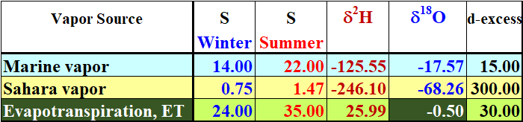

2.50 → δ¹⁸O of water used in irrigation (mixture of enriched river water plus depleted GW)
-10.00 → fractionation to calculate δ¹⁸O of the vapor released by irrigation water evaporation
-7.50 → δ¹⁸O of vapor released by irrigation water evaporation
-3.75 → half of the ET is coming from evaporation of the irrigation water
1.25 → half of ET is coming from transpiration
2.50 → δ¹⁸O of transpiration (it is equal to δ¹⁸O of the irrigation water)
-2.50 → nominal δ¹⁸O of the ET (ET = E+T = -3.75 + 1.25
-0.50 → effective δ¹⁸O of ET used in Noone calculation

From the File named (Isotopic Composition and Specific Humidity of the three sources of Cairo atmospheric moisture_1) in the Folder (LINK2) on the Desktop

Table 2. Maximum, average, and minimum values of δ¹⁸O_{V}/V-SMOW‰, specific humidity, S. g/kg moist air, and percent contributions for the three moisture sources in the local AVMs, downtown Cairo city. The sum of contributions in any row is not 100% since the figures are not for any given data-point in the data set that holds 74 AVM data-points. The number of Summer data-points (55) is about three times that of Winter (19) due to the rarity of precipitation events that can be successfully sampled in Cairo to get valid isotope measurement.

