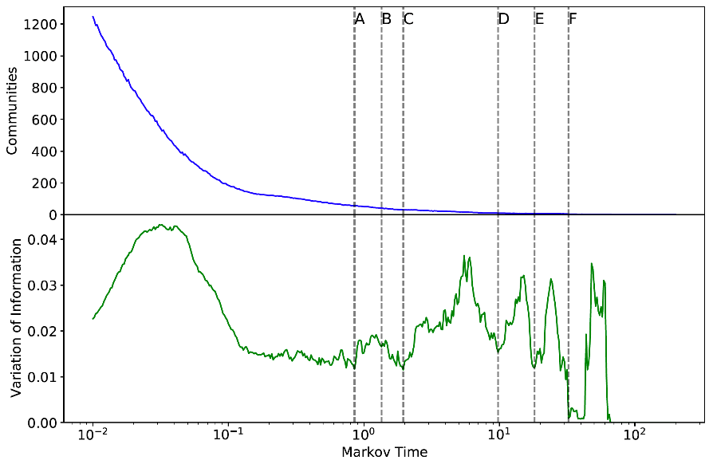
Additional ile 1: Markov Multiscale Community Detection Output. The upper panel shows the number of communities in each partition over increasing Markov time. The lower panel shows the variation of information for each timestep. Vertical dashed lines correspond to the partitions shown in Figure 1, chosen to reflect local minima in the variation of information.

