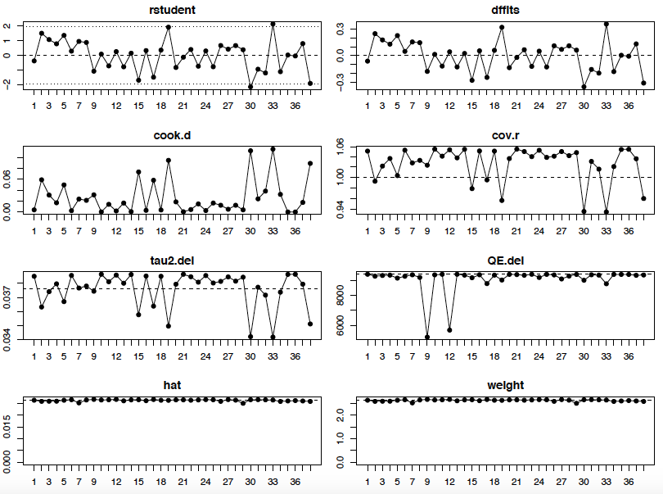
Appendix 9. Plots of leave-one-out diagnostic tests to determine influential studies [Note for interpretation: Influential studies would label in red. In our analysis, no study was found to be influential.]

