Supplementary Information

Twisted oxide lateral homostructures with conjunction tunability

Ping-Chun Wu^{1†}, Chia-Chun Wei^{1†}, Qilan Zhong^{2†}, Sheng-Zhu Ho¹, Yu-Chen Liu¹, Yi-De Liou¹, Chun-Chien Chiu¹, Jo-Chi Hu¹, Kei-Jie You¹, Junding Zheng², Chun-Fu Chang³, Rong Huang², Chun-Gang Duan², Yi-Chun Chen¹, Chang-Yang Kuo^{3,4,5} and Jan-Chi Yang^{1,6*}

¹ Department of Physics, National Cheng Kung University, Tainan 70101, Taiwan
² Key Laboratory of Polar Materials and Devices, Ministry of Education, Department of Electronic Engineering, East China Normal University, Shanghai 200241, China
³ Max-Planck Institute for Chemical Physics of Solids, Dresden, 01187, Germany
⁴ Department of Electrophysics, National Chiao Tung University, Hsinchu 30010, Taiwan
⁵ National Synchrotron Radiation Research Center, Hsinchu 30076, Taiwan
⁶ Center for Quantum Frontiers of Research & Technology (QFort), National Cheng Kung University, Tainan 70101, Taiwan

*e-mail: janchiyang@phys.ncku.edu.tw

Note S1. Density-Functional Calculation of the Binding Energy.

The correlation between the interlayer distance and the binding energy is established by density-functional theory (DFT) calculation. The DFT calculations are performed using the accurate full-potential projector augmented wave (PAW) method, as implemented in the Vienna ab initio simulation package (VASP). The exchange-correlation potential is treated in Perdew-Burke-Ernzerhof (PBE) form of the generalized gradient approximation (GGA) with a kinetic-energy cutoff of 500 eV. Monkhorst-Pack k-point grids (5×5×1) are adopted in calculation. The energy tolerance is 1.0×10⁻⁵ eV/atom. Hellmann-Feynman forces on each atom are less than 1 meV/Å in ground state. The Coulomb interaction parameter U is chosen to be 2 eV for the Fe atom. Interlayer distance is marked by black arrows in the schematic diagram of atomic structure.
Fig. S1. shows the calculation results on the binding energy evolution with interlayer distance of STO-STO, STO-BFO van der Waals bonding and STO-BFO ionic bonding. Bonding energy in ground state are -0.0482eV, -0.1786eV and -2.04eV for STO-STO, STO-BFO van der Waals bonding and STO-BFO ionic bonding. It shows that STO-BFO ionic bonding energy is much higher than van der Waals bonding energy. STO-BFO van der Waals bonding is stronger than it is in STO-STO.

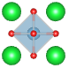
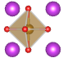
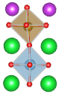

Fig. S1 | Binding energy evolution with interlayer distance of STO-STO, STO-BFO van der Waals bonding and STO-BFO ionic bonding.
Note S2. Controllable twist phi angle of the lateral homostructures.

The morphology and ferroelectric domain patterns of lateral epitaxial BFO thin film grown on twisted (110)-STO template with various twisted angles were characterized by PFM. The angular-dependent demonstration for small, medium, and large twist angles (5˚, 45˚, and 90˚) are shown in Fig. S2a, b, c, respectively. From these topographic images, the twist angle between as-grown and freestanding regions can be distinguished via the [001] BFO stripes. Experimentally, with the applications of both elastic and electrostatic boundary conditions, only two of the eight possible polarization directions with upward component was allowed to be detected. In this manner, two structural variants are retained, whereby the twin-domain of BFO can thus be observed on the freestanding STO region. From previous study, the adoption of miscut STO substrate, which breaks the ferroelectric equivalency, leads to the formation of single domain BFO grown on single crystal STO substrate. Combined with previous XRD study, these results indicate that ionic bonds are formed between the freestanding STO and the BFO_{FS}, rather than weak van der Waals bonds. The corresponding domain structures have been further revealed by PFM. Fig. S2d, e, f show the single-domain and twin-domain features of BFO grown on pristine STO and FS-STO, respectively. Interestingly, in lateral homostructures with medium, and large twist angles, a zigzag domain pattern with 71˚ domain walls emerges near the boundary of the BFO single domain side. Furthermore, the corresponding out-of-plane amplitude exhibits uniform upward polarization on both sides of each later homostructure (Fig. S2g, h, i), regardless of the twisted angles. The observations suggest that the rotation of ferroelectric polarization toward boundaries is to stabilize the uncompensated charges at the interface between BFO_{FS} and BFO_{AG} grown on freestanding STO and substrate, respectively. In contrast, for the sample with a small twisted angle, the electrostatic energy on both sides is equivalent. As a result, the single domain feature is observed at the boundary of the lateral homostructure with a small twisted angle.

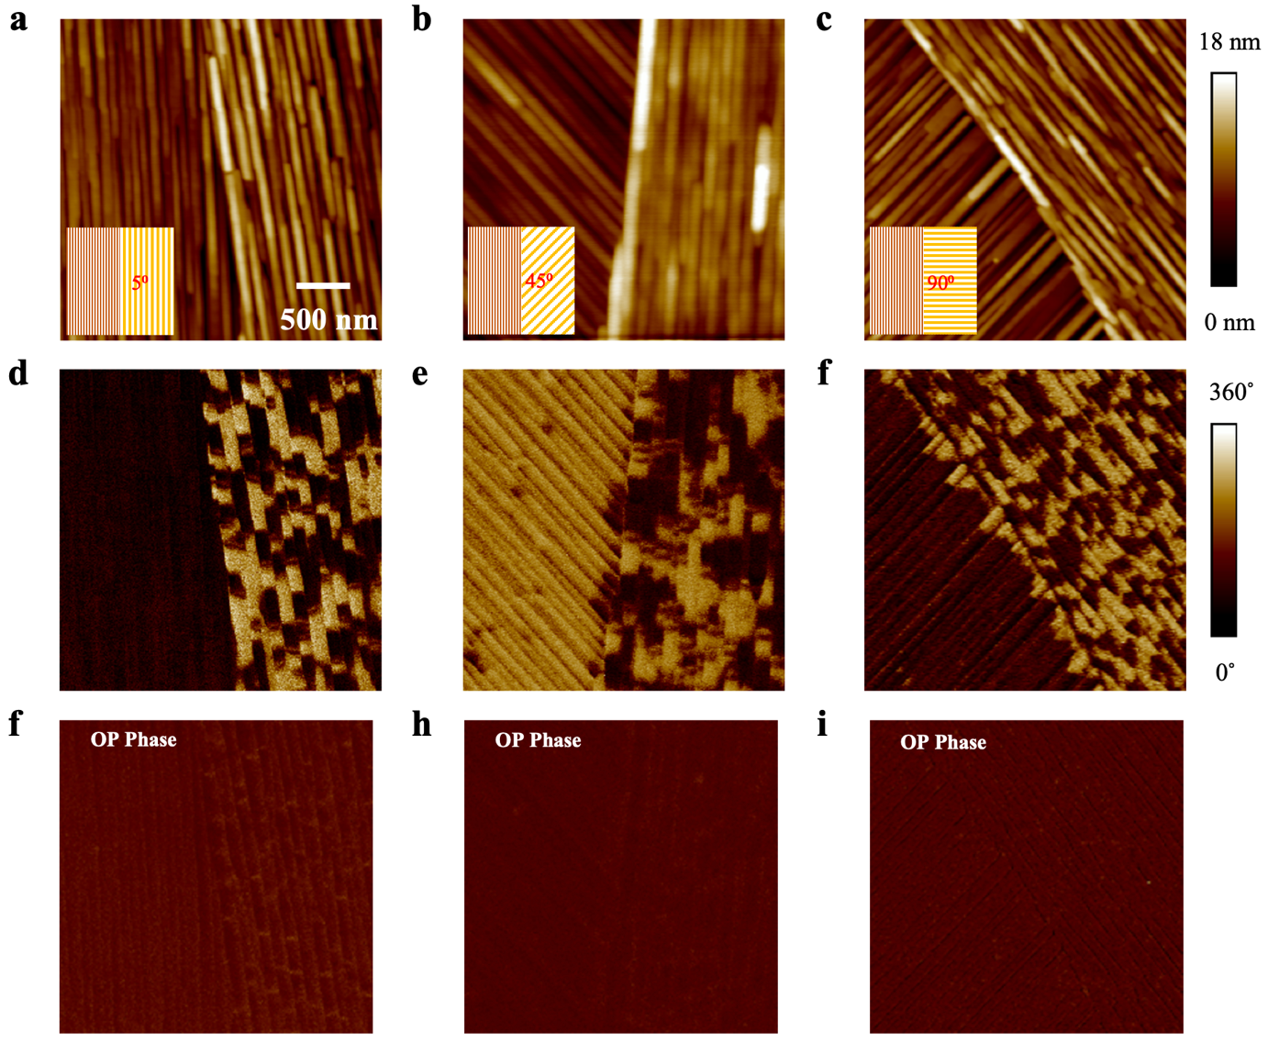
Fig. S2 | Topography and domain structures of lateral homostructures with different twisted angles. a, b and c Topography images of lateral homostructures with the twisted angles of 5˚, 45˚, and 90˚, respectively. d, e and f In-plane phase images for lateral homostructures with twisted angles of 5˚, 45˚, and 90˚, respectively. g, h and i Out-of-plane phase images for lateral homostructures with twisted angles of 5˚, 45˚, and 90˚, respectively.

Note S3. Conjunction tunability
To demonstrate the versatile tunability based on our method, a similar approach has been adopted to fabricate (001)-oriented BFO grown on twist STO(001) template (Fig S3a, b, c). Besides, such an approach is also capable of producing lateral conjunctions with different out-of-plane crystalline directions (Fig. S3d, e, f). Here, freestanding (110) STO was transferred onto (100) STO substrate, followed by the deposition of BFO thin films. As shown in Fig. S3d, e, f, the twist angles could be easily identified via the surface topography, given that the stripes on the surface are correlated to specific crystalline directions. These results indicate that such an approach offers a universal template to the synthesis of lateral homostructures and homojunctions.
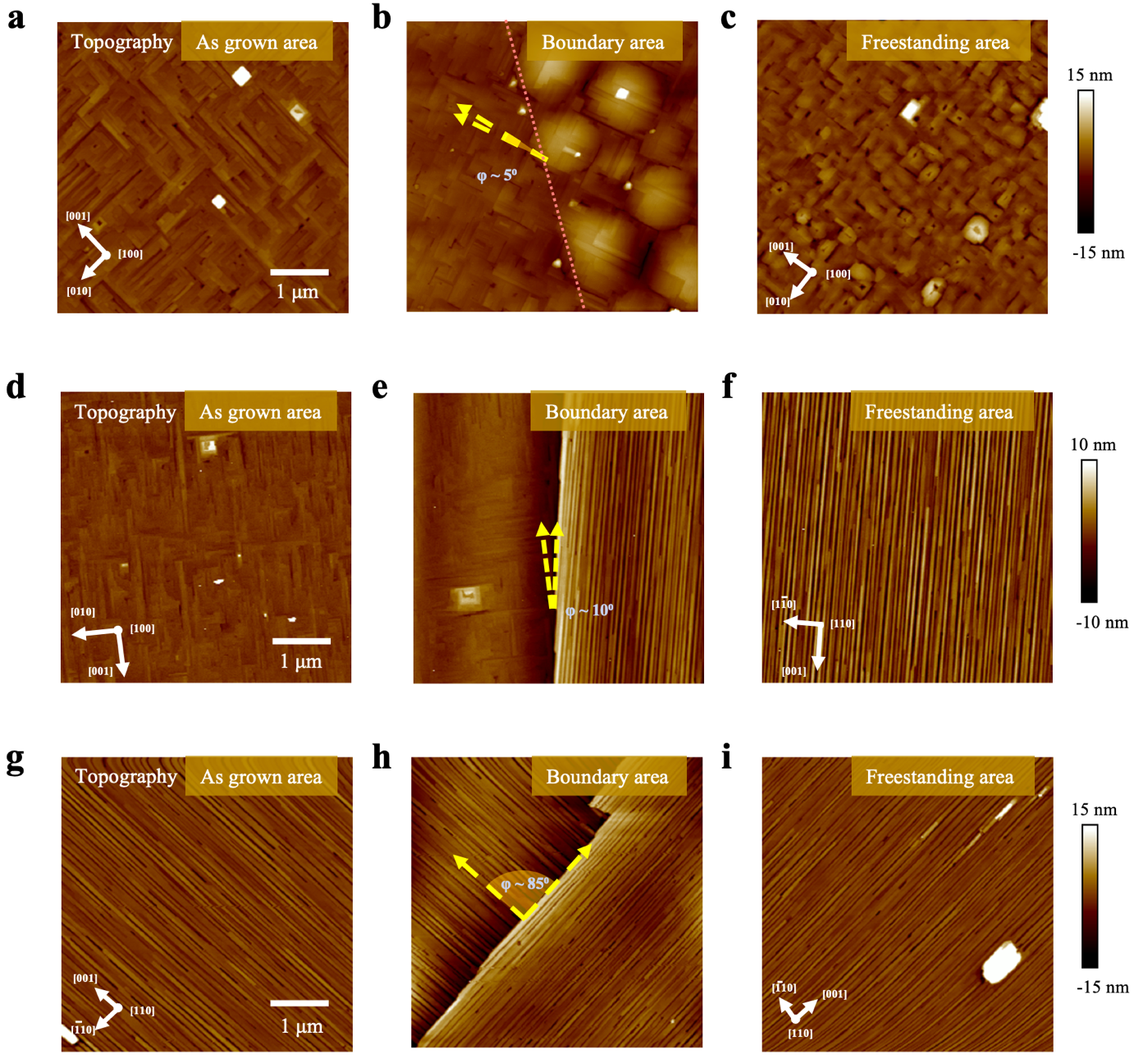
Fig. S3 | BFO lateral homostructures with conjunction diversity along the out-of-plane. a, b and c BFO on (100) STO substrate and (100) FS-STO. d, e and f BFO on (100) STO substrate and (110) FS-STO. g, h and i BFO on (110) STO substrate and (110) FS-STO.

