Supplementary Information for

No or diffuse phase-transition with temperature in one-dimensional Ising model?
Li Zhang^{1,2}, Li-Li Zhang¹, and Yi-Neng Huang^{1,2*}
¹National Laboratory of Solid State Microstructures, School of Physics, Nanjing University, China.
²Xinjiang Laboratory of Phase Transitions and Microstructures in Condensed Matters, College of Physical Science and Technology, Yili Normal University, China.
*Corresponding author. Email: ynhuang@nju.edu.cn

Calculation of global-spontaneous-magnetization in 1D-IM
At present, the method to calculate the global-spontaneous-magnetization of Ising model ^{2, 23} is as follows: (i) Applying a static external field ($B$) to the model system; (ii) Constructing the spin orientation ensemble corresponding to the model; (iii) Calculating the global magnetization of the ensemble based on Boltzmann principle; (iv) Let $B→0$, and the obtained magnetization is the global-spontaneous-magnetization of the system.

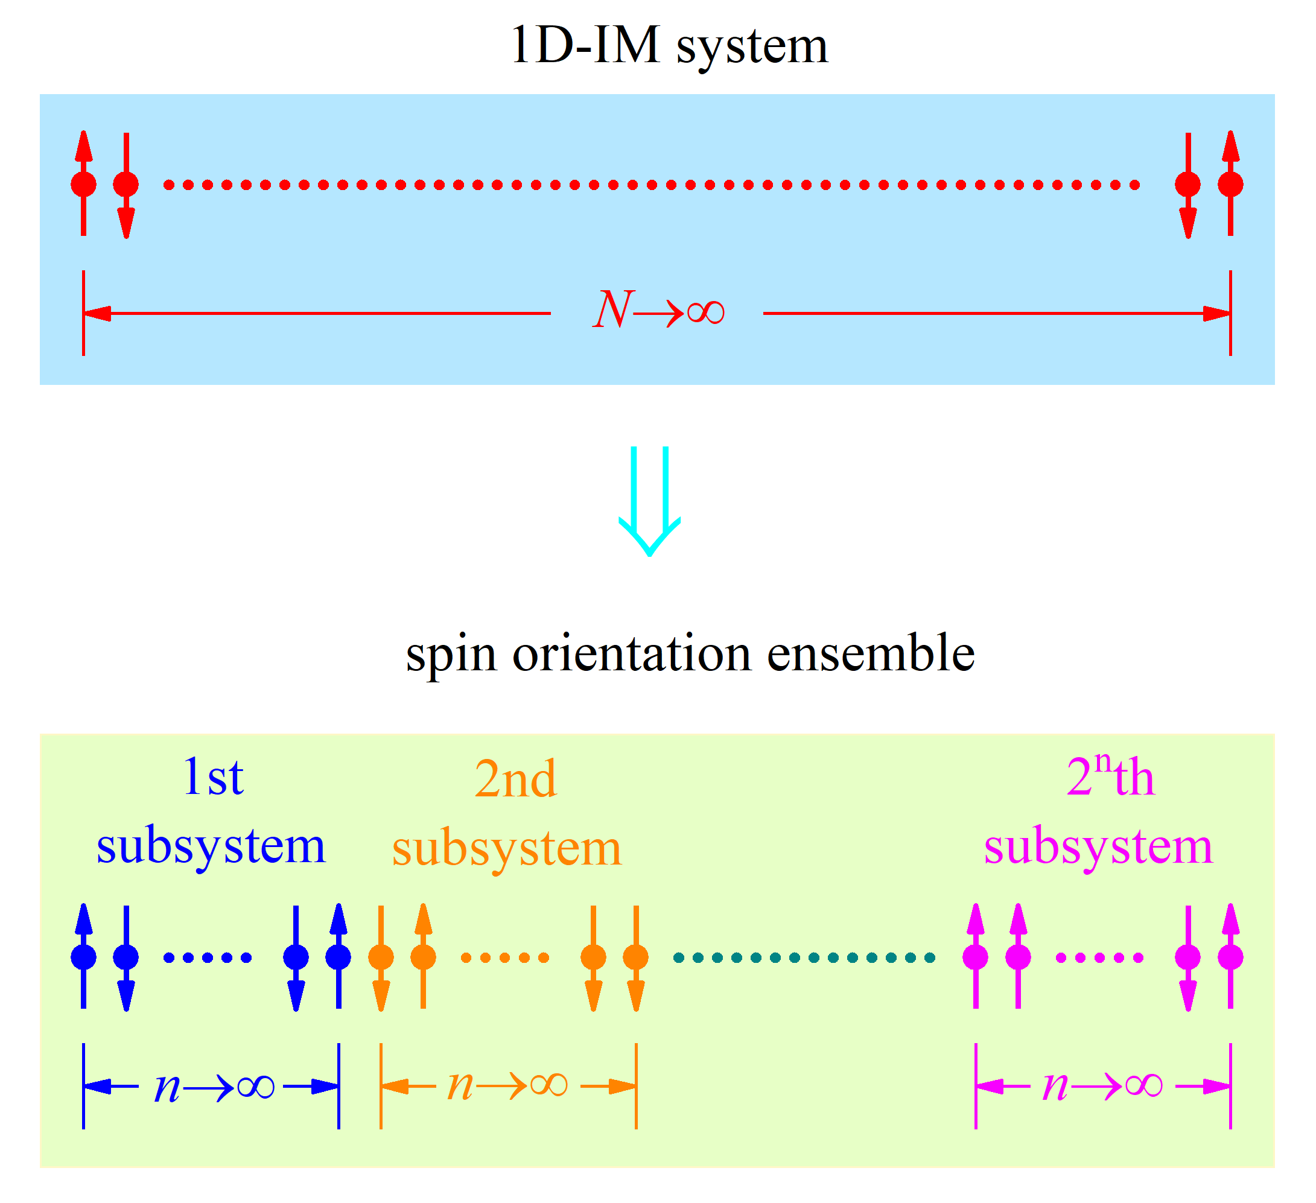
Fig. S1. Diagrammatic sketch of ID-IM system and construction of corresponding spin orientation ensemble.

According to this method, the Hamiltonian ($H_{1D-IM}^{B}$) of 1D-IM with $B$ is,
$$H_{1D-IM}^{B}=\lim_{N→∞}\left[-J\sum_{i=1}^{N-1}{σ_{i}σ_{i+1}}-μB\sum_{i=1}^{N}{σ_{i}}\right] (S1)$$
where $σ_{i}$ is the ith spin and $σ_{i}=±1$, $J$ the interaction energy constant between nearest-neighbor spins, $μ$ the magnetic moment of a spin, and $N$ the number of spins in the model system.
The spin orientation ensemble corresponding to 1D-IM is constructed as shown in Fig. S1, i.e. the whole chain of $N→∞$ spins is divided into $2^{n}$ sub-chains (subsystems) of $n→∞$ spins with different spin orientation configurations.
The Hamiltonian ($H_{n}^{B}$) of the subsystem with $B$ (the endpoint effect of the subsystems can be ignored for $n→∞$) is,
$$H_{n}^{B}=-J\sum_{i=1}^{n-1}{σ_{i}σ_{i+1}}-μB\sum_{i=1}^{n}{σ_{i}} (S2)$$
and based on Boltzmann principle, the partition function ($Z_{n}^{B}$) of the ensemble is,
$$Z_{n}^{B}≡\sum_{σ_{i}=±1,⋯σ_{n}=±1}{exp\left[v\sum_{i=1}^{n-1}{σ_{i}σ_{i+1}}+w\sum_{i=1}^{n}{σ_{i}}\right]} (S3)$$
here $v≡\frac{J}{k_{B}T}$, $w≡\frac{μB}{k_{B}T}$, $T$ is temperature, and $k_{B}$ Boltzmann constant.
From Eq. S3, the global magnetization ($m_{B}$) per spin in 1D-IM is,
$$m_{B}=\lim_{n→∞}\left[\frac{μ}{nZ_{n}}\frac{∂Z_{n}}{∂w}\right] (S4)$$
According to $exp\left(vσ_{i}σ_{i+1}\right)=cosh\left(v\right)\left(1+γσ_{i}σ_{i+1}\right)$ and $exp\left(wσ_{i}\right)=cosh\left(w\right)\left(1+ασ_{i}\right)$, we get,
$$Z_{n}^{B}=\cosh^{n-1}\left(v\right)\cosh^{n}\left(w\right)Q_{n}^{B} (S5)$$
in which $γ≡tanh\left(v\right)$, $α≡tanh\left(w\right)$, and,
$$Q_{n}^{B}≡\sum_{σ_{i}=±1,⋯σ_{n}=±1}{\prod_{i=1}^{n-1}{\left(1+γσ_{i}σ_{i+1}\right)}\prod_{i=1}^{n}{\left(1+ασ_{i}\right)}} (S6)$$
Defining,
$$Y_{n}^{B}≡\sum_{σ_{i}=±1,⋯σ_{n}=±1}{\prod_{i=1}^{n-1}{\left(1+γσ_{i}σ_{i+1}\right)}\prod_{j=1}^{n}{\left(1+ασ_{i}\right)σ_{n}}} (S7)$$
Obviously, $Q_{1}^{B}=2$ and $Y_{1}^{B}=2$.
From $\sum_{σ_{n}=±1}{\left(1+γσ_{n-1}σ_{n}\right)}\left(1+σ_{n}\right)=2\left(1+γσ_{n-1}\right)$ and $\sum_{σ_{n}=±1}{\left(1+γσ_{n-1}σ_{n}\right)}\left(1+σ_{n}\right)σ_{n}=2\left(+γσ_{n-1}\right)$, we obtain,
$$\left[\begin{matrix}Q_{n}^{B} \\ Y_{n}^{B}\end{matrix}\right]=2\left[\begin{matrix}1 & γ \\ & γ\end{matrix}\right]\left[\begin{matrix}Q_{n-1}^{B} \\ Y_{n-1}^{B}\end{matrix}\right] (S8)$$
and,
$$\left[\begin{matrix}Q_{n}^{B} \\ Y_{n}^{B}\end{matrix}\right]=2^{n-1}{\left[\begin{matrix}1 & γ \\ & γ\end{matrix}\right]}^{n-1}\left[\begin{matrix}Q_{1}^{B} \\ Y_{1}^{B}\end{matrix}\right]=2^{n}{\left[\begin{matrix}1 & γ \\ & γ\end{matrix}\right]}^{n-1}\left[\begin{matrix}1 \\ α\end{matrix}\right] (S9)$$
The eigenvalues of the square matrix $\left[\begin{matrix}1 & γ \\ & γ\end{matrix}\right]$ is determined by the following characteristic equation,
$$\left|\begin{matrix}1-{}_{B} & γ \\ & γ-{}_{B}\end{matrix}\right|=0 (S10)$$
resulting in,
$${}_{B}=\frac{1+γ±\sqrt{{\left(1-γ\right)}^{2}+4γ{}^{2}}}{2} \left(S11\right)$$
i.e. the two values (${}_{B}^{1}$ and ${}_{B}^{2}$) of ${}_{B}$ are, respectively,
$$\begin{matrix}{}_{B}^{1}=\frac{1+γ+\sqrt{{\left(1-γ\right)}^{2}+4γ{}^{2}}}{2} \\ {}_{B}^{2}=\frac{1+γ-\sqrt{{\left(1-γ\right)}^{2}+4γ{}^{2}}}{2}\end{matrix} (S12)$$
From Eq. S9 and S12, we get,
$$\left[\begin{matrix}Q_{n}^{B} \\ Y_{n}^{B}\end{matrix}\right]=2^{n}\left[\begin{matrix}U_{11} & U_{12} \\ U_{21} & U_{22}\end{matrix}\right]\left[\begin{matrix}{\left({}_{B}^{1}\right)}^{n-1} & 0 \\ 0 & {\left({}_{B}^{2}\right)}^{n-1}\end{matrix}\right]\left[\begin{matrix}V_{11} & V_{12} \\ V_{21} & V_{22}\end{matrix}\right]\left[\begin{matrix}1 \\ α\end{matrix}\right] (S13)$$
where $\left[\begin{matrix}V_{11} \\ V_{21}\end{matrix}\right]$ and $\left[\begin{matrix}V_{12} \\ V_{22}\end{matrix}\right]$ are the eigenvectors corresponding to ${}_{B}^{1}$ and ${}_{B}^{2}$, and $\left[\begin{matrix}U_{11} & U_{12} \\ U_{21} & U_{22}\end{matrix}\right]≡{\left[\begin{matrix}V_{11} & V_{12} \\ V_{21} & V_{22}\end{matrix}\right]}^{-1}$.
Therefore,
$$\begin{matrix}\lim_{n→∞}\left[\begin{matrix}Q_{n}^{B} \\ Y_{n}^{B}\end{matrix}\right]=2^{n}{\left({}_{B}^{1}\right)}^{n}\left[\begin{matrix}U_{11} & U_{12} \\ U_{21} & U_{22}\end{matrix}\right]\left[\begin{matrix}1 & 0 \\ 0 & 0\end{matrix}\right]\left[\begin{matrix}V_{11} & V_{12} \\ V_{21} & V_{22}\end{matrix}\right]\left[\begin{matrix}1 \\ α\end{matrix}\right] \\ =2^{n}{\left({}_{B}^{1}\right)}^{n}\left[\begin{matrix}V_{11}U_{11}+V_{12}U_{11}α \\ V_{11}U_{21}+V_{12}U_{21}α\end{matrix}\right]\end{matrix} (S14)$$
Based on Eq. S4, S12 and S14, we obtain,
$$m_{B}=\frac{μsinh\left(w\right)}{{\left[\sinh^{2}\left(w\right)+exp\left(-4v\right)\right]}^{1/2}} (S15)$$
According to this equation, it is easy to find $m_{B→0}→0$ for nonzero temperature. $m_{B}$ vs $B$ at series $T$ is shown in Fig. S2.

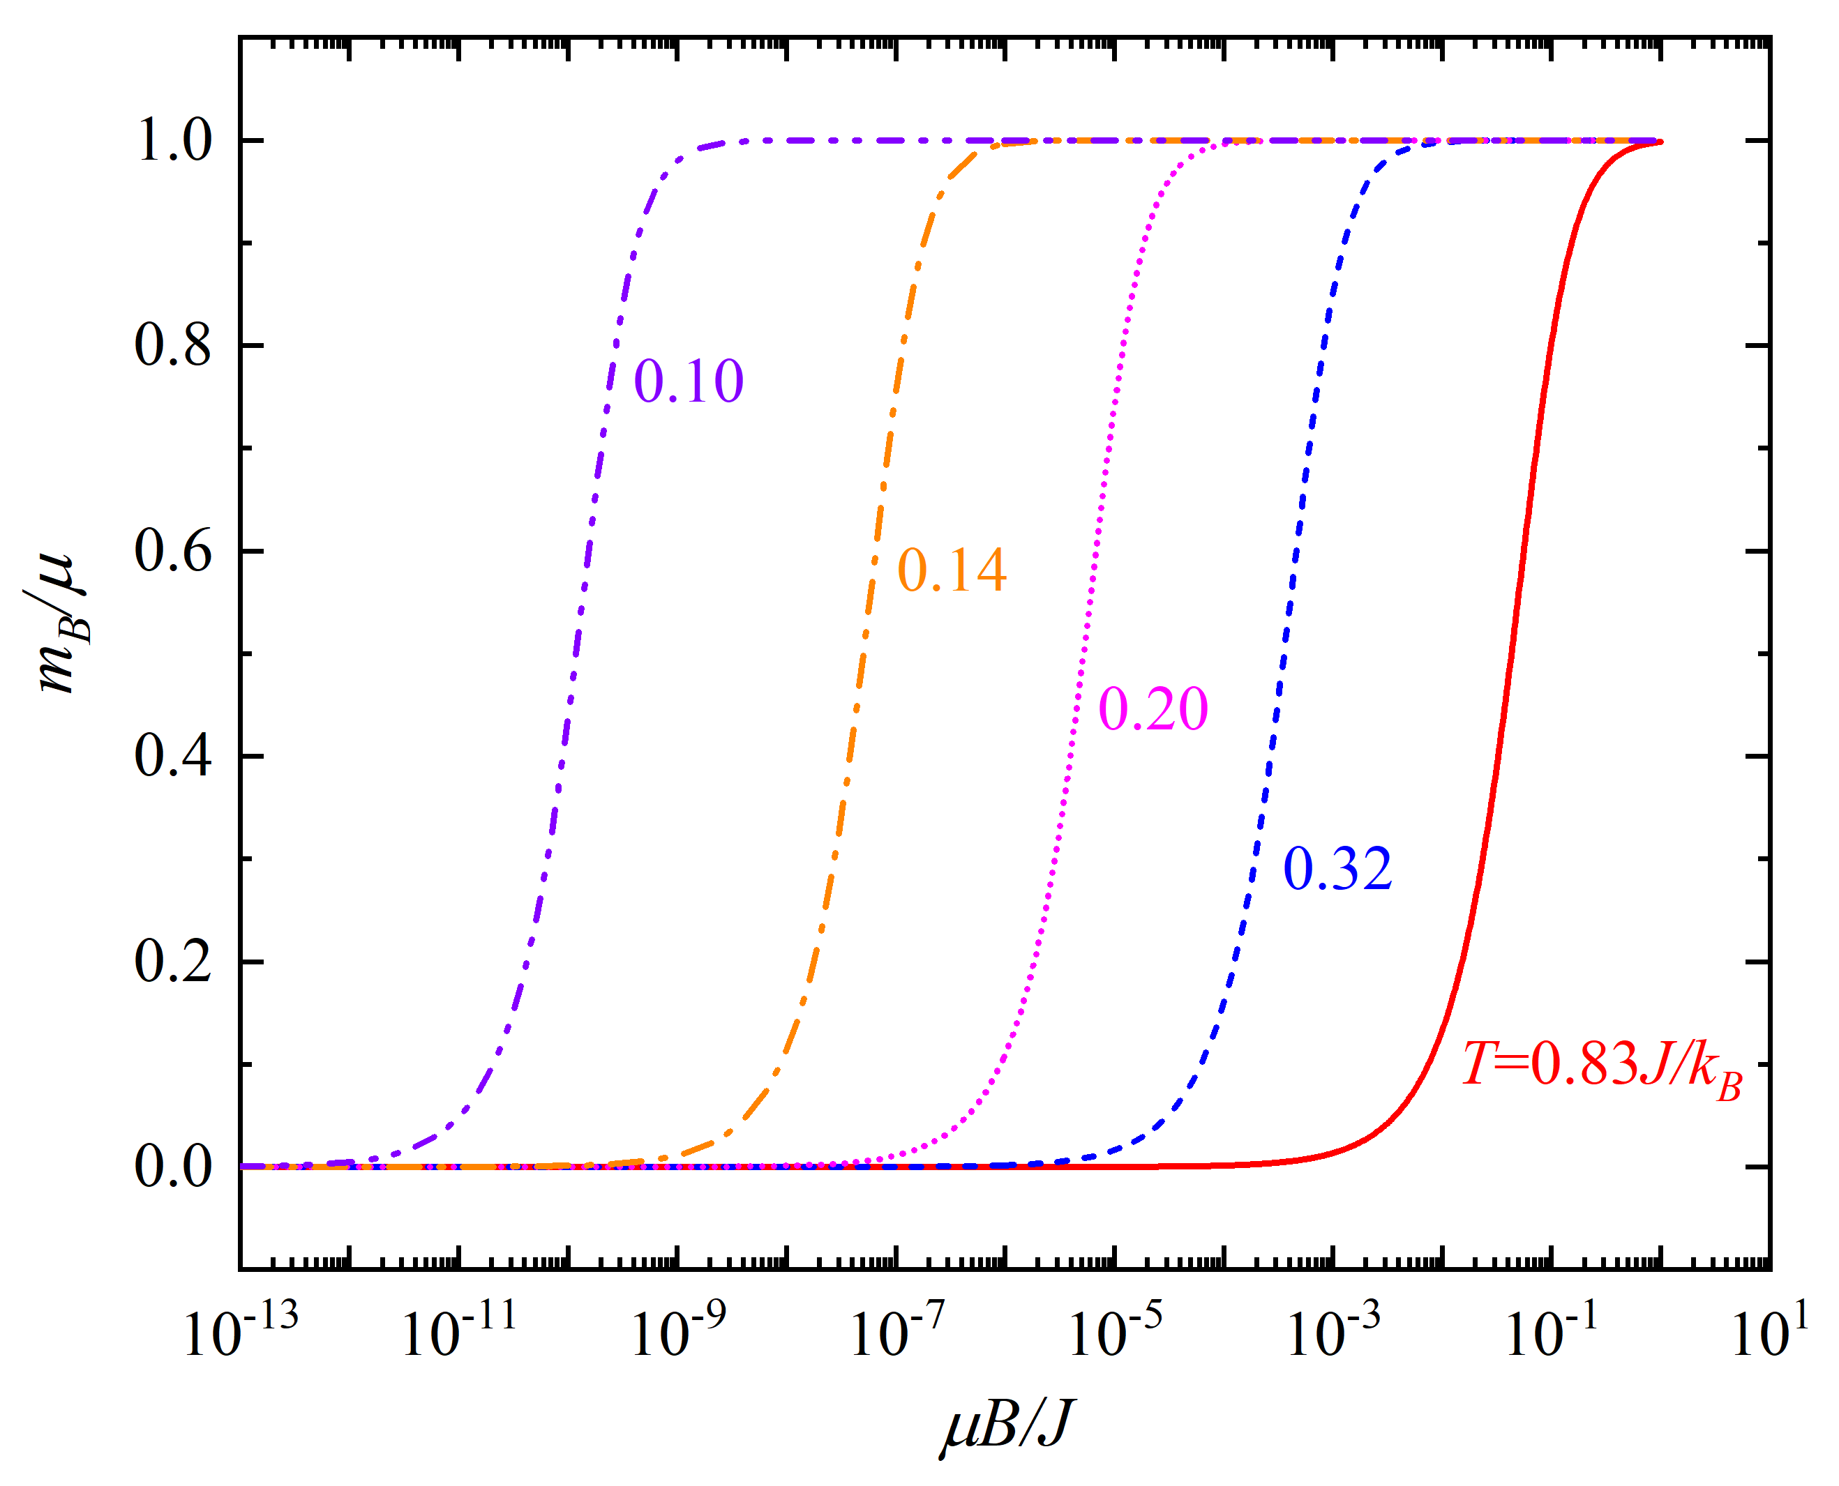

Fig. S2. Global Magnetization ($m_{B}$) per spin in 1D-IM vs external magnetic field ($B$) at series temperature ($T$).

When $B$ is present, the susceptibility (${}_{s}^{B}$) per spin in 1D-IM is,
$${}_{s}^{B}≡\frac{∂m_{B}}{∂B} (S16)$$
From Eq. S15 and S16, we get,
$$\begin{matrix}{}_{s}^{B}=\frac{μ^{2}}{J}\frac{1}{t}\frac{cosh\left(\frac{b}{t}\right)exp\left(-\frac{4}{t}\right)}{{\left[\sinh^{2}\left(\frac{b}{t}\right)+exp\left(-\frac{4}{t}\right)\right]}^{3/2}} \\ \end{matrix} (S17)$$
here $t≡\frac{k_{B}T}{J}$ is reduced temperature, and $b≡\frac{μB}{J}$ reduced magnetic field.
From Eq. S18 and S19, the average internal energy ($u$ ) per spin in 1D-IM is,
$$u=\lim_{n→∞}\left[-\frac{J}{nZ_{n}}\frac{∂Z_{n}}{∂v}\right]=-Jγ (S18)$$
and the average specific heat per spin ($c_{s}$) is,
$$\begin{matrix}c_{s}=\frac{∂u}{∂T} \\ \end{matrix}=\frac{k_{B}}{t^{2}}\left(1-γ^{2}\right) (S19)$$

