Supplementary Information

Precise crystal regulation and harvest by constructing confined flexible droplet crystallizer on 3D-printed sessile platform

Zhijie Yuan¹, Xiaobin Jiang¹*, Yuchao Niu¹, Mengyuan Wu¹, Yingshuang Meng¹, Zhengtao Li¹, Xuehua Ruan², Xiangcun Li¹, Wu Xiao¹, Xuemei Wu¹ and Gaohong He^{1,2}*

¹ State Key Laboratory of Fine Chemicals, School of Chemical Engineering, Dalian University of Technology, Dalian, Liaoning, 116024, China
² School of Chemical Engineering at Panjin, Dalian University of Technology, Panjin 124221, China

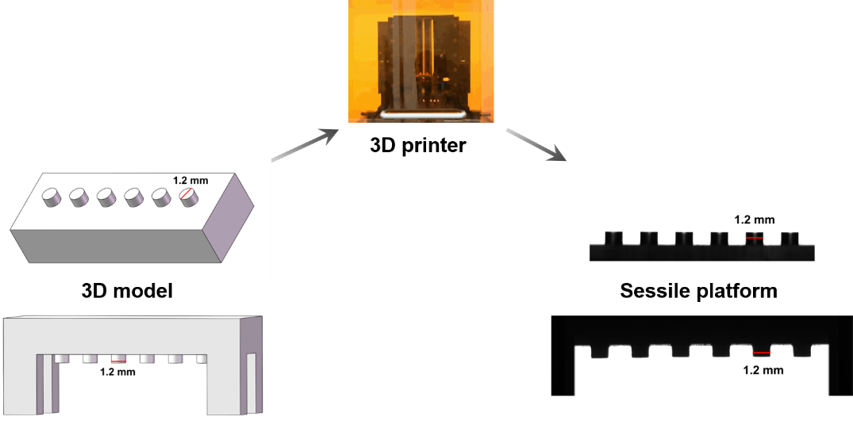
Supplementary Figure 1. Preparation of micro-chip with numerous of matrix-type and regular sessile platforms by high precise 3D printer.

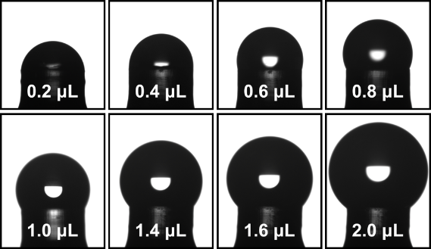
Supplementary Figure 2. The construction of confined flexible droplet crystallizer on sessile platform.

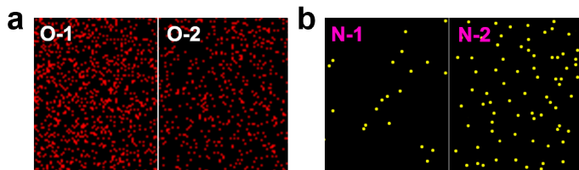
Supplementary Figure 3. The O elemental (a) and N elemental (b) maps of negative (O-1 and N-1) and neutral (O-2 and N-2) sessile platform surface.

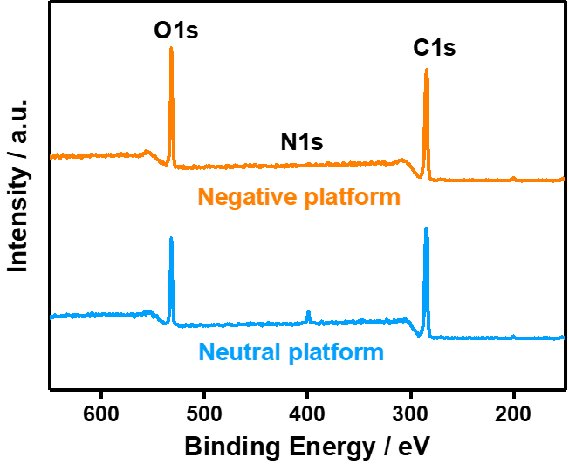
Supplementary Figure 4. The XPS spectra for C 1s, N 1s, and O 1s of negative and neutral sessile platform surfaces.

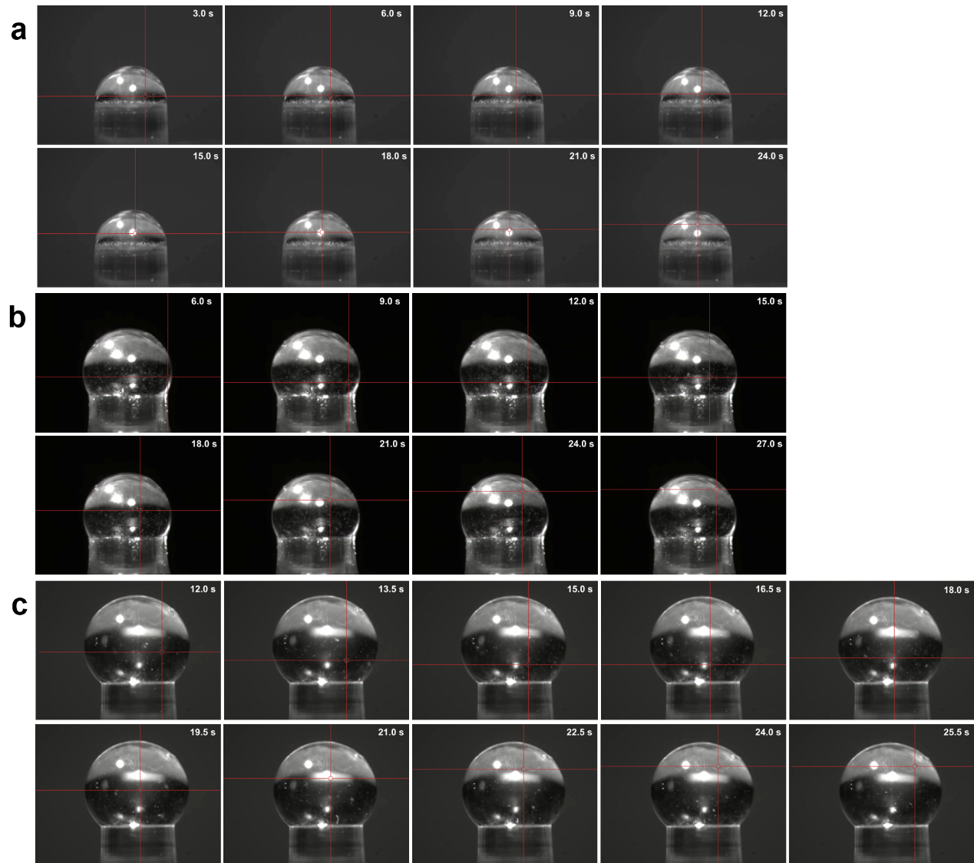
Supplementary Figure 5. The trajectories of particles inside CFDCs with initial contact angles of 90° (a), 120° (b), and 140° (c).

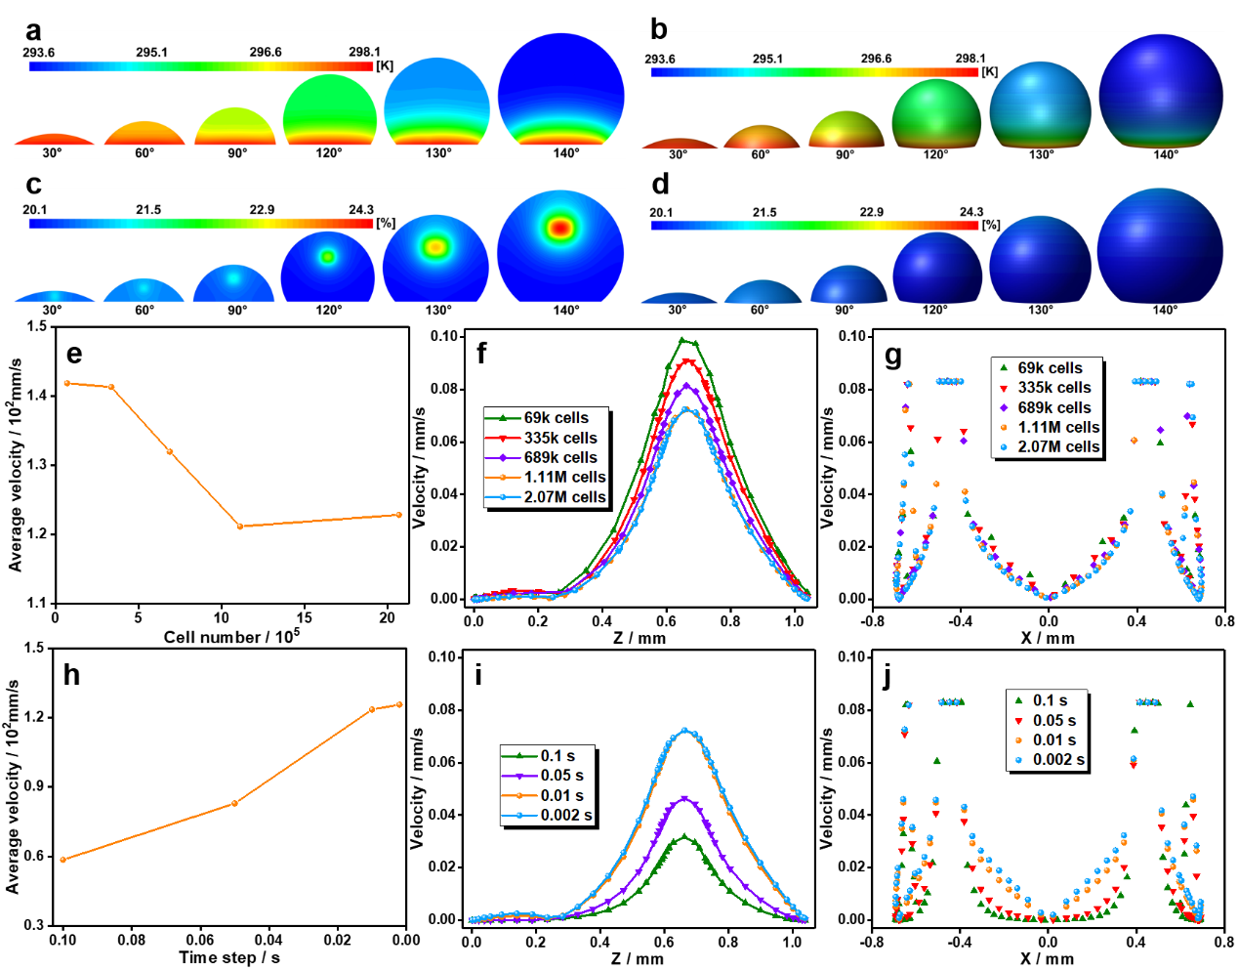
Supplementary Figure 6. The 2D (a) and 3D (b) temperature and the 2D (c) and 3D (d) concentration contours of CFDCs with initial contact angles of 30°, 60°, 90°, 120°, 130°, and 140°. The independence verifications of mesh (e-g) and step (h-j).

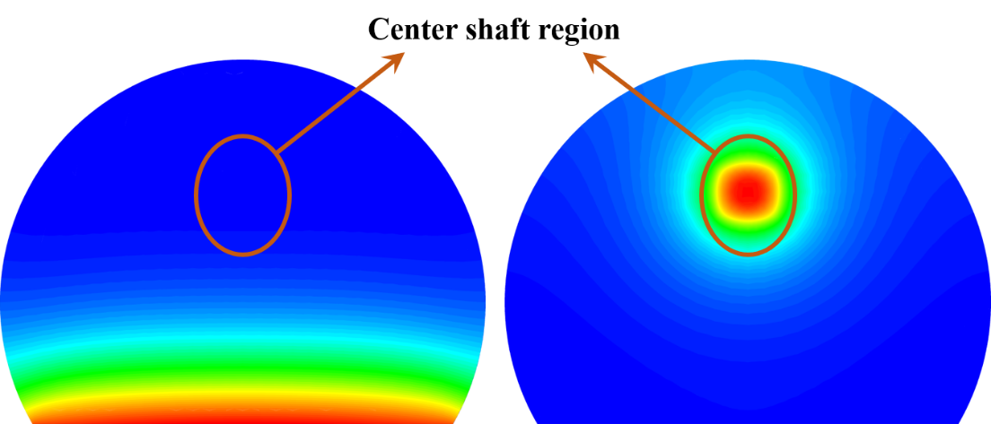
Supplementary Figure 7. Illustration of center shaft region with the lowest temperature and highest concentration inside CFDC.

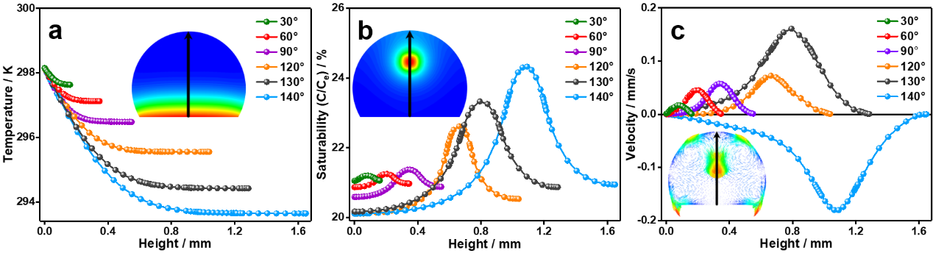
Supplementary Figure 8. The temperature (a), concentration (b), and velocity (c) distributions along the axes of CFDCs with initial contact angles of 30°, 60°, 90°, 120°, 130°, and 140°.

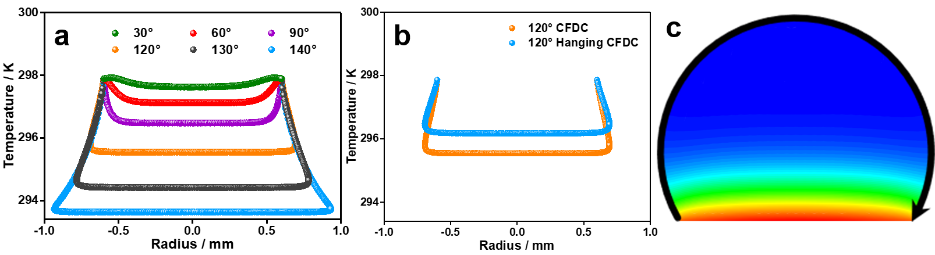
Supplementary Figure 9. The temperature distributions along the gas-liquid interface of CFDCs obtained by CFD simulations with initial contact angles of 30°, 60°, 90°, 120°, 130°, and 140° (a), the sitting and hanging 120° CFDCs (b), and the illustration of temperature distribution along the gas-liquid interface (c).

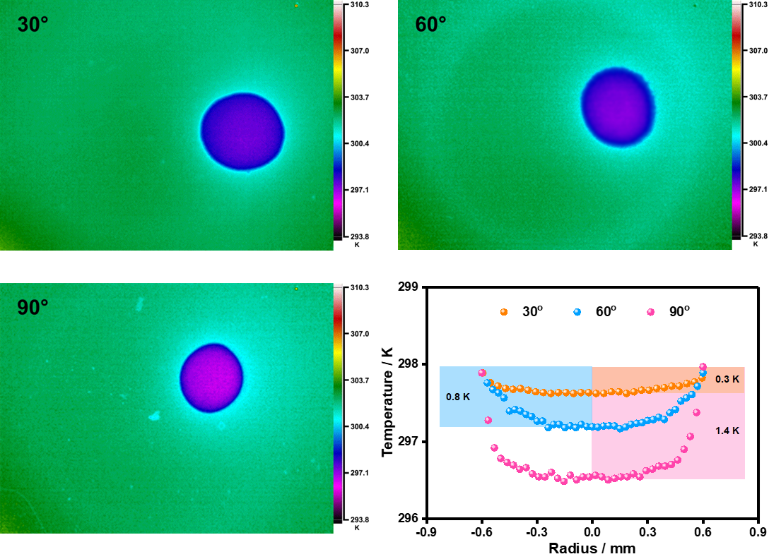
Supplementary Figure 10. The temperature contours of projections on the top and the temperature distributions along the gas-liquid interface of CFDCs obtained by infrared thermal imagers with initial contact angles of 30°, 60°, and 90°.

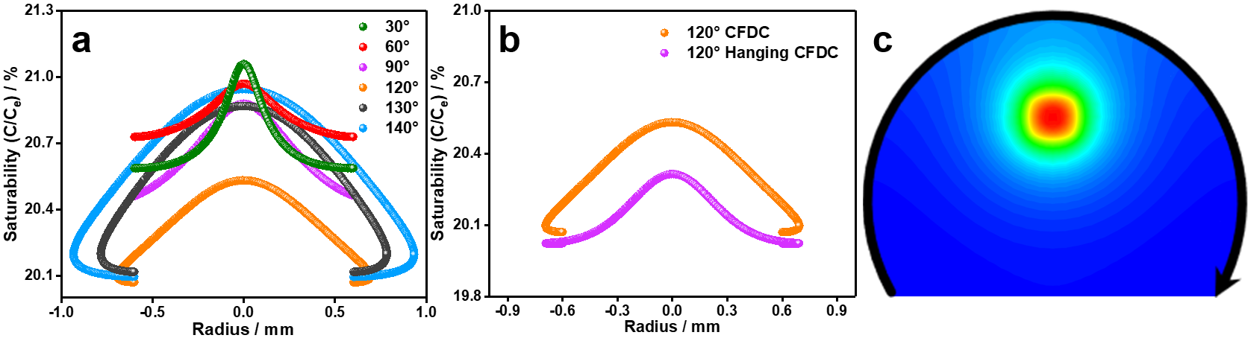
Supplementary Figure 11. The concentration distributions along the gas-liquid interface of CFDCs with initial contact angles of 30°, 60°, 90°, 120°, 130°, and 140° (a), the sitting and hanging 120° CFDCs (b), and the illustration of the concentration distribution along the gas-liquid interface (c).

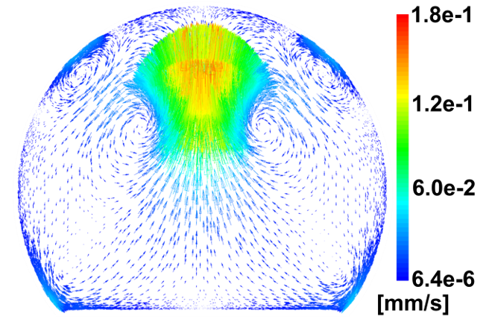
Supplementary Figure 12. The velocity vector projection on the cross-section plane of CFDC with initial contact angle of 130°.

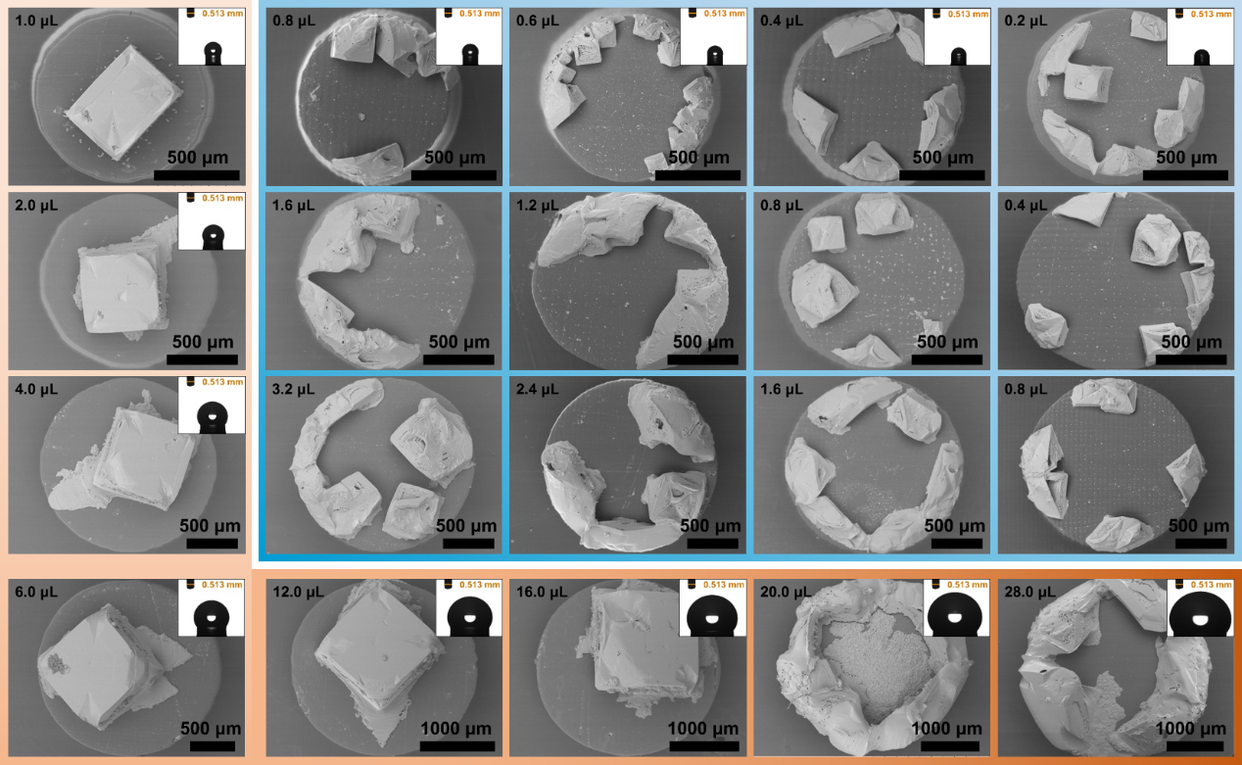
Supplementary Figure 13. The crystal morphologies and the corresponding CFDCs with the scale-up and stage-up.

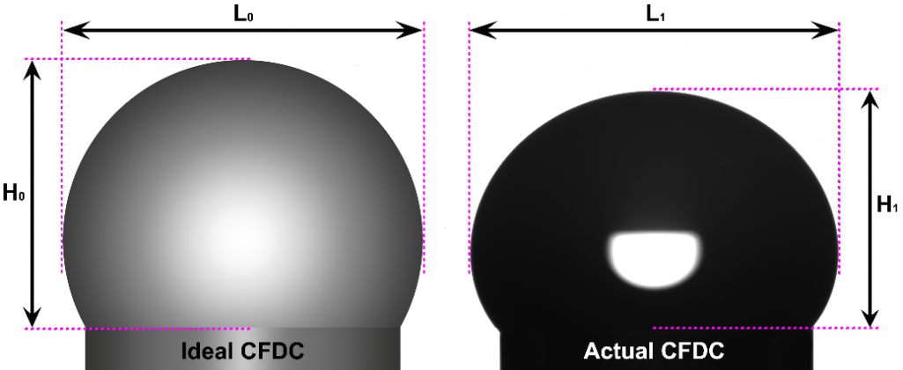
Supplementary Figure 14. Illustration of the aspect ratio for ideal and actual CFDCs.
The aspect ratio (H/L) was calculated by height (H) and wide (L) of CFDC, where the error of aspect ratio was defined as the absolute value of $(\frac{\frac{H_{1}}{L_{1}}}{\frac{H_{0}}{L_{0}}}-1)*100\%$.

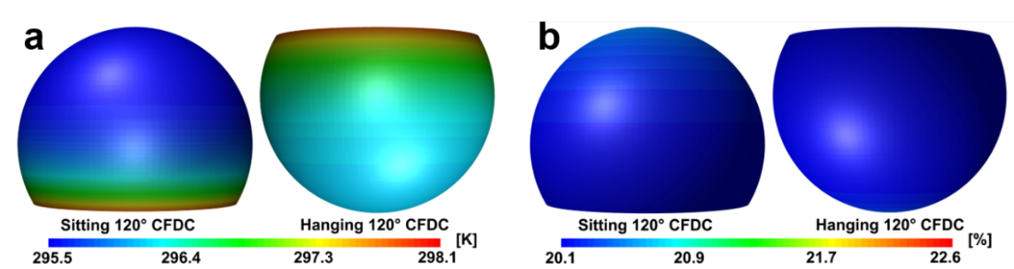Supplementary Figure 15. The 3D contours of temperature (a) and concentration (b) for the sitting and hanging CFDCs with initial contact angle 120°.

Supplementary Table 1. The Marangoni number (Ma) of the Marangoni flow inside CFDCs with initial contact angles of 30°, 60°, 90°, 120°, 130°, 140°, and the hanging CFDC (120°-H).
Initial contact angle / ° | 30 | 60 | 90 | 120 | 130 | 140 | 120-H
Ma | 154.1 | 452.4 | 828.1 | 1373.7 | 2036.0 | 2493.1 | 1003.9
The Ma was utilized to assess the Marangoni flow intensity inside the CFDCs. In general, the Ma can be calculated written as¹:
$$Ma=-\left(\frac{δγ}{δT}\right)∙\frac{R∙∆T}{μ∙α}$$
where R is the radius of the contact line of CFDC, γ is the surface tension, T is the temperature, ΔT is the temperature difference along the CFDC surface. μ is the viscosity, and the α is the thermal diffusivity.

Supplementary Table 2. The error of aspect ratio for the actual FCDCs compared with the ideal droplet (120°) with identical crystallization solution.
FCDCs | Ideal FCDC | Actual FCDCs
Volume / μL | - | 1 | 2 | 4 | 6 | 12 | 16 | 20 | 28
Aspect ratio | 0.75 | 0.766 | 0.78 | 0.763 | 0.719 | 0.699 | 0.694 | 0.67 | 0.643
Error / % | 0 | 2.16 | 4 | 1.78 | 4.14 | 6.8 | 7.41 | 10.72 | 14.11

1. Basu, N. & Mukherjee, R. Evaporative Drying of Sodium Chloride Solution Droplet on a Thermally Controlled Substrate. J. Phys. Chem. B 124, 1266–1274 (2020).

