Supporting Information

Enhanced Catalytic Activity in the Oxidative Synthesis of Benzoxazoles by Tuning Local Electronic structures in N-doped sp³@sp² Hybrid Nanocarbon

Qingqing Gu,^{a,#} Yanan Zhou,^{b,#} Rui Huang,^{c} Yangming Lin, ^{d} Chi Xu,^{a,b} Qian Jiang,ª Siglinda Perathoner,^{e} Gabriele Centi,^{e} Yuefeng Liu^{a,}*

ª Dalian National Laboratory for Clean Energy (DNL), Dalian Institute of Chemical Physics, Chinese Academy of Science, 457 Zhongshan Road, 116023 Dalian, China
^{b} School of Chemical Engineering, Sichuan University, 610065 Chengdu, China
^{c} Zhang Dayu School of Chemistry, Dalian University of Technology, 116024 Dalian, China
^{d} Shenyang National Laboratory for Materials Science, Institute of Metal Research, Chinese Academy of Sciences, 110016 Shenyang, China
^{e}Dept.s ChiBioFarAm and MIFT, University of Messina V.le F. Stagno D’Alcontres 31, 98166 Messina, Italy

# These authors contributed equally.
* Corresponding authors
E-mail: yuefeng.liu@dicp.ac.cn (Y. Liu)

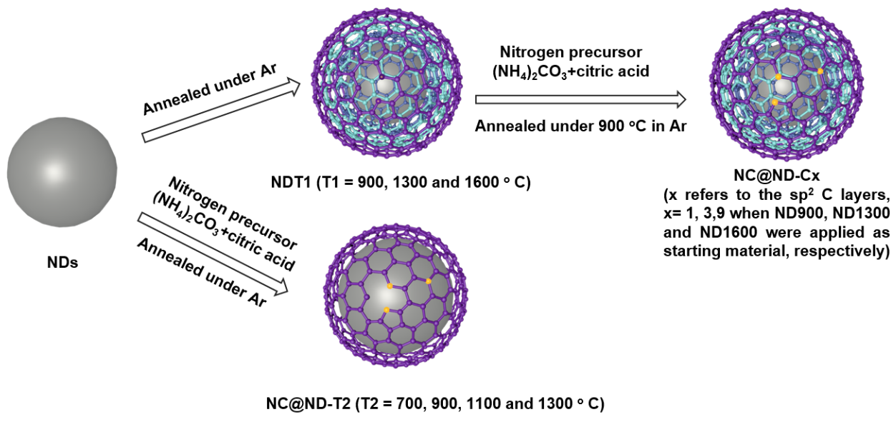
Figure S1. Schematic illustration of the synthesis of N-doped sp²@sp³ nanocarbons hybrids.

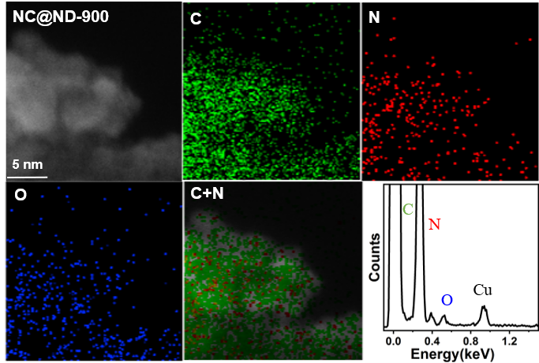

Figure S2. STEM-HAADF image of NC@ND-900 and corresponding EDS spectrum and elemental mapping of C, N and O.
Table S1 Optimization of the reaction temperature and time.
Entry | Catalyst | Temp.  (ºC) | Time  (h) | Con. A*  (%) | Sel. P*  (%) | Sel. I*  (%) | Yield P*  (%)
1 | / | 140 | 2 | 96.1 | 0 | 99.8 | 0
2 | NC@ND-900 | 140 | 2 | 100 | 27.7 | 70.9 | 27.7
3 | NC@ND-900 | 120 | 2 | 100 | 8.8 | 90.1 | 8.8
4 | NC@ND-900 | 100 | 2 | 100 | 3.5 | 95.6 | 3.5
5 | NC@ND-900 | 140 | 12 | 100 | 79.0 | 20.2 | 79.0
6 | NC@ND-900 | 140 | 28 | 100 | 97.4 | 0 | 97.4
7 | NC@ND-900 | 120 | 12 | 100 | 35.6 | 63.0 | 35.6
8 | NC@ND-900 | 100 | 12 | 100 | 16.9 | 82.3 | 16.9
Reaction Conditions: 2 mmol 2-aminophenol (A); 2.2 mmol benzaldehyde (B); 10 mL xylene; 120 mg catalyst; T= 140 ºC ; *GC analysis, nitrobenzene was used as internal standard;

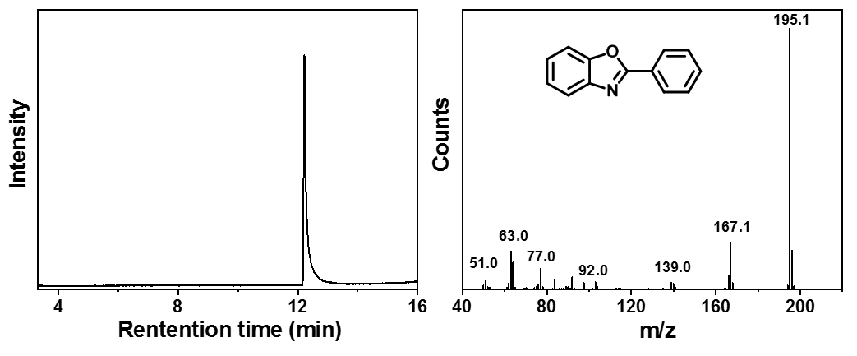
Figure S3. Product structure identification by GC-MS spectrum.

Table S2 Comparison between the catalytic activity of N-doped sp³@sp² hybrids and other reported catalysts in the synthesis of benzoazoles, benzothiazoles, and benzimidazoles
Entry | X | Catalysts | Oxidants | Additives | Temp ( ºC) | Time (h) | Yield (%) | Ref
1 | O | NC@ND-900 | O₂ | / | 140 | 30 | 97.4 | this work
2 | S | NC@ND-900 | O₂ | / | 140 | 100 | 74.8 | this work
3 | NH | NC@ND-900 | O₂ | / | 140 | 100 | 79.2 | this work
4 | O | / | 2,3-Dichloro-5,6-dicyano-1,4-benzoquinone | / | 45 | 12 | 93 | 1
5 | O | 2,6-di-tert-butyl-4-methylpyridine | thianthrene cation radical perchlorate | / | RT |  | 97 | 2
6 | NH | / | oxone | / | RT |  | 90 | 3
7 | NH | Ru(PPh₃)₃(CO)H₂/ Xantphos | / | p-TsOH/ piperidinium acetate | 111 | 8 | 98 | 4
8 | O | [Cp*IrI₂]₂ | / | crotononitrile | 111 | 24 | 100 | 4
9 | S | [Cp*IrI₂]₂ | / | crotononitrile | 111 | 24 | 68 | 4
10 | NH | CuCl/Bpy | air | TEMPO | r.t. | 12 | 95 | 5
11 | O | CuCl/Bpy | air | TEMPO | r.t. | 12 | 89 | 5
12 | S | CuCl/Bpy | air | TEMPO | r.t. | 13 | 93 | 5
13 | O | Au/TiO₂ | / | / | 111 | 24 | 90 | 6
14 | O | Polymer-Incarcerated Pt nanoclusters | O₂ | K₂CO₃ | 30 | 20 | 72 | 7
15 | S | Polymer-Incarcerated Pt nanoclusters | O₂ | K₂CO₃ | 30 | 20 | 83 | 7
16 | O | AgPd NPs/WO_{2.72} | HCOOH | / | 80 | 8 | 99 | 8
17 | O | N-hydroxyphthalimide | O₂ | / | 150 | 15 | 71 | 9
18 | O | 4-methoxy-TEMPO | O₂ | / | 120 | 15 | 96 | 9
19 | O | Darco KB | O₂ | / | 120 | 4 | 78 | 10
20 | O | MIL-101(Cr) | O₂ | / | 120 | 9 | 87 | 11
21 | NH | MIL-101(Cr) | O₂ | / | 55 | 2 | 94 | 11
22 | S | MIL-101(Cr) | O₂ | / | 60 | 2.5 | 87 | 11
23 | NH | SiO₂-OSO₃H | air | / | 80 | 0.5 | 92 | 12
24 | NH | Pt/TiO₂ | / | / | 165 | 24 | 94 | 13
25 | S | Pt/Al₂O₃ | / | / | 165 | 24 | 89 | 13
26 | O | molecular sieve | O₂ | / | 180 | 48 | 86 | 14
27 | O | Ru₂Cl₄(CO)₆/PFMN | / | DABCO | 120 | 24 | 72 | 15
28 | O | Fe₃O₄@SiO₂@PPh₂ | / | DABCO | 110 | 12 | 10 | 15
29 | NH | CoSO₄⋅7 H₂O | air | CF₃COOH | r.t./20 mA | 2.5 | 93 | 16
30 | S | CoSO₄⋅7 H₂O | air | CF₃COOH | r.t./20 mA | 2.5 | 86 | 16
31 | O | CoSO₄⋅7 H₂O | air | CF₃COOH | r.t./10 mA | 6 | 40 | 16
32 | O | copper ferrite NPs | / | / | 130 | 16 | 92 | 17
33 | S | AgPd NPs/WO_{2.72} | HCOOH | / | 80 | 8 | 87 | ¹⁸
34 | NH | AgPd NPs/WO_{2.72} | HCOOH | / | 80 | 8 | 83 | ¹⁸
35 | O | CuFe₂O₄ | O₂ | / | 110 |  | 92 | ¹⁹
36 | S | CuFe₂O₄ | O₂ | / | 110 |  | 93 | ¹⁹
37 | NH | CuFe₂O₄ | O₂ | / | 110 |  | 89 | ¹⁹

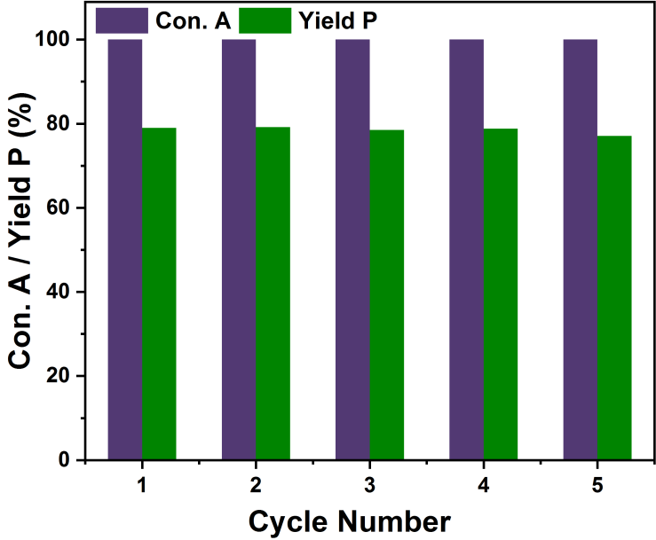
Figure S4. Plot of conversion of aminophenol and yield of 2-phenylbenzoxazole after five runs on NC@ND-900. Reaction conditions: 2 mmol 2-aminophenol; 2.2 mmol benzaldehyde; 10 mL xylene; 120 mg catalyst; T= 140 ºC; Time = 12 h

Table S3 The catalytic performance of NC@ND-900, purified and Fe loaded NC@ND-900.
Entry | Catalyst | Temp.  (ºC) | Time  (h) | Con.A*  (%) | Sel.P*  (%) | Sel.I*  (%) | Yie.P*  (%)
1 | NC@ND-900 | 140 | 2 | 100 | 27.7 | 70.9 | 27.7
2 | NC@ND-900-HCl | 140 | 2 | 100 | 26.5 | 72.3 | 26.5
3 | Fe/NC@ND-900 | 140 | 2 | 100 | 26.1 | 72.9 | 26.1
Reaction Conditions: 2 mmol 2-aminophenol; 2.2 mmol benzaldehyde; 10 mL xylene; 120 mg catalyst; T= 140 ºC.

Table S4 The ICP results of various samples.
Entry | Sample | Fe (wt.%) | Ca (wt.%) | Ba (wt.%) | Ni (wt.%)
1 | NDs | 0.37 | 0.02 | 0.35 | /
2 | ND-purified | 0.01 | 0.13 | / | /
3 | NC@ND-700 | 0.02 | 0.02 | / | /
4 | NC@ND-900 | 0.09 | 0.02 | / | /
5 | NC@ND-1100 | 0.04 | 0.01 | / | /
6 | NC@ND-1300 | 0.08 | 0.01 | / | /
7 | NC@ND-900-HCl | 0.09 | 0.03 | 0.02 | /
8 | Fe/NC@ND-900 | 0.42 | 0.02 | 0.02 | /
Measure conditions: 25 mg sample was mixed with 30 mL HNO₃ in 100 mL autoclave under 200 ºC for 2 days, and then was diluted with DI water to 50 mL.

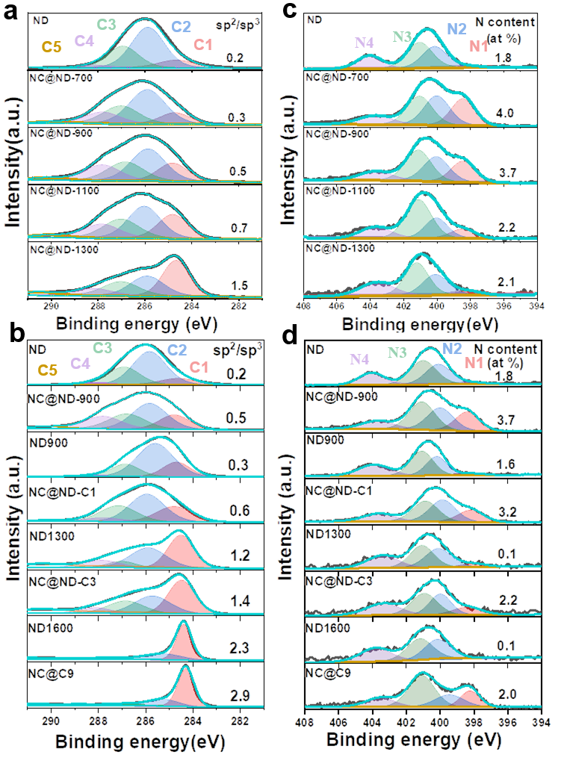
Figure S5. High resolution C1s (a, b) and N1s (c, d) XPS spectra of NDs and different N-doped sp³@sp² nanocarbon. C1: sp² C; C2: sp³ C; C3: C-O, C-N; C4: C=O; C5: O-C=O. N1: pyridinic N; N2: pyrrolic N; N3: graphitic N; N4: N oxide.

Table S5 Summary of XPS N1s data of various samples
Sample | N  (at%) | N1/N  (%) | N2/N  (%) | N3/N  (%) | N4/N  (%) | N1  (at%) | N2  (at%) | N3  (at%) | N4  (at%)
NDs | 1.8 | 2.7 | 33.8 | 41.9 | 21.7 | 0 | 0.6 | 0.8 | 0.4
NC@ND-700 | 4.0 | 25.8 | 31.0 | 30.4 | 12.8 | 1.0 | 1.24 | 1.2 | 0.5
NC@ND-900 | 3.7 | 22.5 | 28.5 | 35.5 | 13.4 | 0.8 | 1.1 | 1.3 | 0.5
NC@ND-1100 | 2.2 | 10.8 | 22.4 | 48.9 | 18.0 | 0.2 | 0.5 | 1.1 | 0.4
NC@ND-1300 | 2.1 | 5.4 | 28.0 | 41.1 | 25.5 | 0.1 | 0.6 | 0.9 | 0.5
ND900 | 1.6 | 3.9 | 29.0 | 40.9 | 26.3 | 0.1 | 0.5 | 0.7 | 0.4
NC@ND-C1 | 3.2 | 20.6 | 33.2 | 32.2 | 14.0 | 0.7 | 1.1 | 1.0 | 0.4
ND1300 | 0.1 | 5.6 | 32.3 | 35.5 | 26.7 | 0.01 | 0.01 | 0.04 | 0.03
NC@ND-C3 | 2.2 | 17.9 | 26.0 | 32.9 | 23.2 | 0.4 | 0.6 | 0.7 | 0.5
ND1600 | 0.1 | 0 | 37.3 | 29.0 | 33.7 | 0 | 0.04 | 0.03 | 0.03
NC@ND-C9 | 2.0 | 17.5 | 20.2 | 47.2 | 15.2 | 0.4 | 0.4 | 0.9 | 0.3

Table S6 Summary of XPS C1s data of various samples
Sample | C  (at%) | N  (at%) | O  (at%) | sp²/sp³ | sp² carbon  fraction (%)
ND | 87.6 | 1.8 | 10.5 | 0.2 | 16.7
NC@ND-700 | 89.9 | 4.0 | 6.1 | 0.3 | 23.1
NC@ND-900 | 92.3 | 3.7 | 4.0 | 0.5 | 33.3
NC@ND-1100 | 93.0 | 2.2 | 4.8 | 0.7 | 41.2
NC@ND-1300 | 93.7 | 2.1 | 4.2 | 1.5 | 60
ND900 | 95.4 | 1.6 | 3.0 | 0.3 | 23.1
NC@ND-C1 | 93.3 | 3.2 | 3.5 | 0.6 | 37.5
ND1300 | 98.9 | 0.1 | 1.0 | 1.2 | 54.5
NC@ND-C3 | 96.5 | 2.2 | 1.3 | 1.8 | 65.5
ND1600 | 98.8 | 0.1 | 1.1 | 2.9 | 74.5
NC@ND-C9 | 96.9 | 2.0 | 1.1 | 3.8 | 79.2

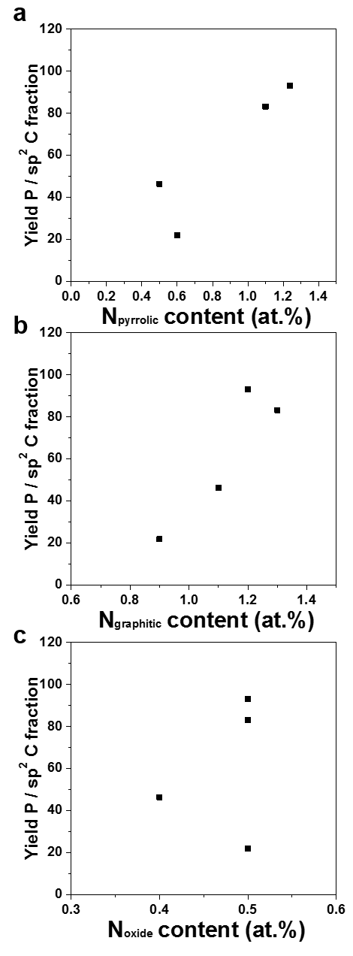
Figure S6. Relationships between pyrrolic N (a), graphitic N (b) and N oxide(c) content and yield of 2-phenylbenzoxazole normalized by sp² carbon fraction.

Table S7 Summary of Raman peaks assignments.
Position | Assignment
1324 cm⁻¹ | Diamond peak
1400 cm⁻¹ | Disorder-induced D band
1590 cm⁻¹ | G band
1640 cm⁻¹ | O-H bending vibrations

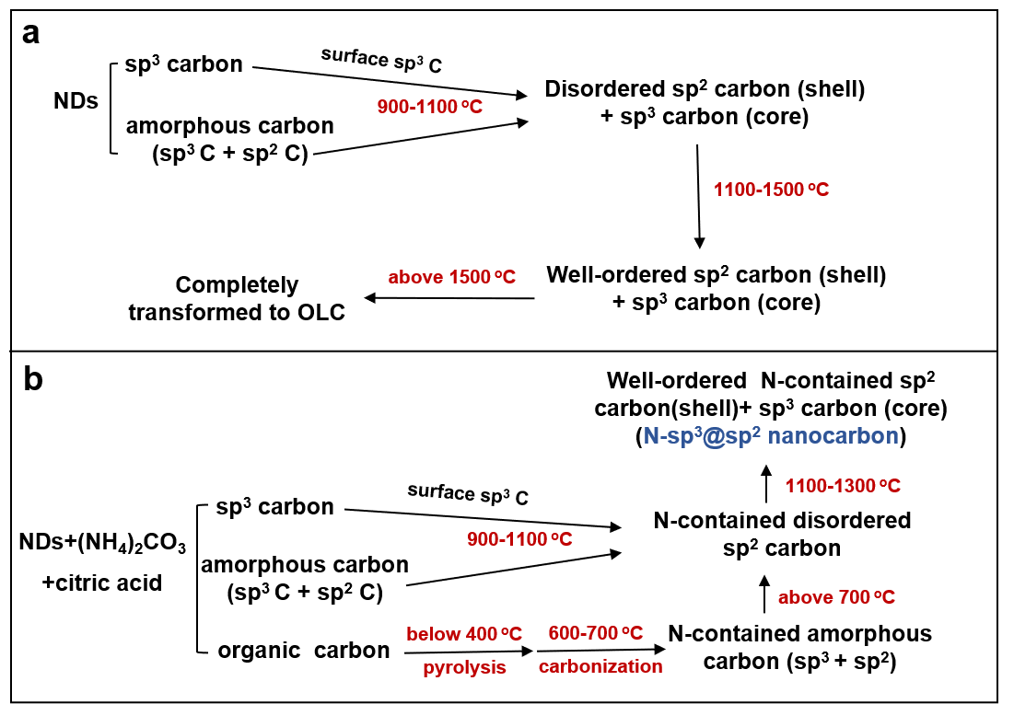
Figure S7. The proposed structure evolution process of (a) NDs and (b)N-sp³@sp² nanocarbon.

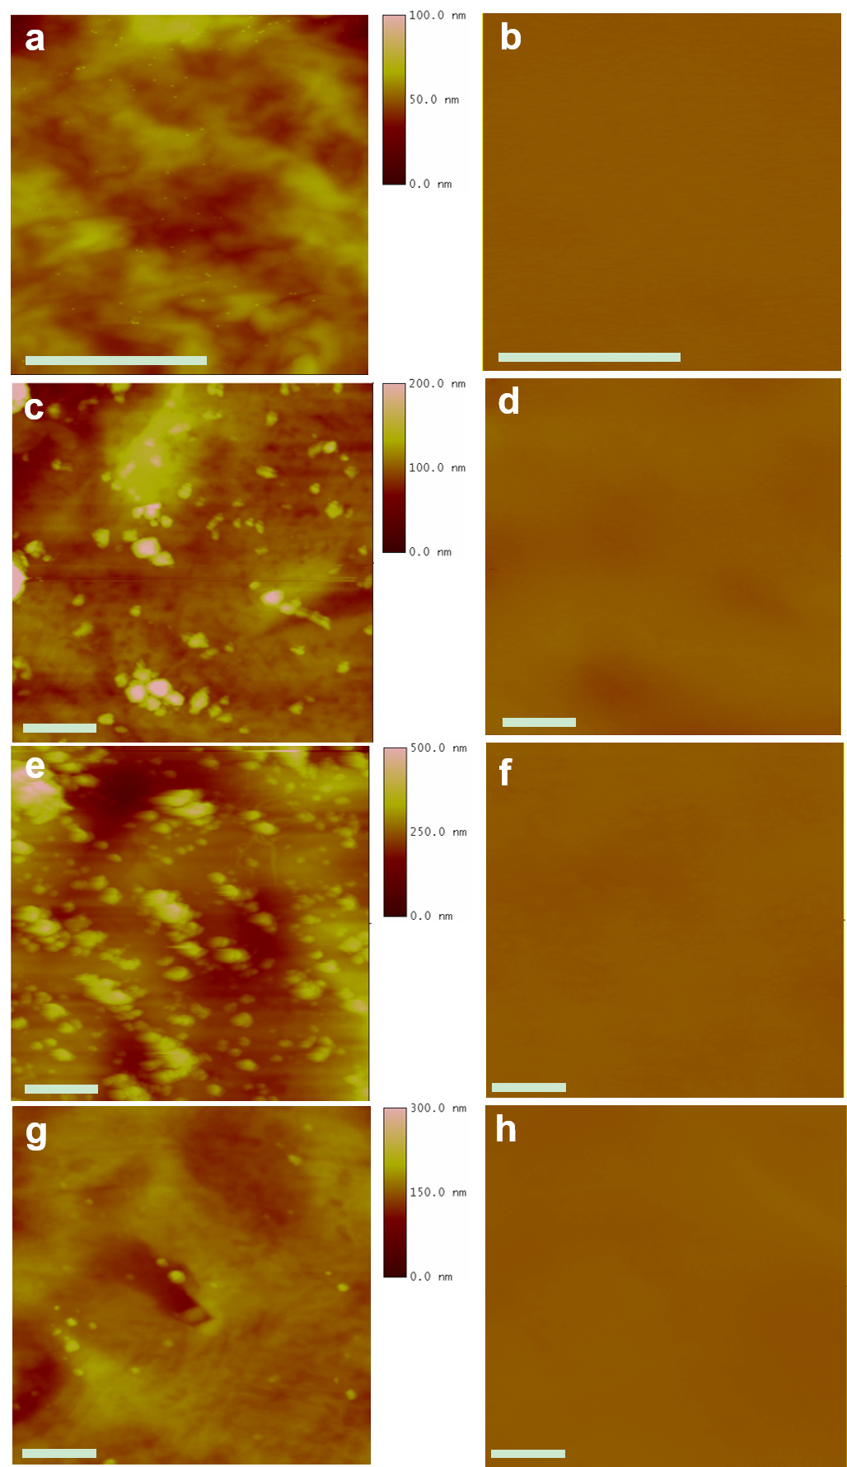
Figure S8. Topography and CPD images of the NC@ND-900 (a, b), NC@ND-C₁ (c, d), NC@ND-C3 (e, f) and NC@C9 (g, h). The scale bar at the bottom left of the figures is 1μm.
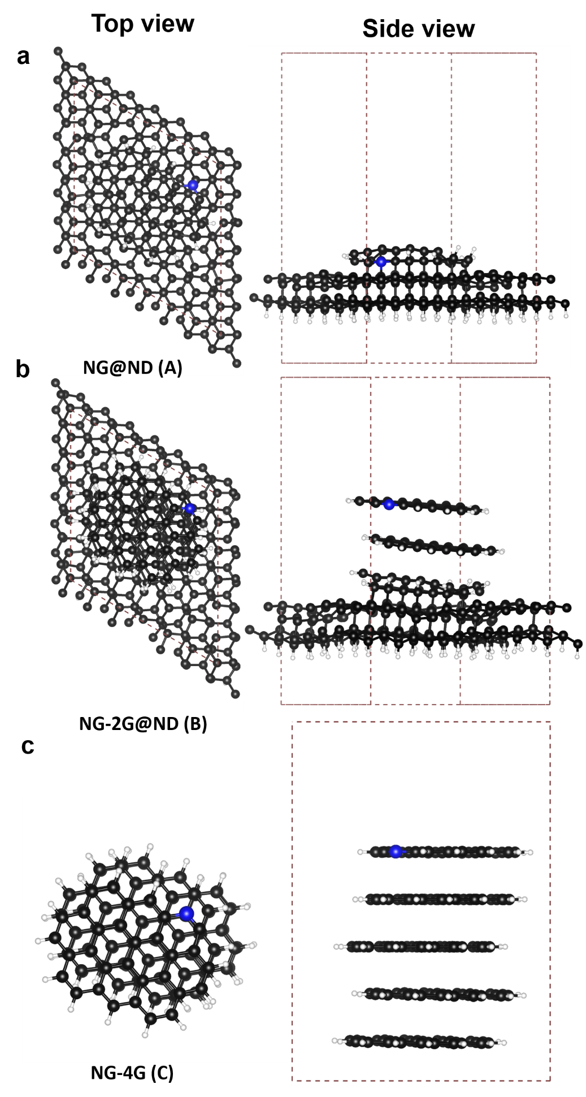
Fig. S9 The top and side view of optimized configurations of (a) NG@ND, (b) NG-2G@ND and (c) NG-4G.
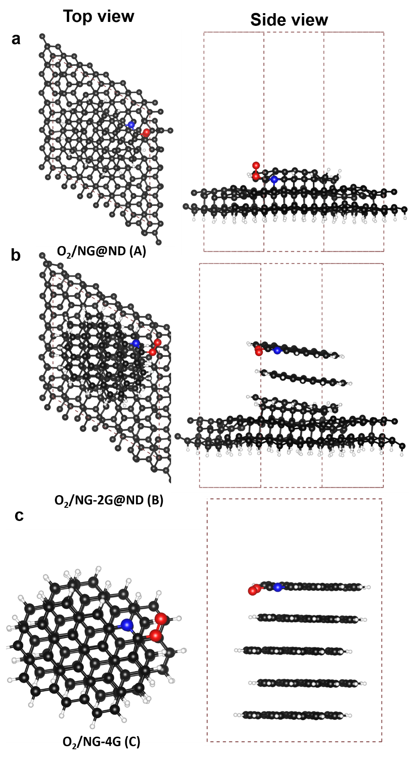
Fig. S10 The top and side view of optimized configurations of (a) O₂/NG@ND, (b) O₂/NG-2G@ND and (c) O₂/NG-4G.

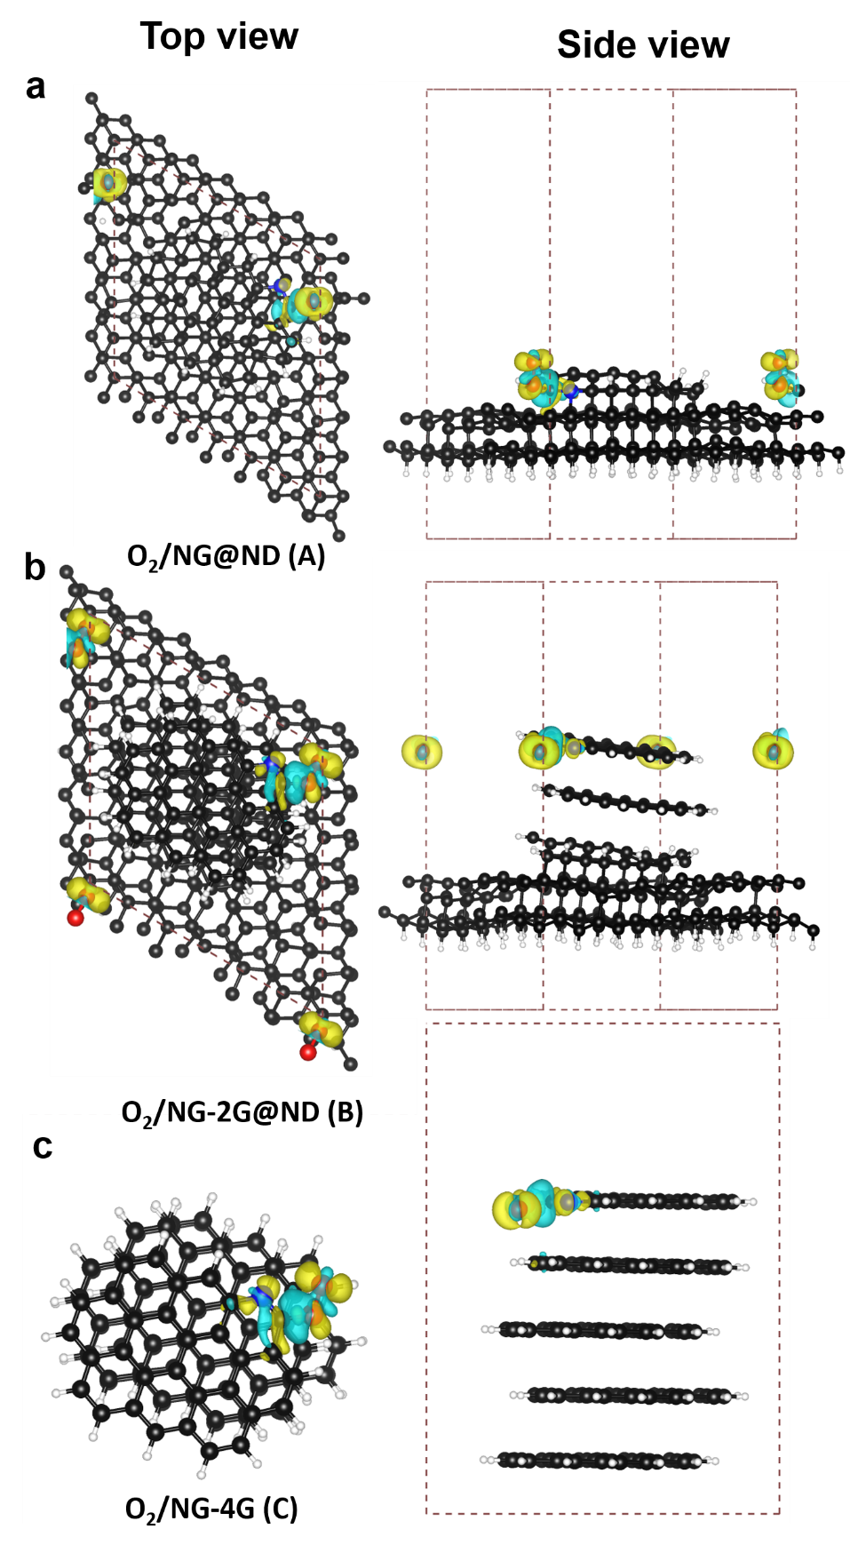

Fig. S11 The top and side view of charge density difference for (a) O₂/NG@ND, (b) O₂/NG-2G@ND and (c) O₂/NG-4G. The yellow areas mean that the accumulation of electrons and the blue region exhibits the depletion of electrons (the isosurface value is ±0.002 e/ A³).
Table S8 Atom charge for the C atoms that adjacent to the doped-N from Bader charge analysis.
C1
C2

Atom | Charge
C1 in NG@ND | 0.23
C2 in NG@ND | 0.31
C1 in NG-2G@ND | 0.47
C2 in NG-2G@ND | 0.58
C1 in NG-4G | 0.37
C2 in NG-4G | 0.60

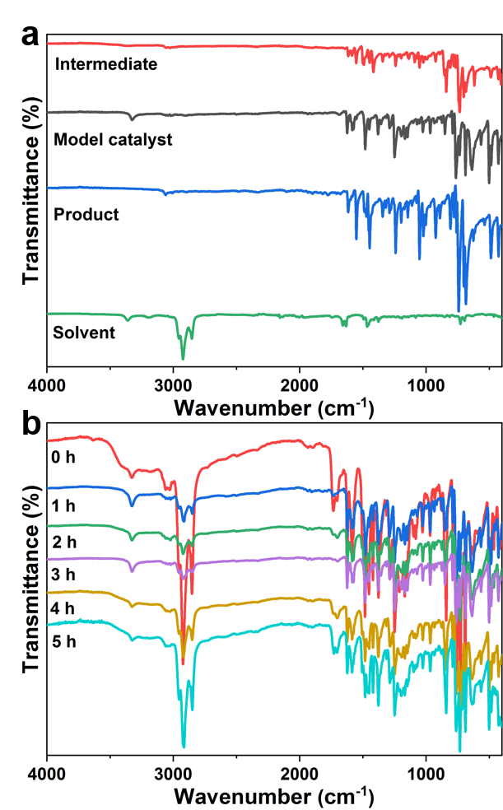
Fig. S12 ATR-IR spectra of (a) reference samples including I (2-(benzylideneamino)phenol), model catalyst (1,10-phenanthroline), product (2-phenylbenzoxazole) and solvent (toluene); (b) catalytic systems with the mixture of I (as reactant), model catalyst and toluene under 140 ºC in oxygen for 1, 2, 3, 4 and 5 h, respectively.

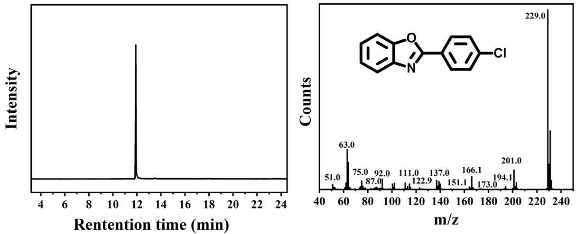

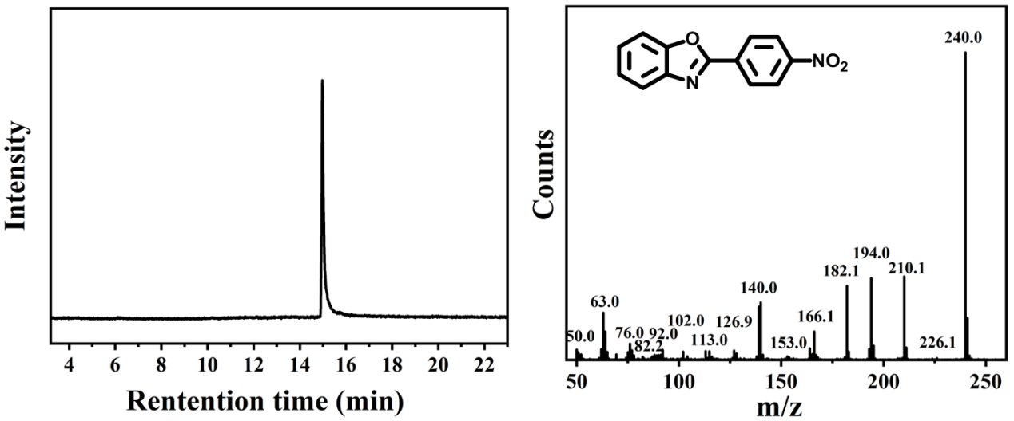
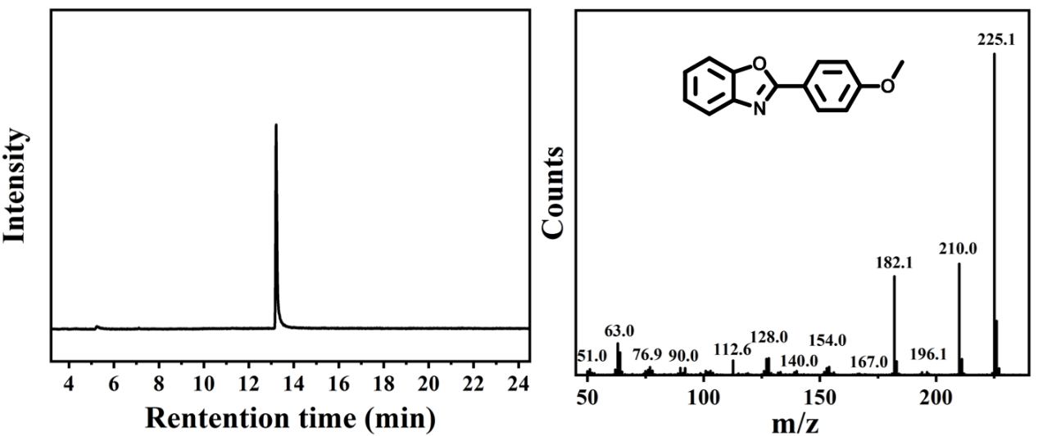
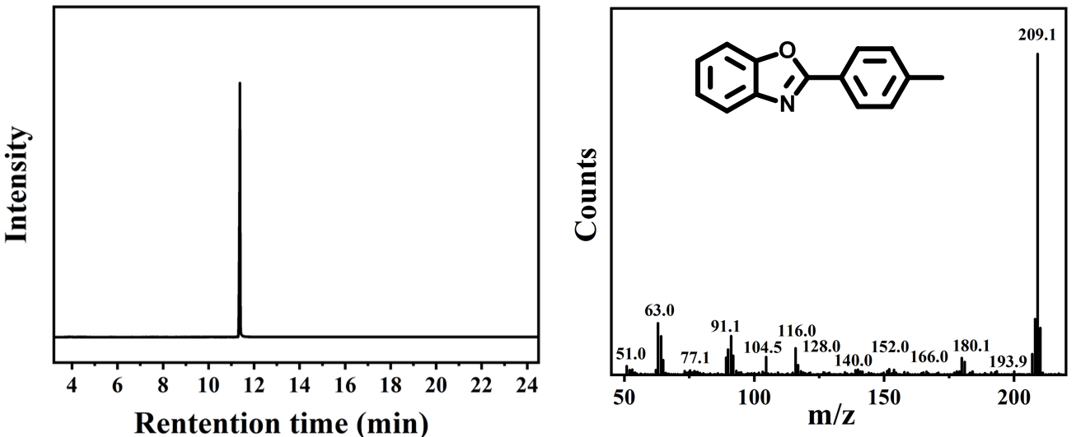

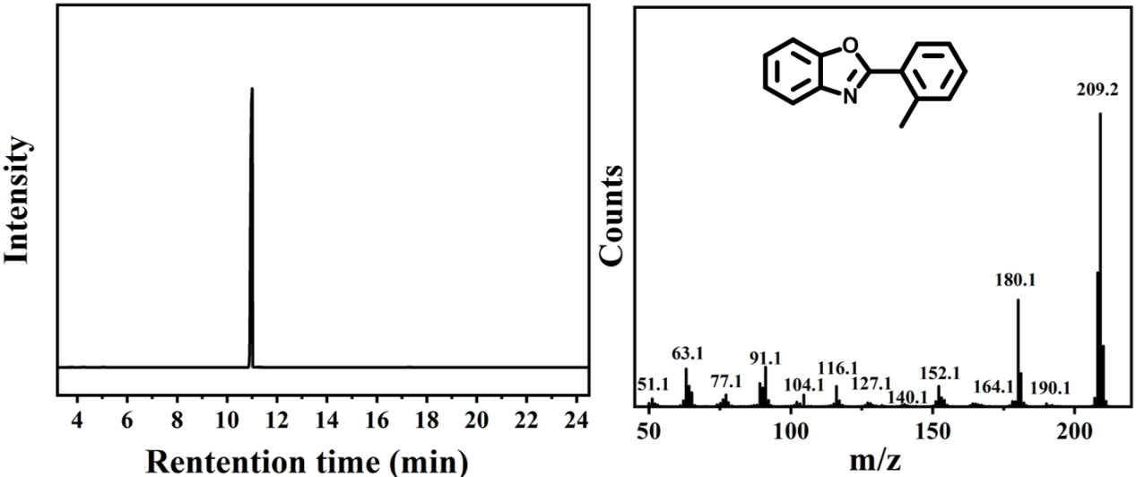

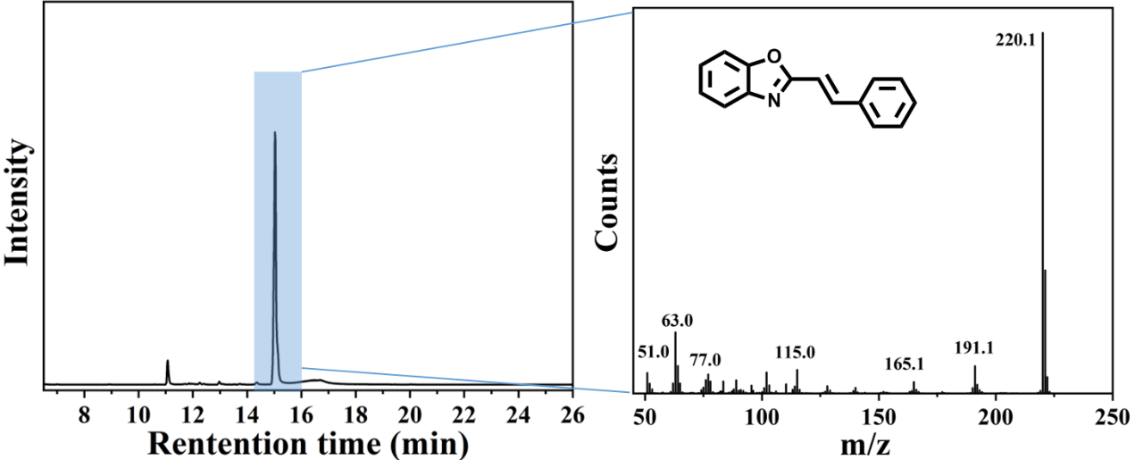

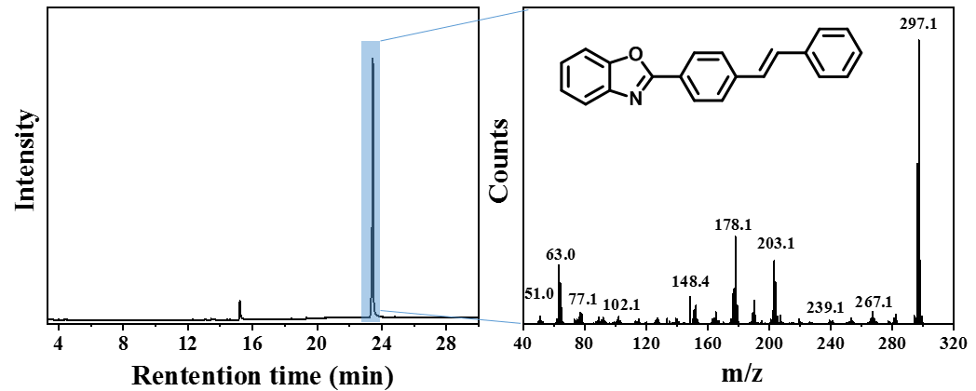

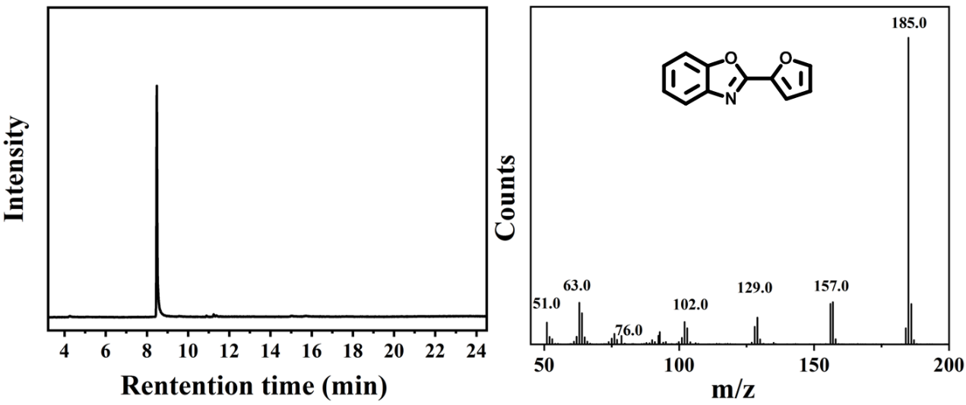

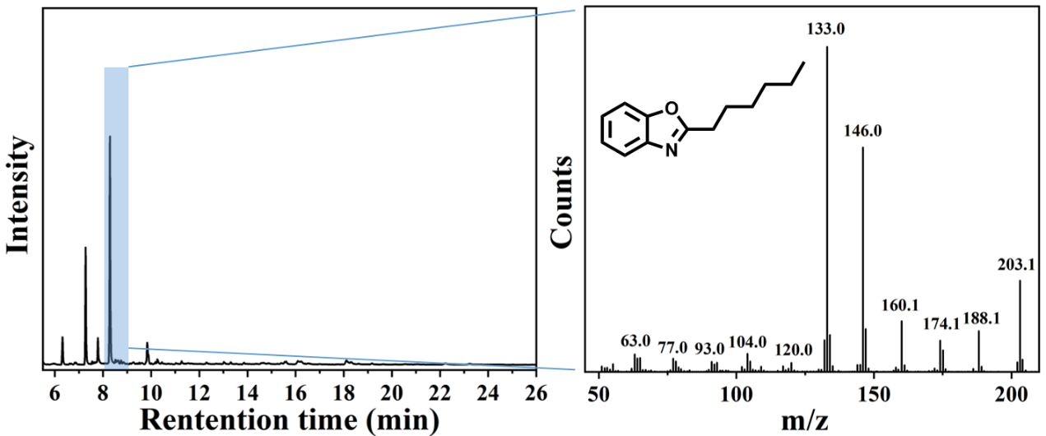

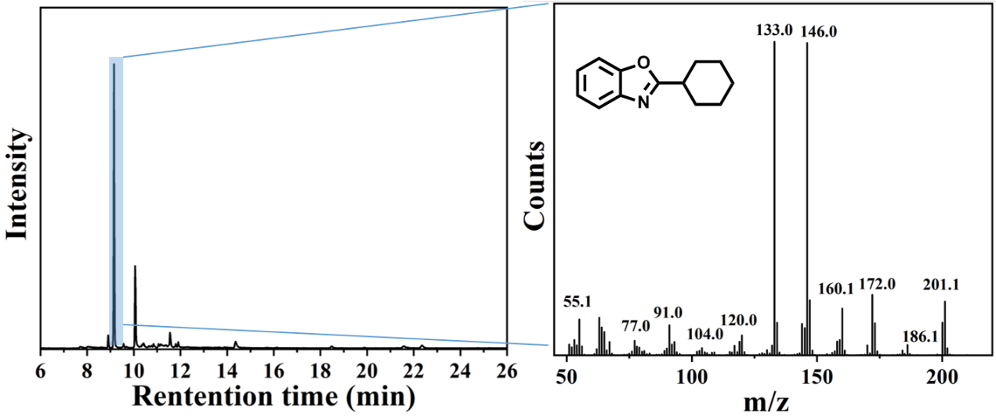

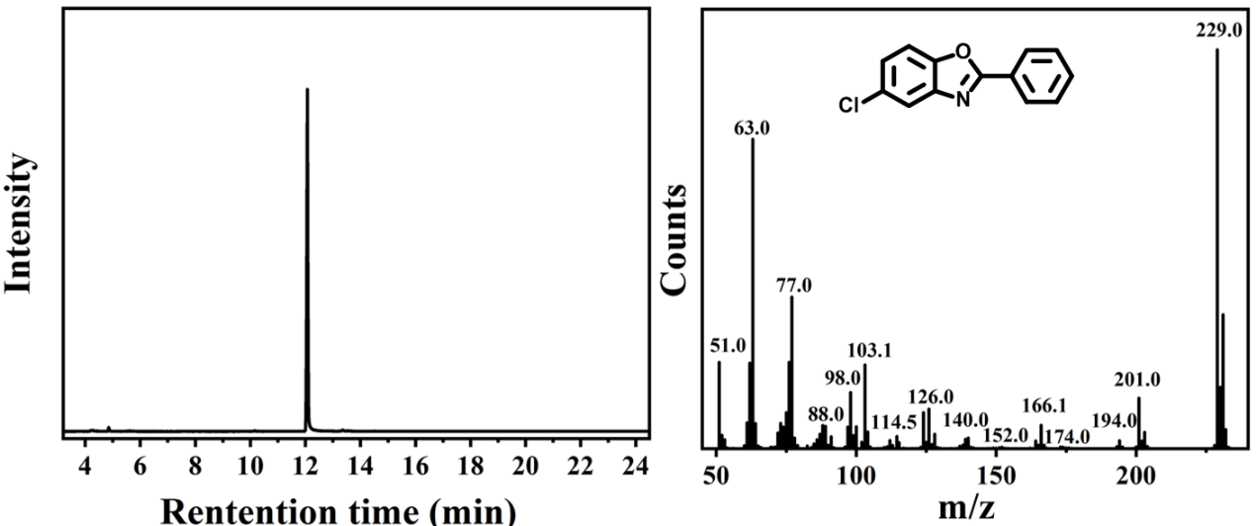

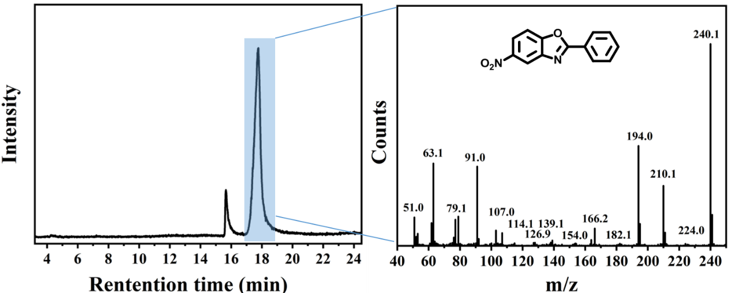

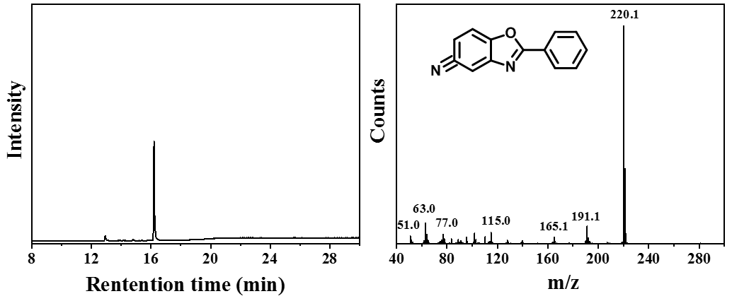

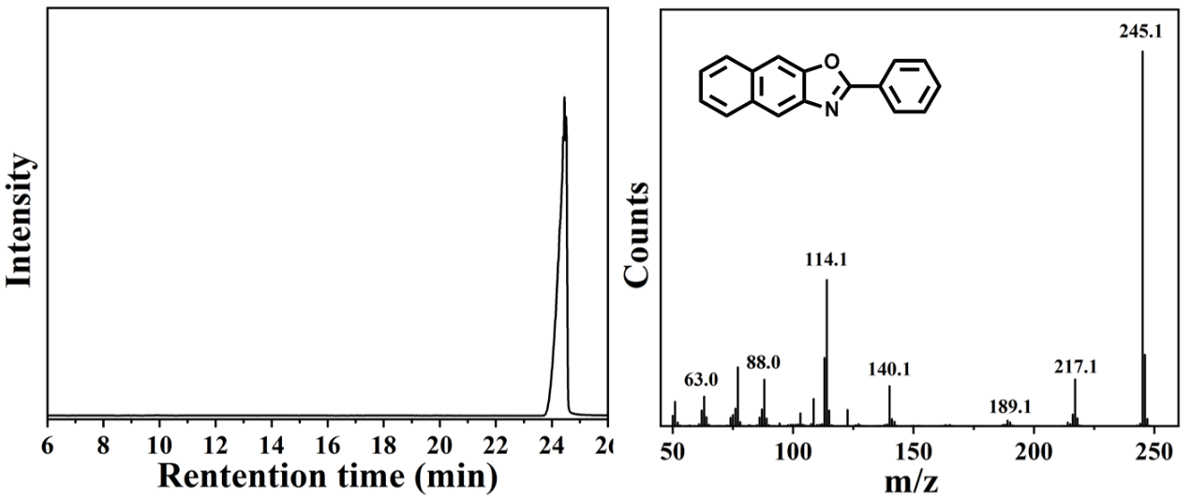

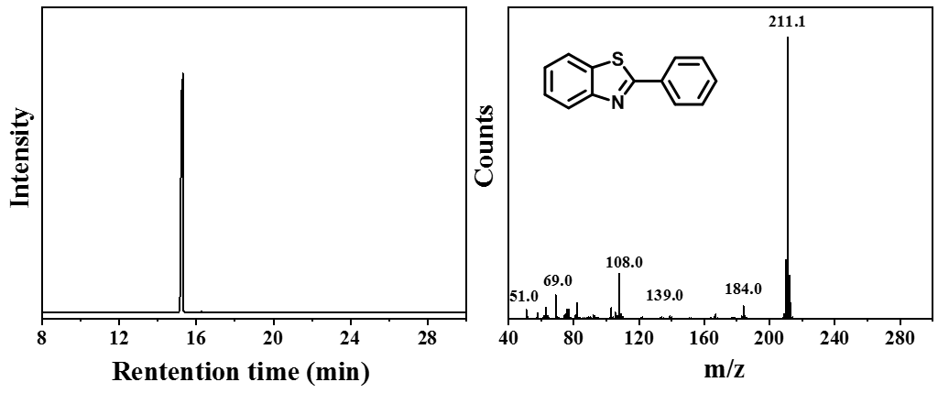

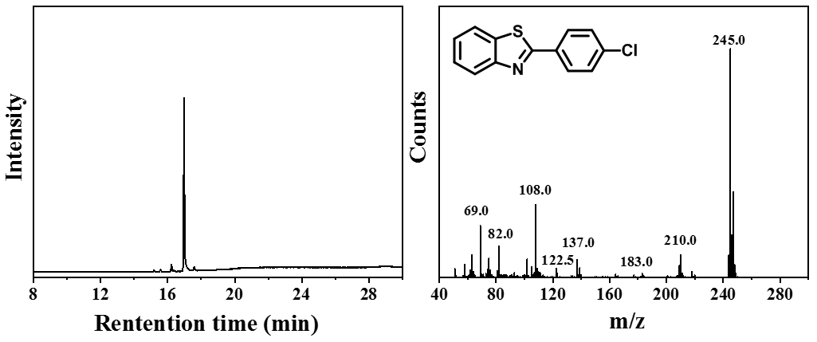

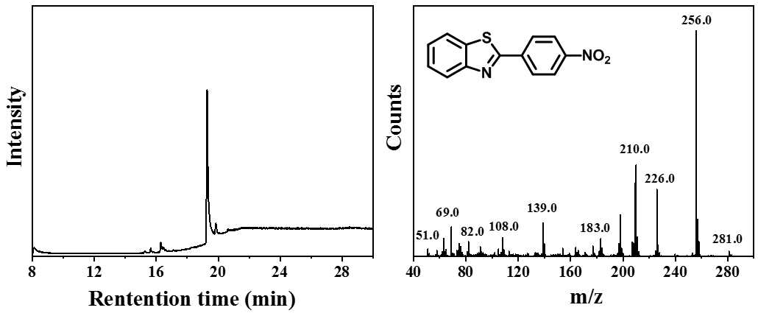

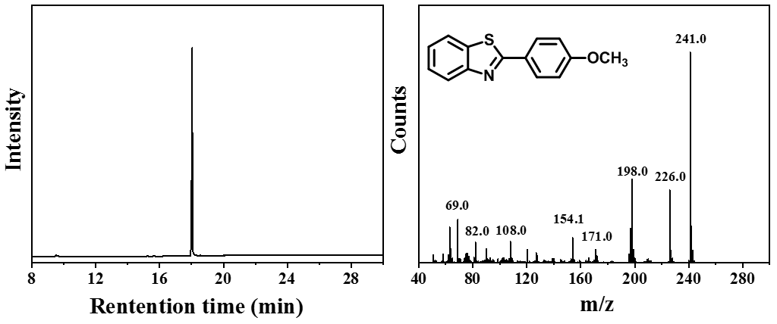

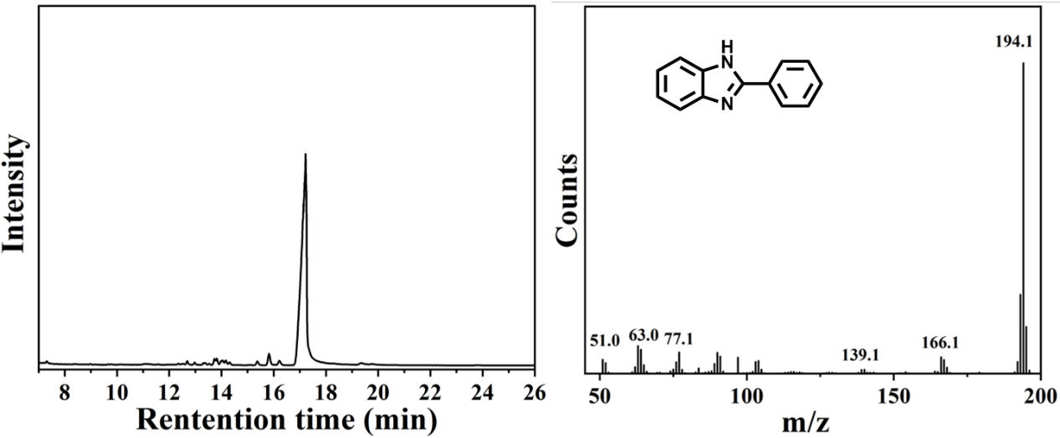

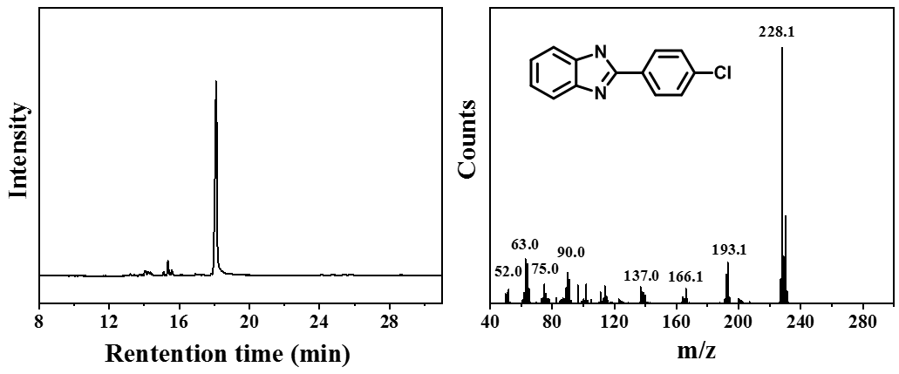

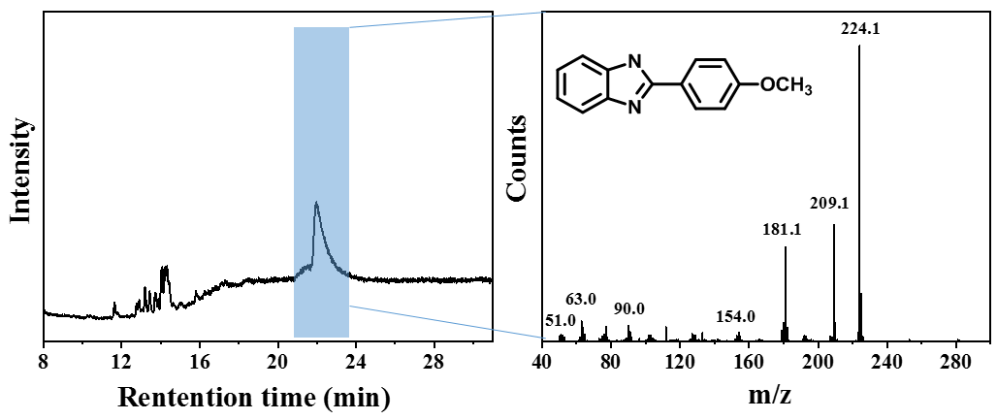

Fig. S13 GC-MS analysis of products (P1-P23) in substrate scope experiments.

References
1. Chang J., Zhao K., Pan S. Synthesis of 2-arylbenzoxazoles via DDQ promoted oxidative cyclization of phenolic Schiff bases - a solution-phase strategy for library synthesis. Tetrahedron Lett. 43, 951-954 (2002).
2. Park K. H., Jun K., Shin S. R., Oh S. W. 2-Arylbenzoxazoles from phenolic schiff's bases by thianthrene cation radical. Tetrahedron Lett. 37, 8869-8870 (1996).
3. Beaulieu P. L., Haché B., von Moos E. A practical Oxone®-mediated, high-throughput, solution-phase synthesis of benzimidazoles from 1, 2-phenylenediamines and aldehydes and its application to preparative scale synthesis. Synthesis 2003, 1683-1692 (2003).
4. Blacker A. J., Farah M. M., Hall M. I., Marsden S. P., Saidi O., Williams J. M. Synthesis of benzazoles by hydrogen-transfer catalysis. Org. Lett. 11, 2039-2042 (2009).
5. Yu J., Xu J., Lu M. Copper‐catalyzed highly efficient aerobic oxidative synthesis of benzimidazoles, benzoxazoles and benzothiazoles from aromatic alcohols under solvent‐free conditions in open air at room temperature. Appl. Organ. Chem. 27, 606-610 (2013).
6. Tang L., Guo X., Yang Y., Zha Z., Wang Z. Gold nanoparticles supported on titanium dioxide: an efficient catalyst for highly selective synthesis of benzoxazoles and benzimidazoles. Chem. Commun. 50, 6145-6148 (2014).
7. Yoo W. J., Yuan H., Miyamura H., Kobayashi S. Facile Preparation of 2‐Substituted Benzoxazoles and Benzothiazoles via Aerobic Oxidation of Phenolic and Thiophenolic Imines Catalyzed by Polymer‐Incarcerated Platinum Nanoclusters. Adv. Syn. Catal. 353, 3085-3089 (2011).
8. Yu C., et al. AgPd nanoparticles deposited on WO_{2. 72} nanorods as an efficient catalyst for one-pot conversion of nitrophenol/nitroacetophenone into benzoxazole/quinazoline. J. Am. Chem. Soc. 139, 5712-5715 (2017).
9. Chen Y. X., Qian L. F., Zhang W., Han B. Efficient Aerobic Oxidative Synthesis of 2-Substituted Benzoxazoles, Benzothiazoles, and Benzimidazoles Catalyzed by 4-Methoxy-TEMPO. Angew. Chem. Int. Ed. 47, 9330-9333 (2008).
10. Kawashita Y., Nakamichi N., Kawabata H., Hayashi M. Direct and practical synthesis of 2-arylbenzoxazoles promoted by activated carbon. Org. Lett. 5, 3713-3715 (2003).
11. Niknam E., Panahi F., Daneshgar F., Bahrami F., Khalafi-Nezhad A. Metal–Organic Framework MIL-101 (Cr) as an Efficient Heterogeneous Catalyst for Clean Synthesis of Benzoazoles. ACS Omega 3, 17135-17144 (2018).
12. Sadeghi B., Ghasemi Nejad M. Silica sulfuric acid: an eco-friendly and reusable catalyst for synthesis of benzimidazole derivatives. J. Chem. 2013, (2012).
13. Chaudhari C., Siddiki S. H., Shimizu K.-i. Acceptorless dehydrogenative synthesis of benzothiazoles and benzimidazoles from alcohols or aldehydes by heterogeneous Pt catalysts under neutral conditions. Tetrahedron Lett. 56, 4885-4888 (2015).
14. Chang W., Sun Y., Huang Y. One‐pot green synthesis of benzoxazole derivatives through molecular sieve‐catalyzed oxidative cyclization reaction. Heteroat Chem. 28, e21360 (2017).
15. Khalafi-Nezhad A., Panahi F. Ruthenium-catalyzed synthesis of benzoxazoles using acceptorless dehydrogenative coupling reaction of primary alcohols with 2-aminophenol under heterogeneous conditions. ACS Catal. 4, 1686-1692 (2014).
16. Lai Y. L., Ye J. S., Huang J. M. Electrochemical Synthesis of Benzazoles from Alcohols and o‐Substituted Anilines with a Catalytic Amount of CoII Salt. Chem. A Eur. J. 22, 5425-5429 (2016).
17. Sarode S. A., Bhojane J. M., Nagarkar J. M. An efficient magnetic copper ferrite nanoparticle: for one pot synthesis of 2-substituted benzoxazole via redox reactions. Tetrahedron Lett. 56, 206-210 (2015).
18. Yu C., et al. One-pot formic acid dehydrogenation and synthesis of benzene-fused heterocycles over reusable AgPd/WO _{2.72} nanocatalyst. J. Mater. Chem. A 6, 23766-23772 (2018).
19. Yang D., et al. Magnetically recoverable and reusable CuFe₂O₄ nanoparticle-catalyzed synthesis of benzoxazoles, benzothiazoles and benzimidazoles using dioxygen as oxidant. RSC Adv. 4, 17832-17839 (2014).

