Extended Data Table 1. Radiative kernel decomposition of E_{c} induced ERF. Factors contributing to the annual mean ERF include aerosol direct radiative forcing and fast adjustments of water vapor, surface albedo, temperature and clouds. Units are in W/m². The values in brackets represent 2 standard deviations.
 | Due to E_{c} of Developing countries | Due to E_{c} of Developed countries
ERF | -0.48 (±0.64) | -0.42 (±0.64)
Direct radiative forcing | -0.16 (±0.061) | -0.066 (±0.035)
H₂O | 0.036 (±0.044) | 0.010 (±0.044)
Albedo | -0.022 (±0.064) | -0.040 (±0.092)
Temperature | -0.019 (±0.11) | -0.007 (±0.076)
Cloud | -0.32 (±0.22) | -0.32 (±0.28)

Extended Data Table 2. Radiative kernel decomposition of E_{c} induced TOA net radiation flux in the fully coupled simulations. Factors contributing to the annual mean net radiation flux include ERF and the responses of water vapor, surface albedo, temperature and clouds. The contributions of all non-ERF factors are in addition to the radiative effects of their fast adjustments presented in Extended Data Table 1. Units are in W/m². The values in brackets represent 2 standard deviations.
 | Due to E_{c} of Developing countries | Due to E_{c} of Developed countries
TOA net radiation flux | -0.073 (±0.50) | -0.12 (±0.55)
ERF | -0.48 (±0.64) | -0.42 (±0.64)
H₂O | -0.26 (±0.062) | -0.32 (±0.068)
Albedo | -0.046 (±0.058) | -0.060 (±0.065)
Temperature | 0.62 (±0.26) | 0.61 (±0.24)
Cloud | 0.090 (±0.30) | 0.062 (±0.32)

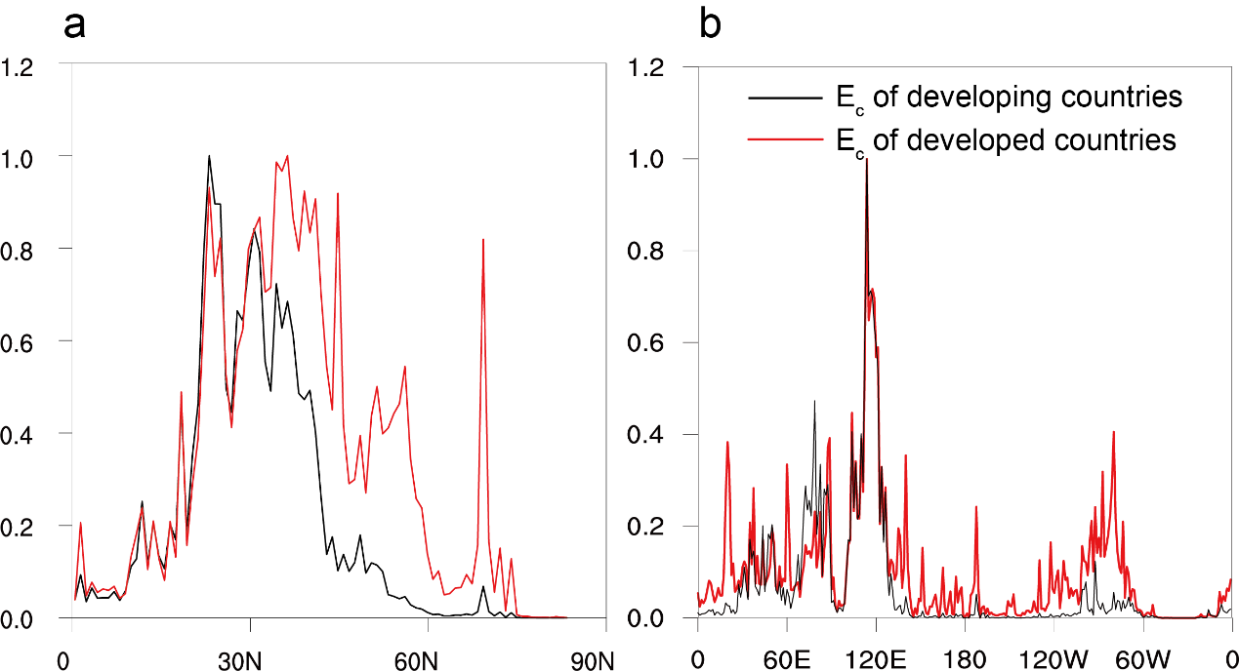
Extended Data Figure 1. Latitudinal and longitudinal variations of emissions in the Northern Hemisphere. Zonal average E_{c} (a) by developing and developed countries, and meridional average E_{c} (b). Emission values are averaged over land and then normalized relative to their min-max value.

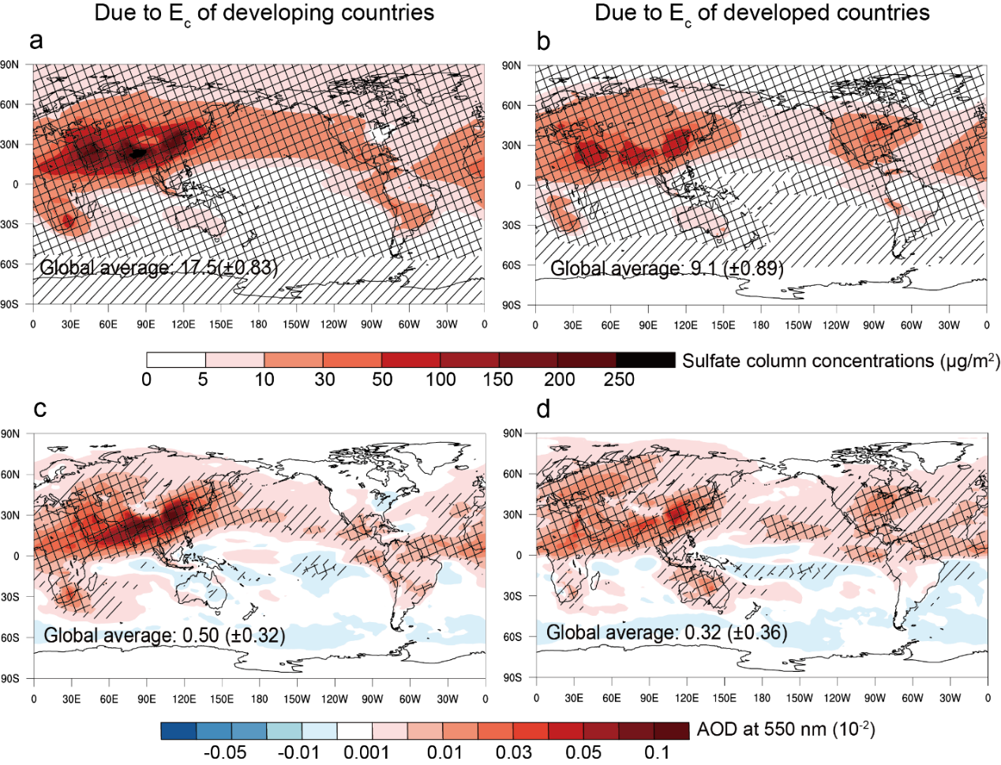
Extended Data Figure 2. Sulfate and AOD responses to consumption-based emissions. Changes in annual mean S_{c} (a, b) and AOD (c, d) due to E_{c} of developing and developed countries. AOD includes the effect of all aerosol compositions. The grid cells with cross lines pass the paired z-test at 95% CI and those with diagonal lines pass the test at 68% CI. The global average with 2 standard deviations is shown in each panel.

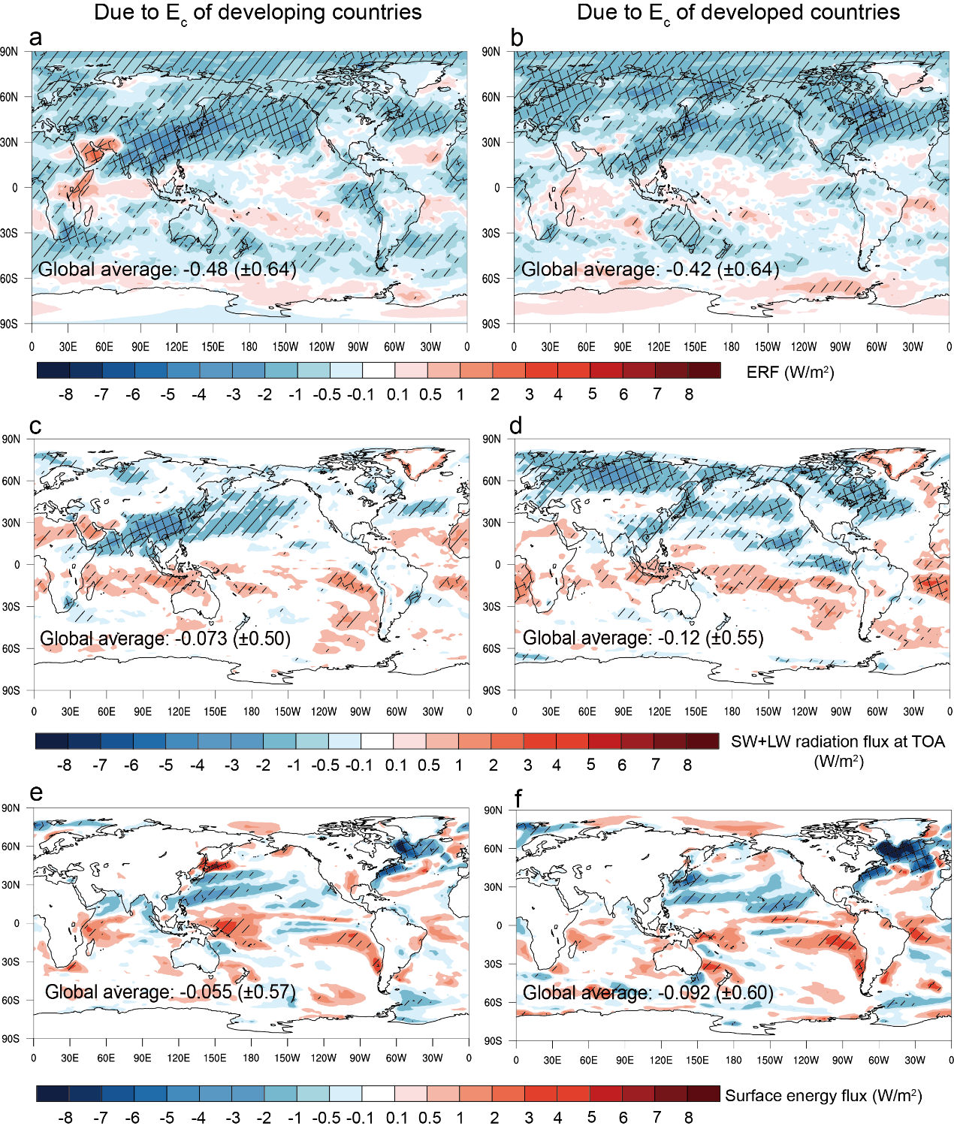
Extended Data Figure 3. Energy imbalance induced by consumption-based emissions. (a,b) Annual mean ERF due to E_{c} of developing and developed countries calculated based on CAM6 simulations. (c-f) Annual mean TOA net radiative flux (shortwave + longwave; c,d) and surface energy flux (shortwave + longwave + latent heat + sensible heat; e,f) due to E_{c} of developing and developed countries calculated based on fully coupled CESM2 simulations. The grid cells with cross lines pass the paired z-test at 95% CI and those with diagonal lines pass the test at 68% CI. The global average with 2 standard deviations is shown in each panel.
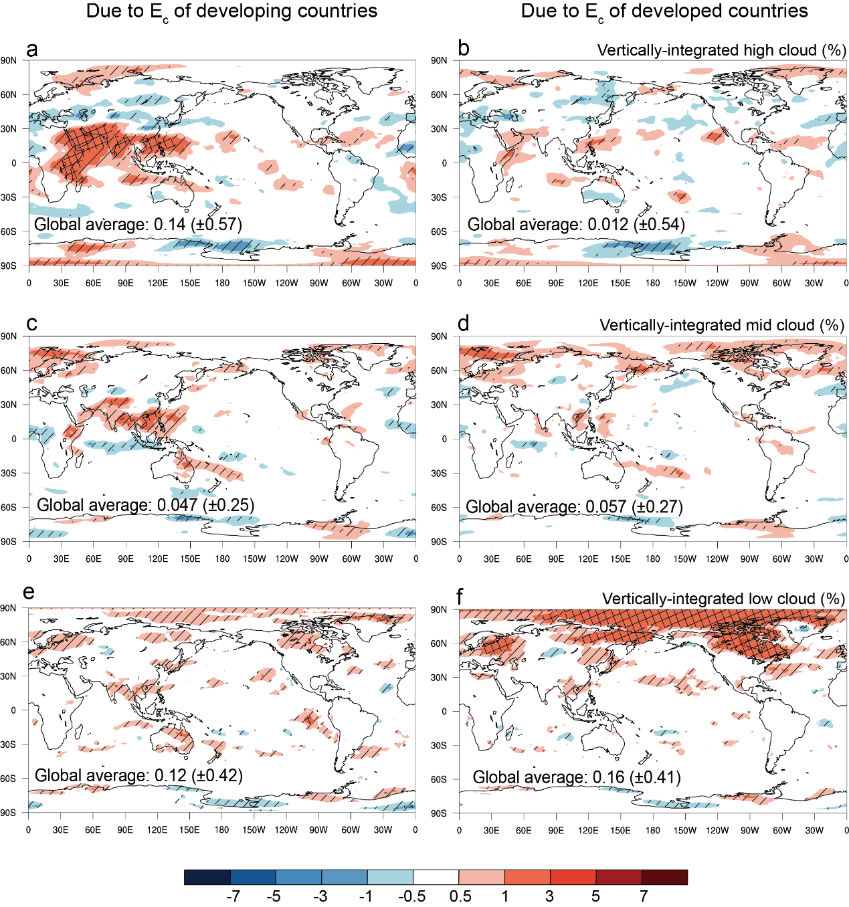
Extended Data Figure 4. Fast adjustment of cloud coverage induced by consumption-based emissions in CAM6 simulations. Changes in annual mean high clouds (cloud top pressure < 400 hPa), mid clouds (700–400 hPa) and low clouds (> 700 hPa) due to E_{c} of developing and developed countries. The grid cells with cross lines pass the paired z-test at 95% CI and those with diagonal lines pass the test at 68% CI. The global average with 2 standard deviations is shown in each panel.
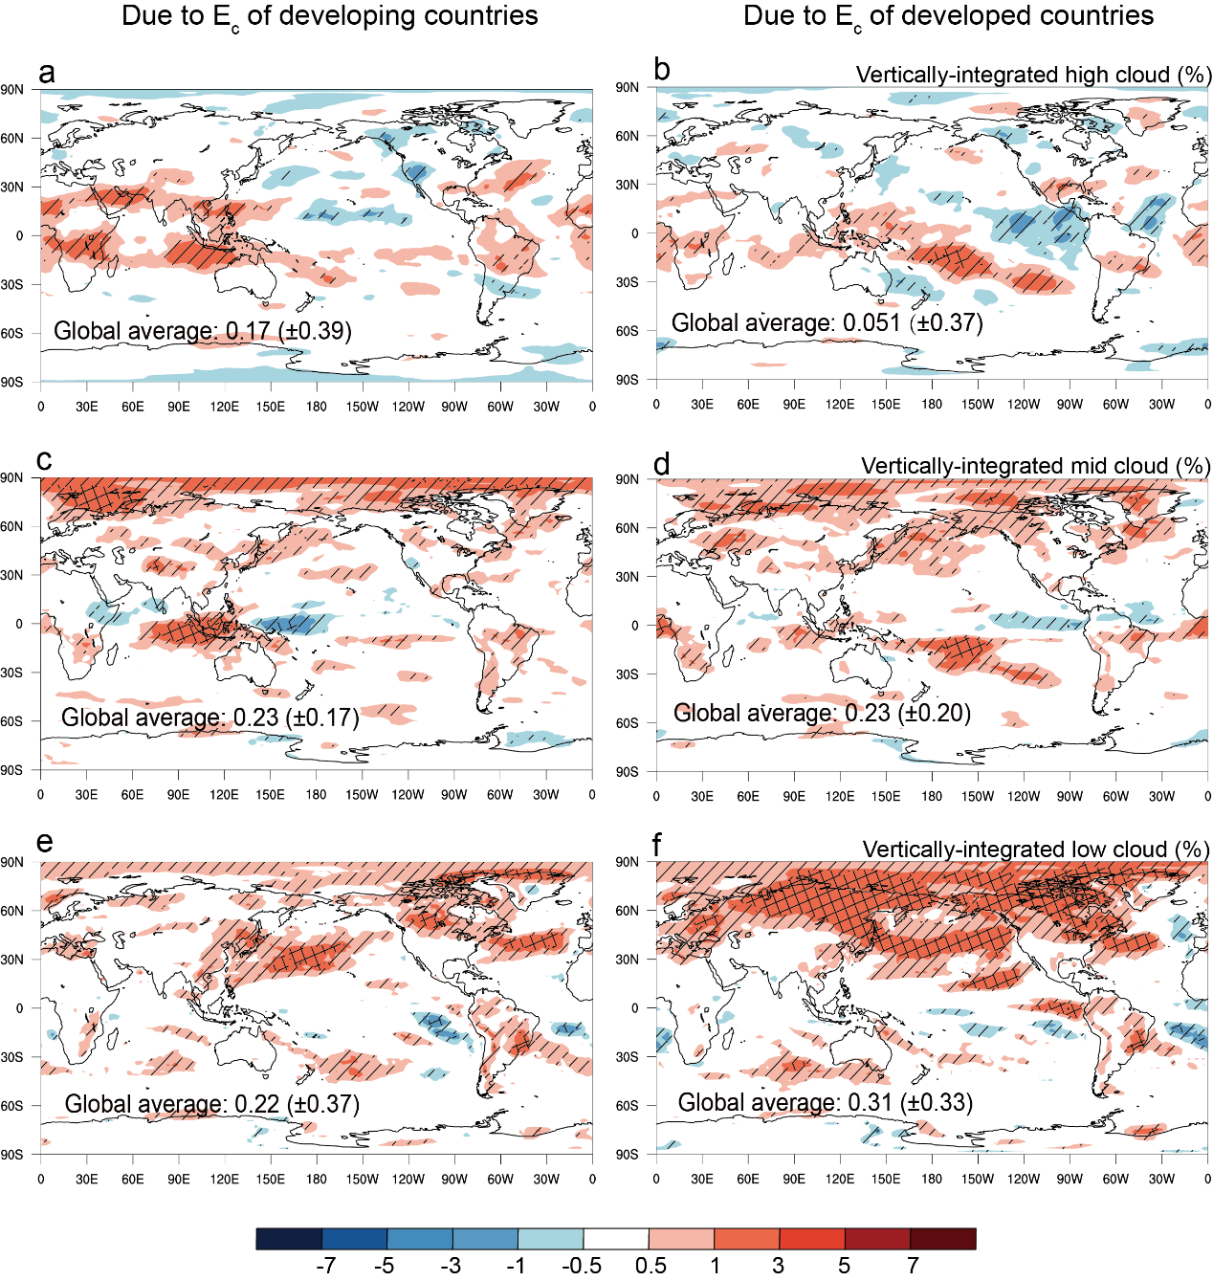
Extended Data Figure 5. Response of cloud coverage to consumption-based emissions in fully coupled CESM2 simulations. Changes in annual mean high clouds (cloud top pressure < 400 hPa), mid clouds (700–400 hPa) and low clouds (> 700 hPa) due to E_{c} of developing and developed countries. The grid cells with cross lines pass the paired z-test at 95% CI and those with diagonal lines pass the test at 68% CI. The global average with 2 standard deviations is shown in each panel.
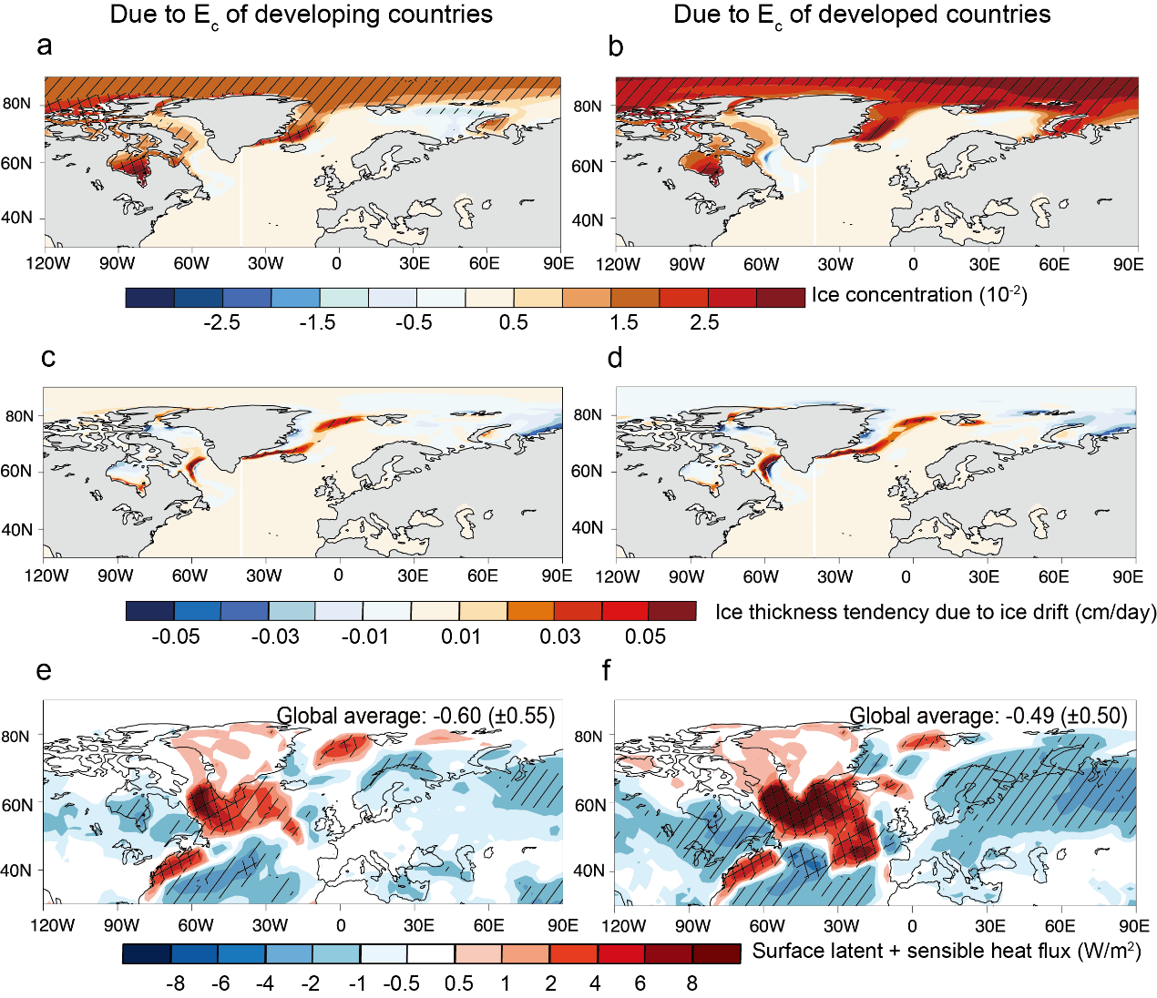
Extended Data Figure 6. Responses of sea ice and heat flux to consumption-based emissions. Changes in annual mean sea ice concentration (i.e., fraction of the area covered by sea ice in each grid cell) (a, b), wind-driven sea ice drift (c, d) and surface heat flux (latent + sensible) (e, f) due to E_{c} of developing and developed countries. The grid cells with cross lines pass the paired z-test at 95% CI and those with diagonal lines pass the test at 68% CI. In e and f, the global average of surface heat flux with 2 standard deviations is shown for comparison.

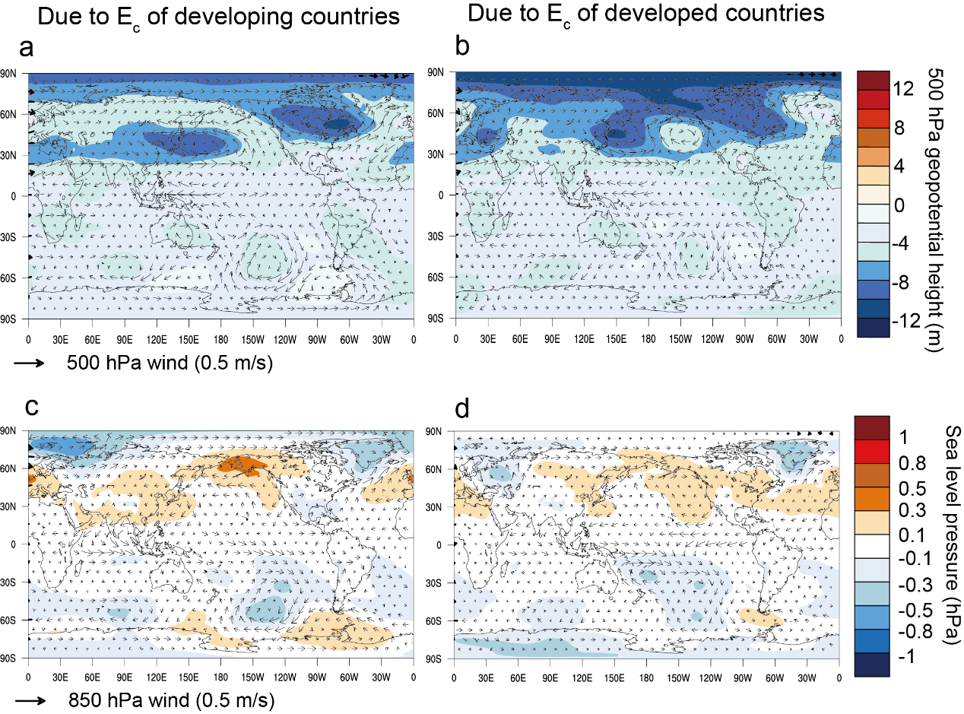
Extended Data Figure 7. Circulation response to consumption-based emissions. Changes in annual mean geopotential height (color, m) and winds (vector) at 500 hPa (a,b) and changes in annual mean sea-level pressure (color, hPa) and winds (vector) at 850 hPa (c,d) due to E_{c} of developing and developed countries.

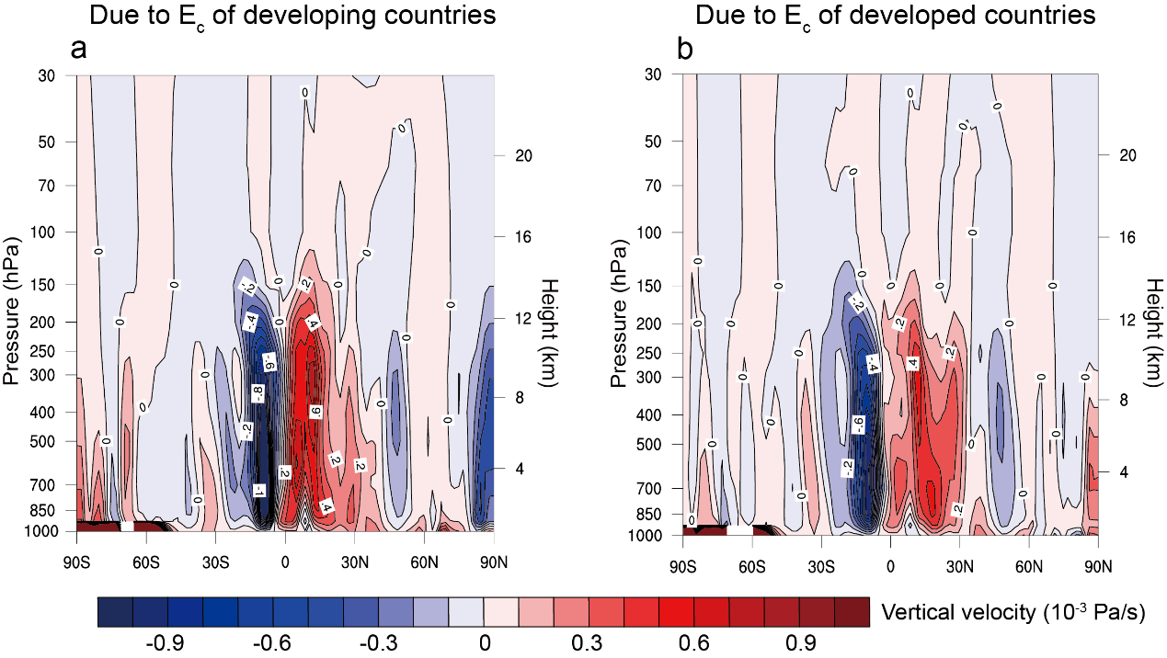
Extended Data Figure 8. Meridional circulation response to consumption-based emissions. Zonal average annual mean changes in vertical velocity ($ω={dp}/{dt}$) due to E_{c} of developing and developed countries. Negative values represent rising air.

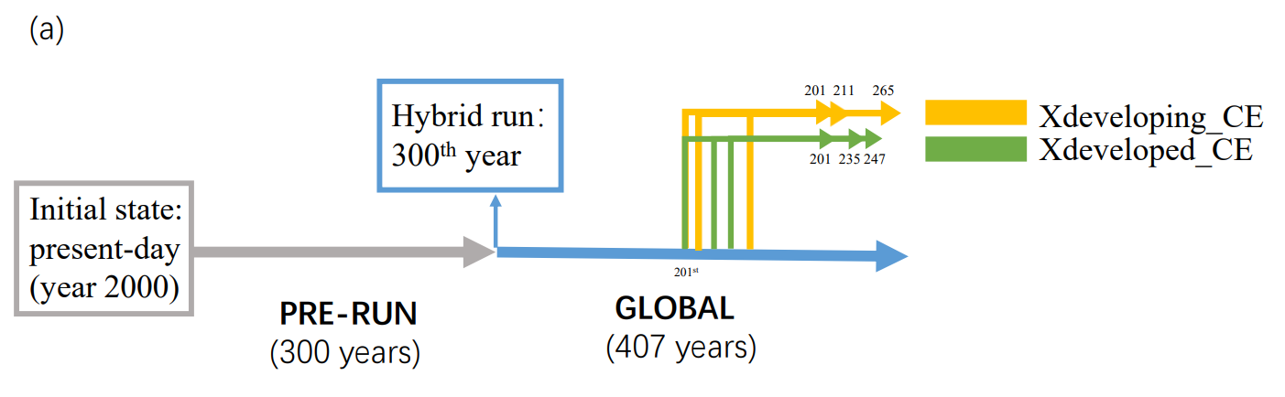
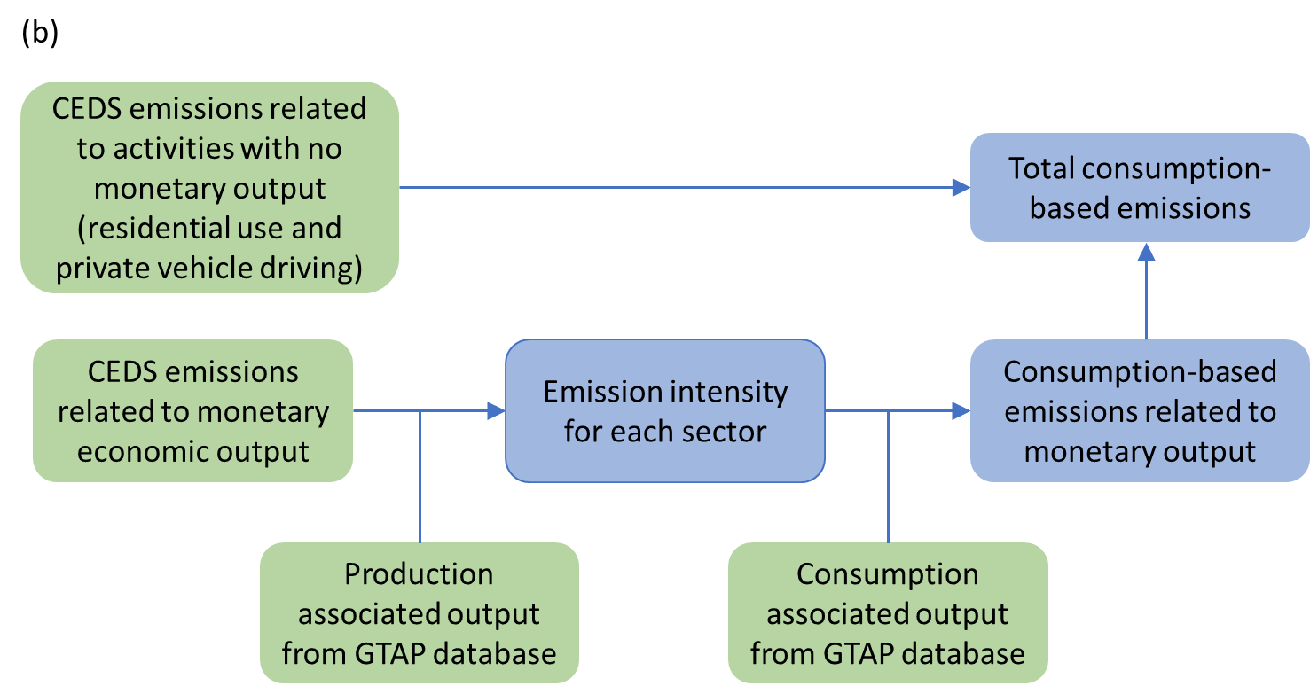
Extended Data Figure 9. Experiment setting (a) and consumption-based emissions calculation (b). Here, the output of each sector refers to production to support both the final consumption of that sector and the intermediate consumption by other sectors worldwide.

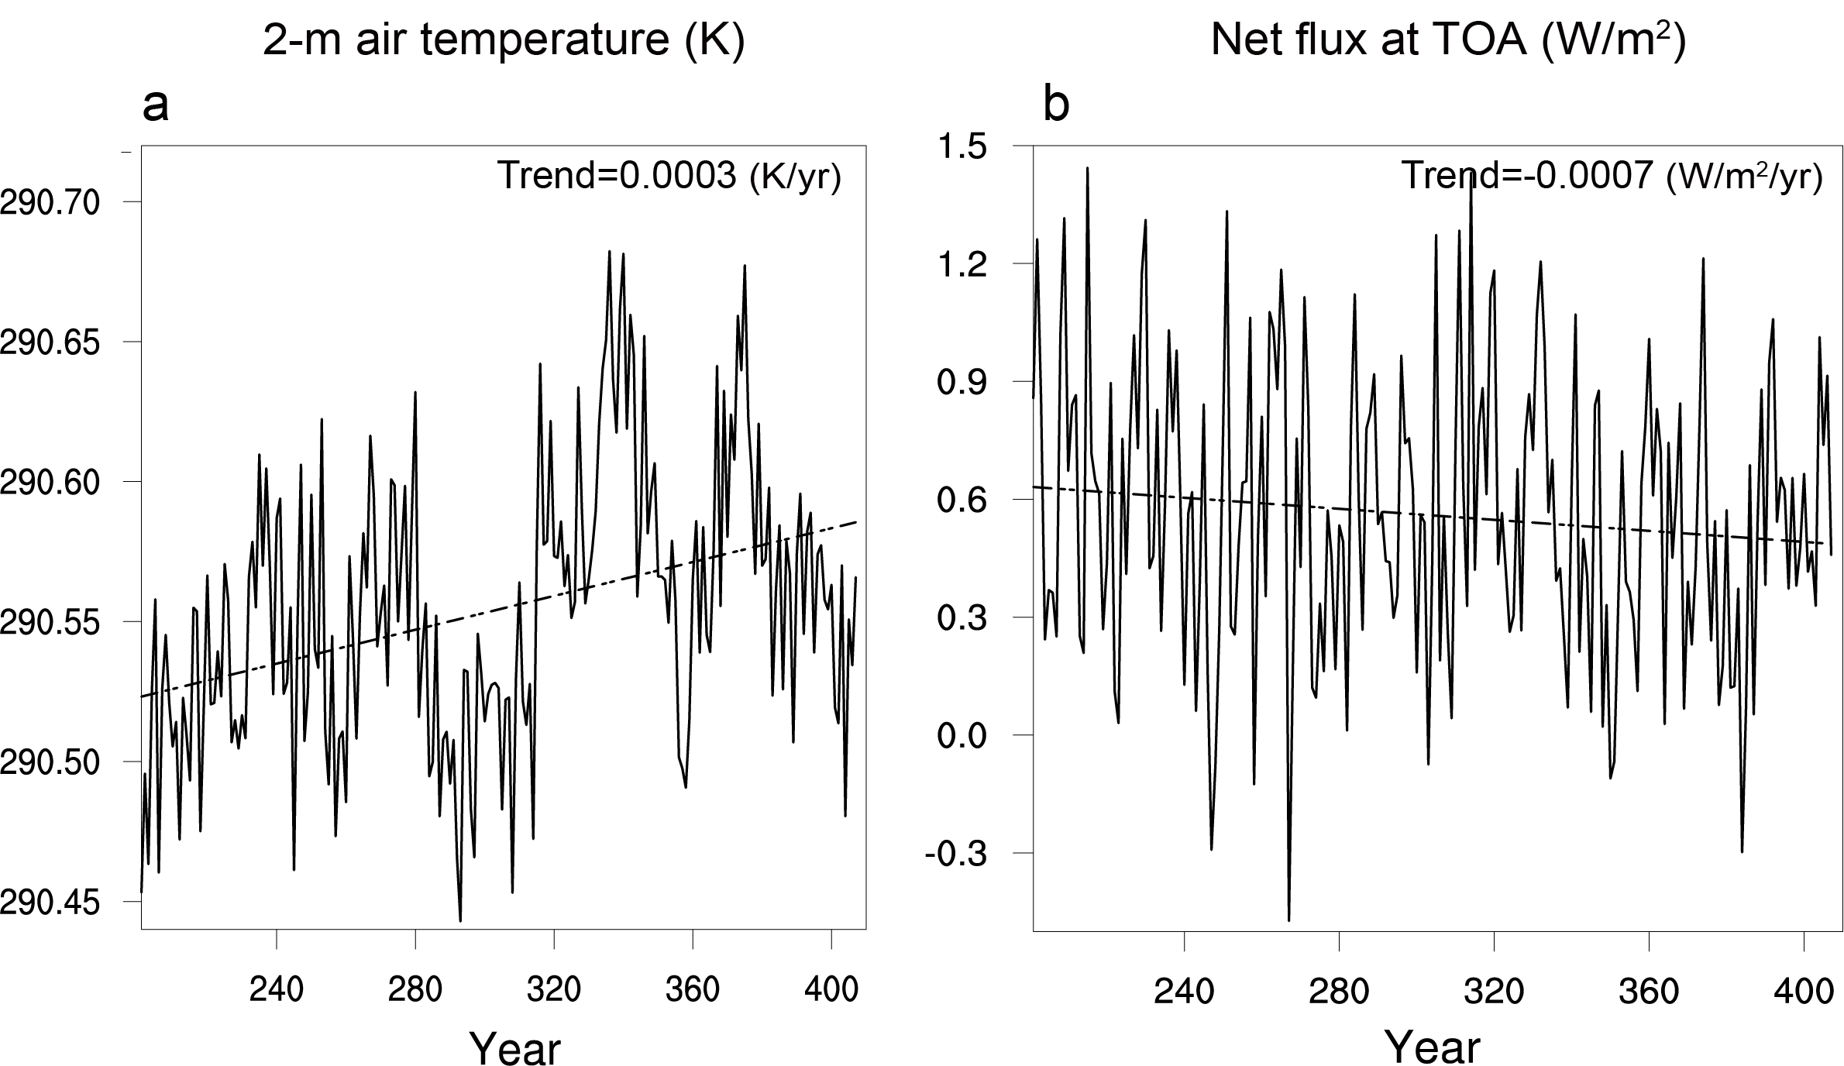
Extended Data Figure 10. Time series of global average annual mean 2-m air temperature and TOA net radiative flux (shortwave + longwave) during the last 207 years of GLOBAL. Linear fit with trend is provided in each panel.

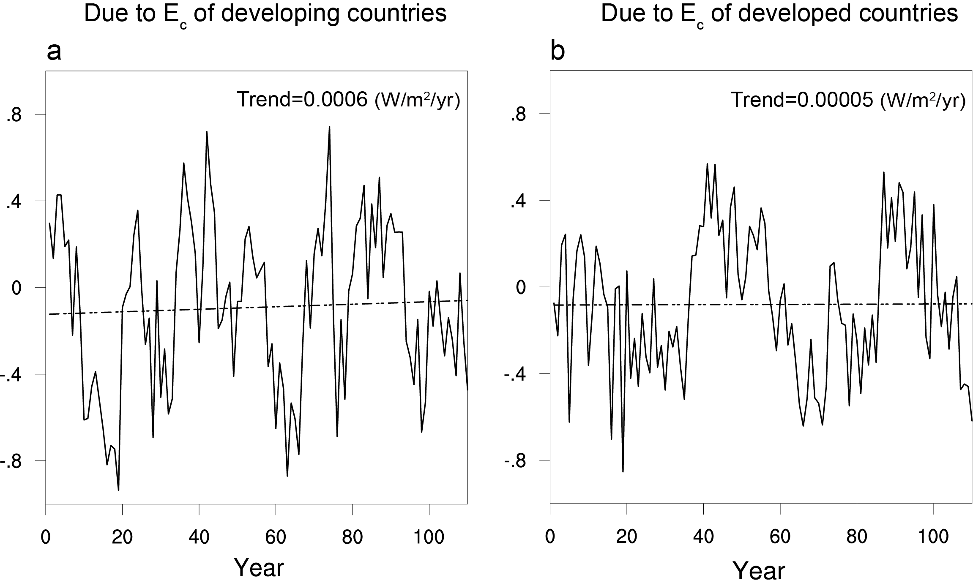
Extended Data Figure 11. Time series of global average annual mean TOA net radiative flux (shortwave + longwave) during the last 110 years of fully coupled simulations perturbed by consumption-based emissions (GLOBAL minus Xdeveloping_CE and GLOBAL minus Xdeveloped_CE). Linear fit with trend is provided in each panel.

