Supplementary materials

Supplementary Table S1 2
Supplementary Table S2 4
Supplementary Table S3. 6
Supplementary Text S1. 7
Supplementary Table S4. 8
Supplementary Table S5 12
Supplementary Figure S1 13
Reference 15

Supplementary Table S1: The position of the sequenced fragment
Target | Chr | Gene | Gene full name | TSS | TES | Start | End
ARHGAP40_16 | 20 | ARHGAP40 | The RHO Guanosine triphosphatase activating protein 40 | 37230576 | 37279295 | 37274153 | 37274356
C5orf34_15 | 5 | C5orf34 | Chromosome 5 open reading frame 34 | 43515273 | 43486802 | 43487447 | 43487684
CCDC124_14 | 19 | CCDC124 | Coiled-coil domain containing 124 | 18045904 | 18054794 | 18054774 | 18054574
COPS8_11 | 2 | COPS8 | Constitutive photomorphogenic homolog subunit 8 | 237994083 | 238007489 | 237992528 | 237992710
DDR1_05 | 6 | DDR1 | Discoid in domain receptor tyrosine kinase 1 | 30852756 | 30867933 | 30852639 | 30852815
DNAJB6_09 | 7 | DNAJB6 | DNAJ homolog, subfamily B, member 6 | 157129710 | 157210133 | 157130190 | 157130031
EIF2AK2_28 | 2 | EIF2AK2 | Eukaryotic translation initiation factor 2α kinase 2. | 37374965 | 37332283 | 37375038 | 37374822
GCK_18 | 7 | GCK | Glucokinase | 44185743 | 44182811 | 44185089 | 44185314
HAAO_13 | 2 | HAAO | 3-hydroxyanthranilate3,4-dioxygenase | 43019751 | 42994228 | 43013714 | 43013885
HAPLN3_02 | 15 | HAPLN3 | Hyaluronan and proteoglycan link protein 3 | 89438857 | 89420515 | 89438585 | 89438810
HHLA3_03 | 1 | HHLA3 | HERV-H LTR-associating 3 | 70820492 | 70833705 | 70820116 | 70820310
IFNGR2_27 | 21 | IFNGR2 | The interferon gamma receptor 2 | 34775201 | 34809828 | 34775191 | 34775397
IL10_25 | 1 | IL10 | Interleukin 10 | 206945839 | 206940946 | 206945211 | 206945446
IL6_21 | 7 | IL6 | Interleukin 6 | 22766760 | 22771621 | 22765200 | 22765453
IL6_22 | 7 | IL6 | Interleukin 6 | 22766760 | 22771621 | 22767361 | 22767112
IL7_10 | 8 | IL7 | Interleukin 7 | 79717758 | 79645006 | 79717646 | 79717816
MDM2_08 | 12 | MDM2 | MDM2 oncogene, E3 ubiquitin protein ligase | 69201951 | 69239324 | 69202015 | 69202223
NAGA_30 | 22 | NAGA | a-N-Acetylgalactosaminidase | 42466846 | 42454337 | 42466437 | 42466229
NDUFC1_01 | 4 | NDUFC1 | NADH dehydrogenase (ubiquinone) 1, subcomplex unknown | 140222364 | 140211070 | 140216838 | 140217048
NFATC4_17 | 14 | NFATC4 | Nuclear factor of activated T cells 4 | 24838203 | 24848810 | 24837955 | 24837799
PIK3R5_12 | 17 | PIK3R5 | Phosphoinositide-3-kinase, regulatory subunit 5 | 8815834 | 8782232 | 8792251 | 8792063
PPARG_20 | 3 | PPARG | peroxisome proliferator‐activated receptor gamma | 12329348 | 12475855 | 12329707 | 12329966
RDH12_23 | 14 | RDH12 | retinol dehydrogenase 12 | 68168602 | 68201168 | 68166518 | 68166775
RDH12_24 | 14 | RDH12 | retinol dehydrogenase 12 | 68168602 | 68201168 | 68167191 | 68167424
RHOG_04 | 11 | RHOG | ras homolog family member G | 3862213 | 3848207 | 3863137 | 3862904
SEPT11_07 | 4 | SEPT11 | Septin 11 | 77870866 | 77959768 | 77871462 | 77871255
STAT1_26 | 2 | STAT1 | The signal transducer and activator of transcription 1 | 191878976 | 191833761 | 191879029 | 191879241
YAP1_29 | 11 | YAP1 | Yes-associated protein | 101981191 | 102104154 | 101980889 | 101981108
ZAR1_06 | 4 | ZAR1 | Zygote arrest 1 | 48492268 | 48496406 | 48492464 | 48492222
Notes: Target: Target fragment of DNA sequencing; Chr: Chromosome; Gene: The name of the gene in which the target fragment is located; TSS: mRNA transcription initiation site; TES: mRNA transcription termination sites; Start: Target fragment initiation site; End: Target fragment termination site; Length: Target fragment sequencing length; Distance to TSS: The distance of the target fragment from the TSS. The minus sign indicates that the target is upstream of the transcription start site.

Supplementary Table S2: Primer information
Target | Length | Distance to TSS | Primer F | Primer R
ARHGAP40_16 | 204 | 43577 | AAAAGGGGAATTTAGAATYGATTTTAGT | ACACCTAAAACAAACTCTACTCTAAAAACC
C5orf34_15 | 238 | 27826 | GGTTTGGTGGTAAGGAGGAAATG | ATTCTATACATTCTCACCCAATTCATCT
CCDC124_14 | 201 | 8870 | GTTATTTTTATTGGGTATTTAGTTTTGAGGT | TCTACACRCCCTTAAACCAAATCAA
COPS8_11 | 183 | -1555 | GAGGTTAGTAAGATTTAAAGTGAGTATAAGGTA | ACCATAACTCATACAATATAATTTCTTCATAC
DDR1_05 | 177 | -117 | TTTYGATGTTTTGGTATATYGTTTGAA | AACTAACTCAATAAAACTACACAAAAACACC
DNAJB6_09 | 160 | 480 | GGTTTYGTYGAGTTTTAGTYGAGTTTTAGT | ATCTAAAACCRAAACCRAAACTAAAATCT
EIF2AK2_28 | 217 | -73 | TAAATTGTATTGGGAAATTTAGATTAAATATGTT | ACAACCTACCTCCTATCATATAAAAATCCTA
GCK_18 | 226 | 654 | GGTTTATTTGGGGTGTAGTTTGT | CAAACAAATCTACAACATCCTAAACA
HAAO_13 | 172 | 6037 | TTATGTGTTTATGGAAATAGGTTTGGAGA | CACCTACCACCTATACTCCACCTACC
HAPLN3_02 | 226 | 272 | GATTTTGTTYGGGAGGTGTGG | AATTTTTCTACTACCRCTTCCTTTCTACC
HHLA3_03 | 195 | -376 | GAATYGGGAGGTTTATYGTTGG | AATTCTAACTTCCCCCAACRAAC
IFNGR2_27 | 207 | -10 | TTTAAAATGGGGTTGATTGGAG | CTCTCCTCTCRAATACTTAATCRCACAATTC
IL10_25 | 236 | 628 | TTTAAATTATTGGTTTTTTAGGTTTGGAA | ATTAAACTAAACCAAATAATACAATAAATATACAAA
IL6_21 | 254 | -1560 | TTATGTAGGAAAGAGAATTTGGTTTAGG | TAAAACAATAACCTCTATTAAACATTTACTCAA
IL6_22 | 250 | 601 | TTAGAATTTAGTAAAGATTTTTTAATGTAGGTAGT | TACTACCTTCCCTACCCCAATACC
IL7_10 | 171 | 112 | GATTGGGAGTTAGAATTATGAGTTGTTAATG | TAACCCTCTTAATCATTCTTCACTTCCTT
MDM2_08 | 209 | 64 | TGTGTYGGAAAGATGGAGTAAGAAGT | AAAACTCCCCAATTTCCTTCAC
NAGA_30 | 209 | 409 | TTGAGGGYGGTYGAGTTAGTTAGGTAGT | ACACTCCTTATAACACTCACCCCTACC
NDUFC1_01 | 211 | 5526 | GAGGGGTAATTTGAGGGTYGAGT | AAACTCTACTACAAAACCCTCRAATCC
NFATC4_17 | 157 | -248 | TTTGGYGGYGTTTGGTGTTGTT | AACTAAAAACCCRAACACCACTTTC
PIK3R5_12 | 189 | 23583 | GGGGTTTAGAYGTTTAGATAGTGTTGG | AAACAAAAAATCTCTCTCRACACAATAC
PPARG_20 | 260 | 359 | GGTAGGGTTATGGTTYGGTAGGATT | TCCCCRTATCCCCRACTCC
RDH12_23 | 258 | -2084 | TTGGAATTTTATTTAGATAATTTGGAAGAT | AAACRATTCTCCTACCTCCATCTCC
RDH12_24 | 234 | -1411 | GGGAGGTYGAGGTGGGTAGA | AATCTTACTATATCACCCAAACTAAAATACAATAC
RHOG_04 | 234 | -924 | ATTTGAAAAGTTTTTGGAAGATAGG | CCCAAACCTAAAATCCAACTTAAAC
SEPT11_07 | 208 | 596 | GGGGAGATTGGAGGAAAGTT | CCCAAAAACTCAATTACRTAATACAACAATA
STAT1_26 | 213 | -53 | GTTTYGTTTAYGYGTTGGGGTATT | ATCTATCCTCTACCTAAATTCTCRACRATAA
YAP1_29 | 220 | -302 | GTTYGYGGGGTAGAATAYGGGGTA | CTCCTCTCRACTCTTCCTTCCTCTA
ZAR1_06 | 243 | 196 | GGAGGAGGYGGGAAGGTAGTT | CCCCRCCRAAAACCATCC
Notes: Length: Target fragment sequencing length; Distance to TSS: The distance of the target fragment from the TSS. The minus sign indicates that the target is upstream of the transcription start site; Primer F: Target fragment forward primer sequence; Primer R: Target fragment reverse primer sequence.

Supplementary Table S3: Source of candidate CpG sites
References | Gene Symbol | Number of CpG islands or cg sites
Daniel A. Enquobahrie（2015）¹ | HAPLN3 | cg08348496
 | HHLA3 | cg09735905
 | RHOG | cg17732521
 | MDM2 | cg12504957
 | DNAJB6 | cg13456653
 | IL7 | cg23512958
 | YAP1 | cg01442799
 | NAGA | cg27187881
 | NDUFC1 | cg15010390
 | SEPT11 | cg00899086
 | DDR1 | cg11977634
 | ZAR1 | cg18342279
Pensee Wu (2018)² | COPS8 | cg16995742
 | PIK3R5 | cg02823329
 | HAAO | cg17283620
 | CDCC124 | cg14060113
 | C5orf34 | cg09101062
 | RDH12 | 2
Ana Laura (2014)³ | GCK | 1
Velosha Naidoo (2018)⁴ | PPARG | 1
Velosha Naidoo (2018)⁴ | IL6 | 2
Jessica Kang (2018)⁵ | IL10 | cg206771801-cg206772098
Enchun Li (2019)⁶ | STAT1 | cg07052015
 | IFNGR2 | cg23508786
 | EIF2AK2 | cg06969118
Bioinformatics Analysis | ARHGAP40 | cg03044376
 | NFATC4 | cg06111454

Supplementary Text S1
Quality control of DNA methylation sequencing results
In order to ensure the consistency of the DNA methylation level detection results of all CpG sites, all our DNA samples are sent in the same batch and tested using the same test method. For the data results after sequencing, we need to evaluate the quality of the original data through Fast QC software. The main evaluation index is the basic quality index (Q value). During sequencing, Q₂₀ indicates that the Q value is greater than or equal to 20, that is, the sequencing error rate (P) during sequencing is less than or equal to 1%; Q₃₀ indicates that the Q value is greater than or equal to 30, that is, the sequencing error rate (P) during sequencing is less than or equal to 0.1%. Generally, Q₂₀ ≥ 90% (ie 90% base sequencing error rate ≤ 1%), and Q₃₀ ≥ 85% (ie 85% base sequencing error rate ≤ 0.1%) are considered as qualified sequencing results. For the raw reads, we eliminated some poor-quality reads according to the standards of sequencing quality evaluation, and finally generated the reads we needed, that is, "clean reads". In this study, the Q value of all base sequencing: Q₂₀≥99.95%, Q₃₀≥96.41%,

Supplementary Table S4: Univariate analysis of all CpG sites
Gene Symbol | CpG site | Missing values | P-value |  | Gene Symbol | CpG site | Missing values | P-value
ARHGAP40 | cg37274183 | 0 | 0.388 | EIF2AK2_28 |  | cg37374961* | 0 | 0.222
 | cg34274257* | 0 | 0.015 |  |  | cg37374898 | 0 | 0.231
C5orf34 | cg43487508 | 0 | 0.012 | DDR1_05 |  | cg30852669 | 1 | 0.469
 | cg43487597* | 0 | 0.612 |  |  | cg30852675 | 1 | 0.561
CCDC124 | cg18054733 | 0 | 0.850 |  |  | cg30852699 | 1 | 0.988
 | cg18054731 | 0 | 0.673 |  |  | cg30852761 | 1 | 0.278
 | cg18054728 | 0 | 0.524 |  |  | cg30852777 | 1 | 0.945
 | cg18054699 | 0 | 0.558 | GCK_18 |  | cg 44185115* | 0 | 0.505
 | cg18054680 | 0 | 0.163 |  |  | cg 44185127* | 0 | 0.797
 | cg18054672 | 00 | 0.130 |  |  | cg 44185141 | 0 | 0.407
 | cg18054644 | 0 | 0.708 |  |  | cg 44185148 | 0 | 0.160
 | cg18054637 | 0 | 0.248 |  |  | cg 44185154 | 0 | 0.096
 | cg18054634 | 0 | 0.844 |  |  | cg 44185159 | 0 | 0.777
 | cg18054622 | 0 | 0.312 |  |  | cg 44185166 | 0 | 0.555
 | cg18054617 | 0 | 0.380 |  |  | cg 44185168 | 0 | 0.863
 | cg18054603 | 0 | 0.822 |  |  | cg 44185174 | 0 | 0.698
COPS8_11 | cg237992563 | 0 | 0.305 |  |  | cg 44185184 | 0 | 0.916
 | cg237992612 | 0 | 0.242 |  |  | cg 44185188 | 0 | 0.950
 | cg237992645 | 0 | 0.138 |  |  | cg 44185197 | 0 | 0.199
DNAJB6_09 | cg157130160 | 1 | 0.992 |  |  | cg 44185200 | 0 | 0.443
 | cg157130156 | 1 | 0.013 |  |  | cg 44185212* | 0 | 0.357
 | cg157130145 | 1 | 0.287 |  |  | cg 44185217 | 0 | 0.673
 | cg157130128 | 1 | 0.837 |  |  | cg 44185219 | 0 | 0.432
 | cg157130125 | 1 | 0.415 |  |  | cg 44185221 | 0 | 0.814
 | cg157130122 | 1 | 0.104 |  |  | cg 44185229* | 0 | 0.132
 | cg157130120 | 1 | 0.067 |  |  | cg 44185235* | 0 | 0.188
 | cg157130108 | 1 | 0.844 |  |  | cg 44185241 | 0 | 0.056
 | cg157130106 | 1 | 0.345 |  |  | cg 44185243 | 0 | 0.240
 | cg157130101 | 1 | 0.594 |  |  | cg 44185246* | 0 | 0.393
 | cg157130092 | 1 | 0.129 |  |  | cg 44185250 | 0 | 0.357
 | cg157130089 | 1 | 0.252 |  |  | cg 44185256 | 0 | 0.270
 | cg157130085 | 1 | 0.018 |  |  | cg 44185262* | 0 | 0.364
 | cg157130076 | 1 | 0.575 |  |  | cg 44185269* | 0 | 0.517
 | cg157130074 | 1 | 0.966 |  |  | cg 44185276* | 0 | 0.256
 | cg157130070 | 1 | 0.766 |  |  | cg 44185287 | 0 | 0.916
 | cg157130066 | 1 | 0.578 | HHLA3_03 |  | cg 70820138 | 0 | 0.539
HAAO_13 | cg 43013772 | 0 | 0.601 |  |  | cg 70820141* | 0 | 0.982
 | cg 43013785 | 0 | 0.289 |  |  | cg 70820150* | 0 | 0.337
 | cg 43013841 | 0 | 0.759 |  |  | cg 70820155* | 0 | 0.946
HAPLN3_02 | cg 89438611* | 1 | 0.471 |  |  | cg 70820158* | 0 | 0.720
 | cg 89438627 | 1 | 0.996 |  |  | cg 70820168* | 0 | 0.074
 | cg 89438643 | 1 | 0.581 |  |  | cg 70820177* | 0 | 0.482
 | cg 89438648 | 1 | 0.048 |  |  | cg 70820197* | 0 | 0.771
 | cg 89438671 | 1 | 0.145 |  |  | cg 70820223* | 0 | 0.484
 | cg 89438685 | 1 | 0.085 |  |  | cg 70820238* | 0 | 0.109
 | cg 89438690 | 1 | 0.708 |  |  | cg 70820247* | 0 | 0.499
 | cg 89438708* | 1 | 0.889 |  |  | cg 70820258* | 0 | 0.237
 | cg 89438711* | 1 | 0.791 |  |  | cg 70820265* | 0 | 0.907
 | cg 89438724 | 1 | 0.460 |  |  | cg 70820275* | 0 | 0.762
 | cg 89438731* | 1 | 0.862 |  |  | cg 70820283* | 0 | 0.316
 | cg 89438733 | 1 | 0.355 |  |  | cg 70820285* | 0 | 0.909
 | cg 89438743 | 1 | 0.401 |  |  | cg 70820287 | 0 | 0.878
 | cg 89438767 | 1 | 0.101 | IL10_25 |  | cg 206945241* | 2 | 0.297
IFNGR2_27 | cg 34775214 | 8 | 0.958 |  |  | cg 206945301* | 2 | 0.427
 | cg 34775231 | 8 | 0.740 |  |  | cg 206945346 | 2 | 0.316
 | cg 34775237 | 8 | 0.361 |  |  | cg 206945376 | 2 | 0.912
 | cg 34775266 | 8 | 0.956 |  |  | cg 206945386 | 2 | 0.330
 | cg 34775291 | 8 | 0.222 | IL7_10 |  | cg 79717683 | 0 | 0.958
 | cg 34775346 | 8 | 0.490 |  |  | cg 79717705* | 0 | 0.836
 | cg 34775358 | 8 | 0.012 |  |  | cg 79717726 | 0 | 0.962
 | cg 34775366 | 8 | 0.191 |  |  | cg 79717730* | 0 | 0.310
IL6_21 | cg 22767323* | 1 | 0.889 |  |  | cg 79717744* | 0 | 0.999
 | cg 22767315* | 1 | 0.406 |  |  | cg 79717750 | 0 | 0.638
 | cg 22767298* | 1 | 0.183 |  |  | cg 79717752 | 0 | 0.412
 | cg 22767292 | 1 | 0.454 |  |  | cg 79717765 | 0 | 0.715
 | cg 22767287 | 1 | 0.408 |  |  | cg 79717776 | 0 | 0.645
 | cg 22767269 | 1 | 0.615 | MDM2_08 |  | cg 69202041* | 0 | 0.143
 | cg 22767230* | 1 | 0.921 |  |  | cg 69202047* | 0 | 0.060
 | cg 22767227* | 1 | 0.699 |  |  | cg 69202054 | 0 | 0.484
 | cg 22767216* | 1 | 0.684 |  |  | cg 69202058* | 0 | 0.365
 | cg 22767198* | 1 | 0.668 |  |  | cg 69202060 | 0 | 0.618
 | cg 22767164* | 1 | 0.283 |  |  | cg 69202073 | 0 | 0.741
NAGA_30 | cg42466409 | 1 | 0.631 |  |  | cg 69202090* | 0 | 0.834
 | cg 42466387 | 1 | 0.133 |  |  | cg 69202105 | 0 | 0.499
 | cg 42466346 | 1 | 0.575 |  |  | cg 69202115 | 0 | 0.426
 | cg 42466321* | 1 | 0.008 |  |  | cg 69202125 | 0 | 0.897
 | cg 42466303 | 1 | 0.145 |  |  | cg 69202129 | 0 | 0.581
 | cg 42466275 | 1 | 0.209 |  |  | cg 69202133* | 0 | 0.918
NDUFC1_01 | cg 140216861 | 0 | 0.916 |  |  | cg 69202150* | 0 | 0.301
 | cg 140216870* | 0 | 0.279 |  |  | cg 69202169 | 0 | 0.604
 | cg 140216885 | 0 | 0.719 |  |  | cg 69202181 | 0 | 0.316
 | cg 140216889* | 0 | 0.258 |  |  | cg 69202184* | 0 | 0.346
 | cg 140216893* | 0 | 0.902 |  |  | cg 69202192* | 0 | 0.844
 | cg 140216904 | 0 | 0.740 |  |  | cg 69202194* | 0 | 0.621
 | cg 140216918 | 0 | 0.943 |  |  | cg 69202196 | 0 | 0.989
 | cg 140216930 | 0 | 0.101 |  |  | cg 69202201 | 0 | 0.350
 | cg 140216940 | 0 | 0.807 | NFATC4_17 |  | cg 24837928* | 0 | 0.577
 | cg 140216944 | 0 | 0.635 |  |  | cg 24837919 | 0 | 0.502
 | cg 140216947 | 0 | 0.663 |  |  | cg 24837915* | 0 | 0.018
 | cg 140216957 | 0 | 0.777 |  |  | cg 24837893* | 0 | 0.055
 | cg 140216978* | 0 | 0.784 |  |  | cg 24837884* | 0 | 0.163
 | cg 140216998 | 0 | 0.601 |  |  | cg 24837877* | 0 | 0.864
 | cg 140217008 | 0 | 0.266 |  |  | cg 24837874* | 0 | 0.102
 | cg 140217012 | 0 | 0.931 |  |  | cg 24837837* | 0 | 0.098
 | cg 140217020 | 0 | 0.401 | PIK3R5_12 |  | cg 8792093 | 0 | 0.825
RDH12 | cg 68166584* | 0 | 0.383 | PPARG_20 |  | cg 12329732* | 0 | 0.732
 | cg 68166586* | 0 | 0.895 |  |  | cg 12329740* | 0 | 0.658
 | cg 68166596 | 0 | 0.848 |  |  | cg 12329745* | 0 | 0.523
 | cg 68166624* | 0 | 0.981 |  |  | cg 12329747* | 0 | 0.974
 | cg 68166633 | 0 | 0.830 |  |  | cg 12329751 | 0 | 0.342
 | cg 68166654* | 0 | 0.301 |  |  | cg 12329755 | 0 | 0.698
 | cg 68166685* | 0 | 0.970 |  |  | cg 12329762 | 0 | 0.372
 | cg 68166717* | 0 | 0.748 |  |  | cg 12329770 | 0 | 0.640
 | cg 68166727* | 0 | 0.758 |  |  | cg 12329800 | 0 | 0.673
 | cg 68167214* | 0 | 0.569 |  |  | cg 12329812 | 0 | 0.536
 | cg 68167228 | 0 | 0.924 |  |  | cg 12329814 | 0 | 0.481
 | cg 68167248 | 0 | 0.601 |  |  | cg 12329821* | 0 | 0.892
 | cg 68167259 | 0 | 0.157 |  |  | cg 12329826 | 0 | 0.730
 | cg 68167288 | 0 | 0.119 |  |  | cg 12329828 | 0 | 0.770
 | cg 68167292 | 0 | 0.770 |  |  | cg 12329839 | 0 | 0.502
 | cg 68167300* | 0 | 0.605 |  |  | cg 12329846* | 0 | 0.786
 | cg 68167304 | 0 | 0.472 |  |  | cg 12329848* | 0 | 0.502
 | cg 68167324* | 0 | 0.019 |  |  | cg 12329862 | 0 | 0.305
 | cg 68167348* | 0 | 0.352 |  |  | cg 12329864* | 0 | 0.364
 | cg 68167363 | 0 | 0.642 |  |  | cg 12329868* | 0 | 0.630
 | cg 68167386 | 0 | 0.042 |  |  | cg 12329874* | 0 | 0.692
 | cg 68167388 | 0 | 0.818 |  |  | cg 12329879* | 0 | 0.330
RHOG_04 | cg 3863098* | 0 | 0.913 |  |  | cg 12329887 | 0 | 0.792
 | cg 3863057* | 0 | 0.771 |  |  | cg 12329889* | 0 | 0.240
 | cg 3863048 | 0 | 0.737 |  |  | cg 12329894* | 0 | 0.716
 | cg 3863026* | 0 | 0.383 |  |  | cg 12329899 | 0 | 0.054
 | cg 3862996 | 0 | 0.946 |  |  | cg 12329904 | 0 | 0.822
 | cg 3862992 | 0 | 0.236 |  |  | cg 12329926* | 0 | 0.291
 | cg 3862977* | 0 | 0.789 |  |  | cg 12329934 | 0 | 0.981
 | cg 3862962 | 0 | 0.352 |  |  | cg 12329937* | 0 | 0.574
 | cg 3862950* | 0 | 0.423 |  |  | cg 12329945 | 0 | 0.870
 | cg 3862942 | 0 | 0.181 |  |  | cg 12329947* | 0 | 0.571
 | cg 3862940 | 0 | 0.562 | SEPT11_ |  | cg 77871441 | 0 | 0.973
 | cg 3862935 | 0 | 0.927 |  |  | cg 77871435* | 0 | 0.945
 | cg 3862932 | 0 | 0.852 |  |  | cg 77871432* | 0 | 0.628
STAT1_26 | cg 191879055* | 0 | 0.264 |  |  | cg 77871415 | 0 | 0.05
 | cg 191879058 | 0 | 0.309 |  |  | cg 77871401 | 0 | 0.752
 | cg 191879065* | 0 | 0.925 |  |  | cg 77871399 | 0 | 0.496
 | cg 191879068 | 0 | 0.676 |  |  | cg 77871385 | 0 | 0.822
 | cg 191879075 | 0 | 0.870 |  |  | cg 77871374 | 0 | 0.487
 | cg 191879078* | 0 | 0.625 |  |  | cg 77871371 | 0 | 0.601
 | cg 191879104 | 0 | 0.037 |  |  | cg 77871369* | 0 | 0.781
 | cg 191879114 | 0 | 0.205 |  |  | cg 77871319 | 0 | 0.211
 | cg 191879127 | 0 | 0.588 |  |  | cg 77871300 | 0 | 0.708
 | cg 191879152 | 0 | 0.837 |  |  | cg 77871298 | 0 | 0.195
 | cg 191879164 | 0 | 0.161 |  |  | cg 77871295 | 0 | 0.781
ZAR1_06 | cg 48492438* | 0 | 0.977 |  |  | cg 77871290* | 0 | 0.914
 | cg 48492436 | 0 | 0.992 | YAP1_29 |  | cg 101980913* | 0 | 0.145
 | cg 48492420 | 0 | 0.604 |  |  | cg 101980918 | 0 | 0.837
 | cg 48492416* | 0 | 0.558 |  |  | cg 101980930* | 0 | 0.203
 | cg 48492413 | 0 | 0.874 |  |  | cg 101980938 | 0 | 0.870
 | cg 48492411* | 0 | 0.651 |  |  | cg 101980940 | 0 | 0.412
 | cg 48492392* | 0 | 0.306 |  |  | cg 101980944* | 0 | 0.176
 | cg 48492390 | 0 | 0.135 |  |  | cg 101980951* | 0 | 0.964
 | cg 48492376* | 0 | 0.399 |  |  | cg 101980956* | 0 | 0.458
 | cg 48492371* | 0 | 0.347 |  |  | cg 101980966 | 0 | 0.807
 | cg 48492356 | 0 | 0.254 |  |  | cg 101980970* | 0 | 0.596
 | cg 48492353 | 0 | 0.159 |  |  | cg 101980977* | 0 | 0.970
 | cg 48492345* | 0 | 0.860 |  |  | cg 101980981* | 0 | 0.831
 | cg 48492339* | 0 | 0.841 |  |  | cg 101980985* | 0 | 0.157
 | cg 48492327* | 0 | 0.617 |  |  | cg 101980994* | 0 | 0.962
 | cg 48492314* | 0 | 0.121 |  |  | cg 101980997* | 0 | 0.475
 | cg 48492305 | 0 | 0.252 |  |  | cg 101980999* | 0 | 0.001
 | cg 48492294* | 0 | 0.543 |  |  | cg 101981004* | 0 | 0.191
 | cg 48492290 | 0 | 0.321 |  |  | cg 101981035 | 0 | 0.840
 | cg 48492287 | 4 | 0.848 |  |  | cg 101981050 | 0 | 0.107
 | cg 48492284* | 0 | 0.252 |  |  | cg 101981056* | 0 | 0.519
 | cg 48492269* | 0 | 0.604 |  |  | cg 101981060* | 0 | 0.028
 | cg 48492260 | 0 | 0.807 |  |  | cg 101981065 | 0 | 0.912
 | cg 48492256* | 0 | 0.318 |  |  | cg 101981067 | 0 | 0.135
 | cg 48492252* | 0 | 0.747 |  |  | cg 101981072 | 0 | 0.077
 | cg 48492248* | 0 | 0.468 |  |  | cg 101981076 | 0 | 0.120
 | cg 48492242 | 0 | 0.524 |  |  | cg 101981080* | 0 | 0.593
 |  |  |  |  |  | cg 101981082 | 0 | 0.908
*: Normal distribution

Supplementary Table S5: Introduction to the gene where the differential CpG locus is located
Gene Symbol | Function summary
ARHGAP40 | It involved in cell cycle progression, cytoskeleton reorganization, cell polarity, migration, and invasion.
C5orf34 | It involved in gene regulation and cell proliferation.
RDH12 | It participates in the metabolism of steroids and retinol.
YAP1 | It interacts with DNA-binding proteins to promote proliferation and inhibit cell apoptosis.
NAGA | It hydrolyzes the α-N-acetylglucosamine bond in glycoconjugates.
HAPLN3 | Aggregation of proteoglycan and hyaluronic acid, cell adhesion.
DNAJB6 | Acts as a molecular chaperone for various cellular processes.
IFNGR2 | Participates in the JAK2-Signal transducer and activators of transcription proteins (STAT) signaling pathway (JAK2-STAT) via signal transduction.
NFATC4 | The product of this gene induces the expression of cytokine genes in T cells.
STAT1 | Participate in a variety of immune pathways and play an important role in mediating type I interferon (IFN-α/β) and type II interferon (IFN-γ).

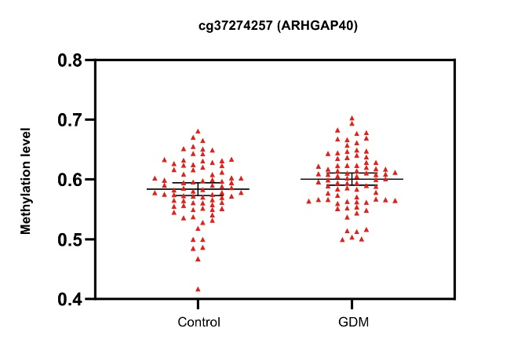
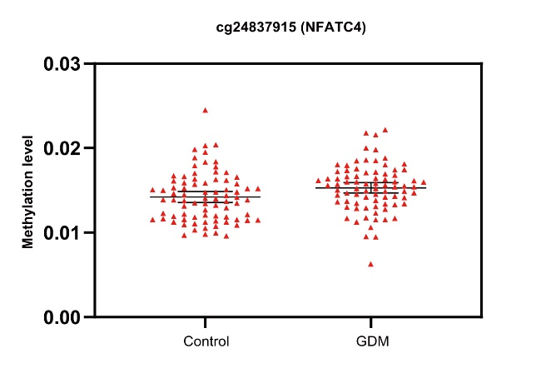
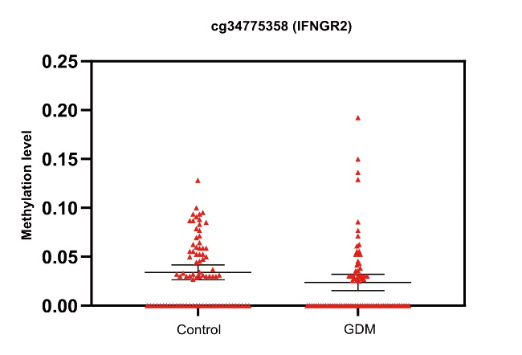
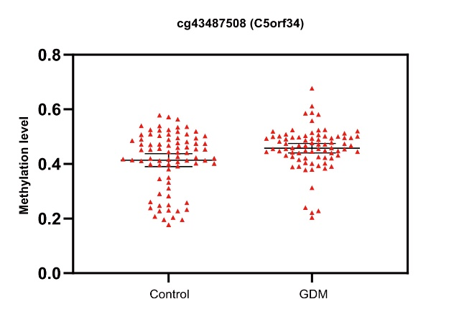
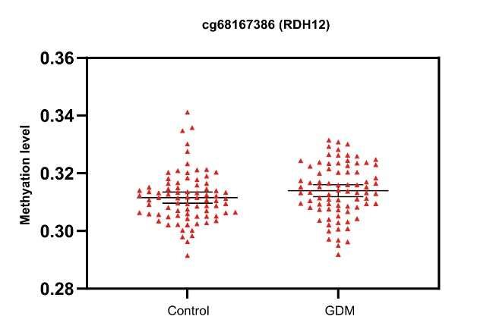
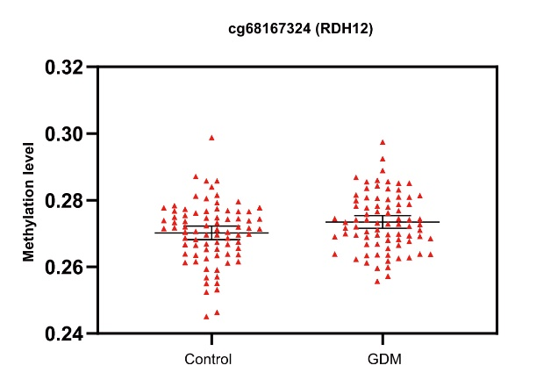
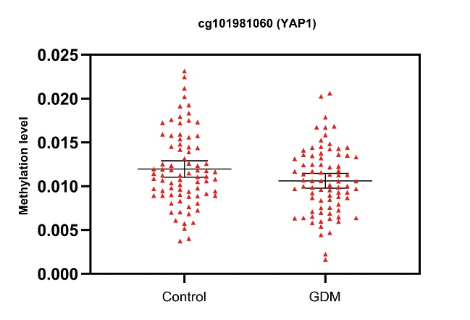
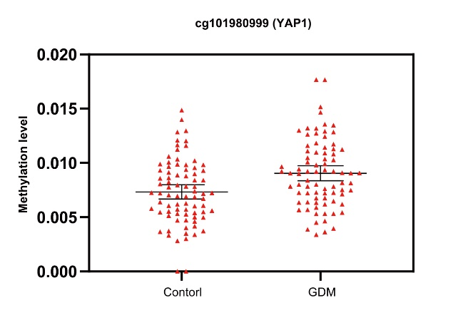

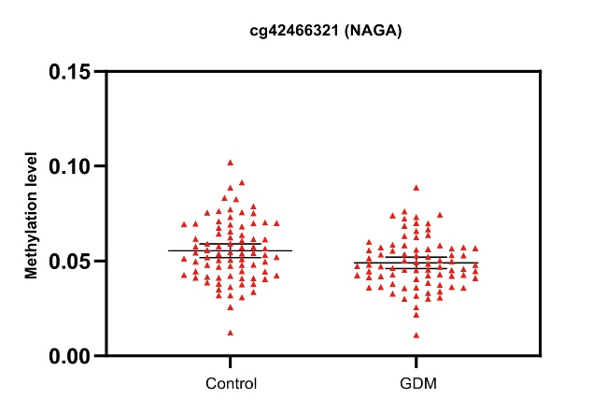
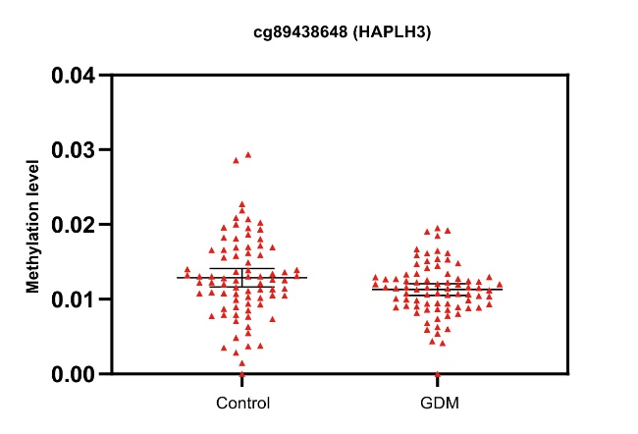
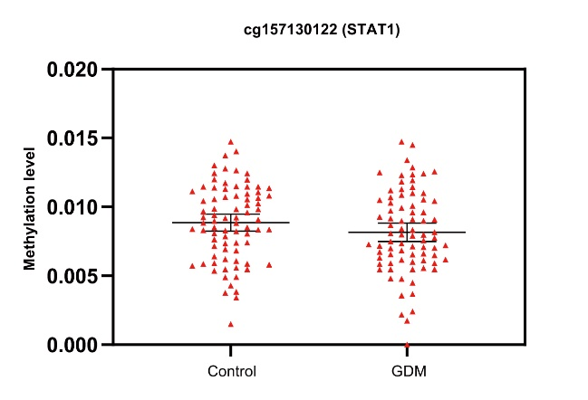
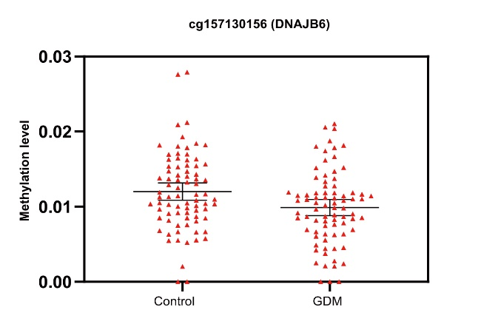
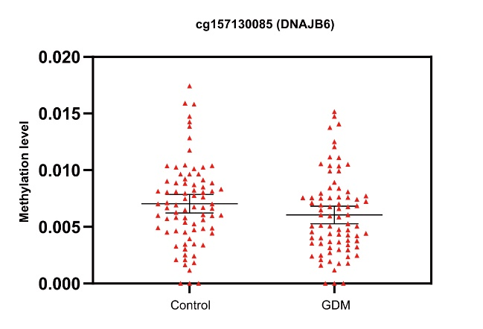

Supplementary Figure S1: DNA methylation level of different CpG sites in GDM and Control group.
Notes: Little red triangle means the methylation levels of samples and the three black lines means the mean±95%CI.

Reference

1. Enquobahrie DA, Moore A, Muhie S, et al. Early Pregnancy Maternal Blood DNA Methylation in Repeat Pregnancies and Change in Gestational Diabetes Mellitus Status-A Pilot Study. Reprod Sci 2015;22(7):904-10. doi: 10.1177/1933719115570903 [published Online First: 2015/02/14]
2. Wu P, Farrell WE, Haworth KE, et al. Maternal genome-wide DNA methylation profiling in gestational diabetes shows distinctive disease-associated changes relative to matched healthy pregnancies. Epigenetics 2018;13(2):122-28. doi: 10.1080/15592294.2016.1166321 [published Online First: 2016/03/29]
3. de la Garza AL, Etxeberria U, Palacios-Ortega S, et al. Modulation of hyperglycemia and TNFalpha-mediated inflammation by helichrysum and grapefruit extracts in diabetic db/db mice. Food Funct 2014;5(9):2120-8. doi: 10.1039/c4fo00154k [published Online First: 2014/07/09]
4. Naidoo V, Naidoo M, Ghai M. Cell- and tissue-specific epigenetic changes associated with chronic inflammation in insulin resistance and type 2 diabetes mellitus. Scandinavian journal of immunology 2018;88(6):e12723. doi: 10.1111/sji.12723 [published Online First: 2018/12/28]
5. Kang J, Lee CN, Li HY, et al. Association of Interleukin-10 Methylation Levels With Gestational Diabetes in a Taiwanese Population. Front Genet 2018;9:222. doi: 10.3389/fgene.2018.00222 [published Online First: 2018/07/11]
6. Li E, Luo T, Wang Y. Identification of diagnostic biomarkers in patients with gestational diabetes mellitus based on transcriptome gene expression and methylation correlation analysis. Reprod Biol Endocrinol 2019;17(1):112. doi: 10.1186/s12958-019-0556-x [published Online First: 2019/12/29]

