Supplementary Information for:

# UV light combined with nitrate remove bisphenol A: kinetics, transformation pathways, and acute toxicity assessment

Zhiquan Lia, Congwei Luoa,b*,Fengxun Tana, Daoji Wua,b, Shishun Wanga, Xiaoxiang Chenga, Fumiao Zhanga, Mingli Lia, Qiao Mac

a School of Municipal and Environmental Engineering, Shandong Jianzhu University, Jinan, 250101, P. R. China.

b Resources and Environment Innovation Institute，Shandong Jianzhu University, Jinan, 250101, P. R. China.

c National Engineering Lab of Coal-Fired Pollution Emission Reduction, School of Energy and Power Engineering, Shandong University, Jinan 250061, P. R. China

*Corresponding authors contact details:

Doc. Congwei Luo, Phone: 86-531-86367291, email: luocongwei2009@163.com

**Table of Contents**

**Text S1 Details of LC/MS/MS and the acute toxicity test method.**

**Text S2 Calculating the contributions from UV, ·OH, and RNS.**

**Table S1 [·OH]ss at different concentrations of NO3− in UV/nitrate process.**

**Table S2 Calculations of the contributions from UV, ·OH, and RNS in UV/nitrate process (Taking control experiment as an example).**

**Table S3 Actual waters quality information.**

**Table S4 Detected intermediate products of bisphenol A in UV/nitrate process.**

**Figure S1** **Removal ratios of BPA in sole NO3−, direct UV and UV/nitrate process.**

**Figure S2** **Removal ratios of UV, ·OH, and RNS in UV/nitrate process.**

**Figure S3** **Changes of TOC before and after reaction in UV/nitrate process.**

**Figure S4 LC/MS/MS results of BPA degradation in UV/nitrate process.**

**Text S1 Details of LC/MS/MS and the acute toxicity test method.**

The LC/MS/MS system was composed with Waters alliance 2695 XELC/MS/MS (Waters, Watford, UK), Zobax SB-C18 (5*μ*m, 4.6 mm × 250 mm, Agilent, USA). Separation was accomplished with a gradient mode: mobile phase A, water; mobile phase B, ACN; flow rate 0.3 mL/min, the ratio of A to B, 0~3min, 70:30; 3~4min, 70:30 to 95:5; 4~6min, 95:5 to 100:0; 6~25min, 100:0; 25~30min, 100:0 to 70:30. This method utilized ESI-LC/MS/MS operating in MRM mode. The Waters alliance 2695 Quattro Premier XE was used in negative ion ESI. The ESI settings were the following: capillary voltage, 3.5kV; cone voltage, 40V; the flow of desolvation gas (Argon gas), 800L/h; the flow of cone gas, 20L/h; collision energy, 20V.

In terms of the acute toxicity test method, 75 *μ*L osmotic pressure adjusting solution was added into 675 *μ*L sample and then 250 *μ*L resuscitated bacterial solution was added to each sample. Samples were mixed and measured after a certain interval of time. Note that methanol used in sample concentration for toxicity analysis was blown away and diluted in phosphate buffer.

**Text S2 Calculating the contributions from UV, ·OH, and RNS.**

(1) ${\text{R}}_{\text{UV}}\text{=}\int_{\text{0}}^{\text{t}}{{\text{k}}_{\text{UV,} \text{BPA}}\left[\text{BPA}\right]}\text{dt=}{\text{k}}_{\text{UV,} \text{BPA}}\left(\int_{\text{0}}^{{\text{t}}_{\text{1}}}{\left[\text{BPA}\right]}\text{dt+…+}\int_{{\text{t}}_{\text{n-1}}}^{{\text{t}}_{\text{n}}}{\left[\text{BPA}\right]}\text{dt}\right)$

(2) ${\text{R}}_{\text{∙OH}}\text{=}\int_{\text{0}}^{\text{t}}{{\text{k}}_{\text{∙OH,} \text{BPA}}{\left[\text{∙OH}\right]}_{\text{ss}}\left[\text{BPA}\right]\text{dt=}{\text{k}}_{\text{∙OH,} \text{BPA}}{\left[\text{∙OH}\right]}_{\text{ss}}}\int_{\text{0}}^{\text{t}}{\left[\text{BPA}\right]\text{dt}}$

$$\text{ =}{\text{k}}_{\text{∙OH,} \text{BPA}}{\left[\text{∙OH}\right]}_{\text{ss}}\left(\int_{\text{0}}^{{\text{t}}_{\text{1}}}{\left[\text{BPA}\right]\text{dt+…+}\int_{{\text{t}}_{\text{n-1}}}^{{\text{t}}_{\text{n}}}{\left[\text{BPA}\right]\text{dt}}}\right)$$

Where $\int_{{\text{t}}_{\text{n-1}}}^{{\text{t}}_{\text{n}}}{\left[\text{BPA}\right]}\text{dt}\text{=}\overline{\left[\text{BPA}\right]}\text{×}\left({\text{t}}_{\text{n}}\text{-}{\text{t}}_{\text{n-1}}\right)$, and $\overline{\left[\text{BPA}\right]}$ is the average concentration of BPA between time tn and tn-1.

(3) ${\text{R}}_{\text{RNS}}\text{=R-}{\text{R}}_{\text{UV}}\text{-}{\text{R}}_{\text{∙OH}}$

**Table S1 [·OH]ss at different concentrations of** **NO3− in UV/nitrate process.**

|  |  |  |  |  |  |
| --- | --- | --- | --- | --- | --- |
| NO3- (mM) | 0 | 10 | 20 | 30 | 50 |
| *k*obs, NB | 4.87510-5 | 5.09510-5 | 5.32410-5 | 6.92510-5 | 7.78010-5 |
| R2 | 0.991 | 0.998 | 0.980 | 0.998 | 0.998 |
| [·OH]ss (M) | - | 5.6410-16 | 1.1510-15 | 5.2610-15 | 7.4510-15 |

**Table S2 Calculations of the contributions from UV, ·OH, and RNS in UV/nitrate process (Taking control experiment as an example).**

|  |  |  |  |  |  |  |
| --- | --- | --- | --- | --- | --- | --- |
| Time (s) | [BPA]  (*μ*M) | $${\text{k}}_{\text{UV,} \text{BPA}}$$ $$\text{×}\int_{{\text{t}}_{\text{n-1}}}^{{\text{t}}_{\text{n}}}{\left[\text{BPA}\right]}\text{dt}$$ | RUV  (*μ*M) | $${\text{k}}_{\text{∙OH,} \text{BPA}}{\left[\text{∙OH}\right]}_{\text{ss}}$$ $$\text{×}\int_{{\text{t}}_{\text{n-1}}}^{{\text{t}}_{\text{n}}}{\left[\text{BPA}\right]}\text{dt}$$ | R·OH  (*μ*M) | RRNS  (*μ*M) |
| 0 | 30 | 0 | 0 | 0 | 0 | 0 |
| 300 | 29.03221 | 0.036898 | 0.036898 | 0.474755 | 0.474755 | 0.456137 |
| 600 | 27.63855 | 0.035422 | 0.072320 | 0.455764 | 0.930519 | 1.358611 |
| 1200 | 26.07389 | 0.067146 | 0.139466 | 0.863944 | 1.794463 | 1.992181 |
| 1800 | 24.79445 | 0.063591 | 0.203057 | 0.818198 | 2.612661 | 2.389833 |
| 2400 | 23.30352 | 0.060127 | 0.263184 | 0.773637 | 3.386298 | 3.046998 |
| 3000 | 22.00291 | 0.056638 | 0.319821 | 0.728737 | 4.115034 | 3.562234 |
| 3600 | 20.8828 | 0.053611 | 0.373433 | 0.689800 | 4.804835 | 3.938933 |

**Table S3 Actual waters quality information.**

|  |  |  |  |
| --- | --- | --- | --- |
| actual waters | surface water | groundwater | drinking water |
| TOC (mg-C/L) | 4.115 | 1.008 | 2.254 |
| total alkalinity (mg CaCO3/L) | 230.63 | 252.41 | 154.01 |
| NO3- (mg-N/L) | 10.418 | 11.41 | 3.67 |
| NO2- (mg-N/L) | 0.1 | nd | 0.003 |
| pH | 7.81 | 7.61 | 8.21 |

**Table S4 Detected intermediate products of bisphenol A in UV/nitrate process.**

|  |  |  |  |  |  |
| --- | --- | --- | --- | --- | --- |
| Compound | RT  (time) | [M-H]- | | Chemical  Formula | Proposed Structure |
| Theoretical m/z | Observed  m/z |
| B79 | 6.789 | 79.13 | 78.9 | C6H8 |  |
| B92 | 29.135 | 92.09 | 91.9 | C6H5O |  |
| B93 | 29.135 | 93.1 | 93.0 | C6H6O |  |
| B97 | 6.789 | 97.14 | 96.8 | C6H10O |  |
| B131 | 7.428 | 131.16 | 131 | C9H8O |  |
| B135 | 29.135 | 135.19 | 134.9 | C9H12O |  |
| B136 | 29.135 | 136.14 | 135.9 | C7H7O2N |  |
| B151 | 6.789 | 151.19 | 151.1 | C9H12O2 |  |
| B181 | 7.428 | 181.17 | 181.1 | C9H10O4 |  |
| B199 | 7.428 | 199.11 | 199.2 | C6H4O6N2 |  |



**Figure S1** Removal ratios of BPA in sole NO3−, direct UV and UV/nitrate process. Experimental conditions: [BPA] = 30 *μ*M, [NO3-] = 30 mM, pH = 7.0, [phosphate] = 5 mM, time = 3600 s, I = 0.172 mW cm-2.



**Figure S2** Removal ratios of UV, ·OH, and RNS in UV/nitrate process. Experimental conditions:[BPA] = 30 *μ*M, [NO3-] = 30 mM, pH = 7.0, [phosphate] = 5 mM, time = 3600 s, I = 0.172 mW·cm-2.



**Figure S3** Changes of TOC before and after reaction in UV/nitrate process. Experimental conditions:[BPA] = 30 *μ*M, [NO3-] = 30 mM, pH = 7, [phosphate] = 5 mM, time = 3600 s, I = 0.172 mW cm-2.

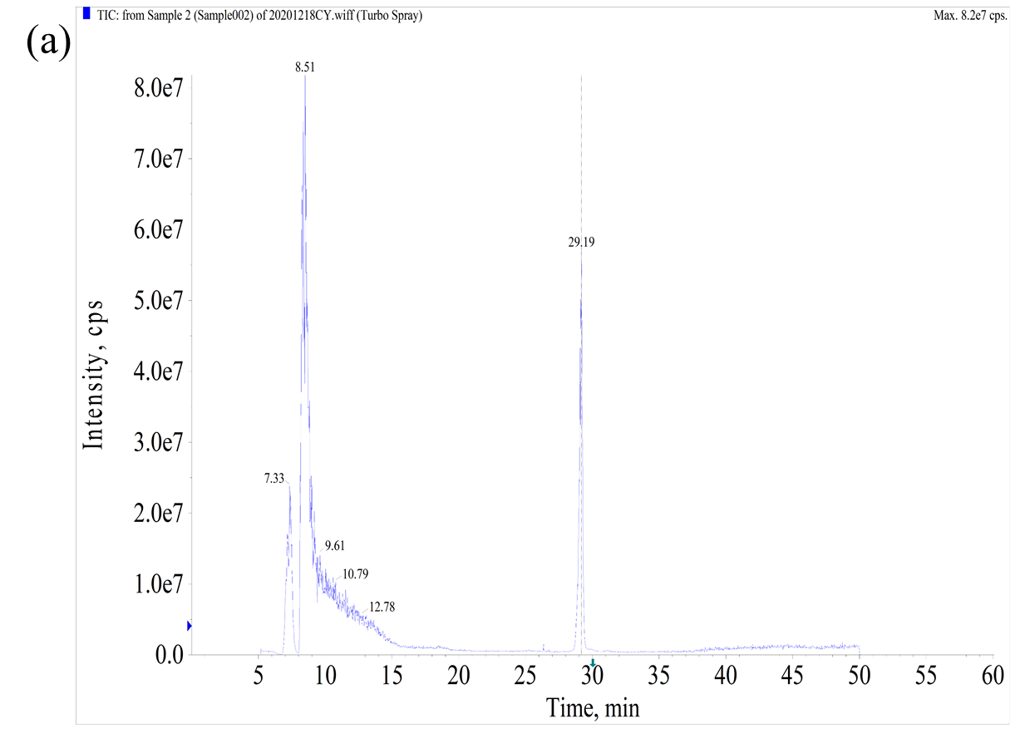

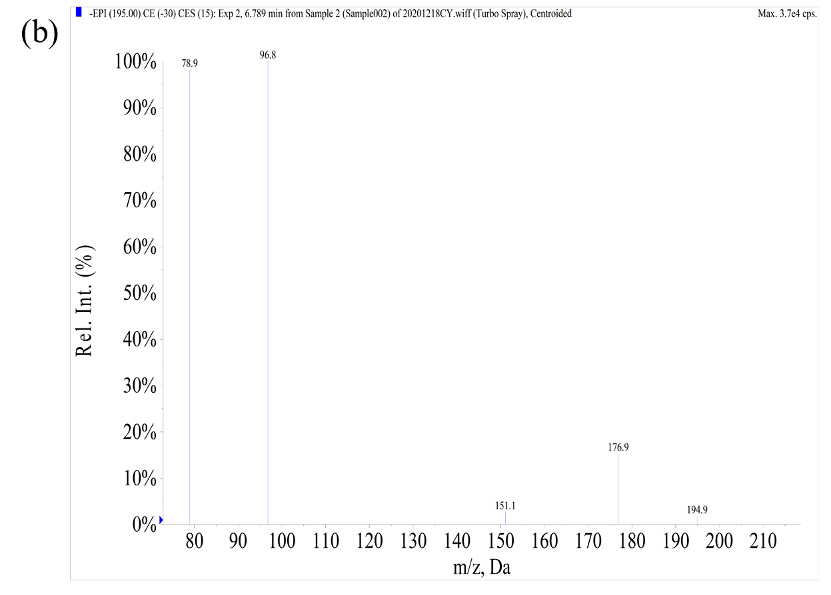

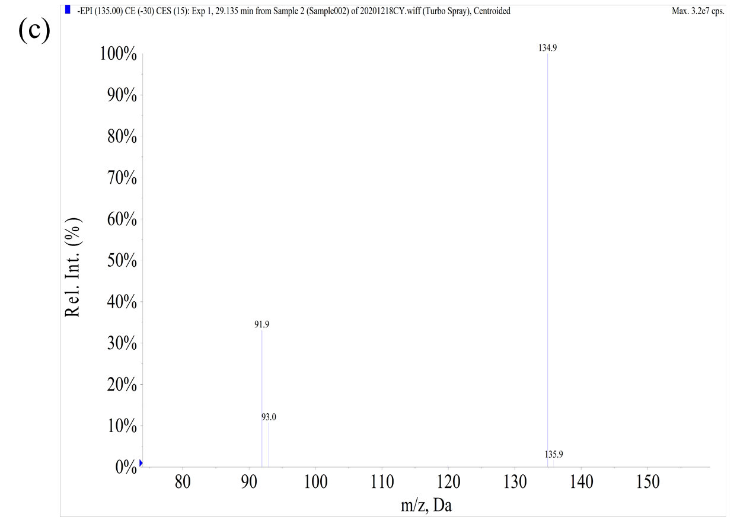

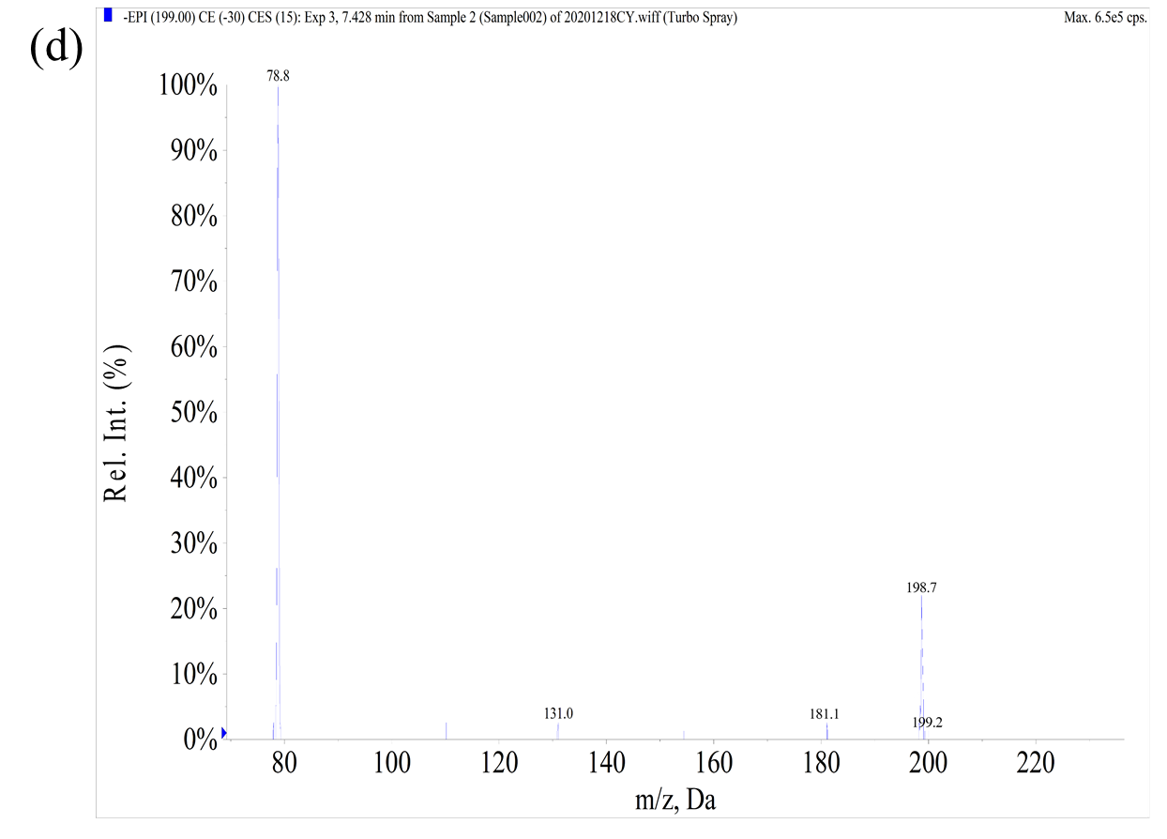

**Figure S4** LC/MS/MS results of BPA degradation in UV/nitrate process. (a) LC chromatogram of BPA in UV/nitrate process. (b) The mass spectra of B79, B97, B151. (c) The mass spectra of B92, B93, B135, B136. (d) The mass spectra of B131, B181, B199.