Supplementary Figure

Figure S1
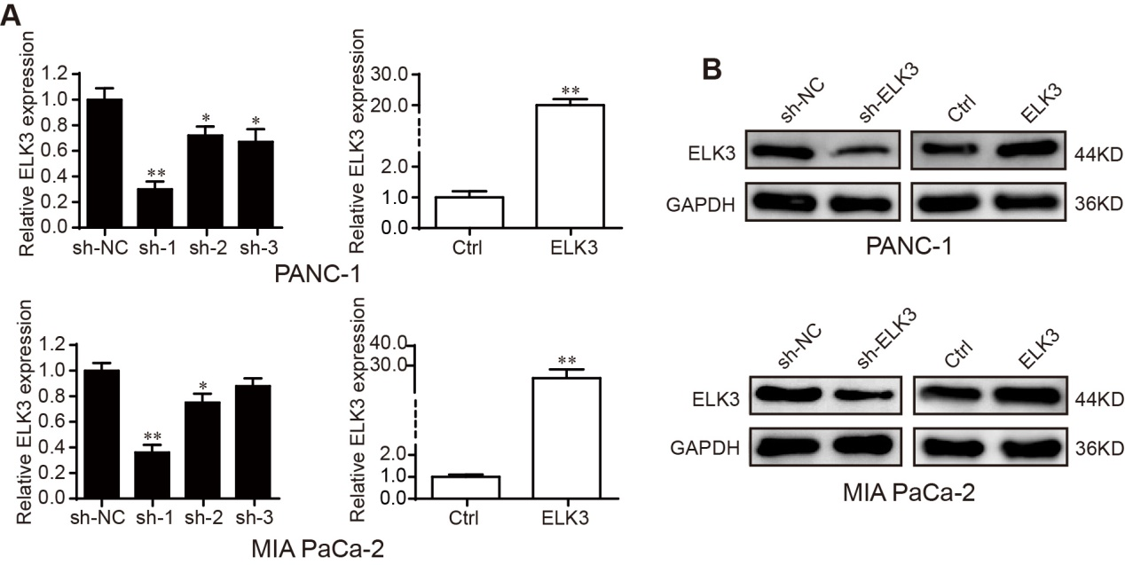

Figure S1 Verify the transfection efficiency of ELK3 in PDAC cells. (A) QRT-PCR analysis of relative ELK3 mRNA expression in stable PANC-1 and MIA PaCa-2 cells with ELK3 knockdown or ELK3 overexpression. (B) Western blot analysis confirming the ELK3 protein level in stable PANC-1 and MIA PaCa-2 cells with ELK3 knockdown or ELK3 overexpression. GAPDH was used as the loading control. Biological triplicate experiments were performed for each group. All data are presented as the mean ± SD. *P < 0.05, **P < 0.01.

Figure S2
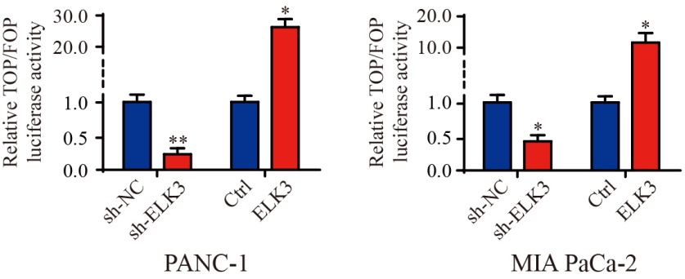
Figure S2 Relative TOP/FOP luciferase activity. TOP/FOP assay showing the activity of β-catenin in PANC-1 and MIA PaCa-2 cells after ELK3 was knockdown or overexpressed. Biological triplicate experiments were performed for each group. All data are presented as the mean ± SD. *P < 0.05, **P < 0.01.

Figure S3
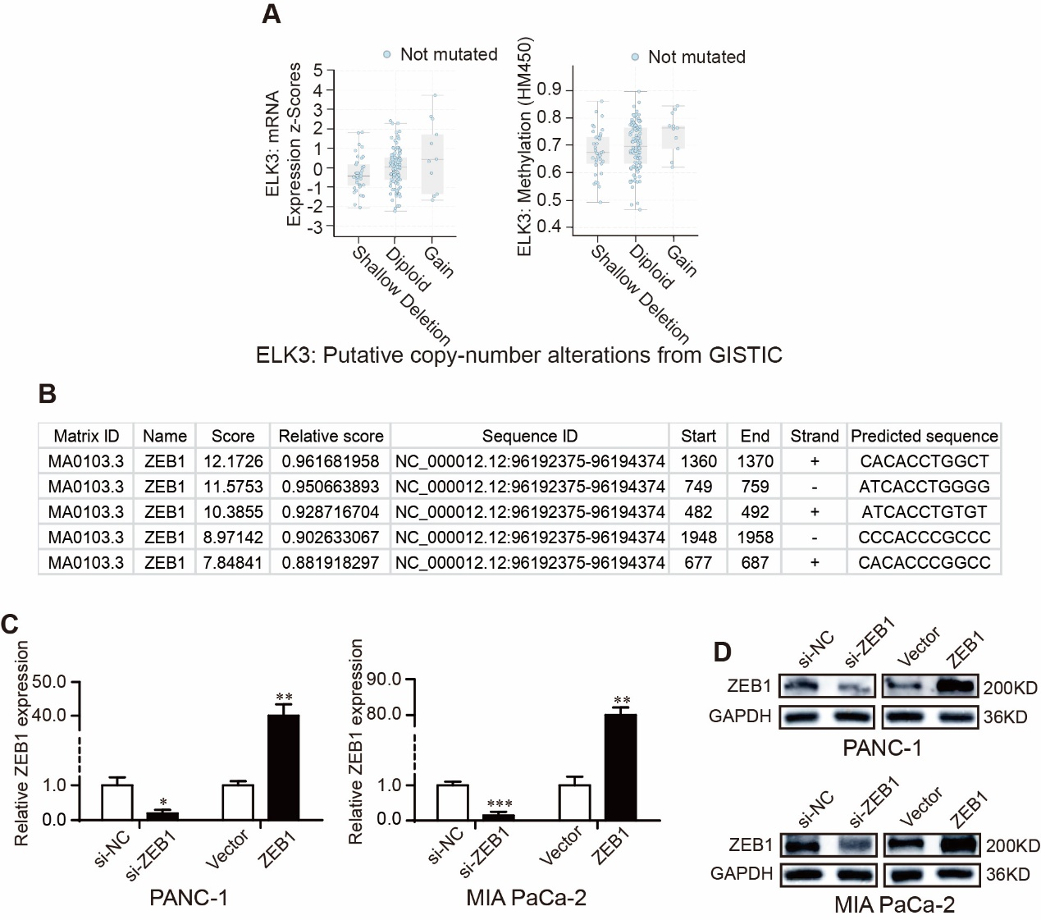

Figure S3 Analyze the gene signature of ELK3 and verify the transfection efficiency of ZEB1 in PDAC cells. (A) The correlation of ELK3 gene expression with its genetic and methylation levels in PDAC. (B) JASPAR database revealing the positions and sequences of five putative ZEB1 binding sites on the ELK3 promoter. (C) QRT-PCR analysis of ZEB1 mRNA in PANC-1 and MIA PaCa-2 cells transfected with si-ZEB1 or ZEB1 overexpression plasmid. (D) Western blot analysis of ZEB1 protein in PANC-1 and MIA PaCa-2 cells transfected with si-ZEB1 or ZEB1 overexpression plasmid, GAPDH was used as the loading control. Biological triplicate experiments were performed for each group. All data are presented as the mean ± SD. *P < 0.05, **P < 0.01.
Figure S4
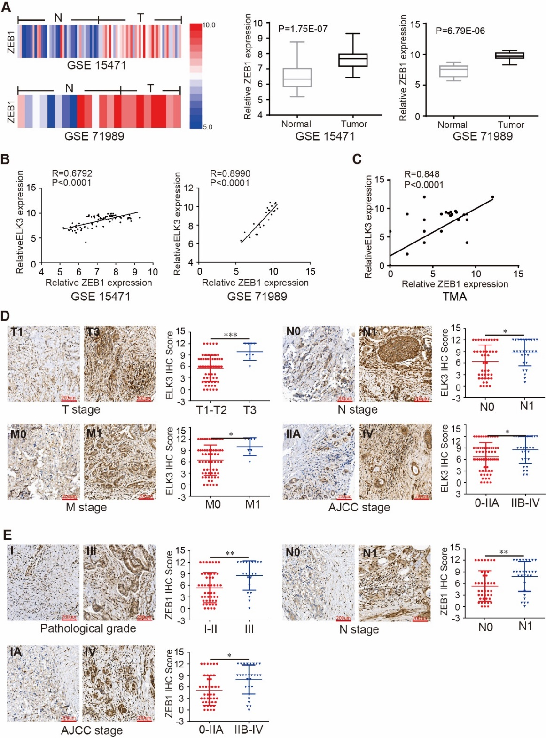
Figure S4 ZEB1 expression in pancreatic cancer tissues. (A) ZEB1 expression level in GEO datasets GSE15471 (T, n = 36; N, n = 36) and GSE71989 (T, n = 14; N, n = 8). (B) The correlation of ELK3 gene expression with ZEB1 in PDAC from GSE15471 and GSE71989. (C) Positive correlation between ZEB1 and ELK3 in TMAs, as detected by IHC scores (R = 0.848, P < 0.0001). (D) Representative IHC images and IHC scores of ELK3 in TMA samples of T1-T2 vs T3 stage, N0 vs N1 stage, distant metastasis M0 vs M1 stage and AJCC 0-IIA vs IIB-IV stage (scale bar: 200 μm; magnification: 200 x). (E) Representative IHC images and IHC scores of ZEB1 in TMA samples of pathological grade I-II vs III, N0 vs N1 stage and AJCC 0-IIA vs IIB-IV stage (scale bar: 200 μm; magnification: 200 x). *P <0.05, **P < 0.01, ***P < 0.001.

