Real-time and on-line parallel detection of key fermentation process parameters by near-infrared spectroscopy in different environments

Chen Yangª, Chen Lingliª, Guo Meijinª, Li Xu^{a*}, Zeng Wei^{b}, Chen Zhongbing^{c}, Tian Xiwei^{a*}, Chu Juª, Zhuang Yingping^{a,d}
ª State Key Laboratory of Bioreactor Engineering, East China University of Science and Technology, Shanghai 200237, China,
^{b}Yidu HEC Biochem. Co. Ltd., Hubei 443300, PR China,
^{c} Zhejiang Biok Co.Ltd, Zhongguan Industrial Park, Zhejiang, PR China,
^{d} Frontiers Science Center for Materiobiology and Dynamic Chemistry, East China University of Science and Technology, Shanghai 200237, China

*Author for correspondence
Address:
Xiwei Tian, Xu Li
State Key Laboratory of Bioreactor Engineering, East China University of Science and Technology
P.O. box 329, 130 Meilong Road, Shanghai 200237, People’s Republic of China
Tel: +86-21-64253021; Tel: +86-21-64253853
E-mail address: tahfy@163.com (Xiwei Tian), xli@ecust.edu.cn (Xu L)

Supplementary materials
1. NIR absorption signals of different wavelengths
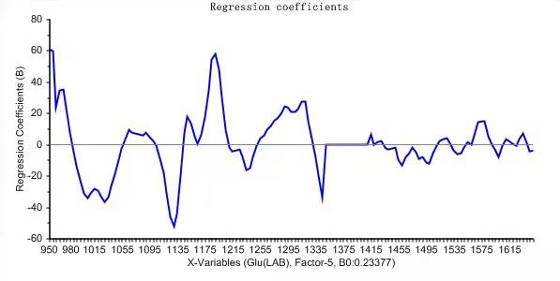
Fig. S1. Absorption signals of glucose in L-LA fermentation broth at NIR wavelengths
Fig. S2. Absorption signals of L-LA in L-LA fermentation broth at NIR wavelengths
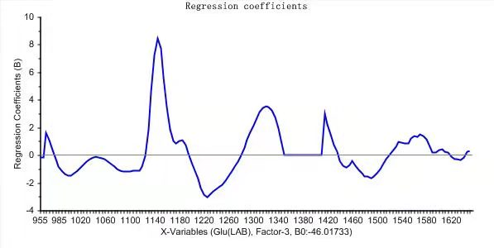
Fig. S3. Absorption signals of glucose in SLs fermentation broth at NIR wavelengths
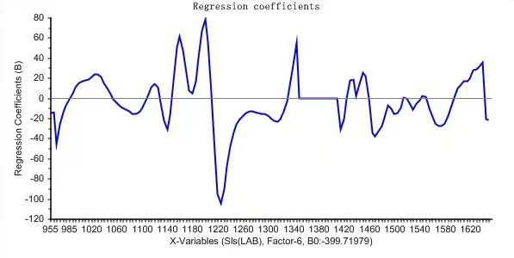
Fig. S4. Absorption signals of SLs in SLs fermentation broth at NIR wavelengths
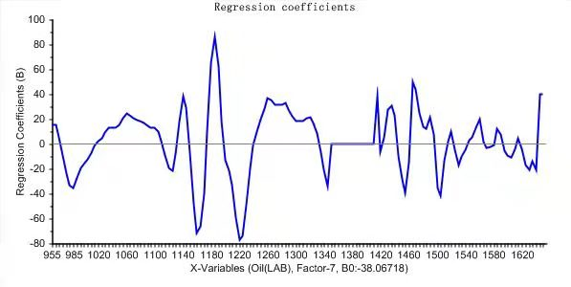
Fig. S5. Absorption signals of oil in SLs fermentation broth at NIR wavelengths
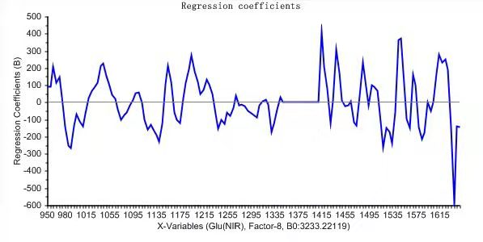
Fig. S6. Absorption signals of glucose in SG fermentation broth at NIR wavelengths
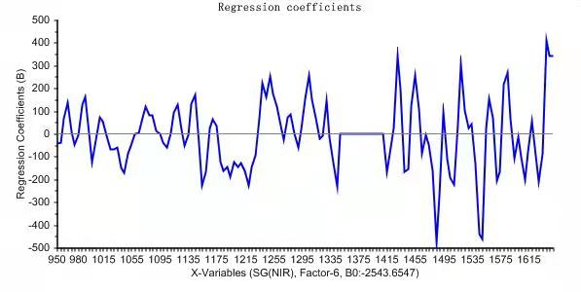
Fig. S7. Absorption signals of SG in SG fermentation broth at NIR wavelengths
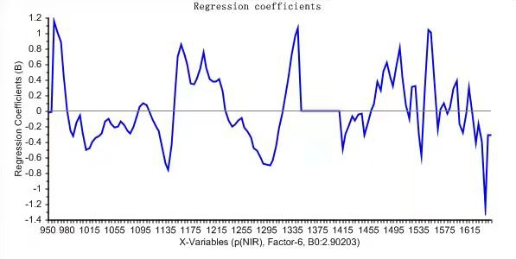
Fig. S8. Absorption signals of NH in SG fermentation broth at NIR wavelengths
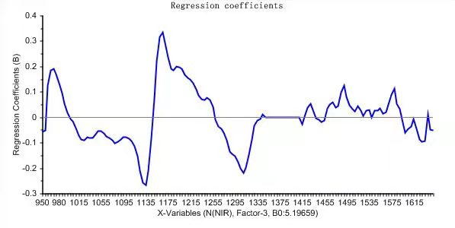
Fig. S9. Absorption signals of NH₄⁺ in SG fermentation broth at NIR wavelengths

2. validation of model performance index
Table S1 Spectral validation of model performance index
 | L-LA fermentation |  | SLs fermentation |  |  | SG fermentation
 | Glu | L-LA | Glu | SLs | Oil | Glu | SG | NH₄⁺ | P
RMSEP | 5.118 | 4.381 | 6.364 | 5.743 | 0.673 | 9.304 | 34.015 | 0.107 | 0.102
R² | 0.99 | 0.95 | 0.92 | 0.98 | 0.98 | 0.97 | 0.80 | 0.90 | 0.95

