Supplemental Information
Enzymatic activities and analysis of a mycelium-based composite formation using peach palm (Bactris gasipaes) residues on Lentinula edodes
Gabriel Goetten de Lima ^{a-b *}, Zaira Chiodini Pedri Schoenherr ^{c}, Washington Luiz Esteves Magalhães ^{a,d}, Lorena Benathar Ballod Tavares ^{c}, Cristiane Vieira Helm ^{d}
ª Programa de Pós-Graduação em Engenharia e Ciência dos Materiais - PIPE, Universidade Federal do Paraná, Curitiba, Paraná, Brazil
^{b} Materials Research Institute, Athlone Institute of Technology, Athlone, Ireland
^{c} Programa de Pós-Graduação em Engenharia Ambiental - PPGEA, Universidade Regional de Blumenau, Blumenau, Santa Catarina, Brazil
^{d} Embrapa Florestas, Colombo, Brazil
* corresponding author: ggoetten@research.ait.ie

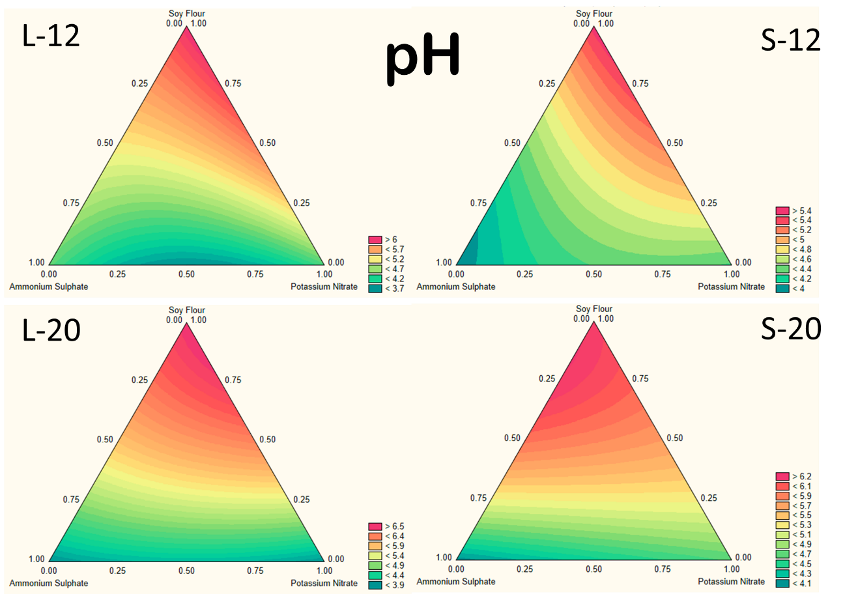
Fig. A.1. Surface contour plot of pH evaluation under different treatments using the studied inoculum solid (S) or liquid (L) and time periods of 12 and 20 days.
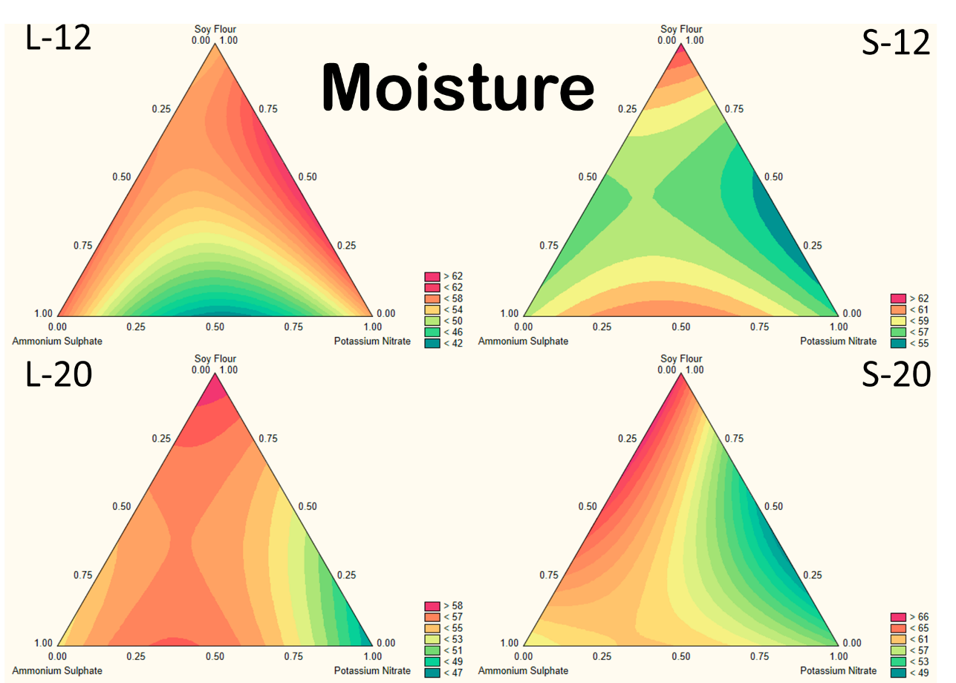
Fig. S.2. Surface contour plot of Moisture evaluation under different treatments using the studied inoculum solid (S) or liquid (L) and time periods of 12 and 20 days.
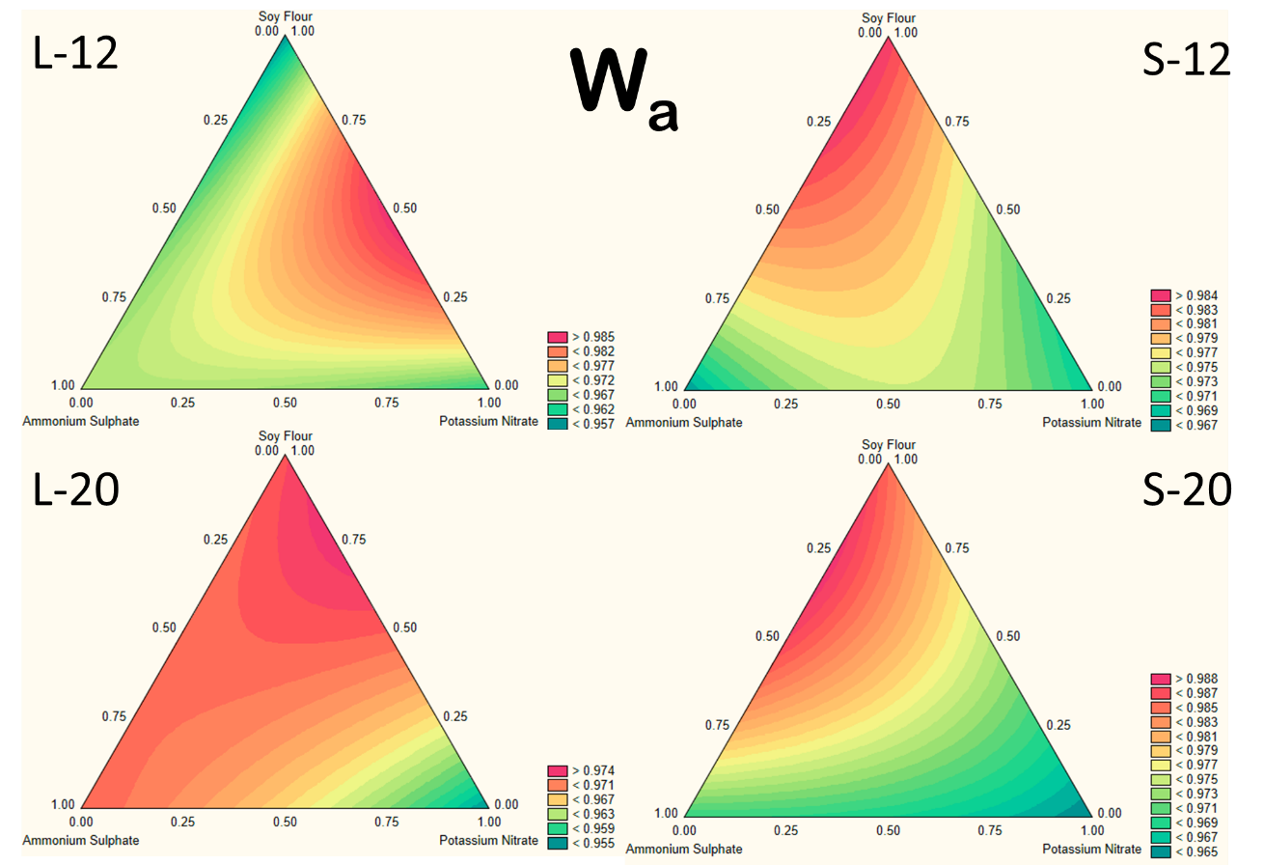
Fig. S.3. Surface contour plot of W_{a} evaluation under different treatments using the studied inoculum solid (S) or liquid (L) and time periods of 12 and 20 days.
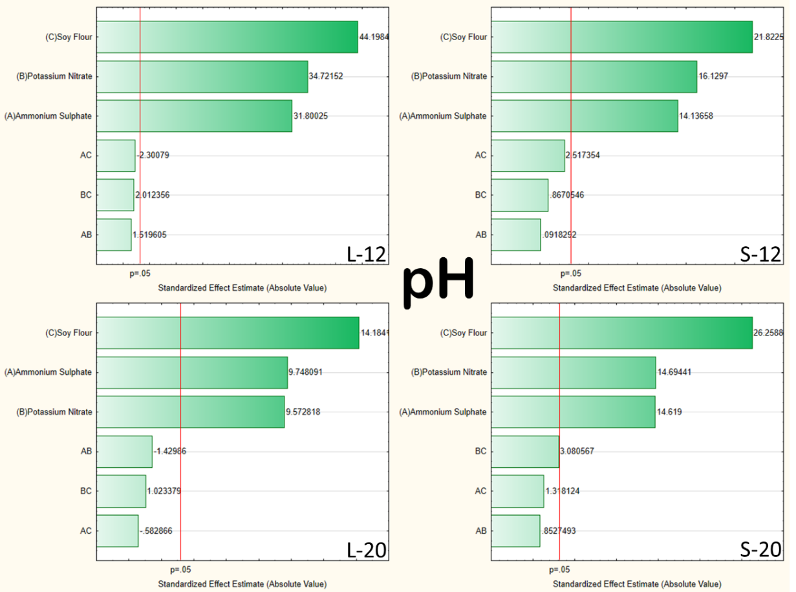
Fig. S.4. Pareto diagram for the studied treatments influence on pH values using inoculum solid (S) or liquid (L) and time periods of 12 and 20 days
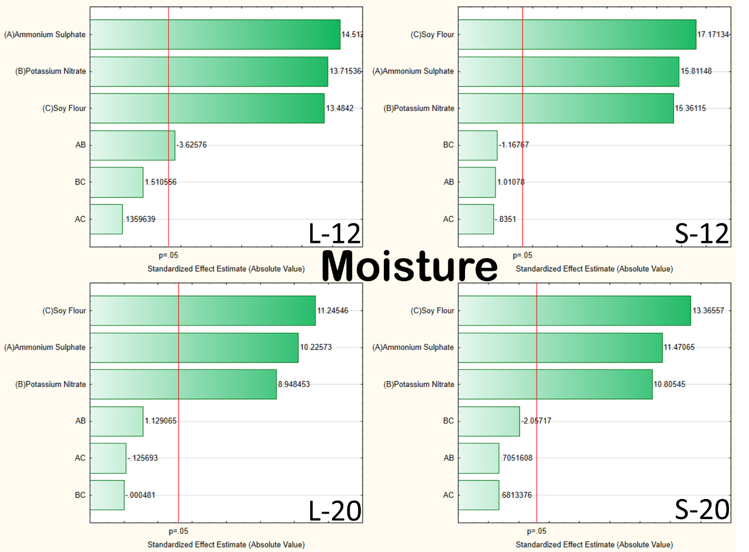
Fig. S.5. Pareto diagram for the studied treatments influence on moisture values using inoculum solid (S) or liquid (L) and time periods of 12 and 20 days
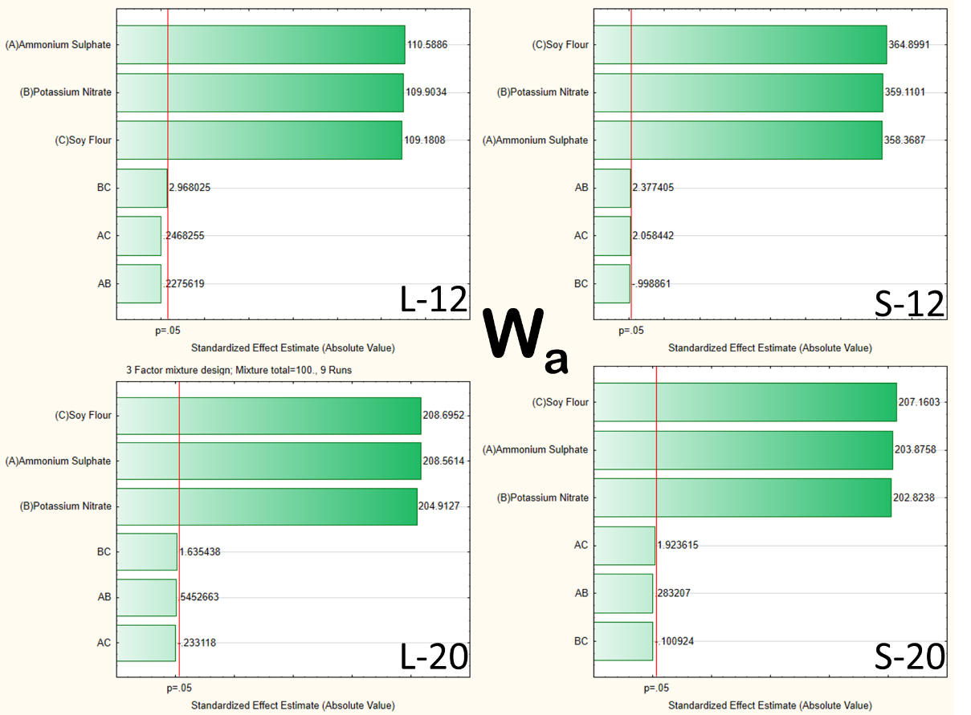
Fig. S.6. Pareto diagram for the studied treatments influence on W_{a} values using inoculum solid (S) or liquid (L) and time periods of 12 and 20 days
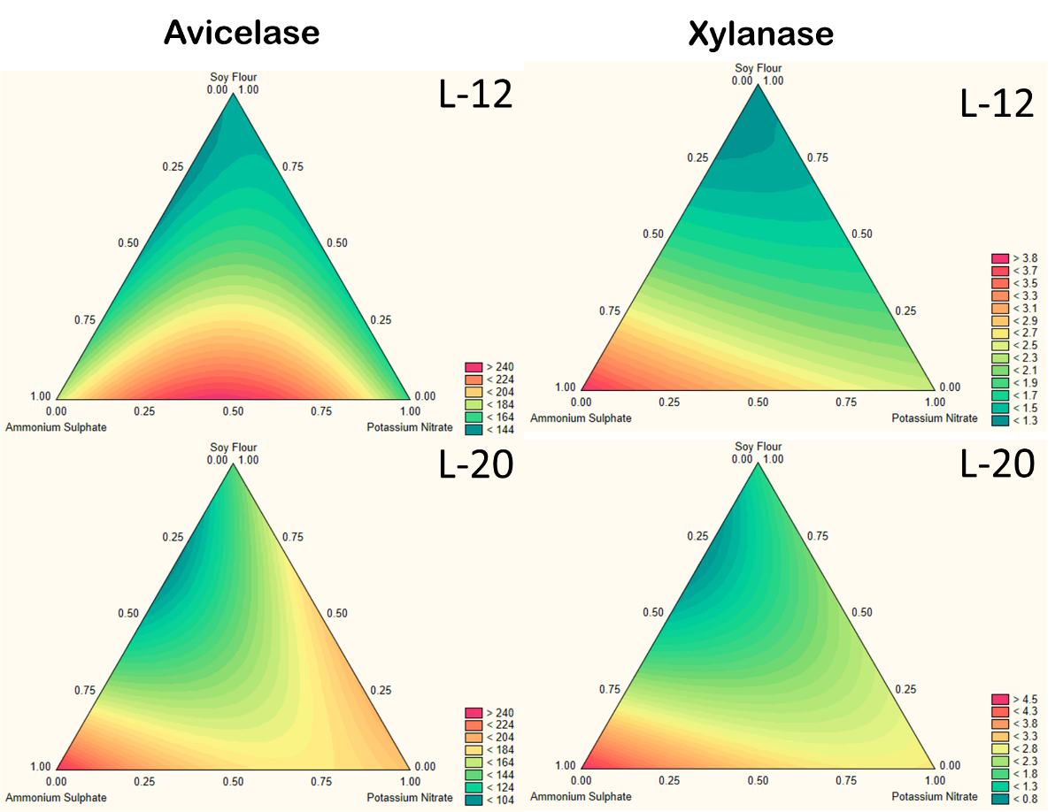
Fig. S.7. Surface contour plot of avicelase and xylanase activities under different treatments using the liquid (L) inoculum and time periods of 12 and 20 days.
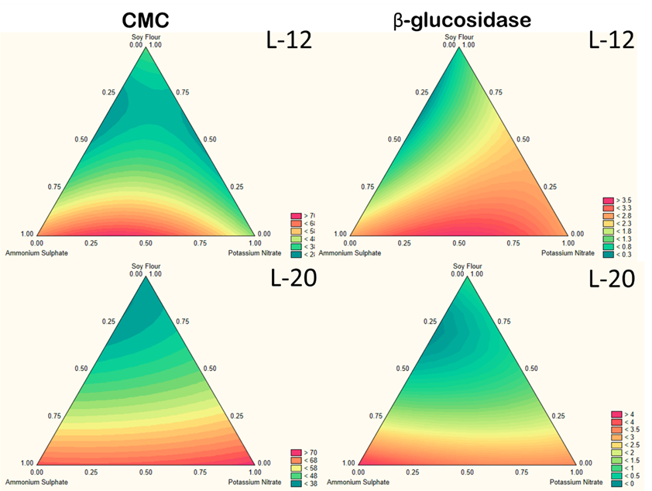
Fig. S.8. Surface contour plot of CMC and β-glucosidase activities under different treatments using the liquid (L) inoculum and time periods of 12 and 20 days.
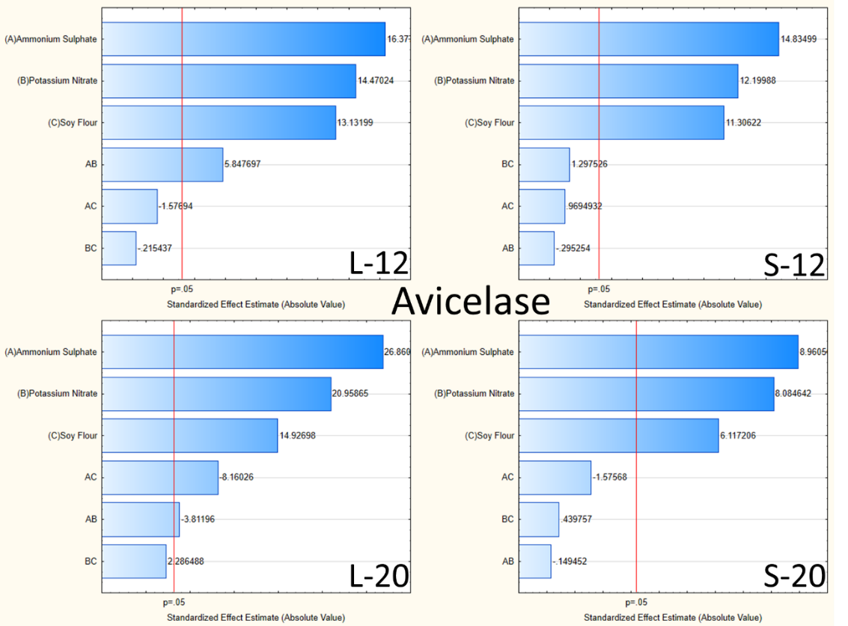
Fig. S.9. Pareto diagram for the studied treatments influence on enzymatic activity avicelase values using inoculum solid (S) or liquid (L) and time periods of 12 and 20 days
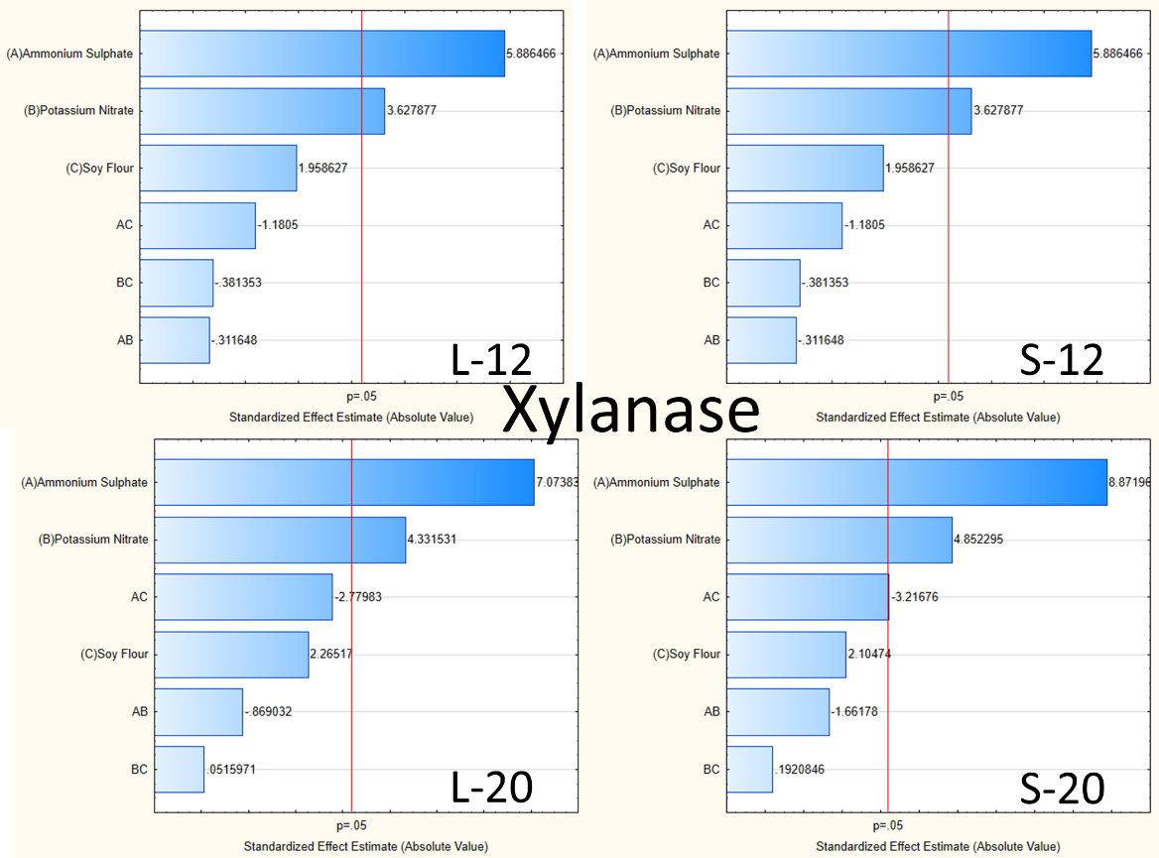
Fig. S.10. Pareto diagram for the studied treatments influence on enzymatic activity xylanase values using inoculum solid (S) or liquid (L) and time periods of 12 and 20 days

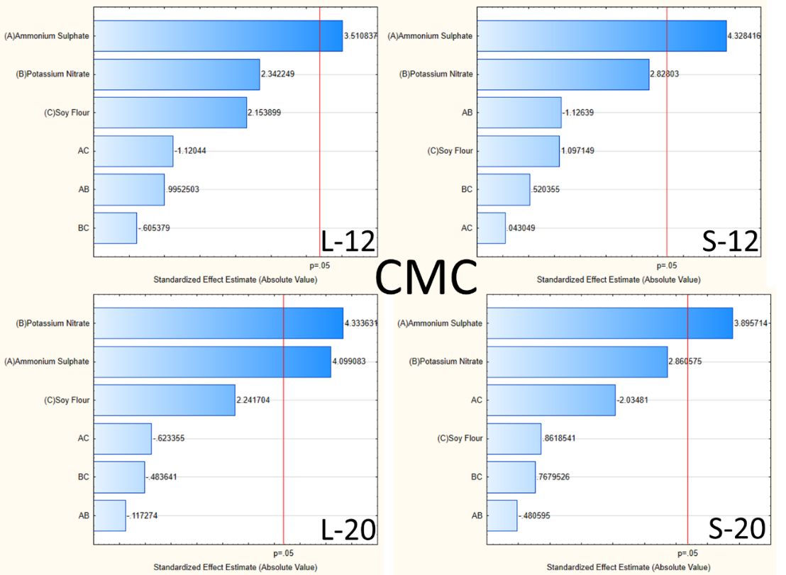
Fig. S.11. Pareto diagram for the studied treatments influence on enzymatic activity CMC values using inoculum solid (S) or liquid (L) and time periods of 12 and 20 days
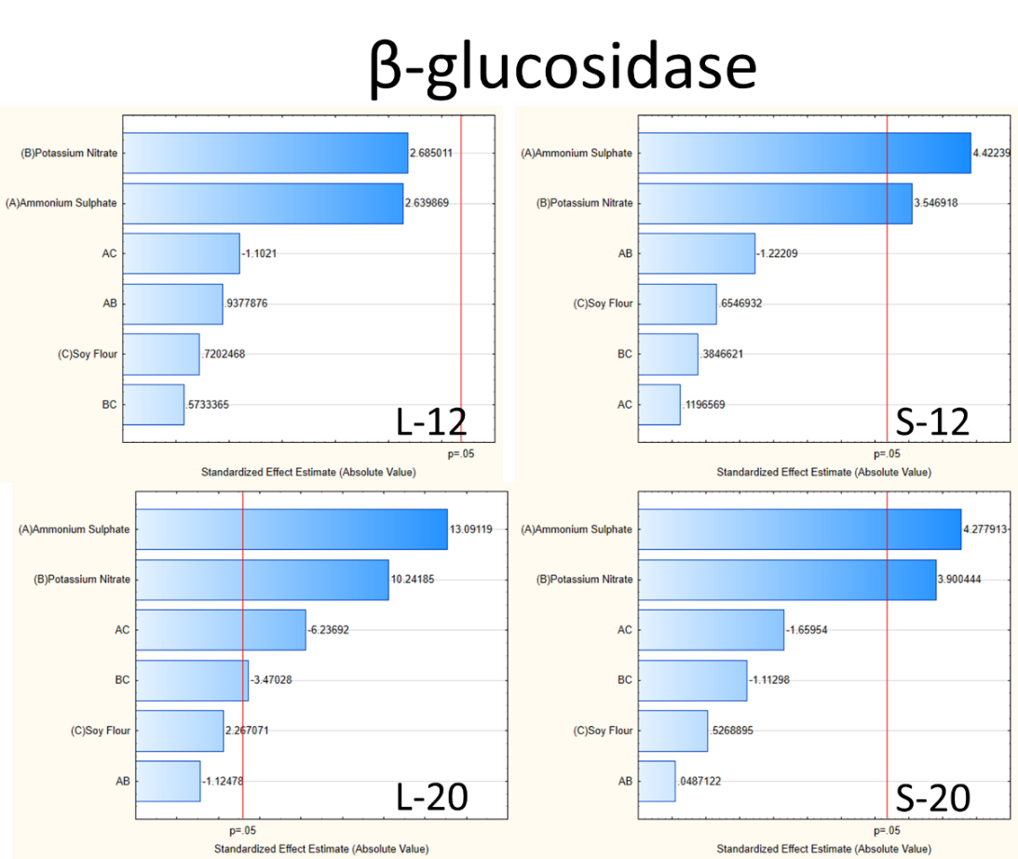
Fig. S.12. Pareto diagram for the studied treatments influence on enzymatic activity β-glucosidase values using inoculum solid (S) or liquid (L) and time periods of 12 and 20 days.
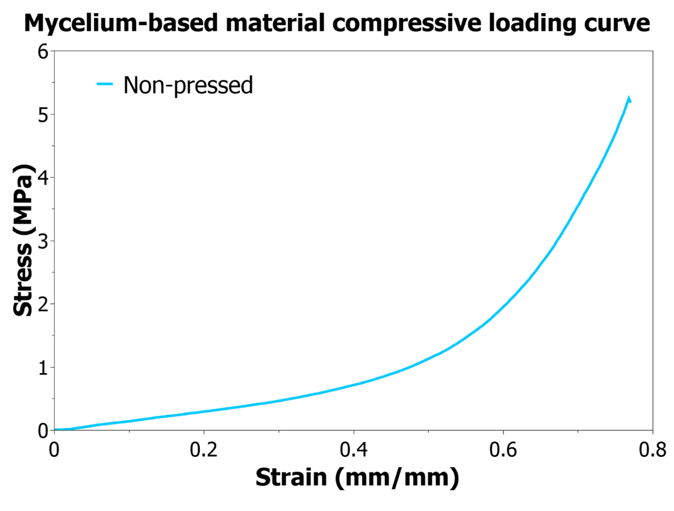
Fig. S.13. Compressive stress-strain response for the studied mycelium-based composite non-pressed sample.

