Supplementary Information
for
Macroscale robust superlubricity on metallic NbB₂
Jia Wang^{1, 2†}, Chang Liu^{3†}, Kaifei Miao¹, Kan Zhang^{1*}, Weitao Zheng¹ and Changfeng Chen⁴
¹State Key Laboratory of Superhard Materials, Department of Materials Science and Key Laboratory of Automobile Materials, MOE, Jilin University, Changchun 130012, China
²Department of Materials Science and Engineering, Jilin Jianzhu University, Changchun 130118, China
³International Center for Computational Methods & Software, College of Physics, Jilin University, Changchun 130012, China
⁴Department of Physics and Astronomy, University of Nevada, Las Vegas, Nevada 89154, USA
†These authors contributed equally to this work

Supplementary Figure S1. Structural characterization of synthesized NbB₂ film.
(a) X-ray diffraction (XRD) pattern. A strong peak at 27.5° accompanied by a weak peak at 56.5° are identified as originating from the (001) and (002) diffraction of the hexagonal NbB₂ structure (JCPDF: 65-0512), respectively. The clean and sharp XRD peaks indicate good crystallinity with a strong structural texture. (b) An HRTEM image of the NbB₂ film. Lattice fringes with a d spacing of approximately 1.66 Å correspond to the (002) planes in the hexagonal NbB₂, corroborating the structural assignment from the XRD results. (c) A cross-sectional SEM image of the NbB₂ film. To enhance film-substrate adhesion, an Nb/NbN interlayer about 500 nm in thickness is introduced between the film and the substrate. The thickness of the NbB₂ film is about 720 nm. (d) An AFM 3D micrograph of the NbB₂ film. The root-mean-square roughness (R_{q}) is about 1.58 nm.
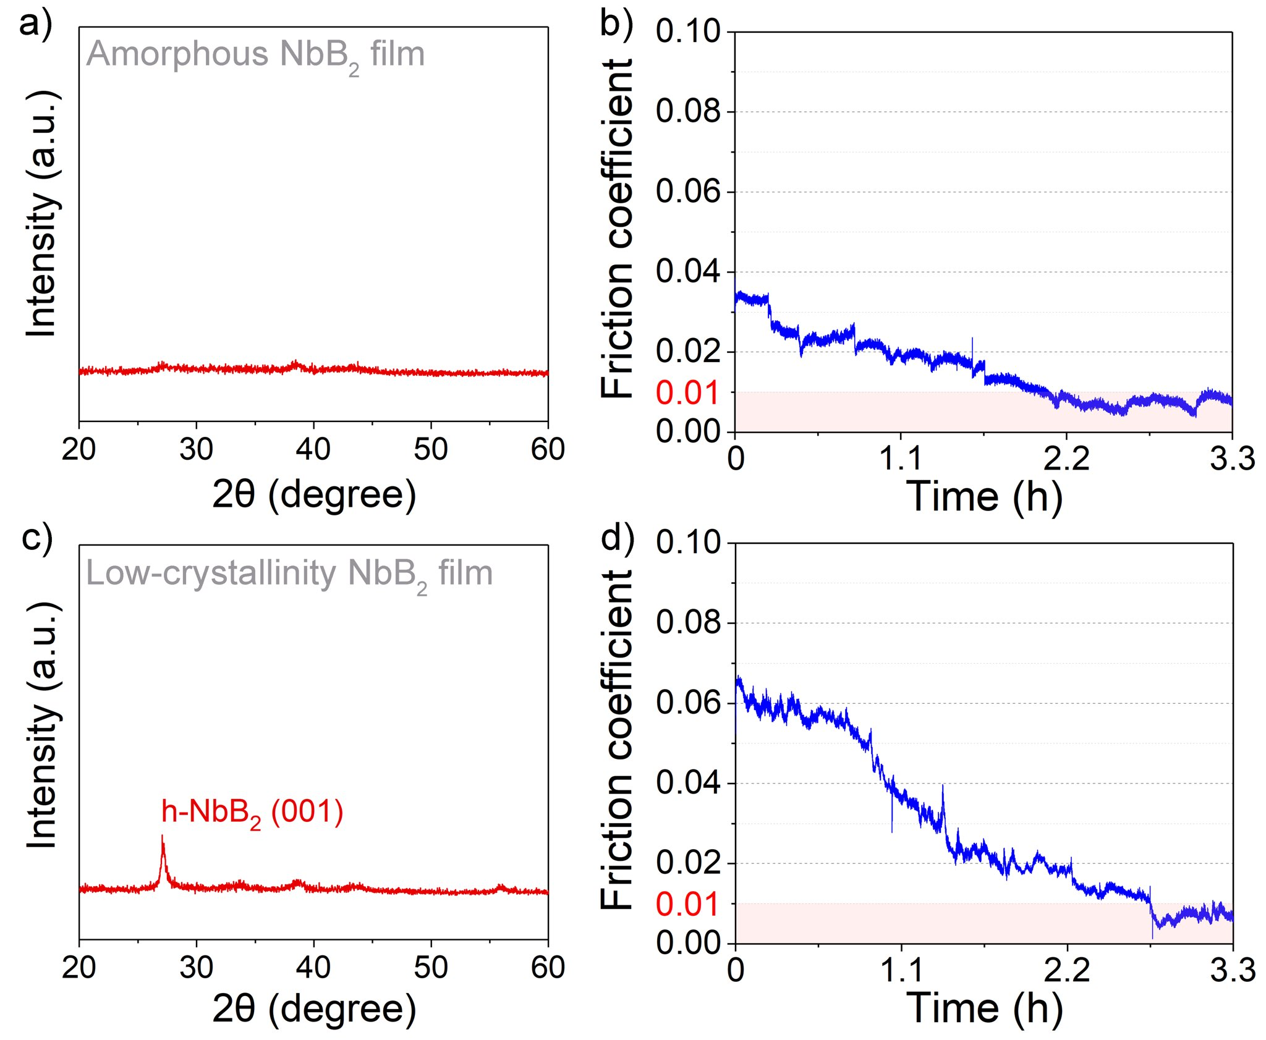

Supplementary Figure S2. Tribotests of NbB₂ films in less crystallized forms.
(a) The XRD pattern of a NbB₂ film in typical amorphous structure. (b) Dynamic friction coefficient of the amorphous NbB₂ film in the three-phase contact mode. After a break-in period around 2.0 hours, the friction coefficient drops below 0.01, entering an SL state that lasts for the subsequent test period with an average friction coefficient of 0.0076. (c) The XRD pattern of a NbB₂ film with low crystallinity compared to that shown in Figure S1(a). (d) Dynamic friction coefficient of the low-crystallinity NbB₂ film in the three-phase contact mode. After a break-in period of about 2.8 hours, the film enters an SL state with an average friction coefficient of 0.0069.

Supplementary Figure S3. Tribological behaviors of NbB₂ films in dry or fully water-covered frictional environments.
(a) Dynamic friction coefficient of the NbB₂ film in good crystallinity measured in a dry frictional environment. The mean friction coefficient of the NbB₂ film during the stabilization period is approximately 0.66. Optical microscope images of (b) the film wear track and (c) the counterpart ball wear scar, both revealing notable abrasions. A significant accumulation of wear debris accompanied by some degree of adhesion is seen on the edge of the wear track and wear scar. (d) Raman spectra of the wear track, original NbB₂ film and wear scar in the dry frictional environment. A comparison of the Raman signals from the wear track and the wear scar after the tribotest finds no significant changes at the wear track center, indicating that the wear track maintains an oxidized state during the friction process. (e) Dynamic friction coefficient of the NbB₂ film in good crystallinity measured in a fully water-covered frictional environment. The mean friction coefficient of the NbB₂ film during the stabilization period is approximately 0.59. Optical microscope images of (f) the film wear track and (g) the counterpart ball wear scar, showing no wear debris attached on the wear track, likely caused by the scouring effect of water. There is also no obvious wear debris accumulation at the center of the ball wear scar. (h) Raman spectra of the wear track, original NbB₂ film and wear scar in the fully water-covered frictional environment. Raman spectra taken after the tribotest show reduction of signals belonging to Nb₂O₅ and H₃BO₃ at the center of the wear track and wear scar compared to those of the original NbB₂ film, indicating that under the influence of an ample amount of water, few tribo-products remain at the frictional interface.

Supplementary Figure S4. Tyndall effect of the tribo-liquid collected after the tribotest in the three-phase contact environment.
(a) When the tribo-liquid is irradiated directly under an infrared light, it exhibits a red optical pathway, showcasing the classic Tyndall effect indicating that a certain concentration of charged colloids exists in the tribo-liquid¹. (b) When an electrolyte solution (NaCl) is injected into the tribo-liquid, the discernible beam path disappears, indicating that the colloidal stability of an electrostatically stabilized dispersion has been broken down.
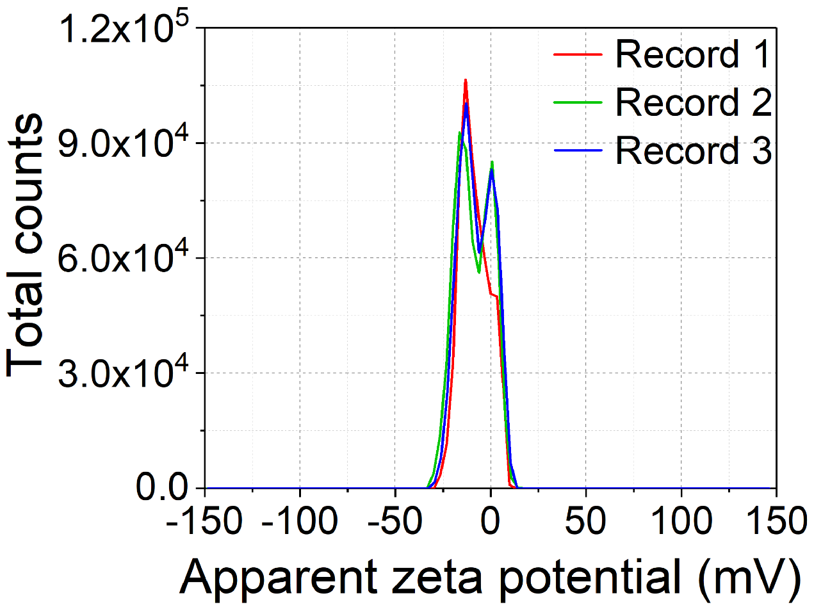

Supplementary Figure S5. Zeta potential distributions of the tribo-liquid.
The zeta potential distributions of the tribo-liquids collected after the tribotests; the results shift to negative values with an average of -8.45 mV.

Supplementary Figure S6. Three-phase contact formed between the tribopairs at the surface of the NbB₂ film in a controlled high-humidity environment.
In a controlled high-humidity environment, a three-phase contact has been formed between the tribopairs. The moisture from the humid environment gathers on the film surface and covers the contact area between the tribopairs, forming the same type of “water bridge” achieved by directly adding a water droplet between the tribopairs. This result shows that a steady-state three-phase contact can realize naturally at the dynamic friction interface in a high-humidity environment.

Reference
[1] Li, D., Muller, M. B., Gilje, S., Kaner, R. B. & Wallace, G. G. Processable aqueous dispersions of graphene nanosheets. Nat. Nanotechnol. 3, 101-105 (2008).

