Supplemental Information:

Tables:
Table S.1.
Correlation table for underground coal mines in the U.S., 1986-2018 (# of Observations = 29,707).
Row | Categories | Variable | Number of CWP | CWP rate | Appalachia | Interior | Western | Small | Medium | Large | Thin seam | Medium seam | Thick seam | Bituminous | Anthracite
1 | CWP number  and rate | Number of CWP | 1.00
2 |  | CWP rate | 0.05¹ | 1.00
3 | Geographic location | Appalachia | -0.01 | 0.00 | 1.00
4 |  | Interior | 0.03¹ | 0.00 | -0.70¹ | 1.00
5 |  | Western | -0.02¹ | 0.00 | -0.69¹ | -0.03¹ | 1.00
6 | Mine size | Small | -0.17¹ | 0.01 | 0.29¹ | -0.24¹ | -0.16¹ | 1.00
7 |  | Medium | 0.02¹ | 0.00 | -0.05¹ | 0.02¹ | 0.05¹ | -0.61¹ | 1.00
8 |  | Large | 0.19¹ | 0.00 | -0.31¹ | 0.28¹ | 0.16¹ | -0.72¹ | -0.12¹ | 1.00
9 | Seam thickness | Thin seam (≤40”) | -0.06¹ | -0.01 | 0.15¹ | -0.10¹ | -0.10¹ | 0.26¹ | -0.13¹ | -0.21¹ | 1.00
10 |  | Medium seam (>40, ≤75”) | 0.01² | 0.01 | 0.12¹ | -0.02¹ | -0.15¹ | -0.05¹ | 0.08¹ | -0.01² | -0.73¹ | 1.00
11 |  | Thick seam (>75”) | 0.05¹ | 0.00 | -0.36¹ | 0.16¹ | 0.35¹ | -0.27¹ | 0.05¹ | 0.29¹ | -0.25¹ | -0.48¹ | 1.00
12 | Coal rank | Bituminous | 0.02¹ | 0.00 | -0.05¹ | 0.04¹ | 0.04¹ | -0.11¹ | 0.06¹ | 0.08¹ | 0.07¹ | -0.02¹ | -0.06¹ | 1.00
13 |  | Anthracite | -0.02¹ | 0.00*** | 0.05¹ | -0.04¹ | -0.04¹ | 0.11¹ | -0.06¹ | -0.08¹ | -0.07¹ | 0.02¹ | 0.06¹ | -1.00¹ | 1.00
Row | Categories | Variable | Number of CWP | CWP rate | Appalachia | Interior | Western | Small | Medium | Large | Thin seam | Medium seam | Thick seam | Bituminous | Anthracite
¹p < 0.01, ²p < 0.05, ³p < 0.1, The numbers without superscripts are not significant at p < 0.1.
Table S.2.
Correlation table (star means different significant level) for surface coal mines in the U.S., 1986-2018 (# of Observations = 32,643).
Row | Categories | Variable | Number of CWP | CWP rate | Appalachia |  | Interior |  | Western |  | Small |  | Medium |  | Large |  | Thin seam |  | Medium seam |  | Thick seam |  | Bituminous |  | Anthracite
1 | CWP number  and rate | Number of CWP | 1.00
2 |  | CWP rate | 0.03¹ | 1.00
3 | Geographic location | Appalachia | 0.01¹ | 0.00 | 1.00
4 |  | Interior | -0.01 | 0.00 | -0.78¹ |  | 1.00
5 |  | Western | -0.01¹ | 0.00 | -0.57¹ |  | -0.07¹ |  | 1.00
6 | Mine size | Small | -0.09¹ | 0.00 | 0.40¹ |  | -0.19¹ |  | -0.39¹ |  | 1.00
7 |  | Medium | 0.03¹ | 0.00 | -0.09¹ |  | 0.08¹ |  | 0.05¹ |  | -0.68¹ |  | 1.00
8 |  | Large | 0.10¹ | 0.00 | -0.44¹ |  | 0.19¹ |  | 0.46¹ |  | -0.67¹ |  | -0.08¹ |  | 1.00
9 | Seam thickness | Thin seam (≤40”) | -0.04¹ | 0.00 | 0.12¹ |  | -0.01 |  | -0.19¹ |  | 0.20¹ |  | -0.06¹ |  | -0.20¹ |  | 1.00
10 |  | Medium seam (>40, ≤75”) | 0.02¹ | 0.01 | 0.08¹ |  | 0.01 |  | -0.14¹ |  | -0.02¹ |  | 0.03¹ |  | -0.1³ |  | -0.74¹ |  | 1.00
11 |  | Thick seam (>75”) | 0.04¹ | 0.00 | -0.28¹ |  | -0.00 |  | 0.45¹ |  | -0.25¹ |  | 0.04¹ |  | 0.30¹ |  | -0.41¹ |  | -0.32¹ |  | 1.00
12 | Coal rank | Bituminous | -0.01² | 0.00 | -0.11¹ |  | 0.08¹ |  | 0.06¹ |  | -0.09¹ |  | 0.06¹ |  | 0.07¹ |  | 0.20¹ |  | 0.02¹ |  | -0.03¹ |  | 1.00
13 |  | Anthracite | 0.01² | 0.00 | 0.11¹ |  | -0.08¹ |  | -0.06¹ |  | 0.09¹ |  | -0.06¹ |  | -0.07¹ |  | -0.20¹ |  | -0.02¹ |  | 0.03¹ |  | -1.00 |  | 1.00
Row | Categories | Variable | Number of CWP | CWP rate | Appalachia | Interior |  | Western |  | Small |  | Medium |  | Large |  | Thin seam |  | Medium seam |  | Thick seam |  | Bituminous |  | Anthracite
¹p < 0.01, ²p < 0.05, ³p < 0.1, The numbers without superscripts are not significant at p < 0.1.

Table S3
VIF test results for the reference points of each independent variable
Variable | VIF
Medium size | 1.65
Large size | 1.26
Appalachia region | 2.29
Interior region | 2.03
Seam height ≤40 | 2.80
Seam height >40 and ≤75 | 2.63

Figures:

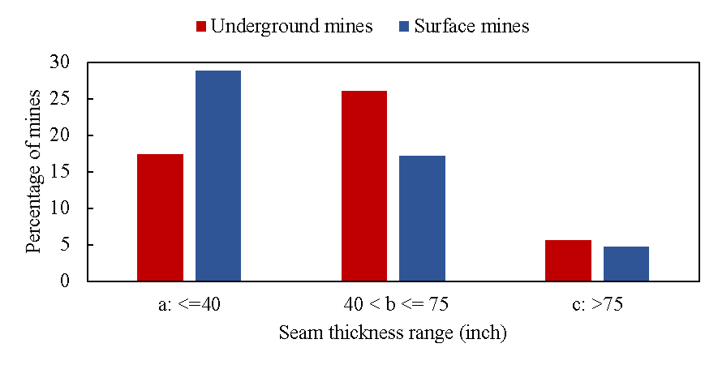
a Fig. 2. Number of CWP cases per subunit in Unites states coal mines during 1986-2018 (total number of CWP is 7337)

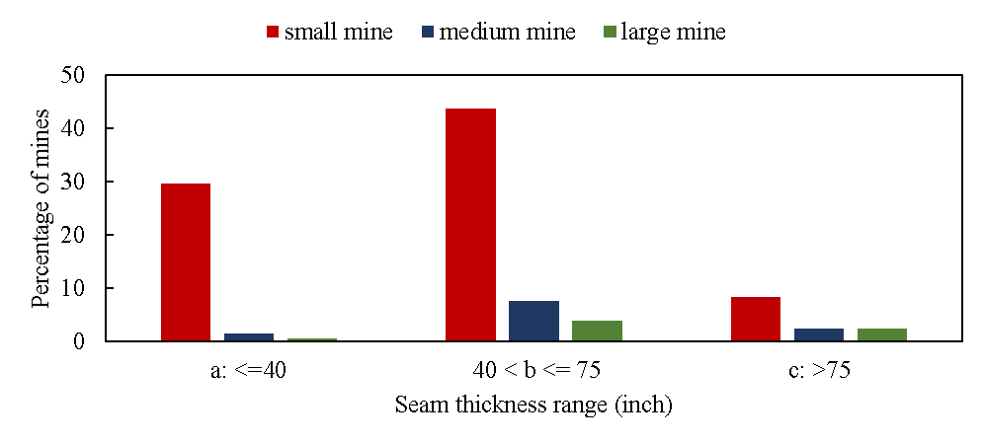
b
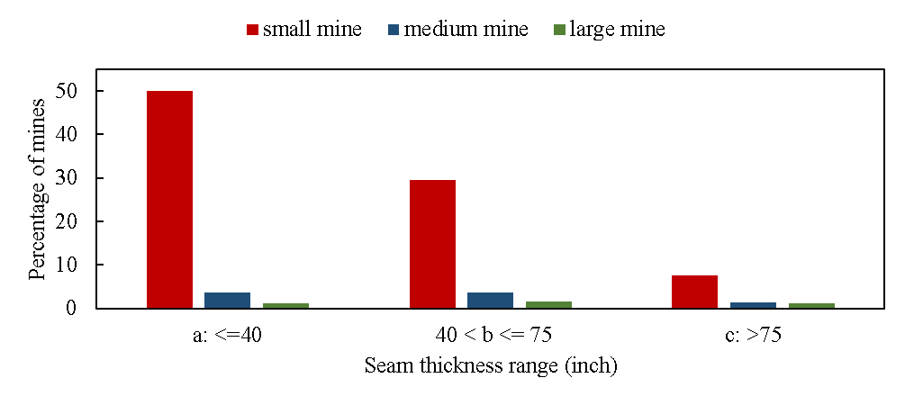
c
Fig. S1. Percentage of coal mines by coal seam thickness (a), and percentage of underground (b) and surface (c) coal mines by coal seam thickness and mine size in the U.S. during 1986-2018.

