Supplementary Table 1 ICD-10 codes to extract study population of admissions with discharge diagnosis of cirrhosis

DIAGNOSIS | ICD-10 code
Variceal bleeding | I85.01
Varices | I85.00, I85.10
Ascites | K70.11, K70.31
Hepatic encephalopathy | K72.90
Hepatorenal syndrome | K76.7
Spontaneous bacterial peritonitis | K65.2
HBV | B180
HCV | B182
Alcoholic cirrhosis | K70.30, K70.31
Alcoholic hepatitis | K70.10, K70.11
Alpha-1 AT deficiency | E88.01
Hemochromatosis | E83.110
Wilson’s disease | E83.01
Budd Chiari syndrome | I82.0
Auto immune hepatitis | K75.4
Biliary cirrhosis | K74.3, 74.4, 74.5
Other causes | K74.0, K74.60, K74.69
Supplementary Table 2 ICD-10 codes to stratify admissions with alcoholic hepatitis to organ failure and acute on chronic liver failure.

Diagnosis | ICD-10
Cardiovascular
Central venous pressure | 4A14XB1
Pulmonary artery/wedge pressure | 02HP32Z
Arterial line | 4A133B1
Septic shock | R57.9
Pulmonary
Mechanical ventilation | Z99.11
Renal
Hemodialysis | Z99.2

Supplementary Table 3 Baseline characteristics comparing hospitalizations in American Indians Alaskan Native (AI/AN) vs. those in races other than AI/AN.
 |  | AI / NA (N=3226) | Non-AI/NA (N=196,522) | P
Age mean, SD |  | 52, 13 | 59, 13 | <0.001
% Females |  | 44 | 39 | <0.001
 | Medicare | 29 | 45
%Pay source | Medicaid | 49 | 25
 | Private and other | 22 | 30 | <0.001
% Elective |  | 9 | 7.8 | 0.013
% ALD |  | 65 | 45 | <0.001
% ALD cirrhosis |  | 50 | 35 | <0.001
% AH |  | 28 | 17 | <0.001
% ACLF |  | 2.8 | 2.2 | 0.16
% Decompensated |  | 40 | 33 | <0.001
 | West NC | 11 | 4
% Division | Mountain | 45 | 6 | <0.001
 | Other | 44 | 90
 | Rural | 15 | 7
% Hospital type | Urban non-teaching | 17 | 26 | <0.001
 | Urban teaching | 68 | 67
 | Q25 | 55 | 34
% income quartile | Q50 | 24 | 26 | <0.001
 | Q75 | 15 | 23
 | Q100 | 6 | 17
SD: Standard deviation; ALD: Alcohol-associated liver disease; AH: Alcoholic hepatitis; ACLF: Acute on chronic liver failure; NC: North central

Supplementary Table 4 Logistic regression analyses on the matched cohort of hospitalizations with decompensated cirrhosis for predictors of alcohol-associated liver disease (ALD) or of alcoholic hepatitis (AH) as etiology of liver disease.
 | Predictors of discharge diagnosis of ALD |  | Predictors of discharge diagnosis of AH
 | OR (95% CI) | P | OR (95% CI) | P
Age in years | 0.986 (0.98-0.992) | <0.001 | 0.969 (0.963-0.975) | <0.001
Females vs. Males | 0.44 (0.39-0.50) | <0.001 | 0.86 (0.74-0.99) | <0.04
Medicaid vs. Medicare | 2.67 (2.25-3.16) | <0.001 | 1.98 (1.59-2.47) | <0.001
Pvt. vs. Medicare | 2.05 (1.70-2.47) | <0.001 | 2.10 (1.64-2.68) | <0.001
AI/AN vs. White | 1.30 (1.04-1.63) | <0.001 | 1.38 (1.10-1.74) | <0.001
AI/AN vs. Black | 1.62 (1.28-2.04) | <0.001 | 2.00 (1.53-2.61) | <0.001
AI/AN vs. Hispanic | 1.63 (1.32-2.00) | <0.001 | 1.82 (1.46-2.29) | <0.001
AI/AN vs. Asian or other | 2.20 (1.77-2.74) | <0.001 | 1.98 (1.54-2.54) | <0.001
Rural vs. Urban teaching hospital | 0.82 (0.67-0.99) | 0.94 | 0.99 (0.78-1.25) | 0.51
Urban non-teaching vs. Urban teaching hospital | 0.95 (0.80-1.14) | <0.004 | 0.83 (0.67-1.02) | 0.1
Zip income Quartile 1 vs. 4 | 0.97 (0.73-1.27) | <0.09 | 0.74 (0.55-1.01) | <0.07
Zip income Quartile 2 vs. 4 | 0.89 (0.67-1.19) | 0.77 | 0.75 (0.54-1.04) | 0.14
Zip income Quartile 3 vs. 4 | 0.87 (0.64-1.18) | 0.87 | 0.86 (0.62-1.21) | 0.65
OR: Odds ratio; CI: Confidence interval; AI/AN: American Indian / Alsaka Native

Supplementary Table 5 Baseline characteristics of hospitalizations in the US with discharge diagnosis of cirrhosis developing ACLF at or during admission.
 | White  (N=57) | Black  (N=79) | Hispanic  (N=62) | Asian or other  (N=74) | AI/NA  (N=78) | P
Age in years (mean, SD) | 54, 13 | 54, 11 | 53, 13 | 56, 12 | 53, 12 | 0.69
% Females | 42 | 54 | 42 | 49 | 45 | 0.86
% Elective admissions | 8.8 | 5.1 | 3.2 | 10.8 | 15.4 | <0.05
% Pay source (MC, MD, Pvt.) | 28, 53, 19 | 42, 43, 15 | 45, 31, 24 | 32, 47, 21 | 49, 38, 13 | 0.13
% Hospital type (R, U non-teaching, U teaching) | 14, 11, 75 | 9, 22, 69 | 13, 18, 69 | 3, 16, 81 | 12, 13, 75 | 0.35
% Zip code income quartile (Q1-4) | 53, 23, 19, 5 | 51, 21, 20, 8 | 48, 31, 15, 6 | 55, 28, 14, 3 | 54, 23, 19, 9 | 0.56
% Alcohol-associated cirrhosis | 53 | 48 | 34 | 32 | 63 | <0.001
% Alcohol-associated hepatitis | 14 | 10 | 6 | 11 | 14 | 0.82
% Alcohol-associated liver disease | 54 | 51 | 34 | 38 | 63 | 0.003
SD: Standard deviation; MC: Medicare; MD: Medicaid; R: Rural; U: Urban

Supplementary Table 6 Logistic regression analyses on the matched cohort of hospitalizations with discharge diagnosis of cirrhosis who developed acute on chronic liver failure at or during hospitalization for predictors of alcohol-associated liver disease (ALD) or of alcoholic hepatitis (AH) as etiology of liver disease.
 | Predictors of discharge diagnosis of ALD |  | Predictors of discharge diagnosis of AH
 | OR (95% CI) | P | OR (95% CI) | P
Age in years | 0.96 (0.93-0.98) | <0.001 | 0.95 (0.91-0.98) | <0.006
Females vs. Males | 0.43 (0.26-0.72) | <0.002 | 0.34 (0.14-0.86) | <0.03
Medicaid vs. Medicare | 1.87 (0.99-3.52) | <0.06 | 8.74 (1.79-43.0) | <0.008
Pvt. vs. Medicare | 2.05 (1.03-4.79) | <0.05 | 9.0 (1.63-50.0) | <0.02
AI/AN vs. White | 1.33 (0.52-3.39) | <0.02 | 1.07 (0.29-3.91) | 0.4
AI/AN vs. Black | 1.29 (0.56-2.98) | 0.013 | 1.23 (0.32-4.71) | 0.4
AI/AN vs. Hispanic | 4.95 (2.11-11.6) | 0.013 | 2.98 (0.69-12.5) | 0.4
AI/AN vs. Asian or other | 3.76 (1.98-9.00) | 0.013 | 1.46 (0.39-5.45) | 0.4
Rural vs. Urban teaching hospital | 0.65 (0.26-1.63) | 0.92 | 0.99 (0.78-1.25) | 0.95
Urban non-teaching vs. Urban teaching hospital | 0.47 (0.23-0.93) | 0.18 | 0.24 (0.05-1.12) | 0.96
Zip income Quartile 1 vs. 4 | 0.42 (0.15-1.09) | <0.09 | 1.90 (0.20-18.4) | 0.36
Zip income Quartile 2 vs. 4 | 0.47 (0.16-1.39) | 0.28 | 0.96 (0.09-10.2) | 0.45
Zip income Quartile 3 vs. 4 | 0.69 (0.22-2.16) | 0.65 | 1.79 (0.17-18.8) | 0.52
OR: Odds ratio; CI: Confidence interval; AI/AN: American Indian / Alsaka Native
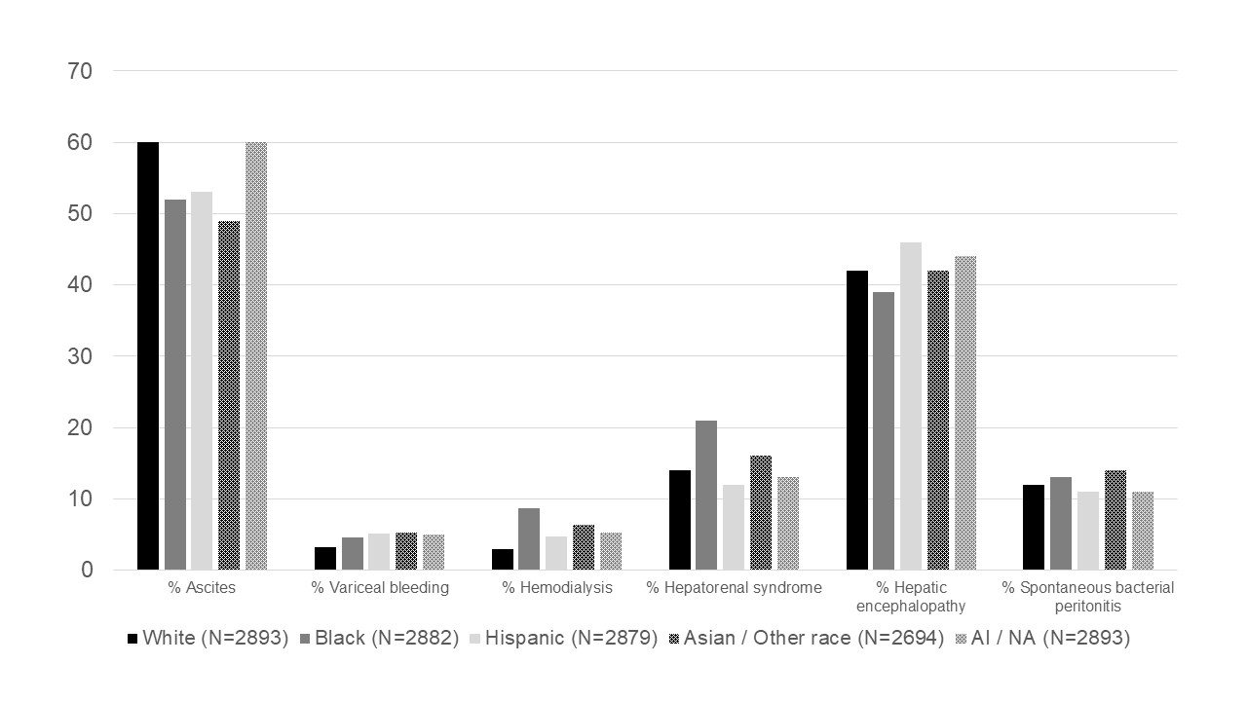
Supplementary Figure 1 Proportion of cirrhosis complications stratified for race in the matched cohort of 4946 hospitalizations with decompensated cirrhosis.

