Virtual screening and molecular dynamics simulation for finding inhibitor of New Delhi metallo-β-lactamase-1
Azhar Salari-jazi¹ , Karim Mahnam² , Parisa Sadeghi¹, Mohamad Sadegh Damavandi¹, Jamshid Faghri¹
1. Department of Microbiology, School of Medicine, Isfahan University of Medical Sciences, Isfahan, Iran
2. Biology Department, Faculty of Sciences, Shehrekord University, Shahrekord, Iran

Figure 1 Hieratical clustering of the range of the our ten final compounds

Table 1phisico-chemical properties
Name | # Acceptors | # Donors | # Rot. Bonds | MolWt | cLogP | TPSA | TPSA [Ertl]
NPC18185 | 12 | 10 | 13 | 578.53 | 2.46 | 3.25 | 220.76
NPC98583 | 18 | 14 | 23 | 882.74 | 3.96 | 3.62 | 354.28
NPC100251 | 20 | 16 | 25 | 914.73 | 3.37 | 3.95 | 394.74
NPC112380 | 18 | 13 | 21 | 868.71 | 3.14 | 3.7 | 351.12
NPC120633 | 9 | 8 | 12 | 680.71 | 7.58 | 2.06 | 171.07
NPC171932 | 10 | 8 | 12 | 562.53 | 3.21 | 2.83 | 189.53
NPC300657 | 11 | 9 | 14 | 726.69 | 7.48 | 2.54 | 213.67
NPC471403 | 15 | 10 | 13 | 814.75 | 3.57 | 2.64 | 248.45
NPC471404 | 16 | 11 | 14 | 830.75 | 3.27 | 2.83 | 268.68
NPC472454 | 13 | 9 | 12 | 590.49 | 2.07 | 3.61 | 234.67
NPC473010 | 10 | 6 | 15 | 668.74 | 6.65 | 1.87 | 166.14

Figure 2 3D alignment of the three class B1, B2 and B3 OF MBL
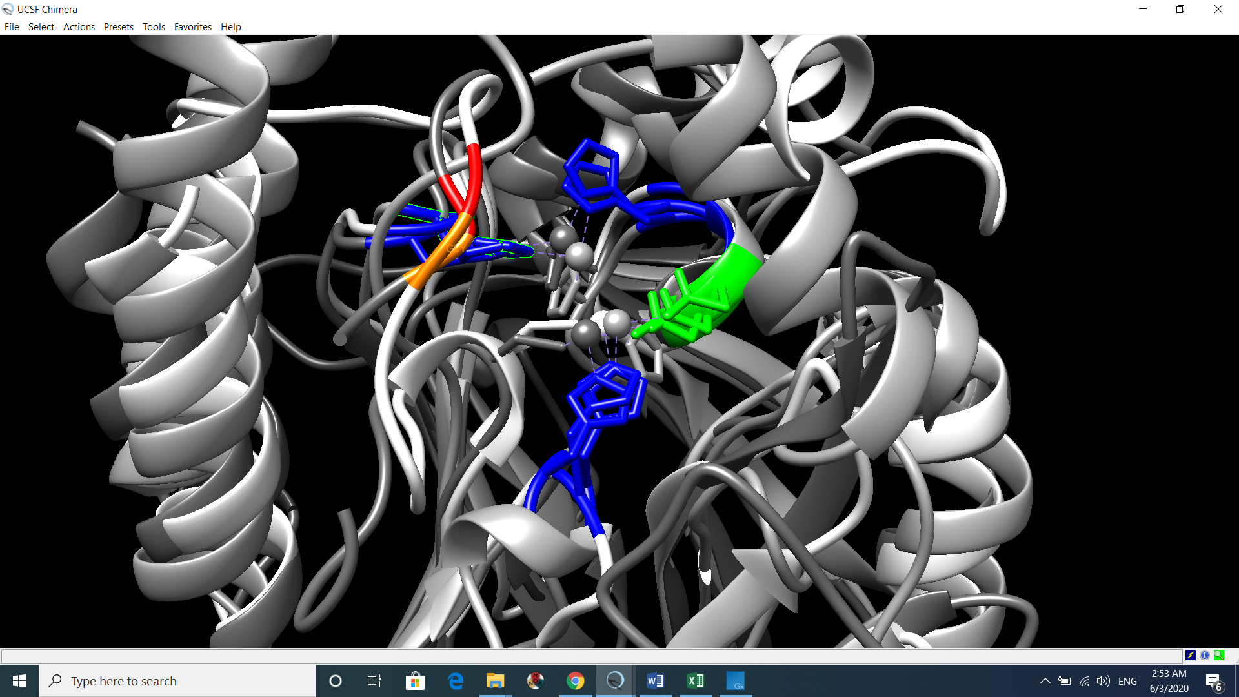
Figure 3 Crucial residue in active site, which were conserve in the MBL. Navy blue residues are histidine. Aspartic acids had green color. Gly and Asn had orange and red color respectively

Table 2 Crucial residues which were conserve in the three class of MBL
NDM-1 | Ser217 | Ser251 | Asn220 | Asp124 | His250 | Lys211 | Ile35 | His189 | Gly219 | His122
B1 | 1 |  | 1 | 1 | 1 |  |  | 1 | 1 | 1
B2=cphA |  | SER265 | Asn233 | Asp120 | His263 | Lys224 |  | His196 | Gly232 | His118
B3=BJP-1 |  |  |  | Asp105 | His242 |  |  | His177 |  | His103

Figure 4 Alignment of all types of the NDM

Figure 5 cphA-biapenem (B2). Interaction among three classes of the MBLS was similar to each other. These resemblance are comparable with Figure6 for BJP(B3) and NDM-1 (B1)

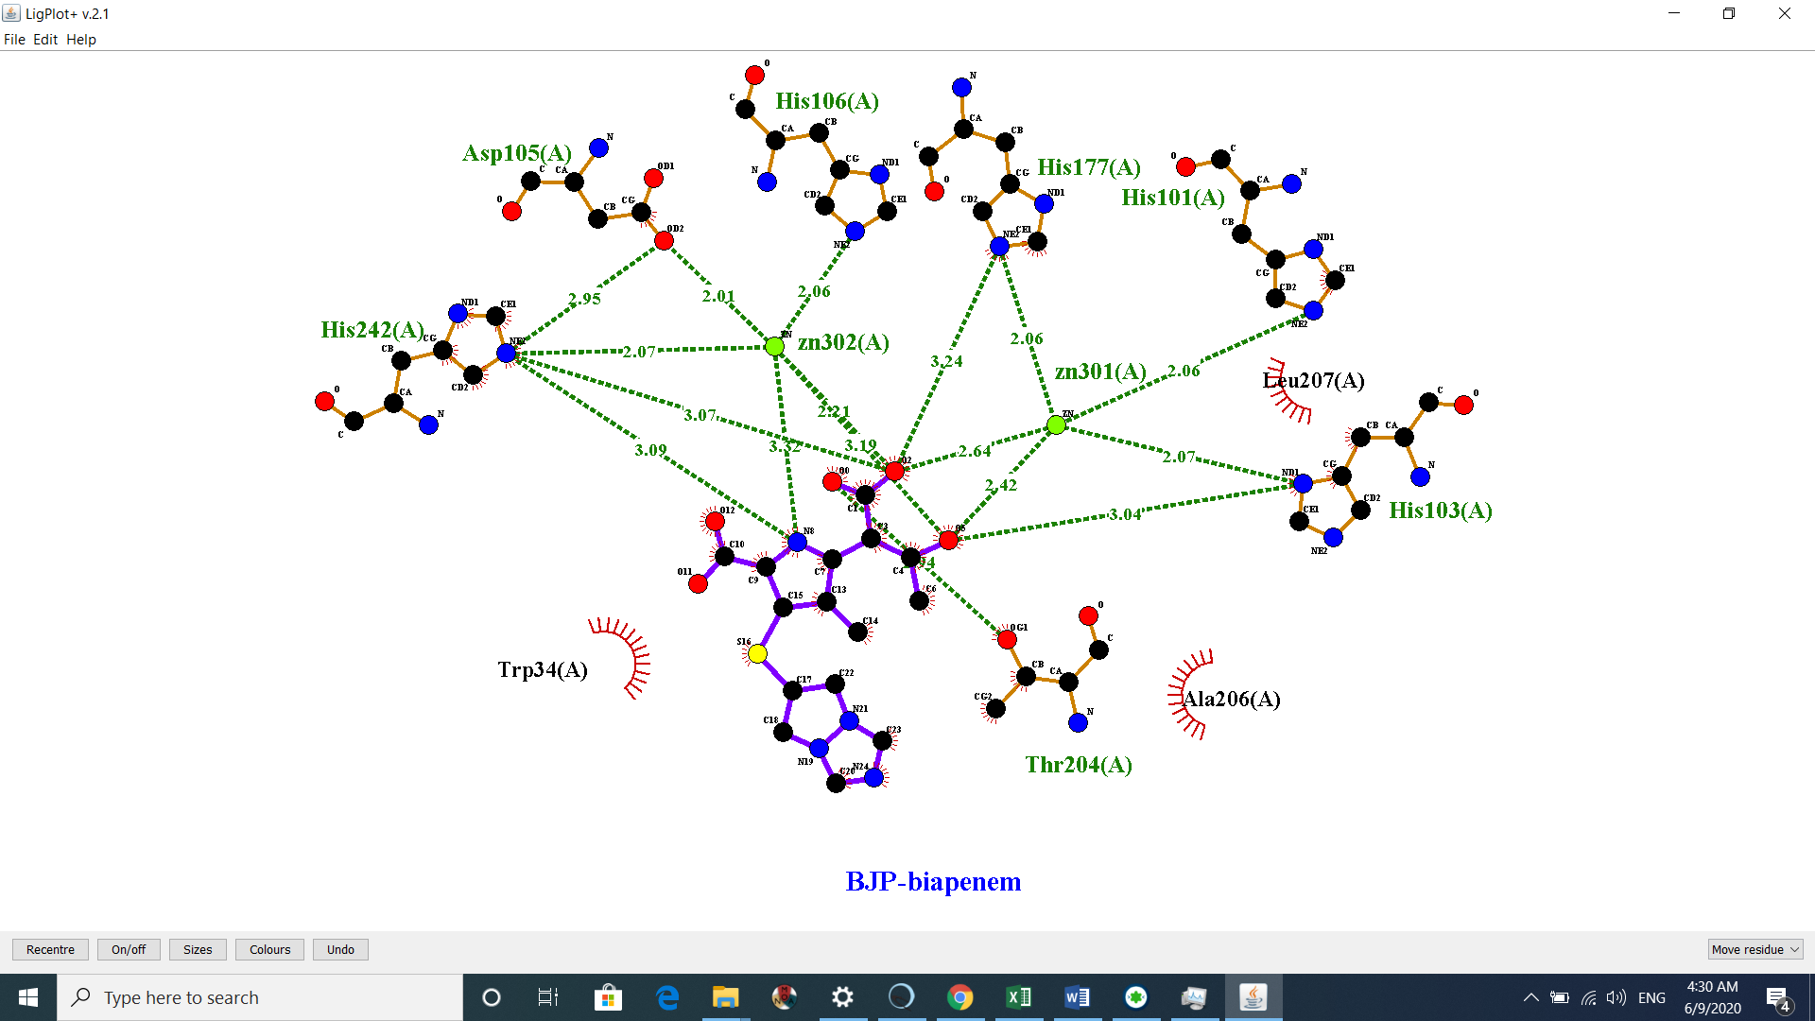
Figure 6 BJP-biapenem

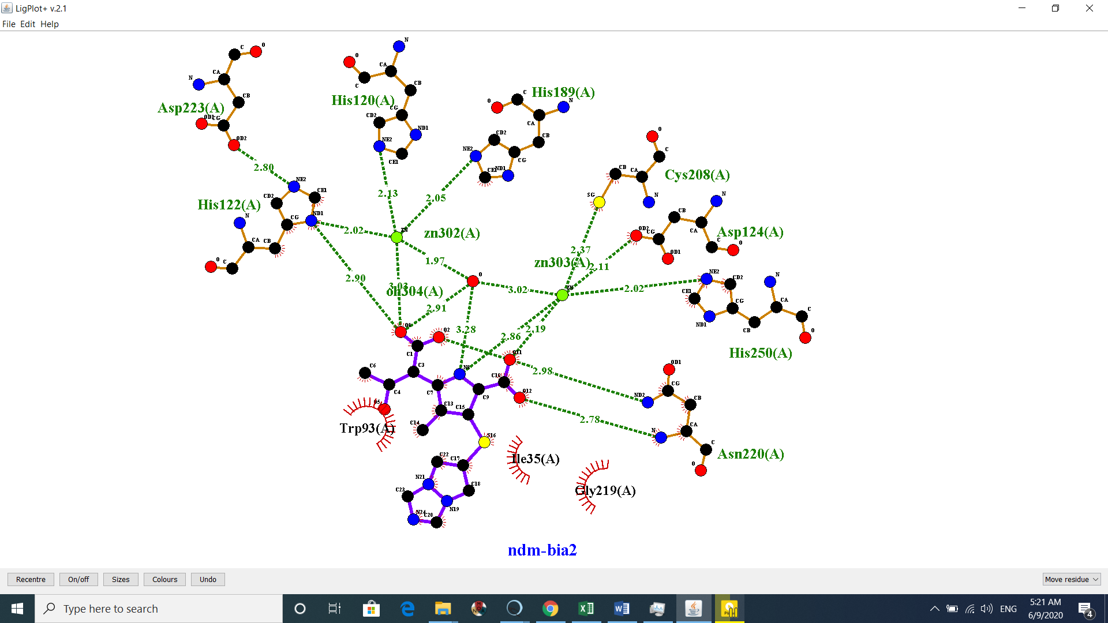
Figure 7 NDM-biapenem

NDM
Bjp
Cph

Figure 8 Distance and angle among the three example key residue key

Figure 9 Distance and angle among the three example key residue. This schematic picture showed high similarity of the coordination among analogue residue. Angels and distances between the key residue of B1, B2 and B3 classes are resemble

Figure 10 Matched biapenems which docked in the NDM,BJP and cphA. pharmacophores were similar among all of them

