Supplementary Figure legends
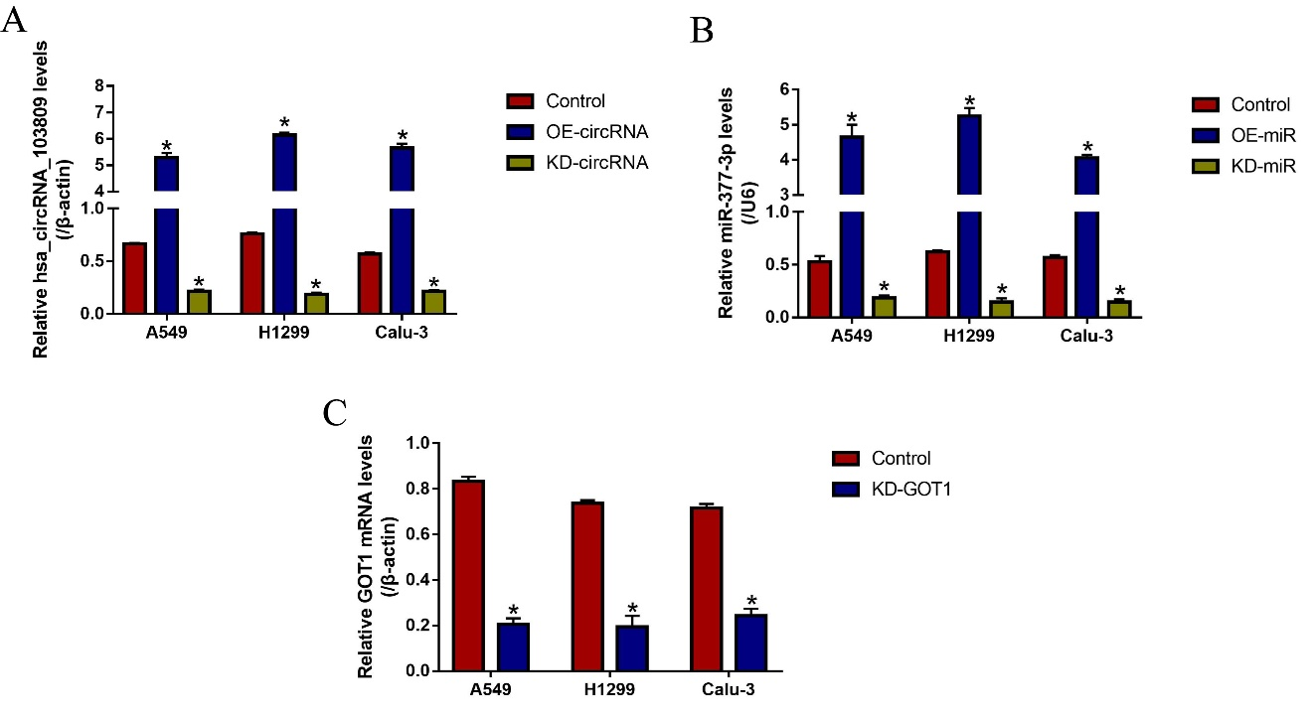
Figure S1. The overexpression and downregulation vectors for (A) hsa_circRNA_103809, (B) miR-377-3p and (C) GOT1 were delivered into A549, H1299 and Calu-3 cells, respectively, and examined by using the Real-Time qPCR analysis. Each experiment repeated at least 3 times. *P < 0.05.

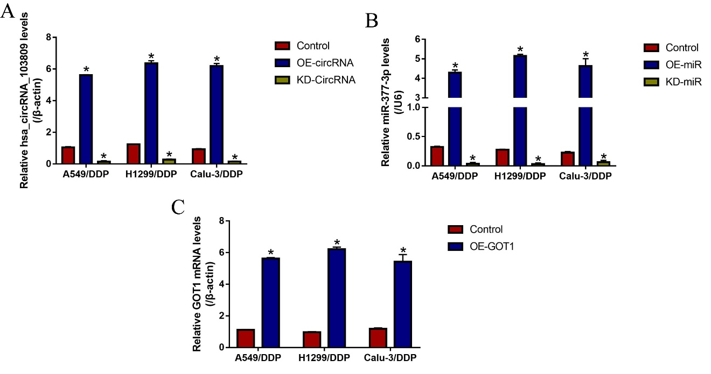
Figure S2. The overexpression and downregulation vectors for (A) hsa_circRNA_103809, (B) miR-377-3p and (C) GOT1 were delivered into A549/DDP, H1299/DDP and Calu-3/DDP cells, respectively, and examined by using the Real-Time qPCR analysis. Each experiment repeated at least 3 times. *P < 0.05.

