**Extended Data**

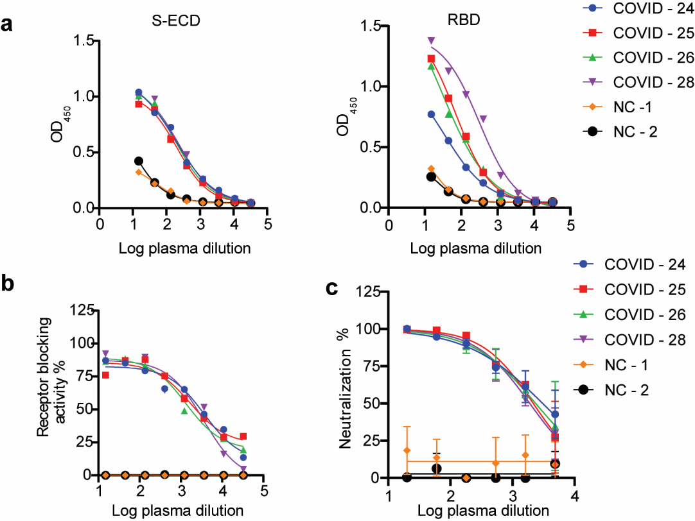

**Extended Data Fig. 1 | Characterization of antibody response induced by SARS-CoV-2 infection. a**,The ELSIA binding curves for four COVID-19 convalescent patients (24, 25, 26 and 28) and two healthy people. Antibody titers was assessed against S-ECD (extracellular domain of S protein) proteins and RBD region of SARS-CoV-2. **b**, The effect of convalescent plasma on the binding of RBD to ACE2. **c**,The neutralization curves for four COVID-19 convalescent patients (24,25,26 and 28) and two healthy people against SARS-CoVD-2 pseudovirus. The data represent one representative experiment of two independent experiments.

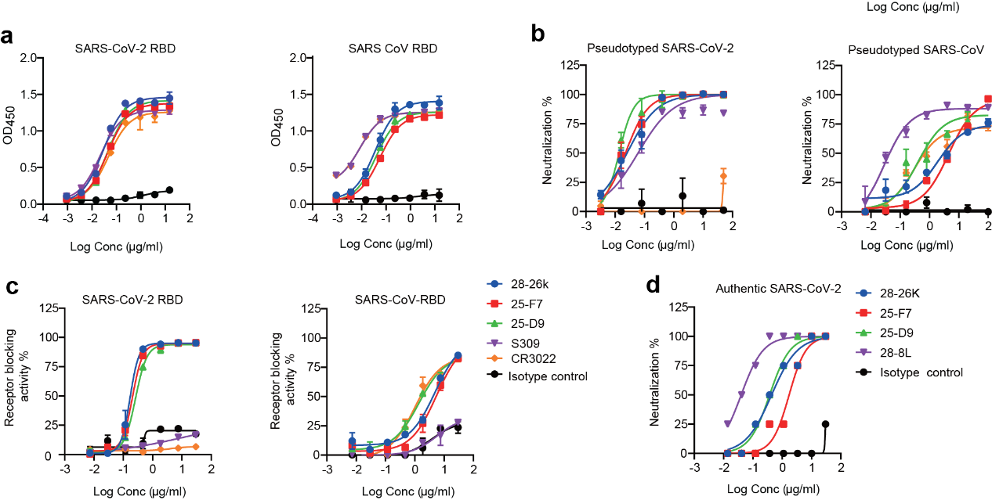

**Extended Data Fig. 2 | Crossing binding and neutralizing activities of 28-26K, 25-F7 and 25-D9.** **a**, The binding curves of 28-26K, 25-F7 and 25-D9 to SARS-CoV-2 RBD (left) and SARS-CoV RBD (right) are shown. The data was shown as mean±SD. **b**, The neutralization curves for 28-26K, 25-F7 and 25-D9 against SARS-CoV-2 pseudo-virus (left) and SARS-CoV pseudo-virus (right). **c**, ACE2 receptor blocking activity of 28-26K, 25-F7 and 25-D9. Left, SARS-CoV-2 RBD; right, SARS-CoV RBD. **d**, The neutralizing activity of 28-26K, 25-F7 and 25-D9 against SARS-CoV-2 authentic virus. Three previously described S309, CR3022, and 28-8L were used as control. For **a-d**, values shown are the means of triplicate. The curves were fit by nonlinear regression in Graphpad Prism.

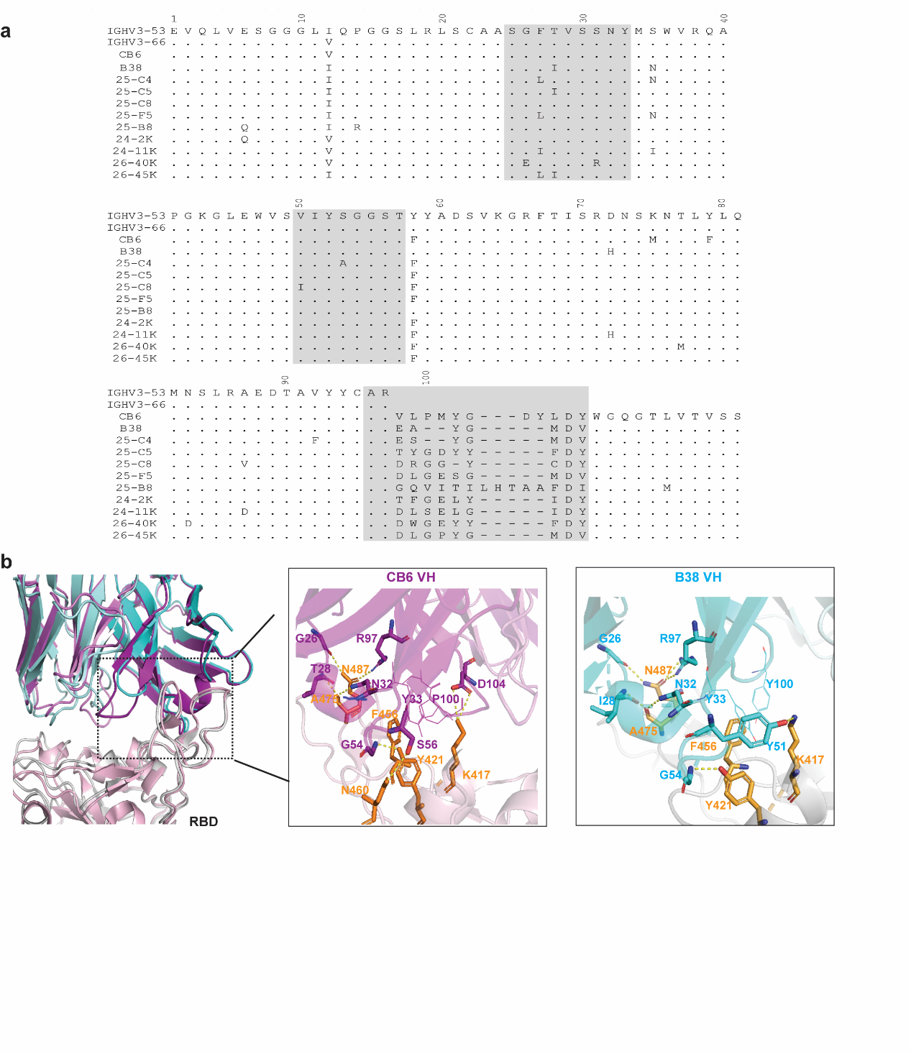

**Extended Data Fig. 3 | Common features of VH3-53/3-56 NAbs. a**,Alignment of the VH amino acid sequences of 3-53/3-56 with its germline configuration. The CDR regions are highlighted in grey. Dots indicate identical residues; Somatic mutations are shown. **b**, Structural alignment of CB6 and B38 binding with RBD. CB6-RBD complex (PDB ID: 7C01) is superimposed on B38- RBD (PDB ID: 7BZ5). CB6-RBD complex: magenta, CB6 VH; violet, CB6 VL; Light pink, RBD. B38-RBD complex: cyan, B38 VH; pale cyan; RBD, grey. Key residues on RBD highlighted in orange sticks. Polar interactions are indicated by yellow dashed lines.

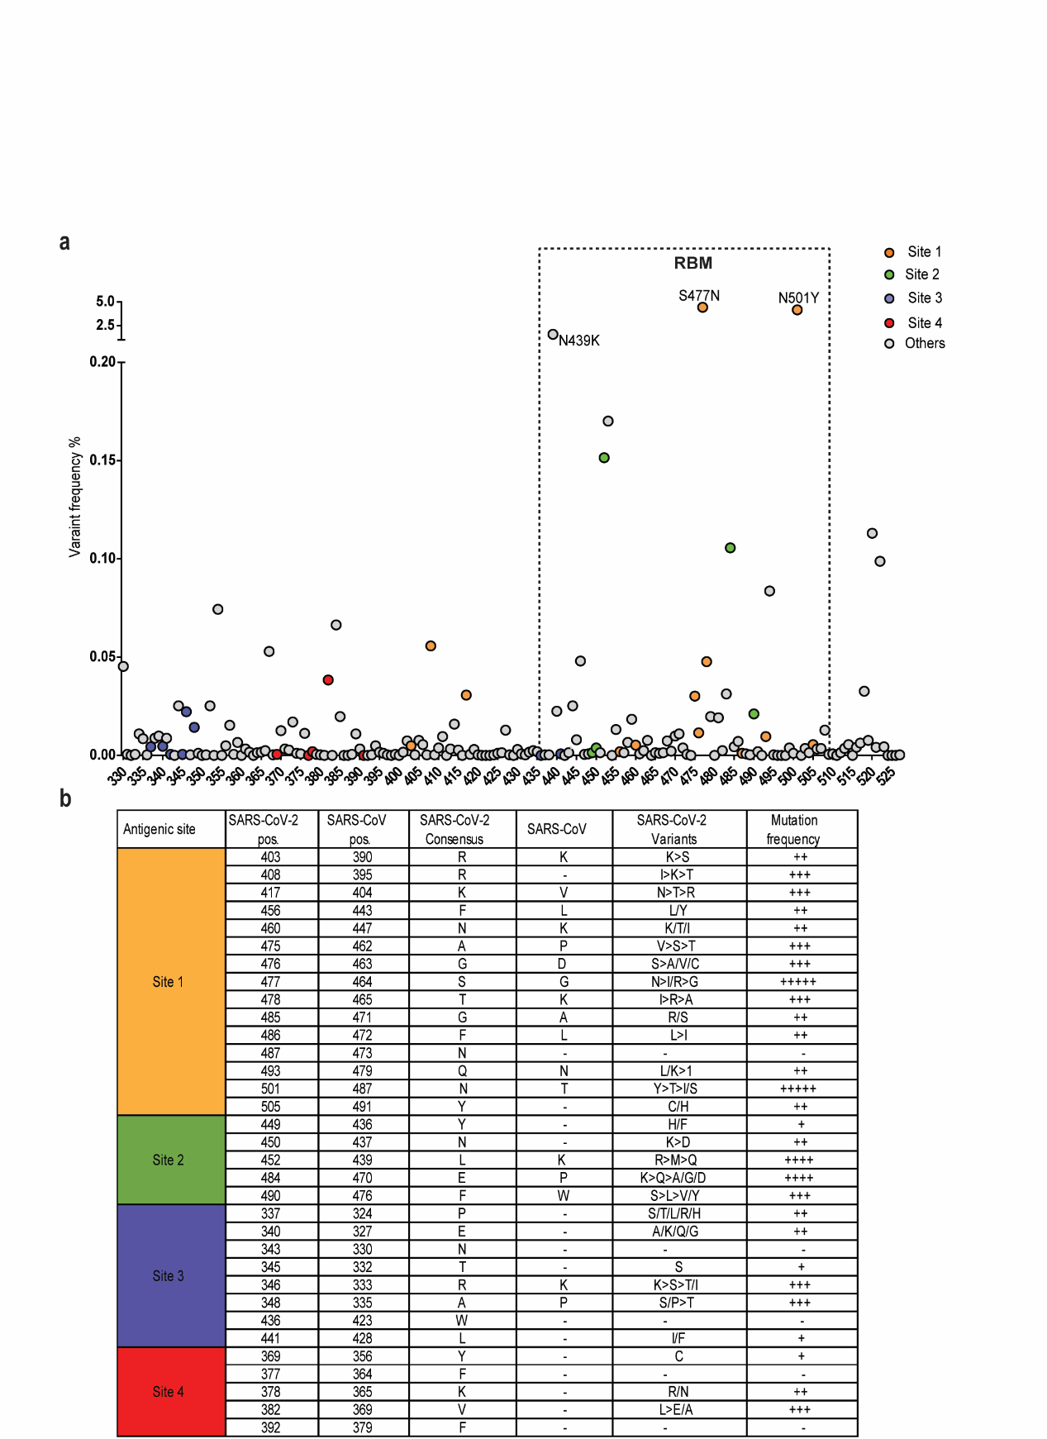

**Extended data Fig. 4 | Conservation of RBD residues.**

SARS-CoV-2 genome sequences (n=364,409) retrieved from GISAID and Genbank on January 19th 2021 (n=11,839) were used to annotate variants of the spike glycoprotein. 3272 mutations had been identified in the S gene of SARS-CoV-2 isolated from humans (CNCB-NGDC, 2021; GISAID, 2021). These mutations lead to 1961 amino acid changes, including 259 substitutions in the RBD region. **a**, Variants are plotted by amino acid position. Each dot is a distinct variant. Color encodes four antigenic sites. Variants are labeled if their prevalence is greater than 1%. **b,** Variability at neutralizing antibody binding residues. “+++++” means > 1%; “++++” means 0.1-1%; “+++” 0.01-0.1%; “++” 0.001-0.01; “+” means 0.0001-0.001; “-” means no varation. “>”, more; “/”, comparable.

**Extended data Table 1** **| Antibody gene usage for selected NAbs.**



mAbs are grouped based on competitive binding experiments. The lineage analysis and the percent identity for each predicted gene usage based on IMGT/VQUEST predictions. VH, heavy chain variable region gene; JH, heavy chain joining region gene; VL, light chain variable region gene; JL, light chain joining region gene.

**Extended Data Table 2 | The alanine mutations resulted in less than 50% binding to the panel of conformation-dependent RBD-specific antibodies and ACE2 when analyzed by ELISA.**



Coloring corresponds to the reactivity to each RBD mutant with < 30% dark orange, 30±70% light salmonand > 70% white. Residues located in the core region are highlighted in green; in the RBM region are highlighted in cyan. Anti- His tag was used to verify the expression level.

**Extended Data Table 3 |** **Plasma samples from 9 individuals were screened by S-ECD and RBD binding titer and neutralizing titer against SARS-CoV-2 pseudovirus.**

|  |  |  |  |  |
| --- | --- | --- | --- | --- |
| **Plasma** | **Ab titer** | | **BT50** | **NT50** |
| **S-ECD** | **RBD** |
| 2 | 3645 | 1215 | 5854 | 7118 |
| 6 | 1215 | 405 | 874 | 1758 |
| 23 | 3645 | 1215 | 1010 | 2521 |
| 24 | 3645 | 1215 | 3661 | 6128 |
| 25 | 3645 | 1215 | 2138 | 4326 |
| 26 | 3645 | 1215 | 1335 | 4723 |
| 27 | 1215 | 405 | 373 | 1957 |
| 28 | 3645 | 3645 | 2812 | 4455 |
| 32 | 405 | 135 | 45 | 540 |

BT50, the highest**plasma dilution** giving a ≥ 50% inhibition of receptor blocking activity.

NT50,the highest**plasma dilution** giving a ≥ 50% inhibition of pseudovirus virus infection.