Supplementary Information
Nanosecond-Resolution Photothermal Dynamic Imaging via MHz Digitization and Match Filtering
Jiaze Yin, Lu Lan, Yi Zhang, Hongli Ni, Yuying Tan, Meng Zhang, Yeran Bai, Ji-Xin Cheng

Supplementary Figure S1
Photothermal dynamic simulation of 300-nm diameter PMMA particle
Supplementary S.1
PDI of nanoparticles with different size
Supplementary Figure S2
PDI of nanoparticles with different size and decay constant map
Supplementary Figure S3
Simulations and PDI results of particle-substrate interface
Supplementary S.2
PDI detection sensitivity improvement over lock-in method
Supplementary Figure S4
Simulation of photothermal signal induced by low duty cycle IR source

Supplementary Movie 1
Time resolved PDI of 300-nm diameter PMMA particles

Supplementary Movie 2
Time resolved PDI of mixture of 300-nm and 500-nm diameter PMMA particles

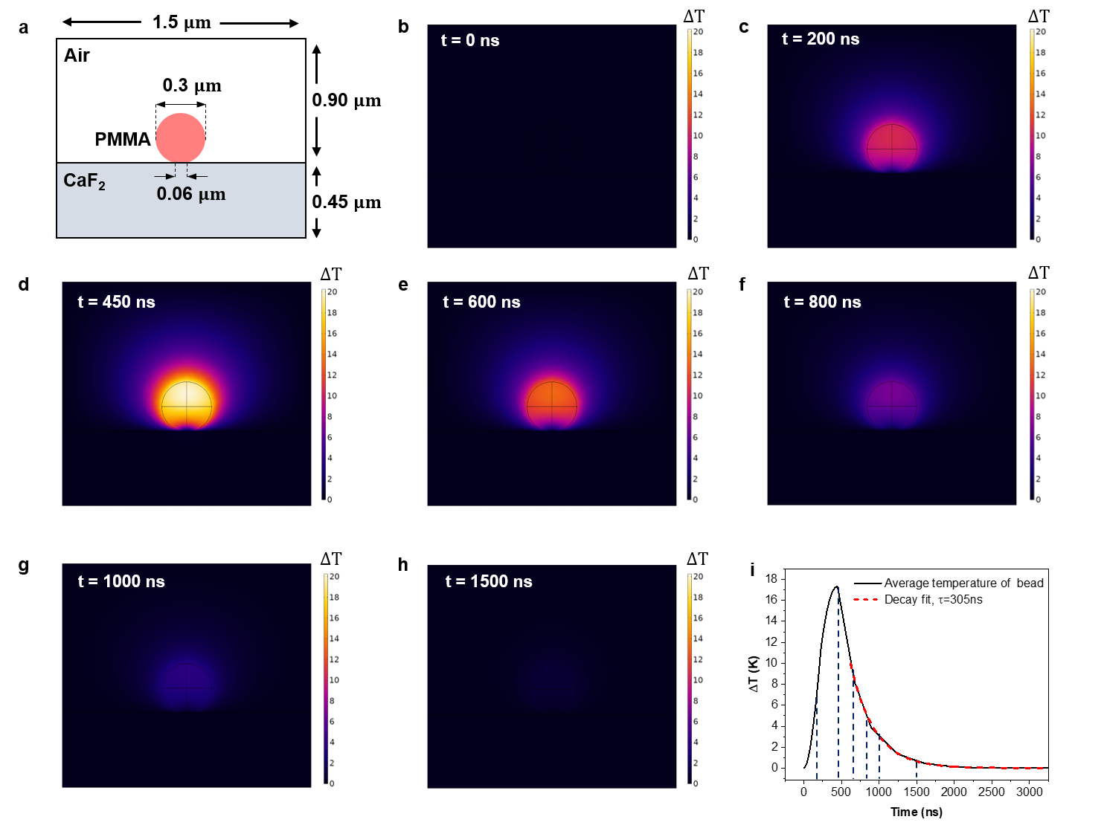
Supplementary Figure 1. Simulation of 300-nm diameter PMMA particle temperature evolvement under pulsed IR heating. (a) Geometric configuration used in the simulation by COMSOL Multiphysics (version 5.5, COMSOL AB, Sweden). Mid-IR heating pulse is set as a symmetric triangle wave with duration of 600 ns. (b-h) The temperature distribution at 0 ns, 200 ns, 450 ns, 600 ns, 800 ns, 1000 ns, 1500 ns, respectively. (i) The time dependent temperature of PMMA particle.

S.1 PDI of nanoparticles with different size
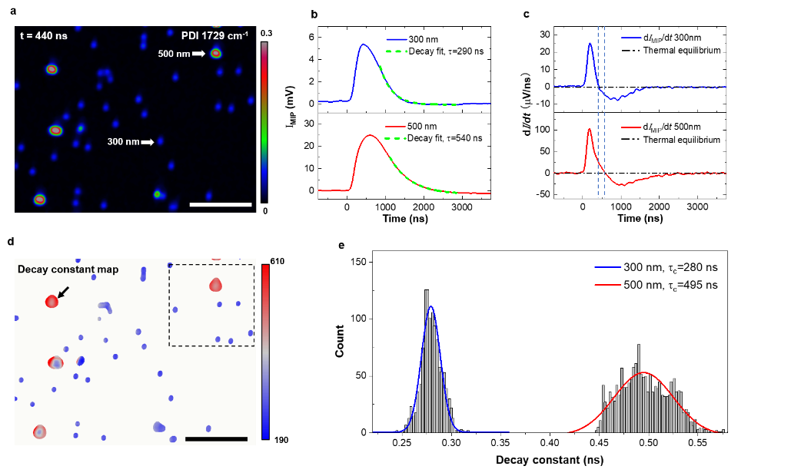
From the photothermal dynamic model we build, both the temperature rise and decay are strongly related to the time constant $mC_{s}/hS$. For spherical particles embedding in a uniform medium, $hS$ can be approximated by $2πkD$¹, where $k$ is the medium heat conductivity and $D$ is the particle diameter. As a result, the decay constant is proportional to$r^{2}ρC_{s}/k$. For the particle with the same material and uniform microenvironment, the time constant has an $r^{2}$dependency. To validate this relationship, we performed PDI of PMMA particles of different sizes, as shown in Fig. S2a. Besides the photothermal intensity difference, we observed a significant difference in their thermal dynamics. The thermal dynamics and heat flux function of indicated particles in Fig. S2a are shown in Fig. S2b and Fig. S2c. The retrieved decay constant for the 300 nm and 500 nm particles are 290 ns and 540 ns, respectively. For statistical analysis, we fit the decay signal at each pixel and generate a decay constant map, indicating the thermal lifetime, as shown in Fig. S2d. The histogram of the selected area in decay constant map is shown in Fig. S2e, where we observe two peaks representing 300 nm and 500 nm with center value of 280 ns and 495 ns, respectively. From this result, the decay constant scaled for 1.8 times between 300 nm and 500 nm particles, smaller than 2.8 times that is estimated with $r^{2}$ dependency. This difference is majorly caused by the influence of variation of substrate-contact area of different particles. CaF₂ substrate has a much larger heat conductivity (9.71 W/(mK)) than air (0.026 W/(mK)). This particle-substrate interface is revealed and analyzed as shown in Fig.S3.
Supplementary Figure 2. PDI of nanoparticles with different size and decay constant map. (a) PDI acquired photothermal intensity image of 300-nm and 500-nm diameter PMMA particles mixture at absorption peak 1729 cm⁻¹. (b) Photothermal dynamics of 300-nm and 500-nm diameter particles. The dash line is the exponential decay fitting. (c) Time-resolved energy flux function acquired by derivative (b) over time. (d) Decay constant map. Acquired by fitting the temporal signal at every pixel with SNR larger than 20. (e) Histogram of decay constant map of selecting area in (d). The decay constant of 300-nm and 500-nm diameter particles shows two peaks with center at 280 ns and 495 ns, respectively. Pixel dwell time: 200 $μs$; Probe power on sample: 20 mW; pump power on sample: 4 mW at 1729 cm⁻¹; Scale bars: 5 $μ$m.
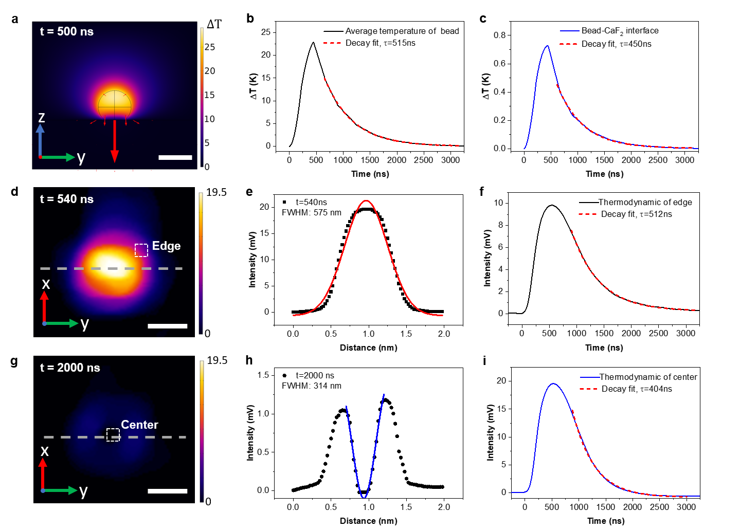

Supplementary Figure 3. Simulations and PDI results of particle-substrate interface. (a) Simulation of temperature distribution and heat flux arrow at t=500 ns of 500-nm diameter PMMA particle under pulse IR heating with duration of 600 ns. (b) Simulation of time dependent temperature of PMMA particle. (c) Simulation of time dependent temperature of particle-CaF₂ substrate interface. (d) PDI experimental result of intensity image at t=540 ns of PMMA particle indicated in Fig. S2d. (e) Intensity profile of line indicated in (d) and gaussian fitting. (f) Thermal dynamic of particle edge indicated in (d). (g) PDI experimental result at t=2000 ns of the same particle in (d). (h) Intensity profile of line indicated in (g) and gaussian fitting. (i) Thermal dynamic of particle center indicated in (g).

S.2 SNR in PDI and lock in amplifier based PHI
We provide a theoretical analysis of PDI sensitivity improvement over lock-in method. Assume there are n frequency components at fundamental and harmonics frequencies of IR repletion rate in the signal. Their amplitudes are denoted as${ S}_{1},{ S}_{2} … S_{n}$. The corresponding noise amplitudes are ${ N}_{1},{ N}_{2} … N_{n}$. For PHI method, the signal-to-noise-ratio is represented as:
 | $${SNR}_{LIA}=\frac{|S_{1}|}{{ |N}_{1}|}$$ | (S.1)
For PDI, with concurrently acquired harmonics, the SNR is written as:
 | $${SNR}_{MF}=\frac{|S_{1}|+|S_{2}|+…+|S_{n}|}{\sqrt{{\left|N_{1}\right|}^{2}+{\left|N_{2}\right|}^{2}+…+{\left|N\right|}^{2}}}$$ | (S.2)

By defining $a_{i}=\left|S_{i}\right|/|S_{1}|$, $b_{i}=\left|N_{i}\right|/|N_{1}|$, equation (S.2) is organized as:
 | $${SNR}_{MF}=\frac{|S_{1}|(1+a_{2}++…+a_{n})}{|N_{1}|\sqrt{1+b_{2}^{2}+…+b_{n}^{2}}}$$ | (S.3)

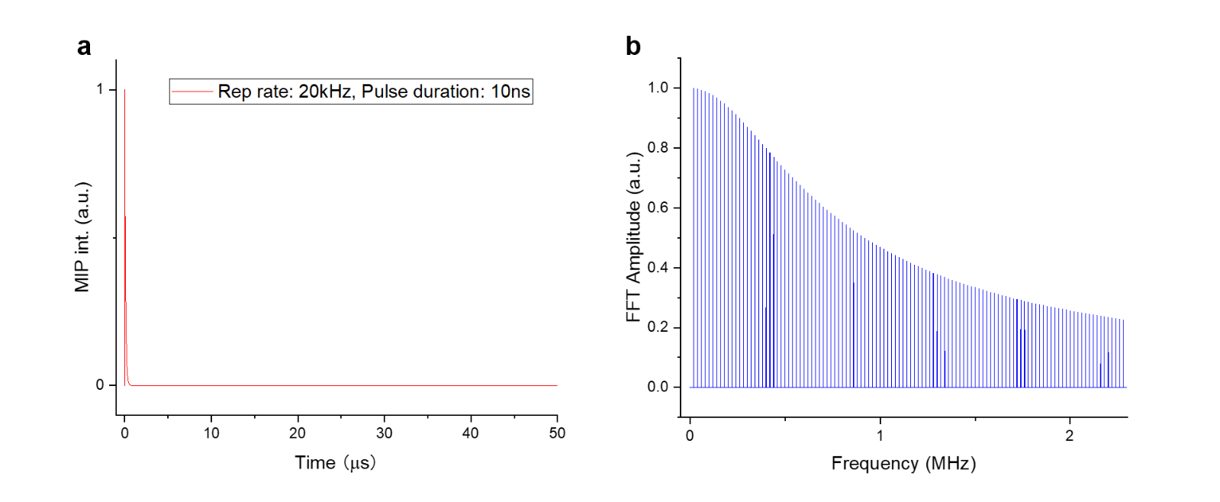
The SNR improvement is subject to the term $(1+a_{2}++…+a_{n})/\sqrt{1+b_{2}^{2}+…+b_{n}^{2}}$, which is significant for low duty cycle signal at low repetition rate. For such signal, the harmonics expand over a wideband in frequency domain, and system noise is majorly dominant by laser 1/f noise, which decreased at high frequency. As an example, the photothermal signal induced by an extreme low duty cycle laser (Repetition rate: 20 kHz; pulse duration 10 ns) is showed in Fig. S4; benefitting of capturing its harmonics inside 2 MHz pass band, the SNR improvement of PDI over PHI is estimated as 23 times.
Supplementary Figure 4. Simulation of photothermal signal induced by low duty cycle IR source. (a) Temporal domain signal. (b) Frequency domain representation of (a).

Supplementary Movie 1. Time resolved PDI of 300-nm diameter PMMA particles

Supplementary Movie 2. Time resolved PDI of mixture of 300-nm and 500-nm diameter PMMA particles

Supplementary references
1. Bergman, T. L., Incropera, F. P., DeWitt, D. P. & Lavine, A. S. Fundamentals of heat and mass transfer. (John Wiley & Sons, 2011).

