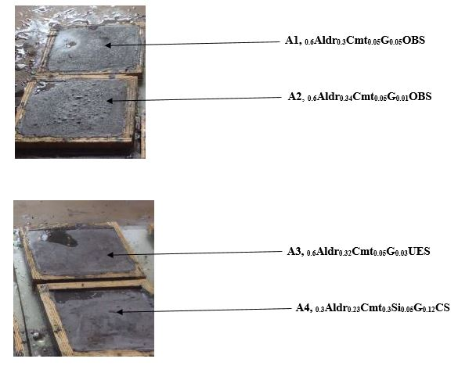
Appendix A
Image of Developed Aluminium dross composite

Nomenclature for developed ceiling materials
Aldr Aluminium Dross
Cmt Cement
G Graphite
Si Silicon
CS Coconut Shell
OBS Oil Bean Stalk

