Supplementary materials

Supplementary Figure 1: Simulation of unfolding primordia.
Supplementary Figure 2: Orientation of horn primordia.
Supplementary Figure 3: Furrow removal analysis.
Supplementary Figure 4: Accordion-like folds (jabara).
Supplementary Figure 5: Origami model of the stalk.

Supplementary Information 1: Division of primordia
Supplementary Information 2: Smoothing algorithm
Supplementary Information 3: Furrow visualization

Supplementary Video 1: Whole primordia
Supplementary Video 2: Cap
Supplementary Video 3: Stalk
Supplementary Video 4: Base

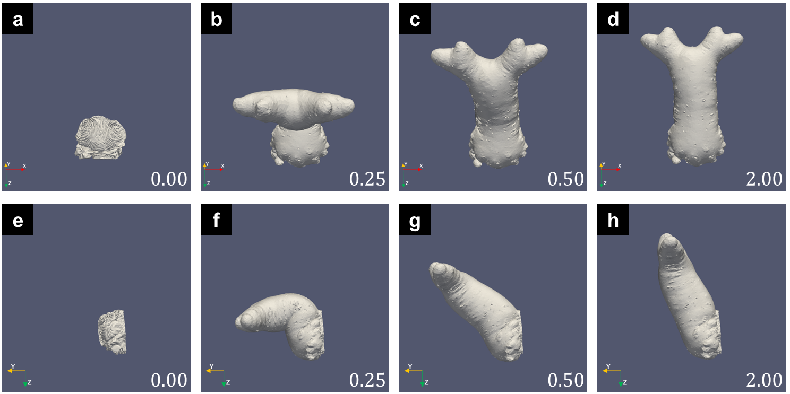

Supplementary Figure 1: Simulation of unfolding primordia.
(a-h) 3D mesh data acquired with the CoMBI method was unfolded with our simulation. (a-d) Viewed from the top side of the primordia. (e-h) Viewed from the left side of the primordia.

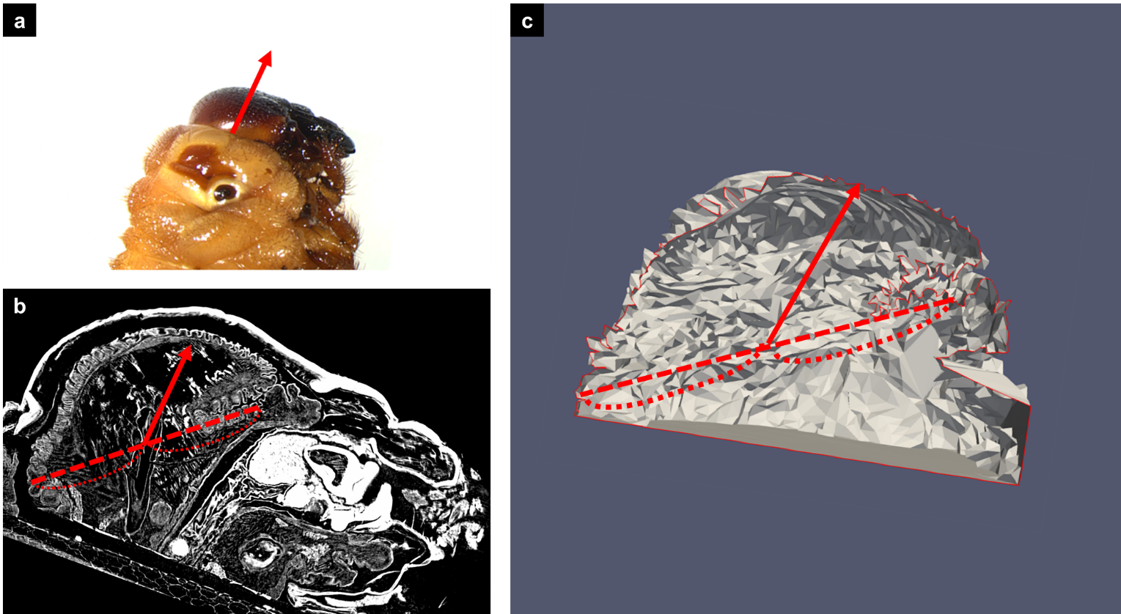

Supplementary Figure 2: Orientation of horn primordia.
(a) The estimated orientation of horn primordia. The orientation of horn primordia was measured using the sagittal plane of the micro-CT data (b) and the mesh data (c). First, the middle point of the proximal end of the horn primordia was found (b, c). Next, the branching point was estimated using the mesh data (c). Then, the orientation was defined as the direction from the middle point to the branching point.

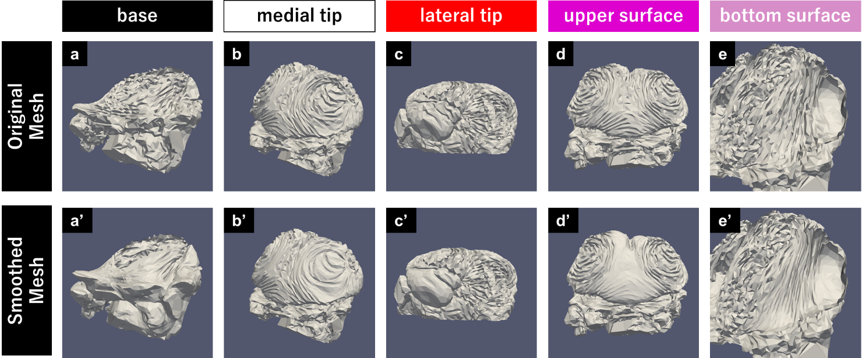

Supplementary Figure 3: Furrow removal analysis.
Furrow removal analysis was performed to study the function of furrows. In the analysis, the furrows in a specific region (subregion) are shallowed by a smoothing algorithm (Laplacian smoothing or HC-modified Laplacian smoothing). The original meshes are shown in the upper panels (a-e) and the smoothed mesh (after shallowing furrows) are shown in the lower panels (a’-e’).

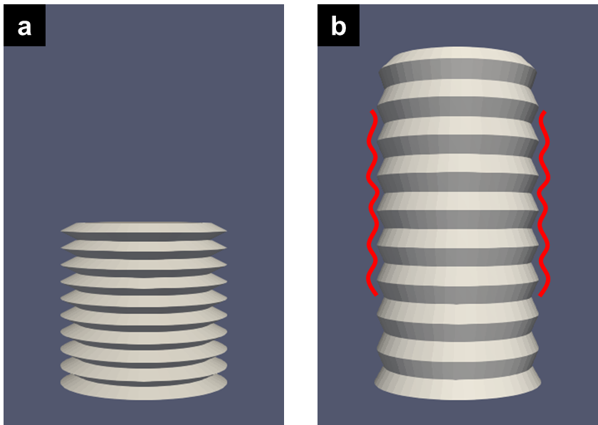

Supplementary Figure 4: Accordion-like folds (jabara).
(a) Accordion-like folds are one of the simplest ways to compress a cylinder short. (b) When unfolded with the computer simulation, the mesh with accordion-like folds was still wavy.

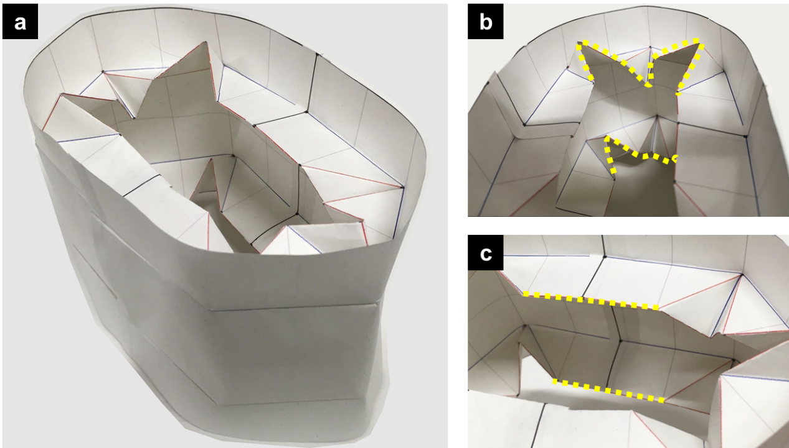

Supplementary Figure 5: Origami model of the stalk.
The folding of the stalk was simplified using origami to facilitate its understanding. Using the wavy fold (b) and the parallel fold (c), a folded cylindrical structure was made (a). The parallel fold could not be bent, while the wavy fold was easily bent to form a curved surface.

Supplementary Information 1: Division of virtual horn primordia.

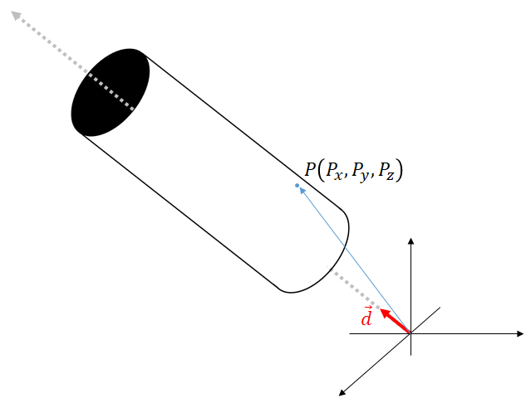
Calculation of the virtual height

To divide the 3D mesh of horn primordia, we used virtual height, which was calculated as follows:
1. The axial direction of the stalk was estimated using the GUI of ParaView¹.
2. The virtual height was defined as the dot product between the direction vector (normalized) and the position vector.

Then, the circumferential length of the contour corresponding to each height was calculated.

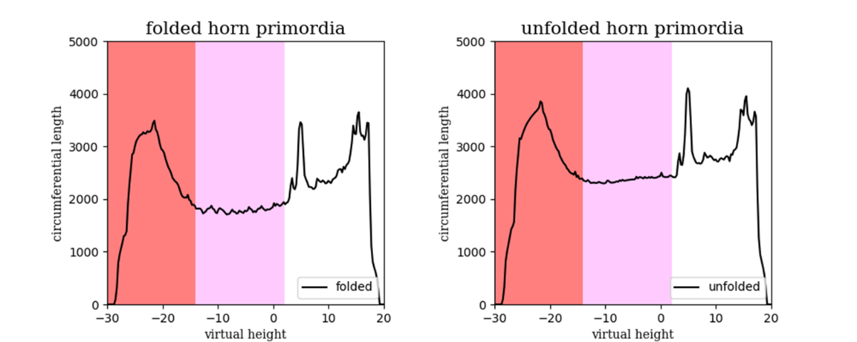
Circumferential length of the contour corresponding to each height

The region in which the circumferential length was constant (colored in pink) was recognized as the “stalk”. Then, the distal region was named “cap” (colored in red) and the proximal region was named “base” (colored in white).

Supplementary Information 2: Smoothing algorithm
To make a smoothed mesh, we applied HC-modified Laplacian smoothing².
In HC-modified Laplacian smoothing, the modified point $p_{i}$, is pushed back to the previous point $q_{i}$ and the original point $o_{i}$.
First, the modified point $p_{i}$ is produced by Laplacian smoothing.

$$p_{i}≝\frac{1}{\left|adj\left(i\right)\right|}\sum_{j∈adj\left(i\right)}{q_{i,j}}$$

In the equation, $adj\left(i\right)$ denotes the set of adjacent vertices of vertex i and $x_{i,j}$ is the position of the j-th connecting vertex.
Then, $b_{i}$ is defined as the difference between the modified point and the previous/original point.

$$b_{i}≝p_{i}-\left(αo_{i}+\left(1-α\right)q_{i}\right)$$

Finally, $d_{i}$ is defined as the weighed average of the difference and is used for correction.

$$d_{i}≝{βb}_{i}+\frac{1-β}{\left|adj\left(i\right)\right|}\sum_{j∈adj\left(i\right)}{b_{j}}$$

See Vollmer 1999 for more information about the algorithm.

The HC-modified Laplacian smoothing was developed to prevent shrinkage of the mesh by smoothing algorithms. To study the function of furrows, it is important not to change the macro shape of horn primordia. The parameters $α$ and $β$, and the number of smoothing times were tuned depending on the mesh (because the fine mesh is resistant to smoothing). The parameters we used to smooth each mesh are shown in the table.

Parameters for smoothing
Original mesh | Number of vertices | $$α$$ | $$β$$ | Times of smoothing
example (used in Fig.1) | 3976 | 0.0 | 0.5 | 21
horn_primordia_1 | 9776 | 0.2 | 0.6 | 11
horn_primordia_2 | 10474 | 0.0 | 0.5 | 21

Supplementary Information 3: Furrow visualization
To determine whether a vertex is located on a ridge or a valley, we first calculated the vertex normal for each vertex. The vertex normal of vertex i, $n_{i}$ was calculated the following way:

1. The facet area $S_{i,j}$ and the normal vector $n_{i,j}$ for each facet around vertex i were calculated using the smoothed mesh.
2. ${sum}_{i}$ was calculated by the weighted summation of all facet normal, and $n_{i}$ was determined by normalization of ${sum}_{i}$.

$${sum}_{i}=\sum_{j∈adj\left(i\right)}{S_{i,j}n_{i,j}}$$
$$n_{i}≝ \frac{1}{\left|{sum}_{i}\right|}{sum}_{i}$$

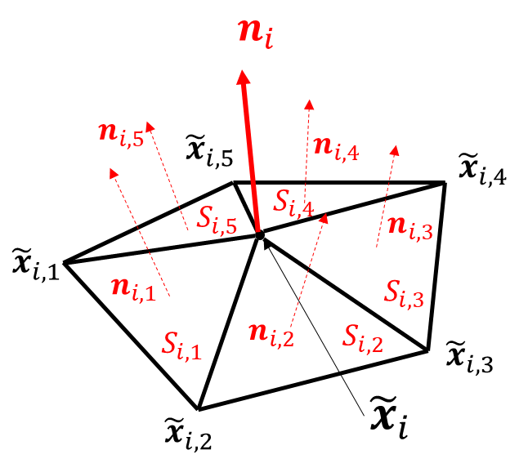
Calculation of the vertex normal vector

Then, the ${discriminant}_{i}$ was calculated with the following equation:

$${discriminant}_{i}≝\left(x_{i}-{\tilde{x}}_{i}\right)・n_{i}$$

In the equation, $x_{i}$ is the position of vertex i of original mesh and ${\tilde{x}}_{i}$ is the position of vertex i of smoothed mesh.

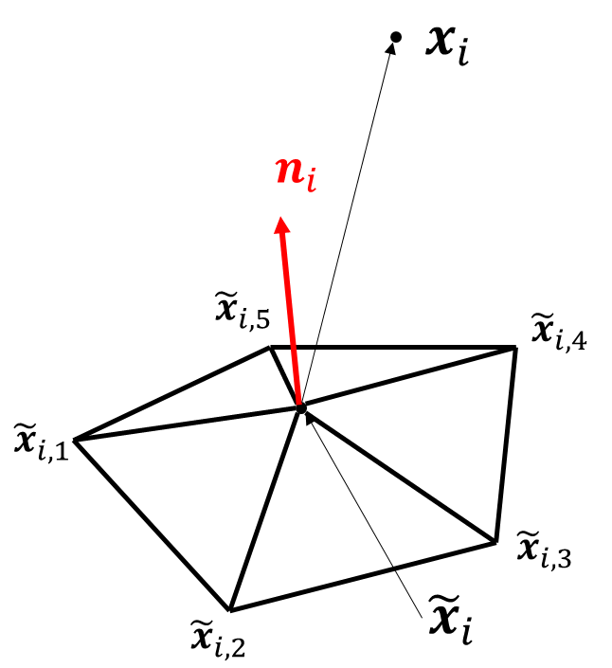
Calculation of the discriminant

When the ${discriminant}_{i}$ was more than 0.5, the vertex i was colorized in white (judged as “on a ridge”). When the ${discriminant}_{i}$ was less than $-$0.5, the vertex i was colorized in black (judged as “on a valley”).

Supplementary references
1. Ahrens, James, Geveci, Berk, Law, Charles, ParaView: An End-User Tool for Large Data Visualization, Visualization Handbook. (Elsevier, 2005) ISBN-13: 978-0123875822
2. Vollmer, J., Mencl, R. & Muller, H. Improved Laplacian Smoothing of Noisy Surface Meshes. Computer Graphics Forum (1999) doi:10.1111/1467-8659.00334.

