Supplementary Materials for Liu, et al. Digestive adaptations of both the fore- and hind-gut in a temperate colobine monkey.
Supplementary Materials including:
- Supplementary Tables 1 - 10
- Supplementary Figures 1 – 5
- Methods

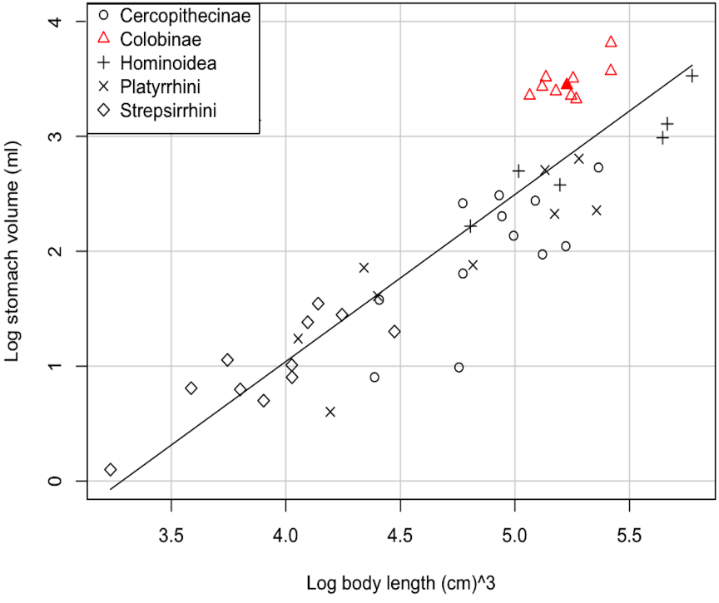
(A)
(B)
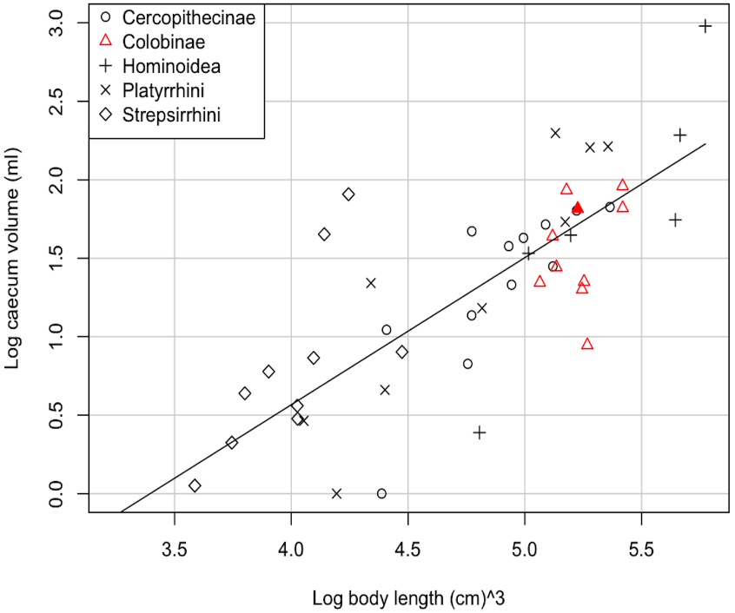
Figure S1. Relationships between body size in cm (log of cubed value) and A) stomach and B) caecum volumes (logs of volumes in ml) in 48 primate species. In each graph, the ten species of the Colobinae included in the analysis are shown as empty red triangles, and the datum point for R. roxellana is shown as a filled red triangle. Other data points are grouped by taxon as in Fig. 1. main text. The figures show that a) as expected, Colobines have large stomachs compared with other primates and b) the sizes of the caecum of Colobines are as expected for primates in general. Importantly, the figures show that the sizes of the R. roxellana stomach and caecum are as expected for a Colobine of the same body size. The results of the least-squares regressions (with the intercept set to zero) using the phylogenetically independent contrasts of these data are – stomach volume: b = 1.22, F_{1, 44} = 58.18, P < 0.001, R² = 0.56; caecum volume: b = 1.27, F_{1, 44} = 47.91, P < 0.001, R² = 0.51.
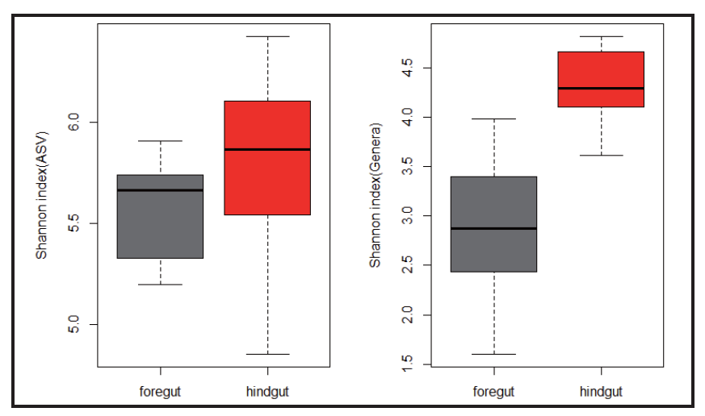
Figure S2. Bacterial community compositions of the R. roxellana foregut and hindgut. (A), Shannon diversity index differences in the bacterial communities that characterize each gut region. Diversity at both ASV (right panel) and genera (left panel) levels are shown. (B), Histogram showing differences in the relative abundances of rare phyla in the bacterial communities characterizing the foregut (left bar) and hindgut (right bar). (C), Relative abundances of minor phyla in the bacterial communities.

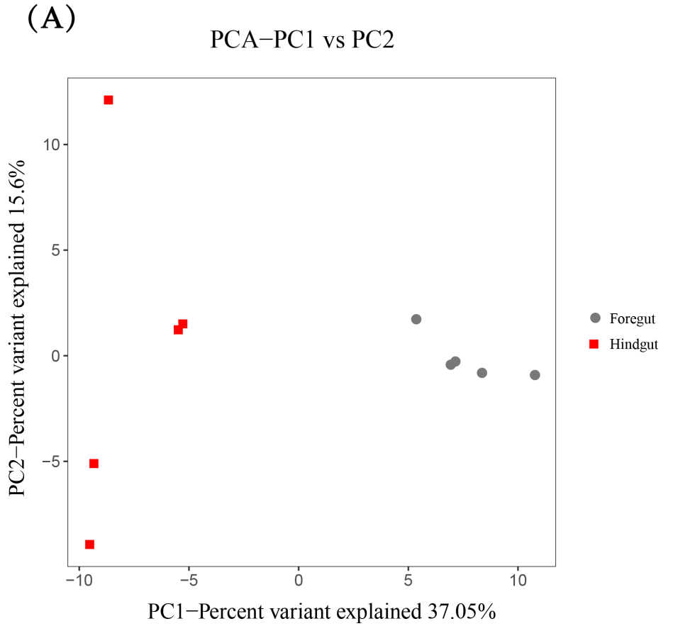
Figure S3. Different function compositions of the R. roxellana foregut and hindgut. (A), Principal component analysis showing different KEGG pathway function compositions in five samples of the two groups (Foregut vs. Hindgut). (B), Bidirectional clustering heatmap showing the relative abundances of different 40 GH families that characterize each gut region (asterix means significant difference) (see the detail in Table S7).

Figure S4. Relative abundance of grouped GH families in Table S8. G and S represent the average frequency of GH identified in the metagenomic of all 5 GSM foregut and hindgut respectively (Numbers of other 4 animal overall sequenced genes are coming from original papers). We compared the percentages of these groups relative to the total number (rely on using different version of database) of GH identified in each species to compare the distribution pattern.

Figure S5. KEGG pathway abundance differed significant between foregut and hindgut. Pathway IDs were ordered by the ratio between the mean abundance of foregut and hindgut. Terms at the top of the barplots are more abundant in the foregut, and ones at the bottom are more abundant in hindgut.
Methods
Study species. The golden snub-nosed monkey (GSM; Rhinopithecus roxellana) is an endangered species endemic to China. Once widely distributed across China, R. roxellana is now restricted to a few mixed/deciduous temperate montane forests in Sichuan, Shaanxi, Hubei, and Gansu provinces[1, 2]. GSMs feed on a wide range of foods. When available, the leaves of woody angiosperms can contribute up to 50% of their diet[3]. A study in Hubei Province, a region that has mild winters, showed that throughout the year the resident GSMs feed mainly on lichens[4]. Prior to the present research programme, the composition of the diet of GSMs in temperate populations that experience harsh winters was largely unknown[5].

Comparative morphology of the major components of the GSM digestive system.
We added these new data for the GSM to a dataset that consisted of the same measurements for 47 additional primate species, from five families/sub-families [6](Table S2), including 10 colobine species. Data for each species comprised of measurements taken from one to six individuals and we used the species mean for each trait as a single datum point. To quantify the measurements of each of the GSM gut components relative to other primate species, we regressed the logarithm of the volume (ml) of the stomach, caecum, or colon against the log of the cubed value of body length (cm). For ease of interpretation, we plotted these data, grouped for taxonomic group, with the value for the GSM highlighted (Fig. 1; Fig. S1). We assessed statistical significance using phylogenetically independent contrasts (PICs), to account for potential non-independence of data between species via common descent [7]. We constructed a phylogeny of all 48 primate species included in our analyses from previously published primate phylogenies [4, 8-11]. Because our phylogeny contained three polytomies we reduced the degrees freedom for each test by two. For these analyses we used the add-in package ‘PDAP’[12] for the software package ‘Mesquite’ [13].
Cellulose and hemicellulose analysis. These samples were all dried in an oven for 24h at 45˚C and then stored individually in sealed plastic bags until they could be analysed in the laboratory.We directly measured crude protein (CP), lipids (CL), ash, acid detergent fiber (ADF), neutral detergent fiber (NDF) and acid detergent lignin (ADL) from 0.5 dry mass sample [14]（for details see Hou et al. 2018 [5]). All samples were ground and sieved through a 1-mm screen. All analyses were replicated three times. NDF, ADF and ADL were measured sequentially with an ANKOM A2000i fibre analyser (ANKOM, Macedon, NY).
The Chinese Academy of Science and the animal care committee of the Wildlife Protection Society of Shaanxi Province, China reviewed and approved all of the research protocols reported in this study.
Macronutrient analysis
We measured directly crude protein (CP), crude lipids (CL), ash, acid detergent fiber (ADF), neutral detergent fiber (NDF) and acid detergent lignin (ADL). All samples were re-dried at 102oC for 12h and ground using a 1- mm mill. All analyses were repeated three times. Nitrogen content was measured using the Kjeldahl method (using a BUCHI, K-360), with crude protein calculated by multiplying the nitrogen content by 6.25[15-17]. We assayed crude lipid content via 50 petroleum ether extract using a FOSS Soxtec machine (FOSS 2050, Shanghai). NDF, ADF and ADL were measured sequentially with an ANKOM A2000i fiber analyser[18]. Samples were assayed for neutral detergent fiber with residual ash (with sodium sulphite andα-amylase), then for acid detergent fiber with residual ash, and finally for acid detergent lignin [19]. Total non-structural carbohydrate (TNC) content was calculated by subtracting the percentage of lipid, crude protein, NDF, and ash from 100 [20, 21]. Cellulose was determined as the difference between ADF and ADL; hemicellulose was determined as the difference between NDF and ADF.
MetaVx™ Library Preparation of 16S rRNA. Next generation sequencing library preparations and Illumina MiSeq sequencing were undertaken at GENEWIZ, Inc. (Suzhou, China). DNA samples were quantified using a Qubit 2.0 Fluorometer (Invitrogen, Carlsbad, CA, USA), where 30 to 50 ng of DNA was used to generate amplicons using a MetaVx™ Library Preparation kit (GENEWIZ, Inc., South Plainfield, NJ, USA). V3-V4 hypervariable regions of prokaryotic 16SrDNA were selected for generating amplicons and following taxonomy analysis. GENEWIZ designed a panel of proprietary primers aimed at relatively conserved regions bordering the V3-V4hypervariable regions of bacteria and Archaea16S rDNA. The V3 and V4 regions were amplified using forward primers containing the sequence “CCTACGGRRBGCASCAGKVRVGAAT” and reverse primers containing the sequence “GGACTACNVGGGTWTCTAATCC”. At the same time, indexed adapters were added to the ends of the 16S rDNA amplicons to generate indexed libraries ready for downstream NGS sequencing on Illumina Miseq.
DNA libraries were validated by an Agilent 2100 Bioanalyzer (Agilent Technologies, Palo Alto, CA, USA), and quantified by a Qubit 2.0 Fluorometer. DNA libraries were multiplexed and loaded on an Illumina MiSeq instrument according to the manufacturer’s instructions (Illumina, San Diego, CA, USA). Sequencing was performed using a 2x300 paired-end (PE) configuration; image analysis and base calling were conducted using MiSeq Control Software (MCS) embedded in the MiSeq instrument.
Metagenome library Preparation and Sequencing. Metagenome library preparations were constructed following the manufacturer’s protocol (NEBNext® Ultra™ II DNA Library Prep Kit for Illumina®) For each sample, 200 ng genomic DNA was randomly fragmented to <500bp by sonication (Covaris S220). The fragments were treated with End Prep Enzyme Mix to repair both ends and add a dA-tailing in one reaction, followed by a T-A ligation to add adaptors to both ends. Size selection of Adaptor-ligated DNA was then performed using AxyPrep Mag PCR Clean-up (Axygen), and fragments of ~410 bp (with the approximate insert size of 350 bp) were recovered. Each sample was then amplified by PCR for 8 cycles using P5 and P7 primers, with both primers carrying sequences which can anneal with flowcell to performbridge PCR and P7 primer carrying a six-base index allowing for multiplexing. The PCR products were cleaned-up using AxyPrep Mag PCR Clean-up (Axygen), validated using an Agilent 2100 Bioanalyzer (Agilent Technologies, Palo Alto, CA, USA), and quantified by Qubit 3.0 Fluorometer (Invitrogen, Carlsbad, CA, USA).
Libraries with different indexes were multiplexed and loaded on an Illumina HiSeq instrument according to the manufacturer’s instructions (Illumina, San Diego, CA, USA). Sequencing was carried out using a 2x150 paired-end (PE) configuration; image analysis and base calling were conducted by the HiSeq Control Software (HCS) + OLB + GAPipeline-1.6 (Illumina) on the HiSeq instrument.

1. Liu X, Stanford CB, Yang J, Yao H, Li Y: Foods eaten by the Sichuan snub-nosed monkey (Rhinopithecus roxellana) in Shennongjia National Nature Reserve, China, in relation to nutritional chemistry. Am J Primatol 2013;75(8):860-871.
2. Amato KR, Metcalf JL, Song SJ, Hale VL, Clayton J, Ackermann G, Humphrey G, Niu K, Cui D, Zhao H et al: Using the gut microbiota as a novel tool for examining colobine primate GI health. Global Ecology and Conservation 2016;7:225-237.
3. Matsuda I, Murai T, Clauss M, Yamada T, Tuuga A, Bernard H, Higashi S: Regurgitation and remastication in the foregut-fermenting proboscis monkey (Nasalis larvatus). Biology Letters 2011;7(5):786-789.
4. Perelman P, Johnson WE, Roos C, Seuanez HN, Horvath JE, Moreira MA, Kessing B, Pontius J, Roelke M, Rumpler Y et al: A molecular phylogeny of living primates. PLoS Genet. 2011; 7(3):e1001342.
5. Hou R, He S, Wu F, Chapman CA, Pan R, Garber PA, Guo S, Li B: Seasonal variation in diet and nutrition of the northern-most population of Rhinopithecus roxellana. Am J Primatol. 2018; 80(4):e22755.
6. Chivers DJ, Hladik CM: Morphology of the gastrointestinal tract in primates: Comparisons with other mammals in relation to diet. Journal of Morphology 1980;166(3):337-386.
7. Stevens CE, Hume ID: Comparative physiology of the vertebrate digestive system.. ed. 2. 1995.
8. Purvis A: A composite estimate of primate phylogeny. Philos Trans R Soc Lond B Biol Sci. 1995;348(1326):405-421.
9. Pozzi L, Disotell TR, Masters JC: A multilocus phylogeny reveals deep lineages within African galagids (Primates: Galagidae). BMC Evol Biol. 2014;14:72.
10. Wang XP, Yu L, Roos C, Ting N, Chen CP, Wang J, Zhang YP: Phylogenetic relationships among the colobine monkeys revisited: new insights from analyses of complete mt genomes and 44 nuclear non-coding markers. PLoS One. 2012;7(4):e36274.
11. Li J, Han K, Xing J, Kim HS, Rogers J, Ryder OA, Disotell T, Yue B, Batzer MA: Phylogeny of the macaques (Cercopithecidae: Macaca) based on Alu elements. Gene 2009;448(2):242-249.
12. Midford PE, Garland, J. T. & Maddison, W. P. PDAP: PDTREE Package for mesquite, 2.73 2010.
13. Madison WPM: Mesquite: a modular system for evolutionary analysis. Evolution 2009; doi:10.1234/12345678
14. Griswold, E K: Diversity of Extracellular Proteolytic Activities AmongPrevotellaSpecies from the Rumen. Current Microbiology 1999;39(4):187-194.
15. Maynard LA, Loosli JK: Animal Nutrition 6th Edition. 1969.
16. Waterman PG, Ross JAM, Bennett EL, Davies AG: A comparison of the floristics and leaf chemistry of the tree flora in two Malaysian rain forests and the influence of leaf chemistry on populations of colobine monkeys in the Old World. Biological Journal of the Linnean Society 2008; 34(1):1-32.
17. WATERMAN, PG, ROSS, JAM, BENNETT, EL, DAVIES, AG: A COMPARISON OF THE FLORISTICS AND LEAF CHEMISTRY OF THE TREE FLORA IN 2 MALAYSIAN RAIN FORESTS AND THE INFLUENCE OF LEAF CHEMISTRY ON POPULATIONS OF COLOBINE MONKEYS IN THE OLD-WORLD. BIOL J LINN SOC. 1988.
18. Van Soest PJ, Robertson JB, Lewis BA: Methods for dietary fiber, neutral detergent fiber, and nonstarch polysaccharides in relation to animal nutrition. J Dairy Sci 1991, 74(10):3583-3597.
19. Rothman JM, Dierenfeld ES, Hintz HF, Pell AN: Nutritional quality of gorilla diets: consequences of age, sex, and season. Oecologia 2008;155(1):111-122.
20. Conklin-Brittain NL, Knott CD, Wrangham RW: Energy Intake by Wild Chimpanzees and Orangutans: Methodological Considerations and a Preliminary Comparison. 2006.
21. Rothman JM, Chapman CA, Soest PJV: Methods in Primate Nutritional Ecology: A User's Guide. International Journal of Primatology 2011;33(3).

